Extension Question – Two Masses and an Inclined Plane
Study the following diagram.
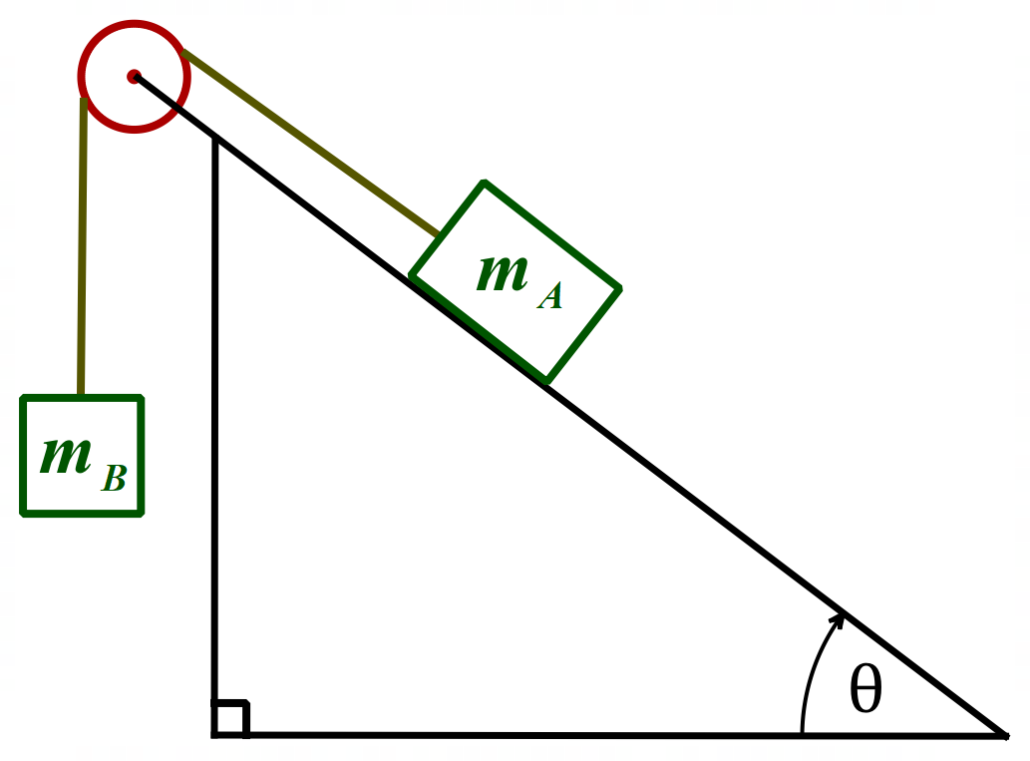

Block A of mass 10.0 kg rests on a ramp inclined at θ = 37° to the horizontal. It is connected by a light, inextensible cord, which passes over a massless, frictionless pulley, to a second block, Block B of mass m_{B}, which hangs freely as shown in the diagram above.
- Determine the range of values for mass m_{B} which will keep the system at rest, given that the coefficient of static friction is μ_{s} = 0.40.
- Calculate the acceleration of the system, if the coefficient of kinetic friction is μ_{k} = 0.30 and m_{B} = 10.0 kg. Take g = 9.80 ms⁻².

Solution is on the next page.

Solution
- Let us think for a moment about which ways Block A can move.
If the mass of Block B is zero or is sufficiently small, Block A will slide down the ramp. The friction force on Block A would be directed up the ramp. So, let us draw the free-body diagram for this case (using bolded letters to represent all vectors).
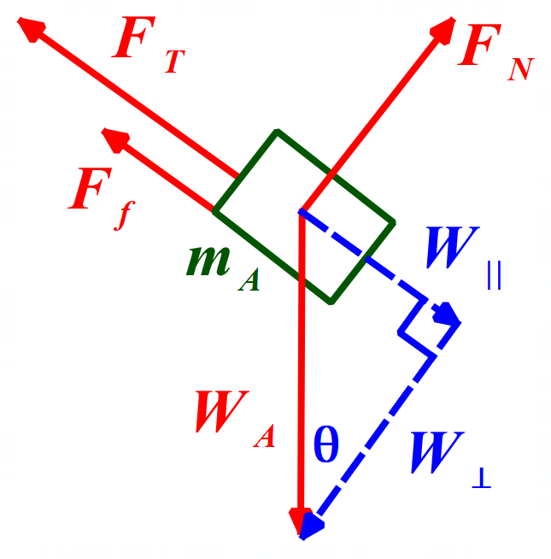
In the above free-body diagram:
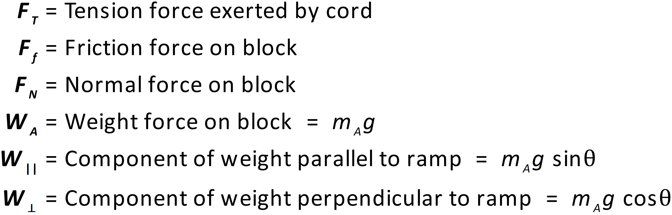
If the mass of Block B is large enough, Block A will move up the ramp. The friction force on Block A would be directed down the ramp, opposing the motion. We can now draw the free-body diagram for this case, using same symbols as above.
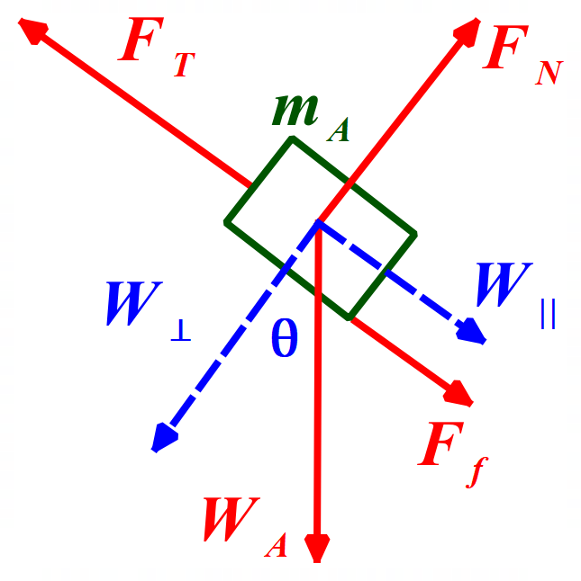
I have simply moved 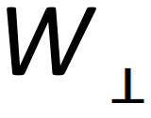 to make room for 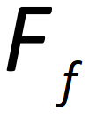 . The force on the block up the ramp is provided by the tension in the cord.
The free-body diagram for Block B is as follows.
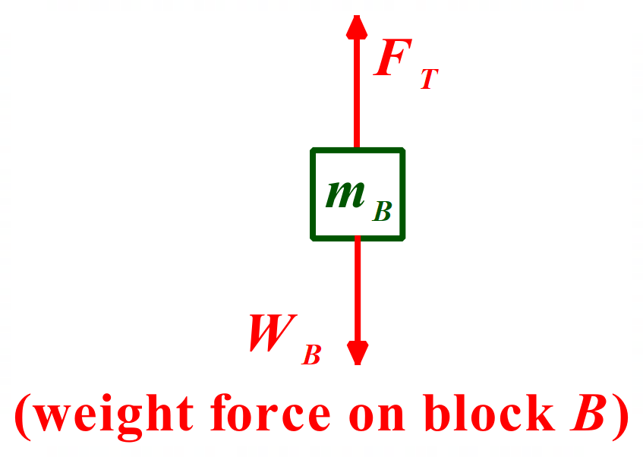
Now we can use Newton’s 2nd Law to determine the range of values for mass m_{B} which will keep the system at rest, given that the coefficient of static friction is μ_{s} = 0.40.
Regardless of whether Block A moves up or down the ramp, Newton’s 2nd Law for the direction perpendicular to the ramp yields the same equation:
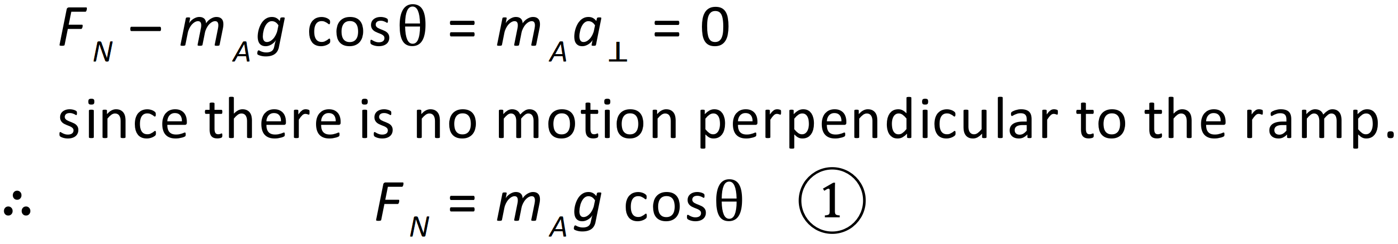
Let us consider the case where Block A moves down the ramp:
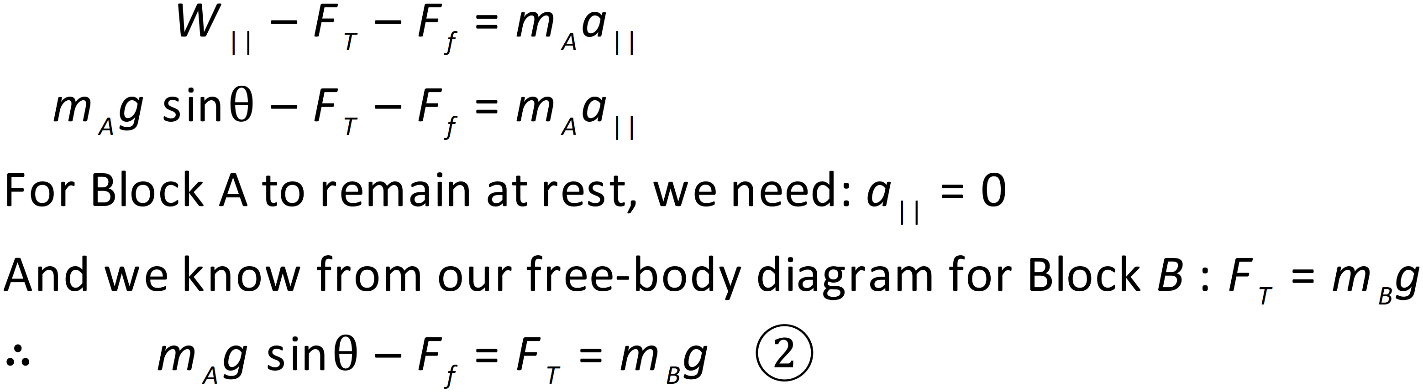
We now need to realise that:
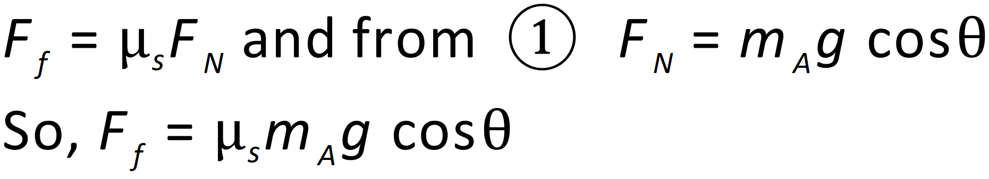
The minimum value for m_{B} at which it prevents the motion of Block A will occur when static friction is maximum, that is when μ_{s} = 0.40. This value of m_{B} is given by:
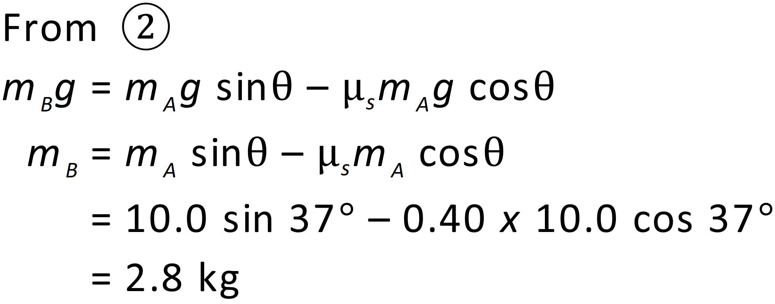
Therefore, if m_{B} < 2.8 kg, Block A will slide down the ramp.
Now we consider the case where Block A is pulled up the ramp. Studying the second of our free-body diagrams and applying Newton’s 2nd Law, we have:

The maximum value m_{B} can have without causing Block A to accelerate up the ramp is given by:

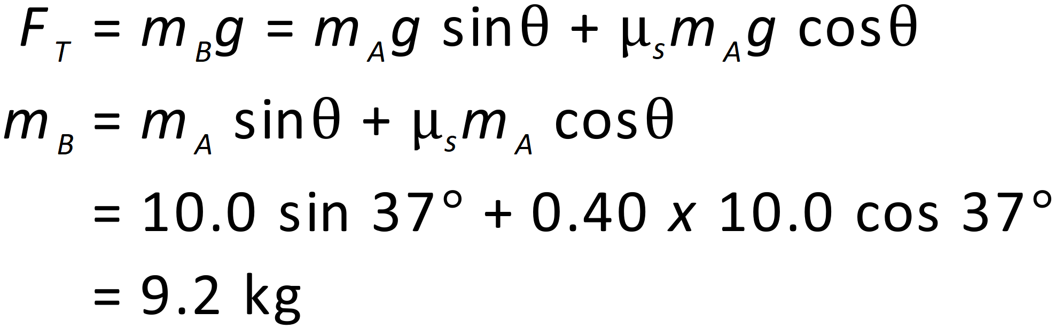
Therefore, to keep the system at rest, 2.8 kg < m_{B} < 9.2 kg.
- Since m_{B} > 9.2 kg, Block B will fall and Block A will be pulled up the ramp. Applying Newton’s 2nd Law to Block A, we have:
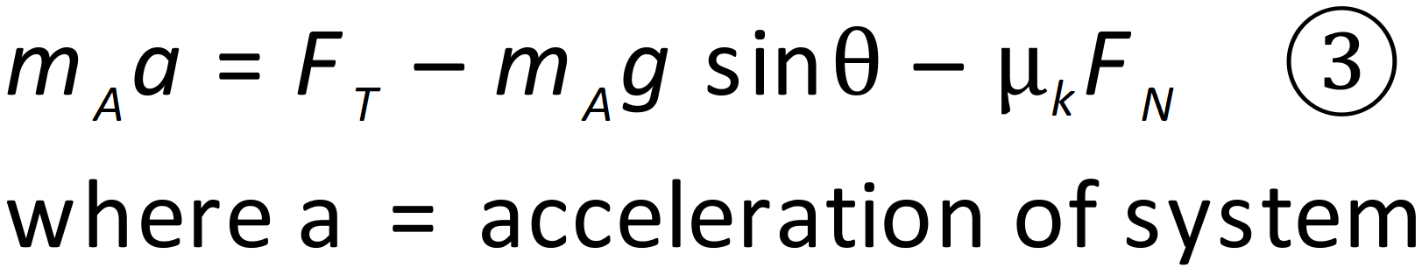
Applying Newton’s 2nd Law to Block B, we have:
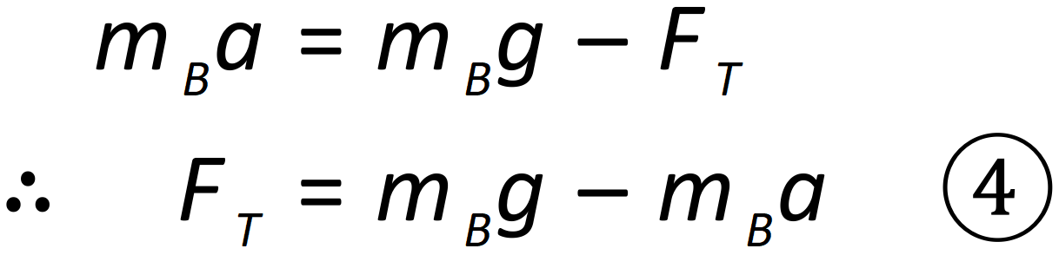
Now substitute for 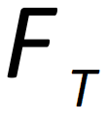 from equ (4) into equ (3):

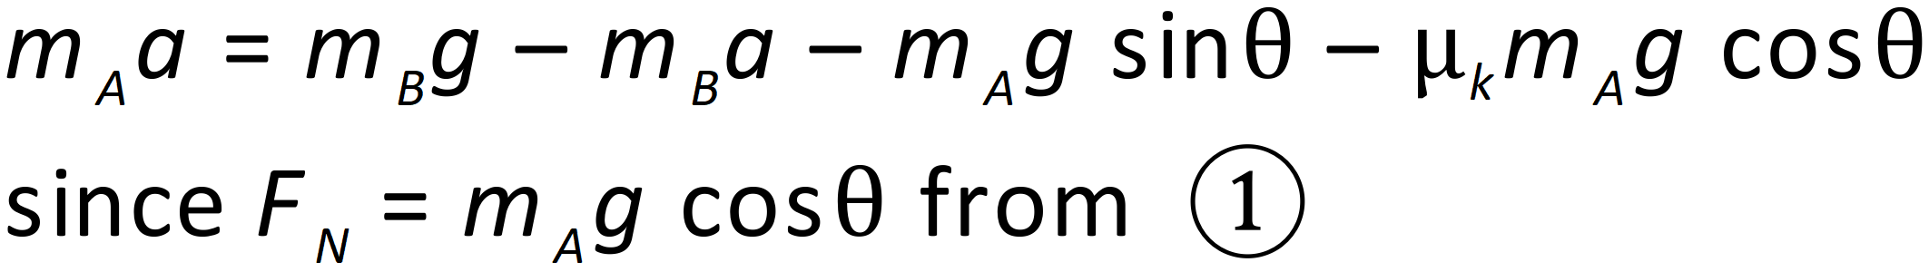

Now we can solve this equation for 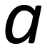 :

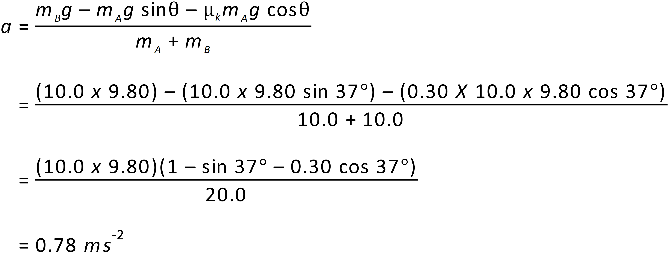
Thus, the acceleration of the system is 0.78 ms⁻² with Block B falling and Block A being pulled up the ramp.

In summary, what was our process here, to solve this problem? We drew some free-body diagrams. We applied Newton’s 2nd Law using the information from the diagrams. We did a little bit of thinking about what conditions would produce the minimum and maximum values of m_{B}, then we used maths to solve the relevant equations.

This is a difficult question for Stage 6 Physics. Hence, why I call it an extension question. If you have understood it, you are doing extremely well. Keep up the great work.

Food For Thought
For some extra thinking – you might like to consider why in problems we often say that the pulley is massless and frictionless. Real pulleys have mass and friction is inherent in their workings.

The reason is that the presence of friction and inertia (mass) in the pulley modifies the transmitted tension. Therefore, to make things simple, we often use the massless and frictionless pulley approximation. For the frictionless/massless situation, the tension in the string on both sides of the pulley is the same - and not zero. With friction the tensions would be different - and if it was large enough, and the two masses were not too different, the masses might not move at all. Having to account for the mass and frictional effects of the pulley makes a problem more complex to solve.

