DYNAMICS WORKSHEET 3 – FORCES
Solutions to these problems are available on the Fundamentals of Mechanics page of my website.
- 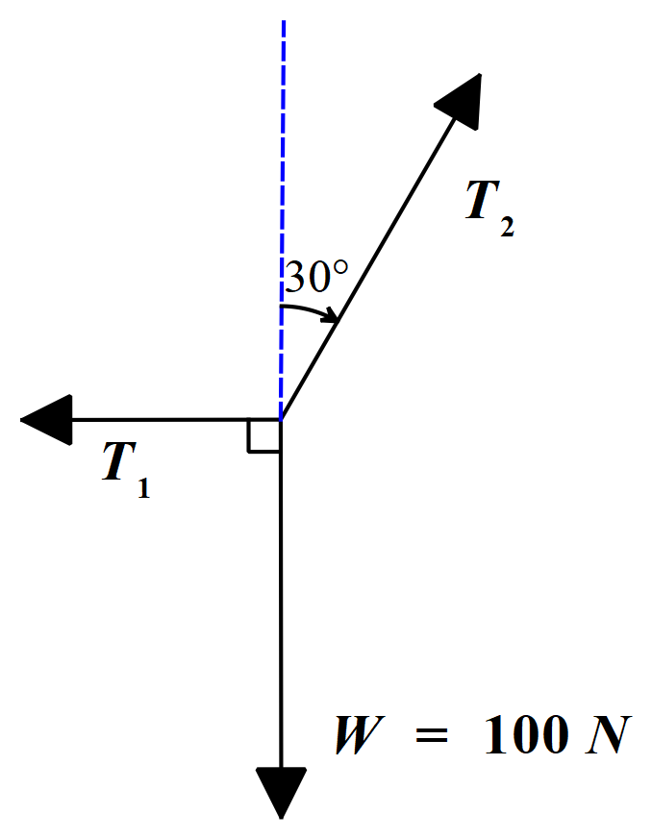A weight of 100 N is supported in equilibrium by two ropes, as shown in the free body diagram below.
One of the ropes pulls in a horizontal direction and the other in a direction of 30° with the vertical. Calculate the tension in each rope. (T₁ = 57.7 N, T₂ = 115 N)
- 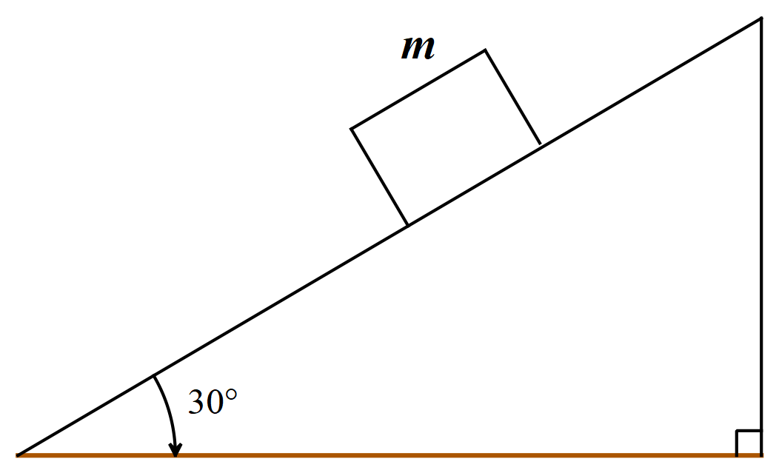In the diagram below a block of mass m is sliding down a 30° incline. The coefficient of sliding friction is 0.20. Take g = 9.8 ms⁻². Find the acceleration of the block down the incline. (3.2 ms⁻²)
- Assuming the acceleration due to gravity is 9.8 ms⁻², determine the force that a 90 kg woman exerts on the floor of an elevator when it:
  - Is at rest
  - Rises with constant velocity 1.5 m/s
  - Descends with constant velocity 1.5 m/s
  - Rises with constant acceleration 1.5 ms⁻²
  - 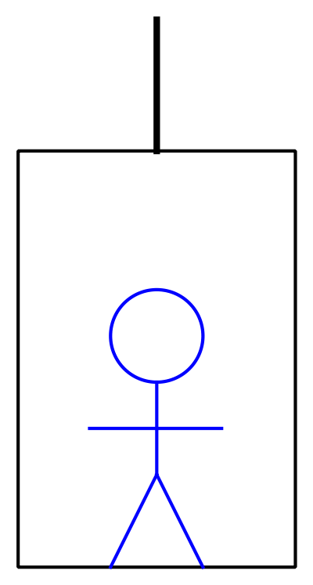Descends with constant acceleration 1.5 ms⁻²
Answers: (a), (b) & (c) are all 882 N; (d) 1017 N; (e) 747 N
- 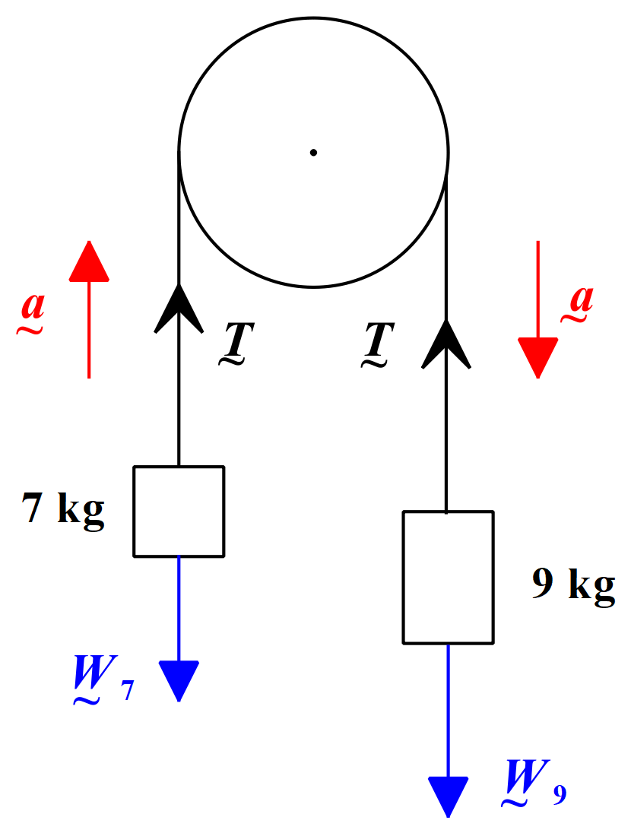A cord passing over a pulley has a 7 kg mass tied to one end and a 9 kg mass on the other. Determine the acceleration of the masses and the tension in the cord. Neglect friction and the mass of the cord. Take g = 9.8 ms⁻². (a = 1.23 ms⁻², T = 77.2 N)
- 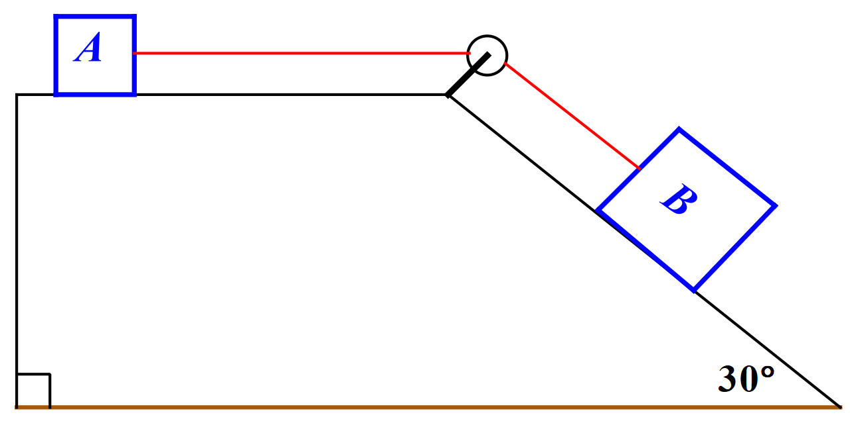
In the diagram above, block A has a mass of 20 kg and block B has a mass of 30 kg. The two blocks are joined by a thin, inextensible, cord. The cord passes through a pulley as shown. When released, the system of masses accelerates. The coefficient of friction for the surface is 0.2. Assume that the acceleration due to gravity is 9.8 ms⁻² and that the mass of the cord is negligible. Find the acceleration of the system and the tension in the cord.
(1.14 ms⁻², 62 N)
If you have difficulty with questions 3, 4 or 5, it may help to read the “Tensions in Strings” topic notes available on the Fundamentals of Mechanics page of the website.

