PHYSICS COURSE – YEAR 11

MODULE 4: ELECTRICITY AND MAGNETISM

Worksheet 1

- Study the circuit shown below.
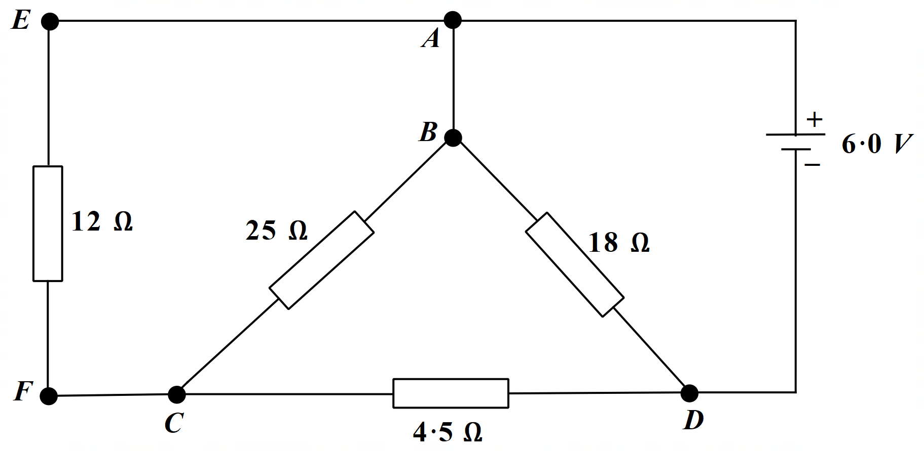
  - Determine the equivalent resistance of this circuit.
  - Find the current in the 18 Ω resistor.
  - Calculate the current in the 12 Ω resistor.
  - What is the power dissipation in the 4.5 Ω resistor?
- A Wheatstone bridge is one type of “bridge circuit” used to make measurements of resistance. The unknown resistance to be measured, R_{x}, is placed in the circuit with accurately known resistances R₁, R₂ and R₃. One of these, R₃, is a variable resistor which is adjusted so that when the switch is closed, the ammeter shows zero current flow.
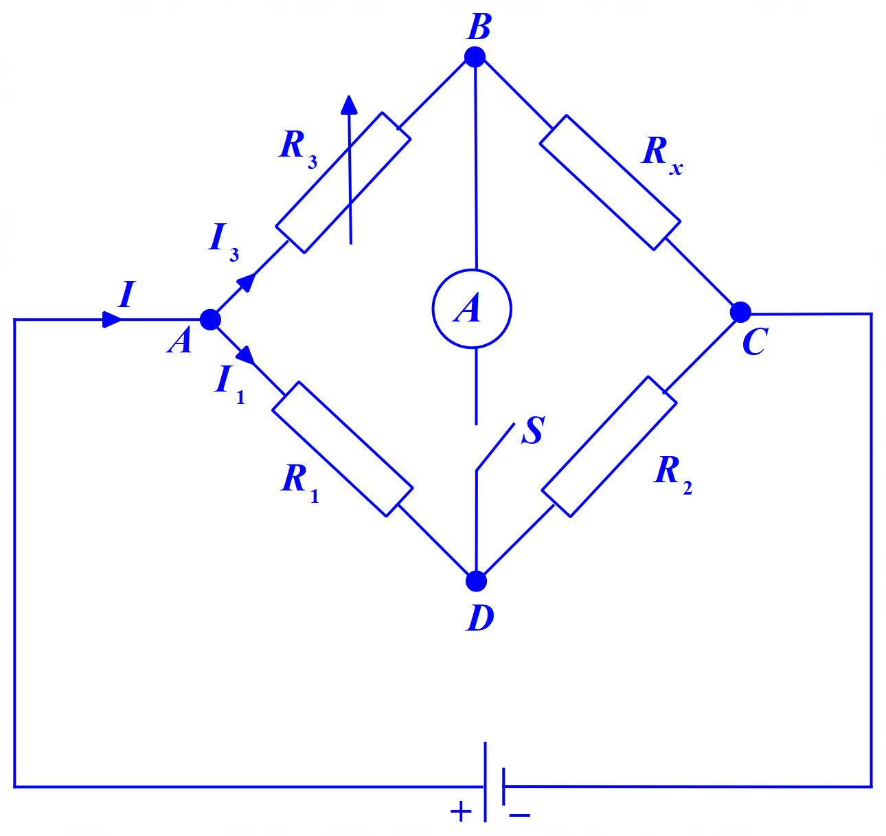
  - Determine R_{x}, in terms of R₁, R₂ and R₃ only.
  - If the above bridge is “balanced” when R₁ = 630 Ω, R₂ = 972 Ω and R₃ = 78.6 Ω, what is the value of the unknown resistance?

Solutions appear on the next page. Try the problems first.

Solutions

- If you are not sure which resistors are in series and which in parallel, trace the path of conventional current flow with your finger from the positive terminal of the battery. Where your finger reaches a point where you have two or more different directions you could take, that section of resistors is in parallel. Also, remember that conventional current always flows from the positive to the negative terminal. It cannot flow backward.
So, the current leaves the positive terminal of the battery and travels anticlockwise around the circuit. When the current reaches A it has two ways to go – AE and AB. So, these paths AE and AB lead into two parallel arms of the circuit. Let us follow AB first. At B, the current again has two possible paths to follow – BC and BD. So, the paths BC and BD lead into parallel arms. Let us follow BC first. At C, the current must flow toward the negative terminal, that is, it must flow toward D. Clearly, then the two resistors in the arm BCD are in series with each other and that arm is in parallel with BD.
Now let us complete the tracing by following path AE. The current in this arm follows the path AEFC. It is in parallel with both other arms BCD and BD. At C, the current from AEF must flow on toward D. It cannot flow up toward B because it would be heading back toward the positive terminal.
So, we are now able to draw an equivalent circuit to the one provided – a circuit that for many people is a lot easier to work with. It follows below – the labelling of points bears no relation to the labelling in the original circuit diagram.
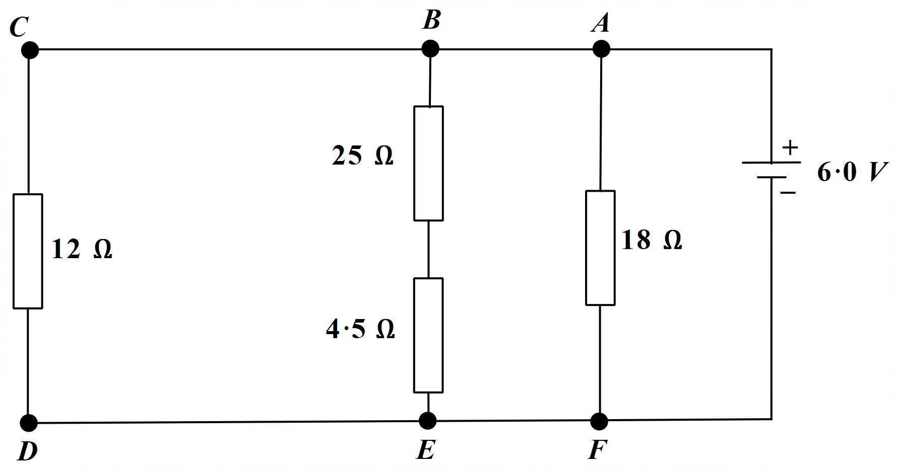
It is much easier in this diagram to pick which resistors are in series and which in parallel. We can use this equivalent circuit to answer the questions we have been asked. Once you are familiar with this method of creating an equivalent circuit diagram for difficult circuits, you can create the equivalent circuit very quickly. Obviously, you do not need to explain what you are doing, as I have above. You just state that you are re-drawing the circuit in an equivalent way.
  - 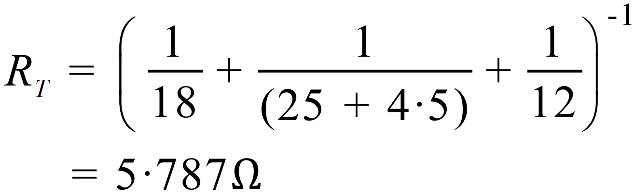
  - 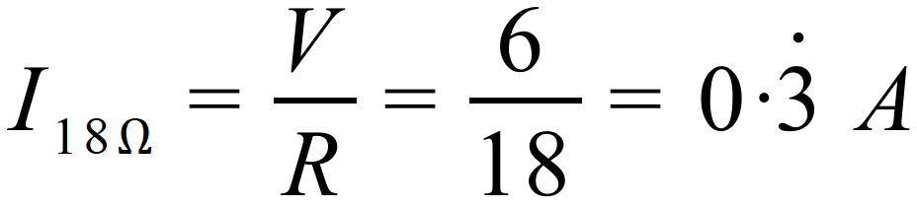
  - 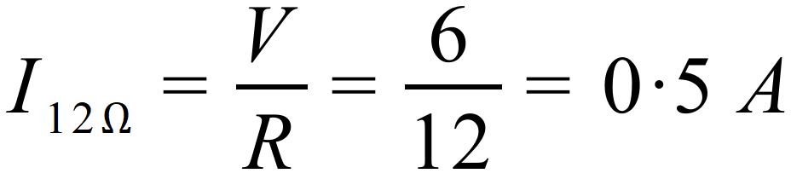
  - 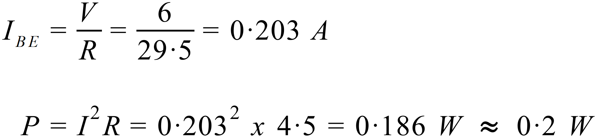

  - 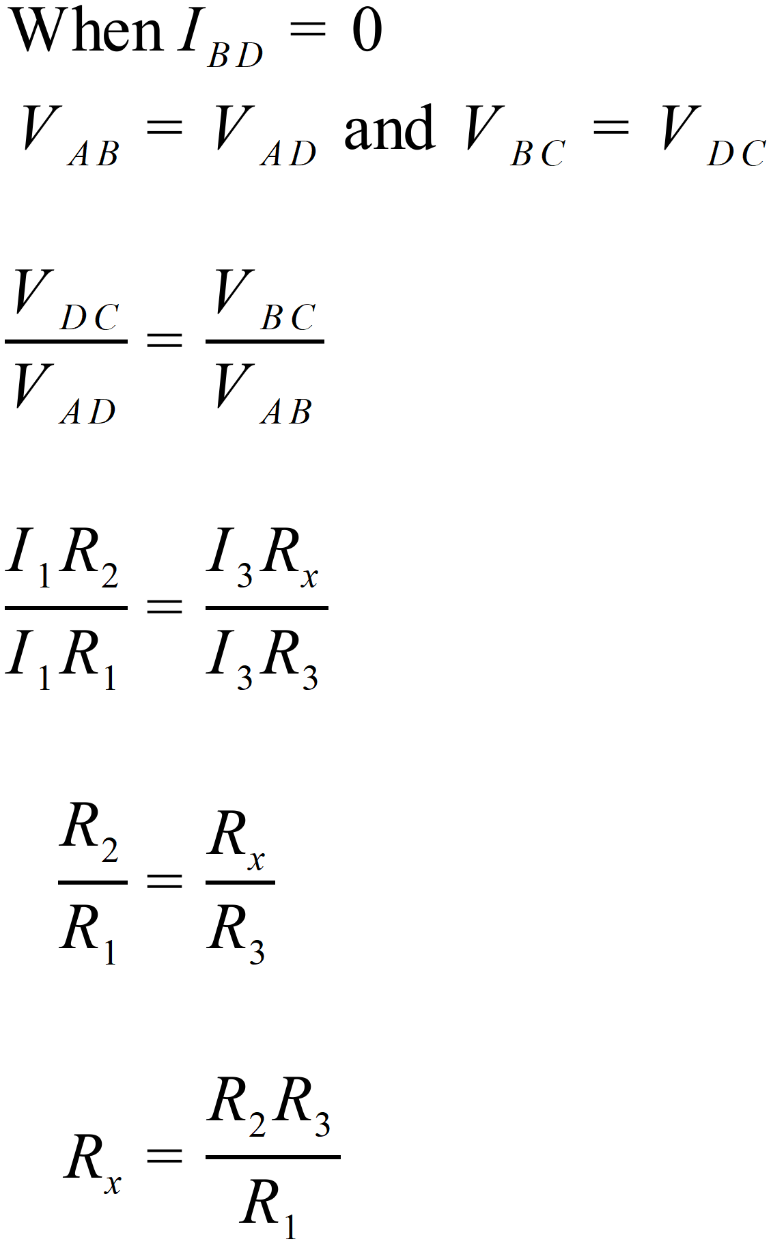
  - 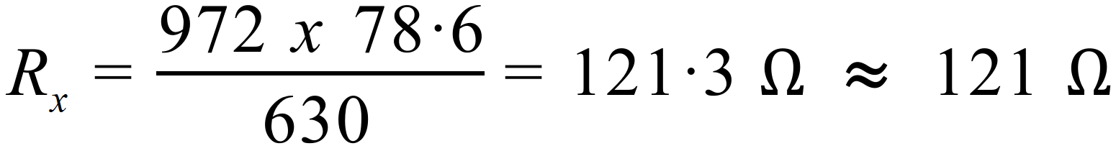
Unknown resistance is 121 Ω.

