MODULE 3: WAVES AND THERMODYNAMICS

Worksheet – Sound Waves

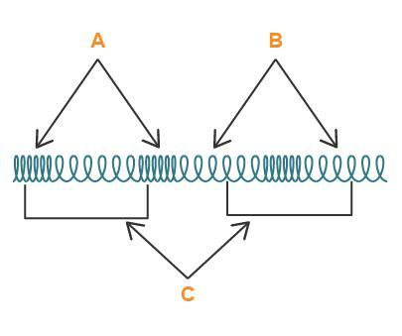
Diagram From: Wikimedia Commons
Define each of the variables in the diagram of a longitudinal wave above.
- Examine the animations below showing the displacement-distance and pressure-distance graphs for the longitudinal wave set up in the pipe closed at one end in the top animation.

Diagram From: Wikimedia Commons - Animation courtesy of Dr
Dan Russell, Grad. Prog. Acoustics, Penn State – Additional
information about using this content is available at
http://www.acs.psu.edu/drussell/Demos/copyright.html
Describe what is happening in the bottom animation – the pressure-distance graph.

- A wire of length 140 cm and mass 52.0 g is stretched by hanging a load of mass 16.0 kg on it. Calculate the frequency of the fundamental mode of vibration of the wire.
- A pipe open at both ends is 40 cm long. Find the frequencies of the 2nd and 3rd harmonics, taking the speed of sound in air as 340 m/s.
- A pipe closed at one end is 1.20 m long. This pipe is sounded on a day when the speed of sound is 336 m/s. Calculate the frequency of its fundamental and first overtone.
- Two organ pipes, one open and one closed, when producing their fundamental modes are giving the same note. What is the ratio of their lengths?
- Two open organ pipes, one of which is 0.60 m long and the other 0.61 m long, produce 19 beats in 4.00 second when sounded together. Find the velocity of sound.
- Define the term reverberation as it is used in reference to sound.
- Find the frequency of the note heard by the station master standing at rest on a train station as a train travelling at 22.2 m/s (a) approaches and (b) recedes from the station. The frequency of the train whistle is 750 Hz and the speed of sound is 330 m/s.
- A high-quality loudspeaker is advertised to reproduce at full volume, frequencies from 30 Hz to 18,000 Hz with uniform sound level ±3 dB. That is, over this frequency range, the sound level output does not change by more than 3 dB for a given input level. By what factor does the sound intensity change for the maximum change of 3 dB in output sound level? (Hint: Let the average sound intensity be I₁ and the average sound level be β₁. Then the maximum intensity, I₂, corresponds to a sound level β₂ = β₁ + 3 dB. We can then use our equation that relates sound level and sound intensity.)

