MODULE 3: WAVES AND THERMODYNAMICS

Worksheet – Sound Waves - Solutions

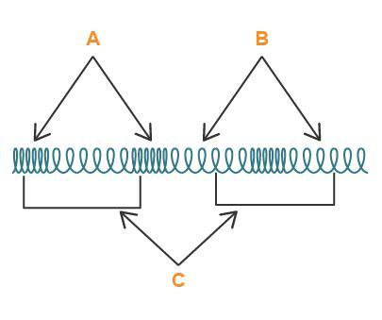
Diagram From: Wikimedia Commons
Define each of the variables in the diagram of a longitudinal wave above.
A = compression – an area of higher pressure (and therefore higher particle density) of the medium through which the longitudinal wave is travelling - particles of the medium have moved closer together than when they are at equilibrium
B = rarefaction - an area of lower pressure (and therefore lower particle density) of the medium through which the longitudinal wave is travelling - particles of the medium have moved further away from each other than when they are at equilibrium
C = wavelength of the longitudinal wave – the distance between two consecutive identical points on the wave
- Examine the animations below showing the displacement-distance and pressure-distance graphs for the longitudinal wave set up in the pipe closed at one end in the top animation.

Diagram From: Wikimedia Commons - Animation courtesy of Dr
Dan Russell, Grad. Prog. Acoustics, Penn State – Additional
information about using this content is available at
http://www.acs.psu.edu/drussell/Demos/copyright.html
Describe what is happening in the bottom animation – the pressure-distance graph.
The bottom animation shows a graph representing the pressure variation associated with this standing sound wave. When the local density of the particles increases above the ambient value, the pressure variation is positive; this occurs when the particles are moving inward toward a displacement node location. When the local density of the particles decreases below the ambient value, the pressure variation is negative; this occurs when the particles move outward away from a displacement node location. If you compare the three animations, you will notice that the pressure nodes (locations where the pressure is always zero) coincide with the displacement antinodes, there the local particle density does not change as the particles move back and forth together. (Explanation courtesy of Dr Dan Russell, Grad. Prog. Acoustics, Penn State.)

- A wire of length 140 cm and mass 52.0 g is stretched by hanging a load of mass 16.0 kg on it. Calculate the frequency of the fundamental mode of vibration of the wire.
- A pipe open at both ends is 40 cm long. Find the frequencies of the 2nd and 3rd harmonics, taking the speed of sound in air as 340 m/s.
- A pipe closed at one end is 1.20 m long. This pipe is sounded on a day when the speed of sound is 336 m/s. Calculate the frequency of its fundamental and first overtone.

- Two organ pipes, one open and one closed, when producing their fundamental modes are giving the same note. What is the ratio of their lengths?
- Two open organ pipes, one of which is 0.60 m long and the other 0.61 m long, produce 19 beats in 4.00 second when sounded together. Find the velocity of sound.
- Define the term reverberation as it is used in reference to sound.
Reverberation is a persistence of sound after the sound is produced. A reverberation is created when a sound or signal is reflected causing numerous reflections to build up and then decay as the sound is absorbed by the surfaces in the space, which could include furniture, people, and air.

- Find the frequency of the note heard by the station master standing at rest on a train station as a train travelling at 22.2 m/s (a) approaches and (b) recedes from the station. The frequency of the train whistle is 750 Hz and the speed of sound is 330 m/s.
- A high-quality loudspeaker is advertised to reproduce at full volume, frequencies from 30 Hz to 18,000 Hz with uniform sound level ±3 dB. That is, over this frequency range, the sound level output does not change by more than 3 dB for a given input level. By what factor does the sound intensity change for the maximum change of 3 dB in output sound level? (Hint: Let the average sound intensity be I₁ and the average sound level be β₁. Then the maximum intensity, I₂, corresponds to a sound level β₂ = β₁ + 3 dB. We can then use our equation that relates sound level and sound intensity.)

