LATENT HEAT QUESTIONS

- Calculate the heat absorbed by an electric refrigerator in changing 2 kg of water at 15° C to ice at 0° C.
- Determine the resulting temperature, t, when 0.150 kg of ice at 0° C are mixed with 0.300 kg of water at 50° C.
- 0.5 kg of water and 0.100 kg of ice are in thermal equilibrium at 0° C. If 0.200 kg of steam at 100° C is introduced into the mixture, find the final temperature and composition of the mixture. (Extension Question)
DATA

Specific heat capacity of water is 4184 Jkg⁻¹K⁻¹.

Specific Latent Heat of Fusion of ice = 3.35 x 10⁵ Jkg⁻¹

Specific Latent Heat of Vaporization of water = 2.26 x 10⁶ Jkg⁻¹

Solutions commence over the page.

Solutions

- Heat absorbed in changing water at 15° C to water at 0° C:
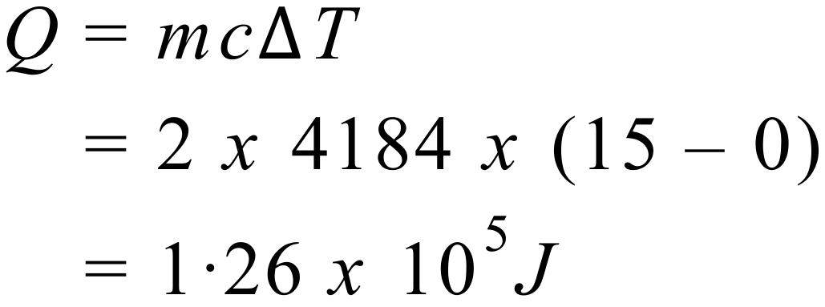
Heat absorbed in changing water at 0° C to ice at 0° C:
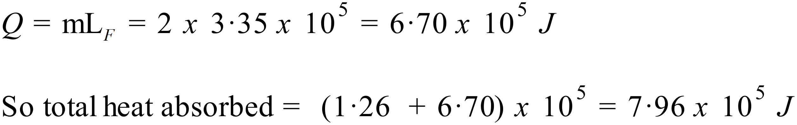
- So, the water is going to melt the ice. We need to calculate how much heat that takes. The liquid water produced by the melting ice will initially be at 0° C. So, we have to work out how much heat is required to raise the temperature of this water to the final temperature, t. The 0.300 kg of water at 50° C is going to lose heat in this process. We need to determine how much heat it loses.
Heat to melt ice:
Heat to raise temperature of 0.150 kg of water at 0° C to final temperature:
Heat lost by 0.300 kg of water at 50° C:
Heat lost by the warmer water = heat gained by the ice & ice water
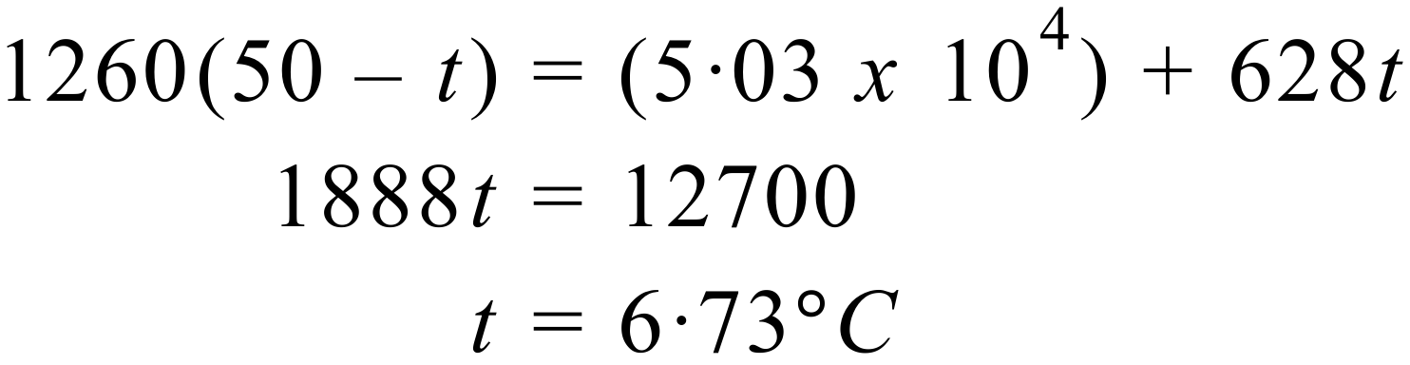
Resulting temperature is 6.73° C.
- Our plan of attack is to determine the expression for the heat required to melt the ice and raise the temperature of the water to the final temperature – let’s call it t; and the expression for the heat given up by the steam in condensing and cooling to the final temperature, t. That will enable us to find t, since the two expressions must be equal. So, let’s get that done first. Remember, the 0.5 kg of water and 0.1 kg of ice are in thermal equilibrium at 0° C initially. So, once the ice has melted, there will be 0.6 kg of water to raise from 0° C to t.
Heat to melt ice & raise temperature of water to final temperature, t:
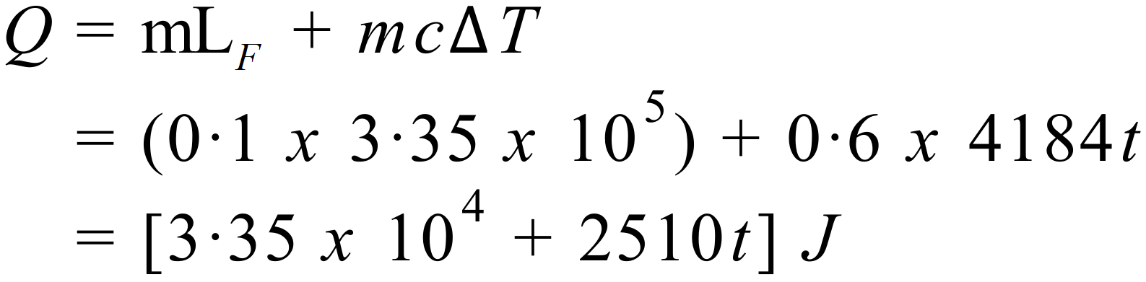
Heat given up by steam in condensing & cooling to final temperature, t:
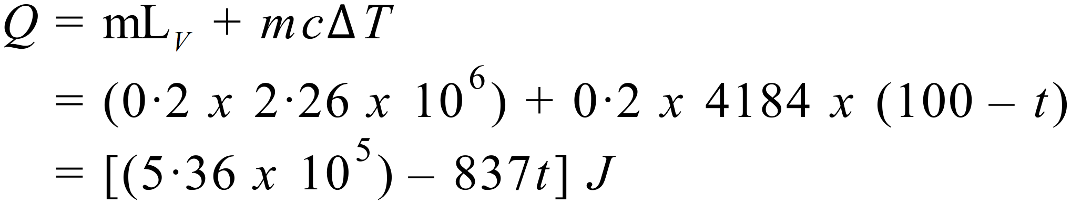
Then, heat absorbed by cold body = heat given up by hot body
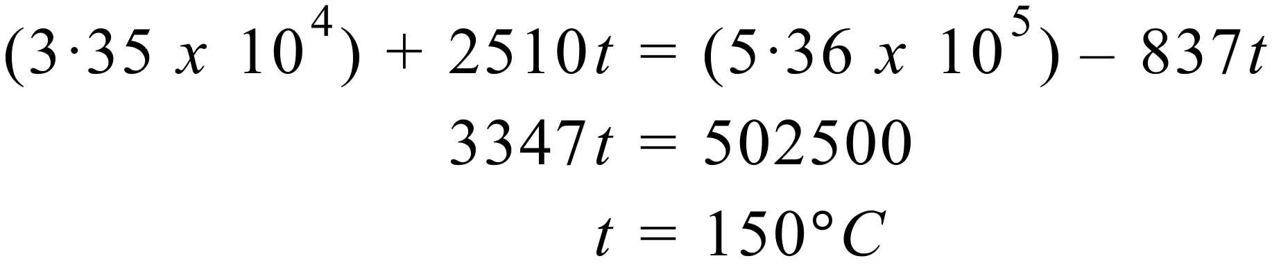
Now, let’s think for a moment what this means. If t had been less than 100° C, it would mean that all of the steam had condensed, and the water had risen to whatever temperature t represented. A value of t > 100° C, means there was more steam than necessary to raise the temperature of the ice and water to 100° C. Thus, the final temperature of the mixture of steam and water is 100° C and some steam is not condensed. Let M be the mass of steam that has condensed.
Heat to melt ice and raise temperature of water to 100° C:
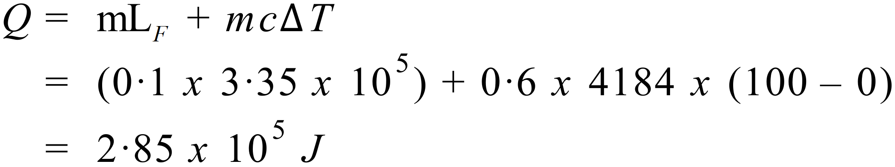
Heat given up by M kg of steam in condensing:
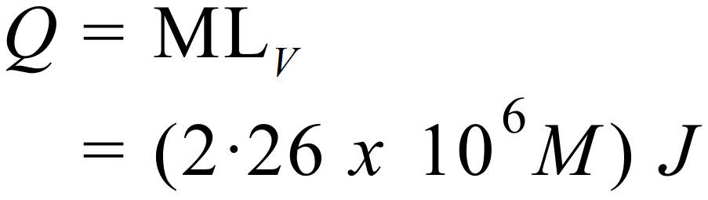
And heat absorbed by cold body = heat given up by hot body
