CIRCULAR MOTION QUESTIONS

- A ball of mass 0.1 kg is swung in a horizontal circle of radius 3.0 m with a period of 0.5 second. For this ball, calculate:
  - The angular velocity;
  - The linear velocity;
  - The frequency of the motion;
  - The centripetal acceleration; and
  - The centripetal force.
Answers: (a) 4π rads⁻¹; (b) 12π ms⁻¹; (c) 2 Hz; (d) 48π² ms⁻²; (e) 4.8π² N
Note – In an exam give an approximation to the answers with π as well as the precise answer.
- A flywheel 20 cm in radius has a period of revolution of 0.10 s. Calculate the centripetal acceleration of a point on its edge. Answer: 790 ms⁻².
- A body of mass 1.0 kg has a velocity of 1.0 ms⁻¹. When it reaches a point P, it is acted on by a force of 10 N which is always at right angles to the direction of motion. Find the time taken for the body to return to the point P. Answer: π/5 s
- A solid sphere of mass 1.0 kg attached to a rope is whirled in uniform circular motion. As shown in the diagram below, the mass travels clockwise as viewed from above. On reaching point P, the rope snaps. Which path, A, B or C will the mass now follow? Explain. Answer: Over page.
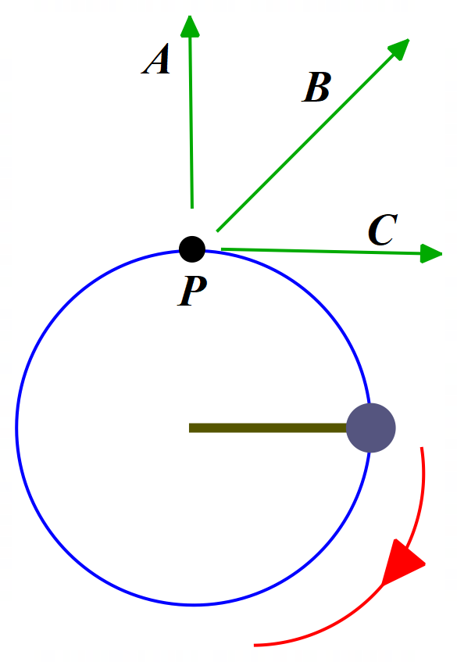
- A conical pendulum consists of a mass of 0.075 kg on the end of a string 0.900 m long. The period of the pendulum is 1.2 s. Calculate:
  - The tension in the string; and
  - The angle from the vertical of the string.
Take g = 9.8 ms⁻². (Hint: Draw a diagram & resolve the relevant forces.)
Answers: (a) 1.9 N; (b) 67°
- A curve on the highway is to be banked, so that sideways skidding will not occur for traffic moving at 80 km/hr. If the radius of the curve, measured in a horizontal plane, is 100 m, what is the angle of bank of the road surface? Take g = 9.8 ms⁻². Ignore effects due to the friction of the tyres on the road surface. (Hint: Draw a diagram and resolve the normal reaction between a vehicle and the road.) Answer: 27°
- Extension Problem: A jet at the lowest point of a loop is travelling at 525.0 ms⁻¹ in a circular path of radius 4800.0 m. The jet is upright, so that the pilot is on the inside of the loop.
  - At this lowest point of the loop, what is the normal force acting on the pilot due to the seat. The mass of the pilot is 60.0 kg.
Answer: 4.03 x 10³ N, upwards towards centre of circular loop.
  - Determine the normal acceleration of the pilot at the lowest point of the loop.
Answer: 67.2 ms⁻², upwards towards centre of circular loop.
  - Calculate how many g of acceleration the pilot experiences at this point.
Answer: 6.9 g, upwards towards centre of circular loop.
Take g = 9.8 ms⁻². Ignore effects due to air resistance. (Hint: Draw a diagram of the jet at the bottom of the loop showing the forces acting on it at that point.)
Answer to Q4: Path C – When the rope snaps, the centripetal force ceases to act and by Newton’s 1st Law, the mass will continue to move in the same straight line until acted on by an unbalanced external force. In other words, the mass will move off along the tangent to the circular motion at point P, in the direction of its linear velocity.

Solutions can be found on the next page.

SOLUTIONS

- 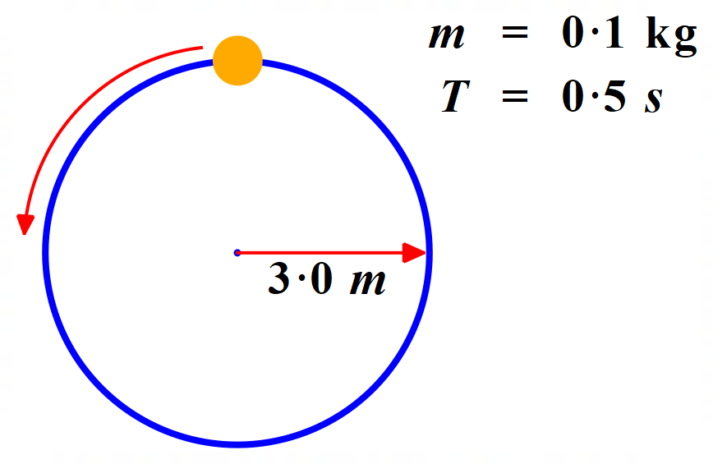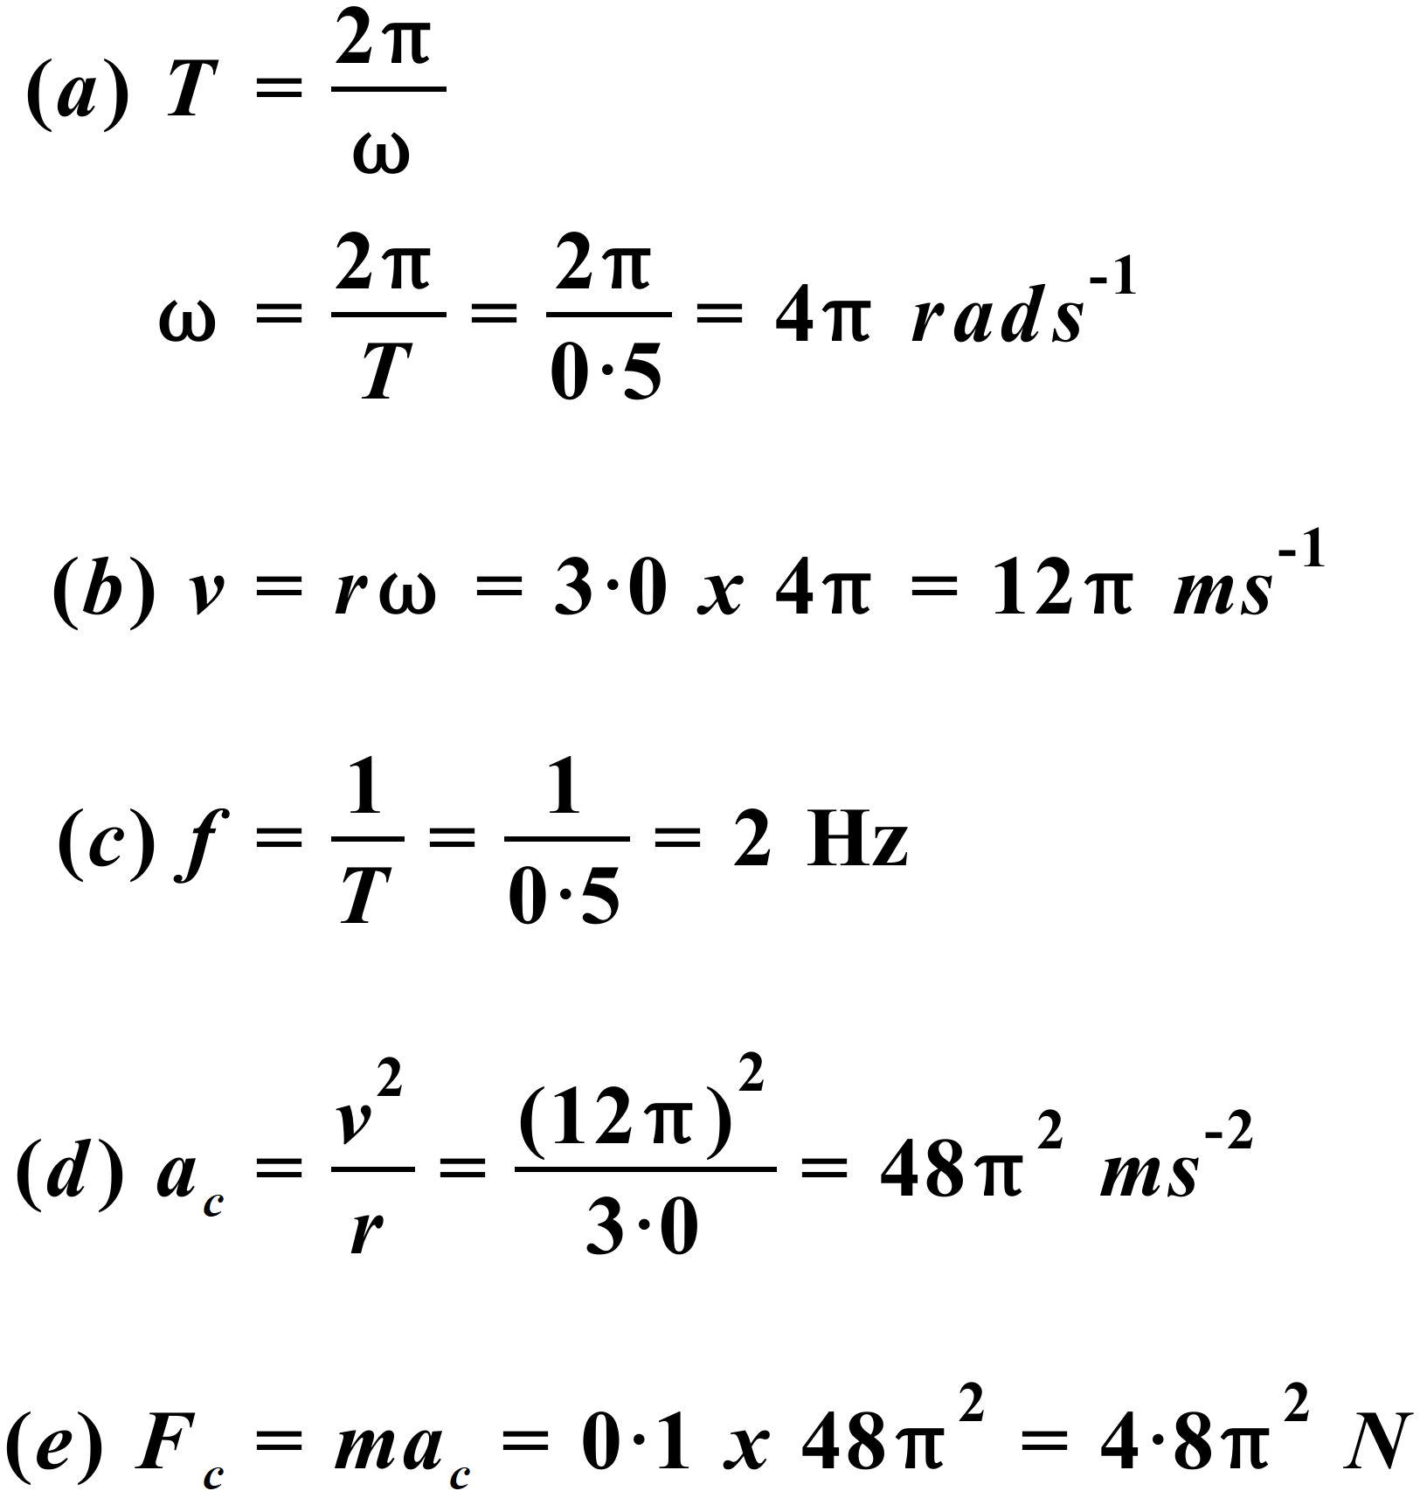
- 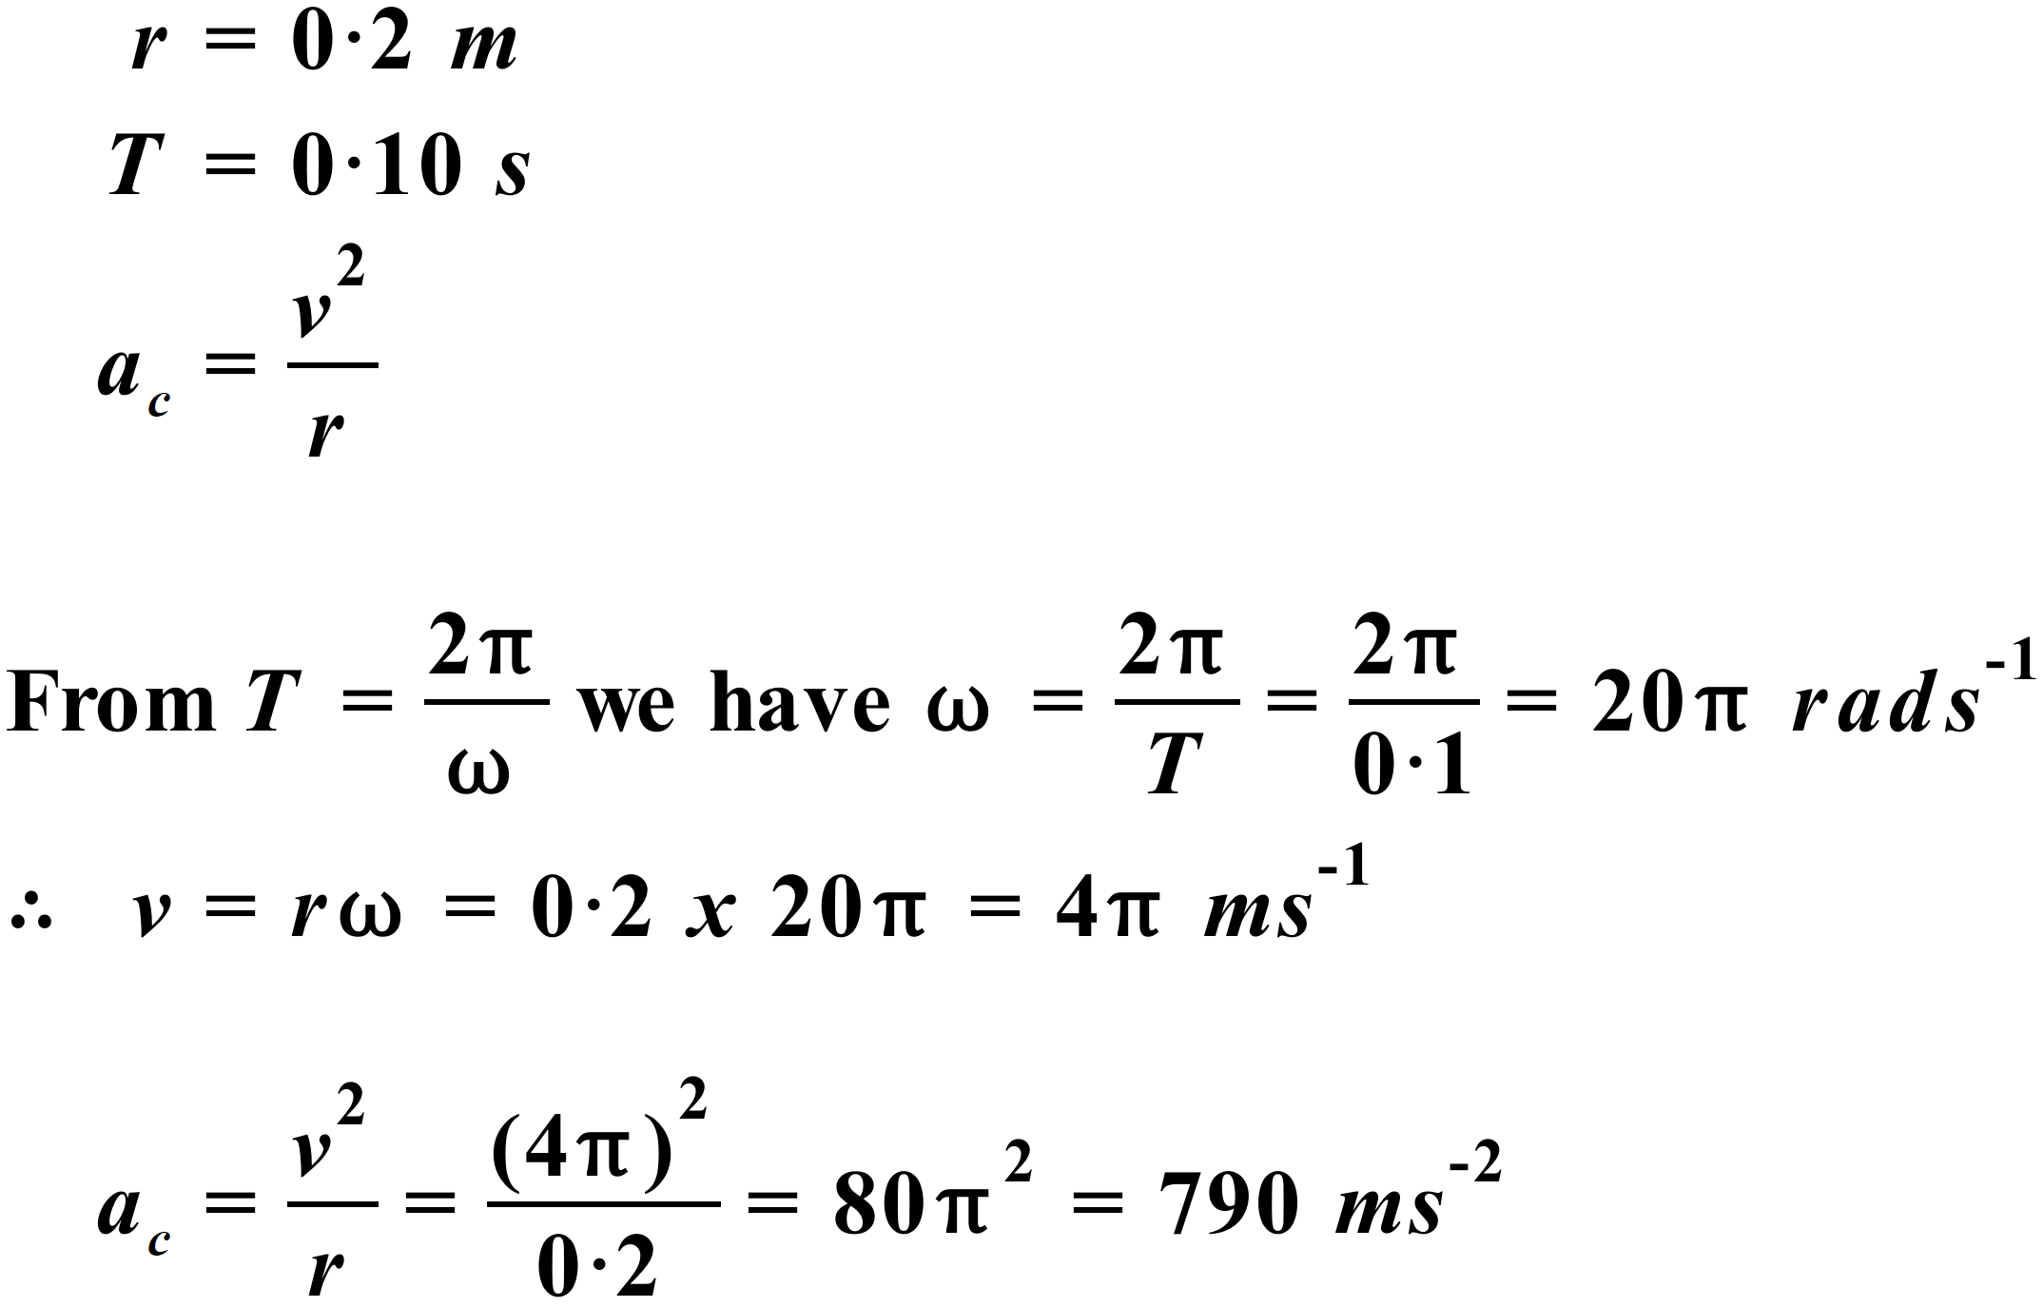

- When the 10 N force starts acting, it will cause the body to commence UCM. We have been asked to find the period of this motion – the time taken for one complete revolution of UCM. So, we need 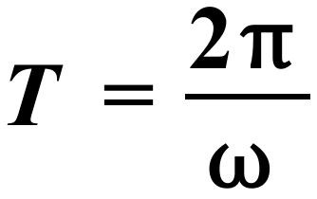 . We don’t know 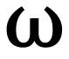 yet but we do know the centripetal force, 10 N, and the mass and velocity of the body.
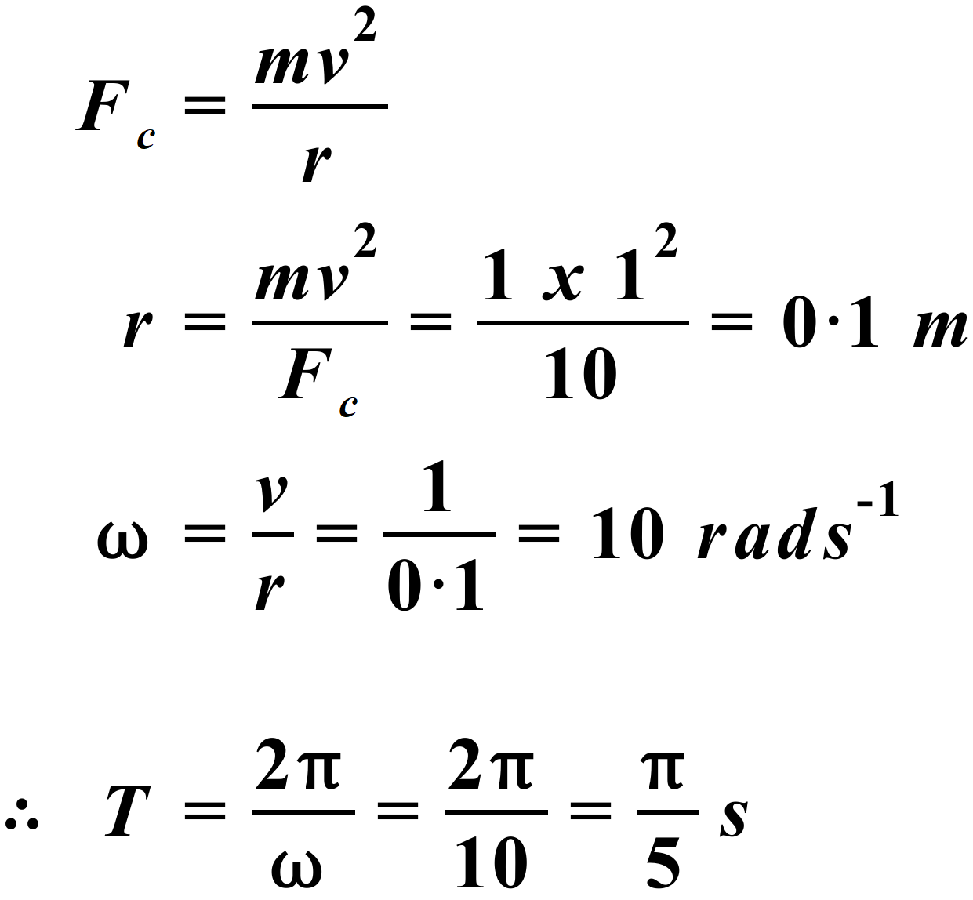
- Path C – When the rope snaps, the centripetal force ceases to act and by Newton’s 1st Law, the mass will continue to move in the same straight line until acted on by an unbalanced external force. In other words, the mass will move off along the tangent to the circular motion at point P, in the direction of its linear velocity.
- 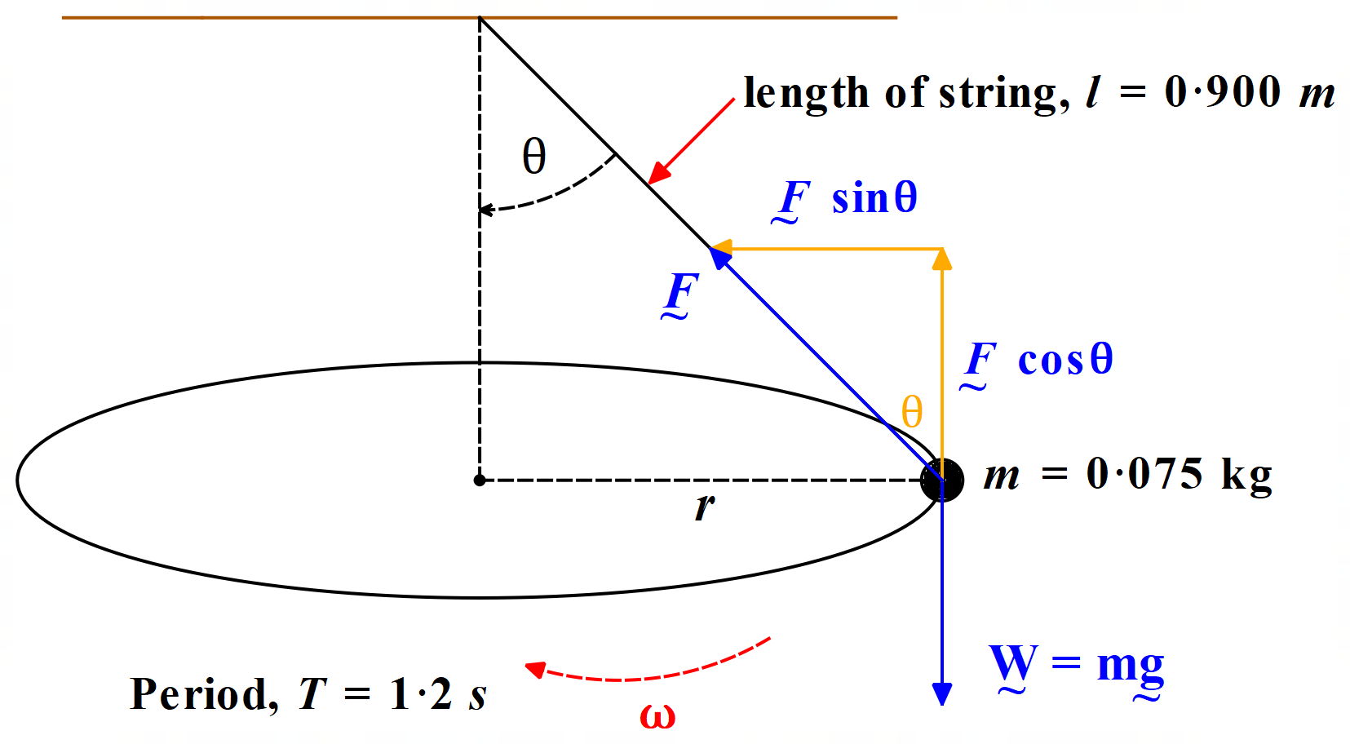First, we draw a diagram of the situation & then we resolve the relevant forces.
Now we analyze the situation mathematically. F is the tension force in the string. W is the weight force acting on the mass.
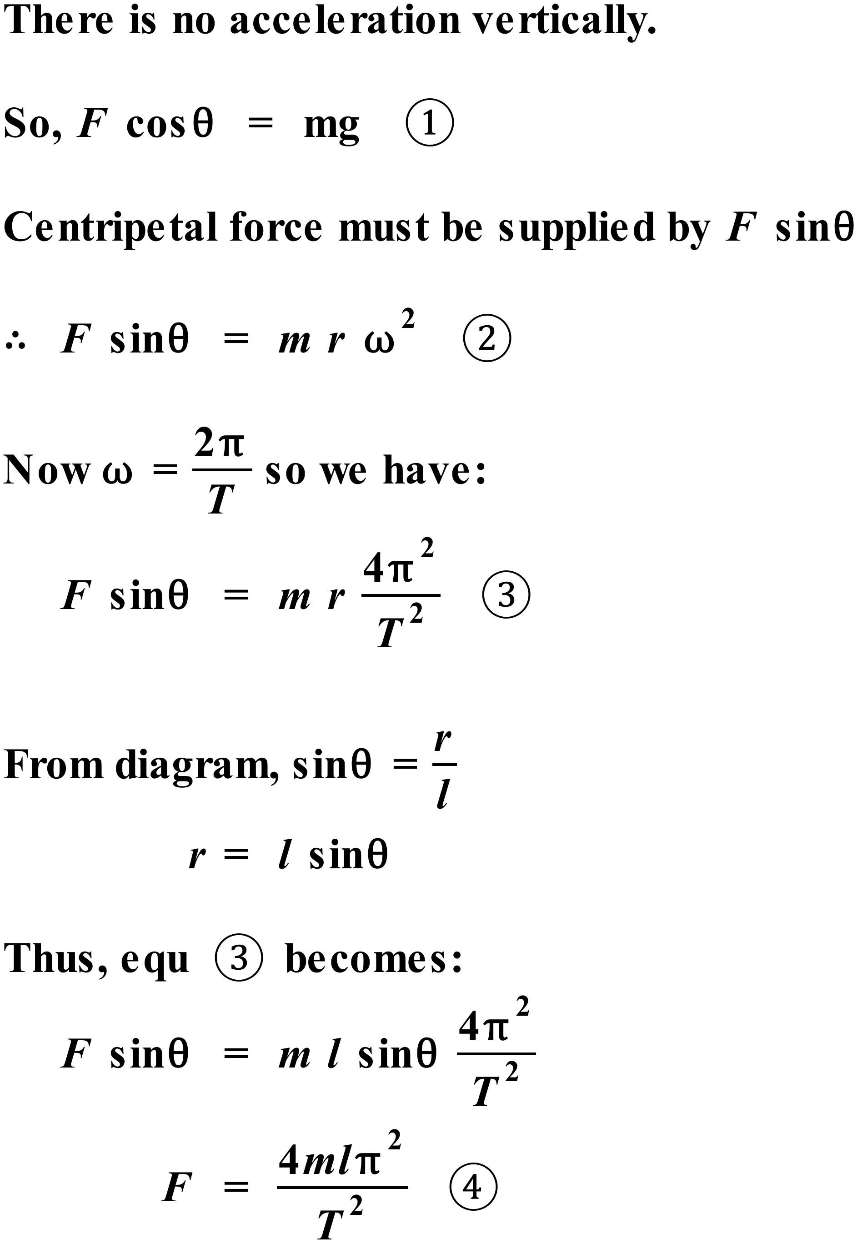
Note: You can solve most problems concerning conical pendula (pendulums) using equations 1 & 4 above. You can choose to memorize these if you wish. However, if you understand how to derive them, there really is no need to memorize them.
So, using equ 4, we have:
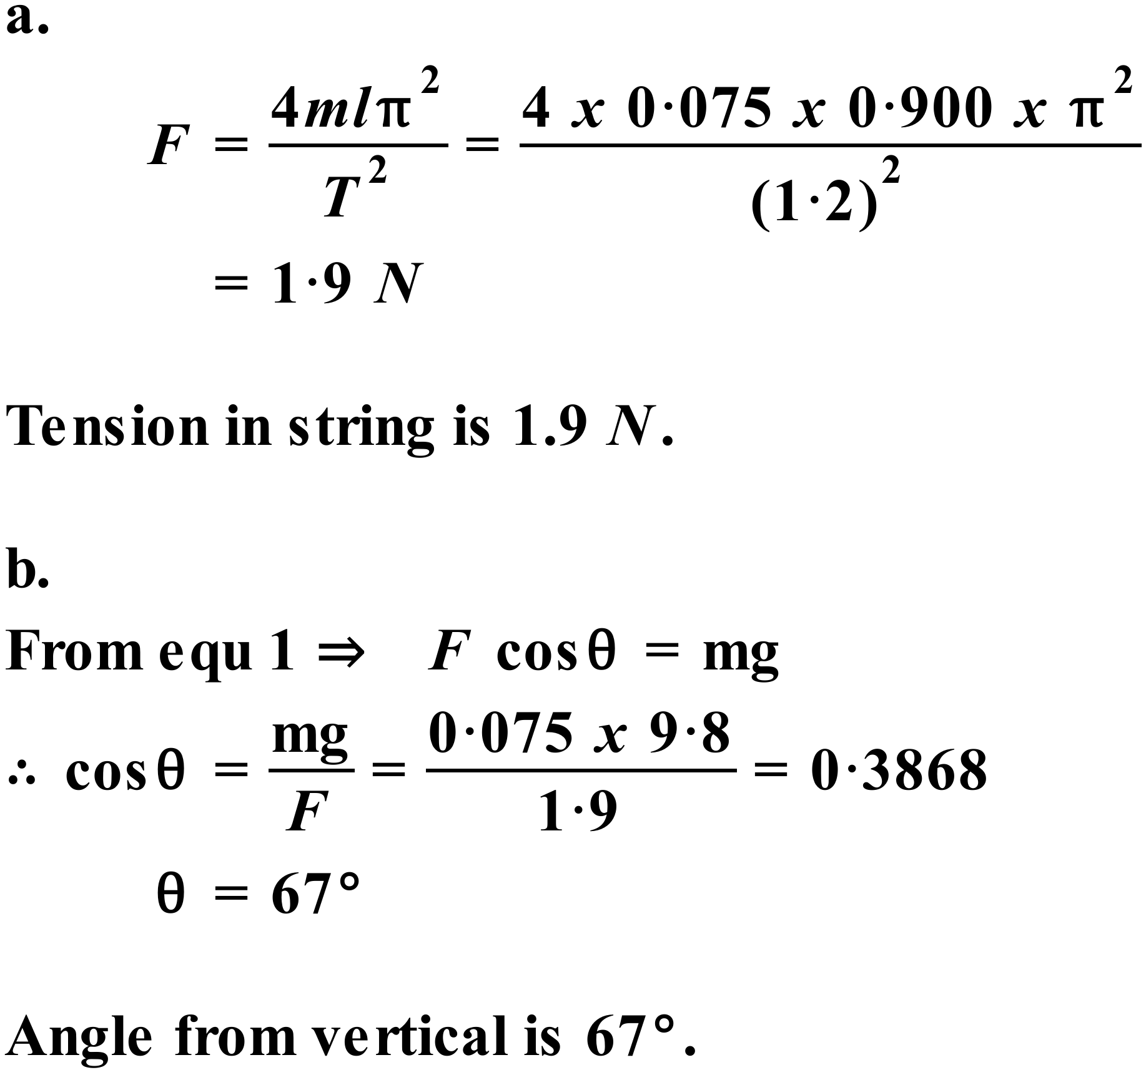
- 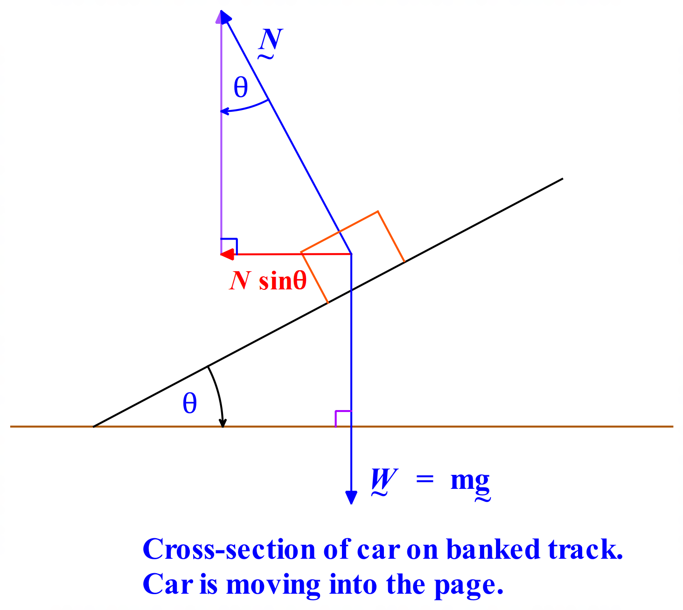Let’s draw a diagram and resolve the relevant forces.
Clearly, θ is the angle we need to calculate. The only force acting in the horizontal direction, is the horizontal component of the normal force, N sinθ. This must provide the centripetal force that keeps the car in UCM around the bend and stops the car skidding sideways.
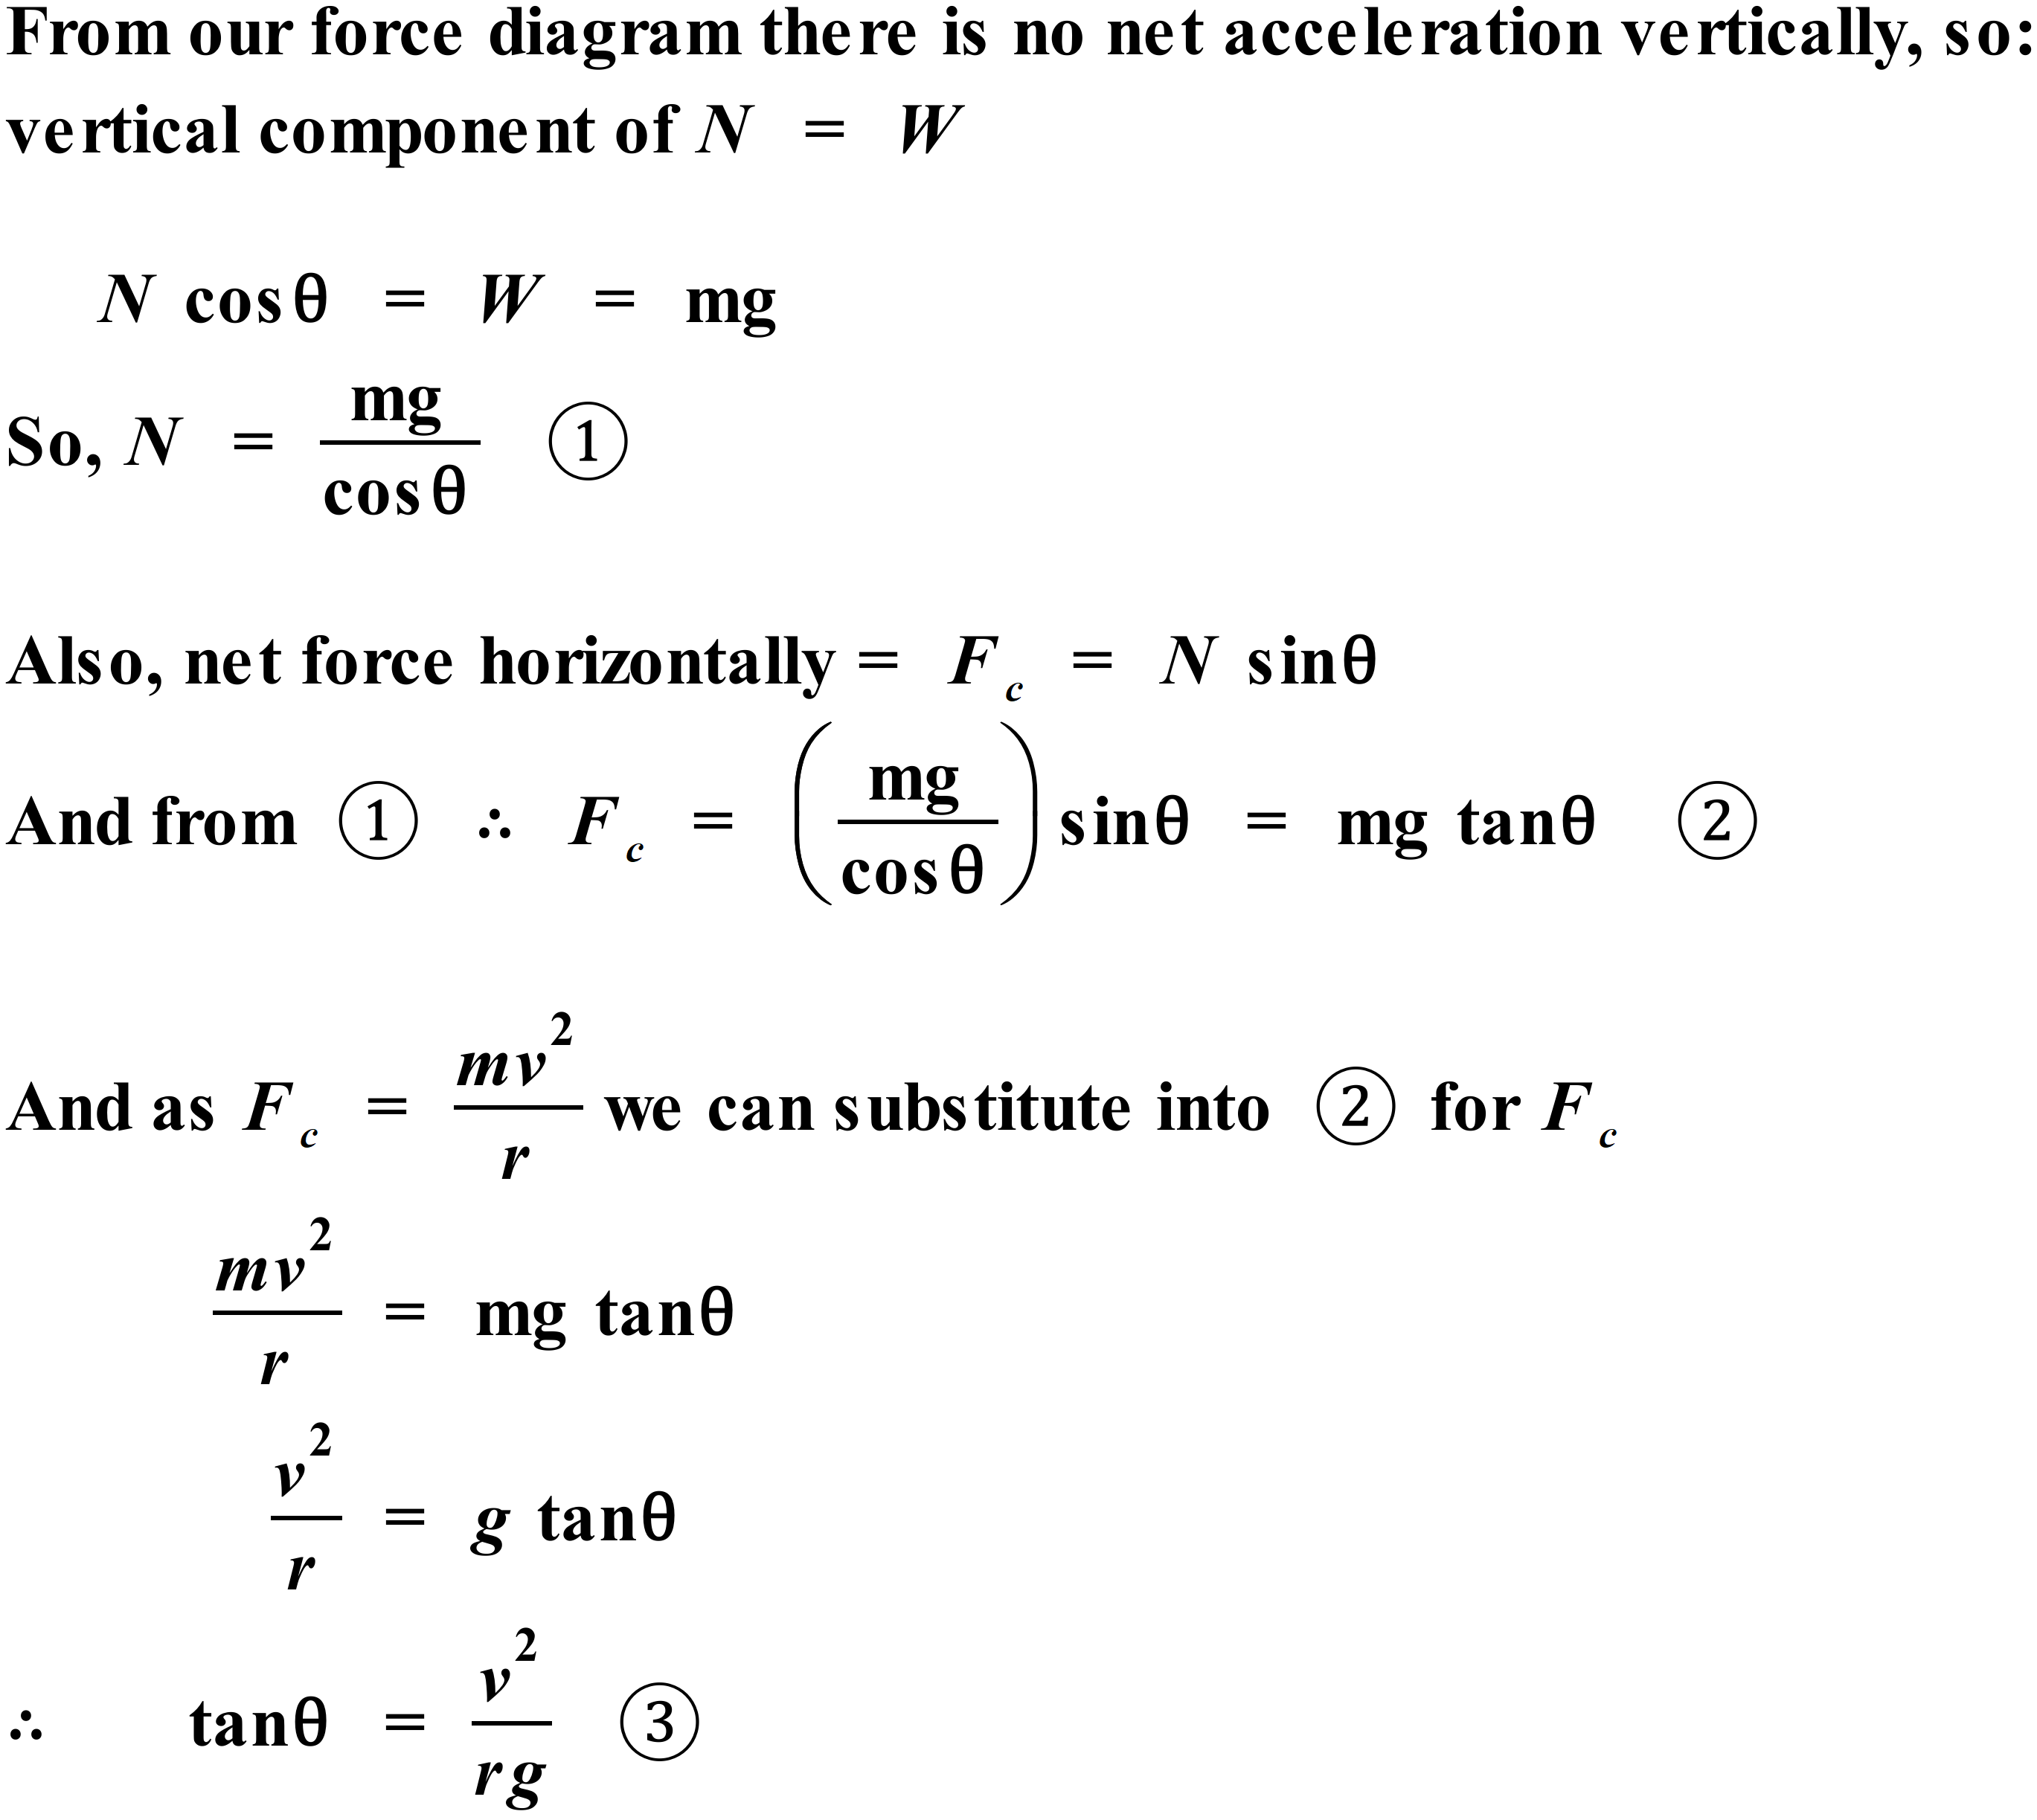
Note: You can choose to memorize this formula but it is not difficult to derive when you need it. Familiarize yourself with the method, so you understand what you are doing and can derive the formula quickly.
Using equ 3 we have:
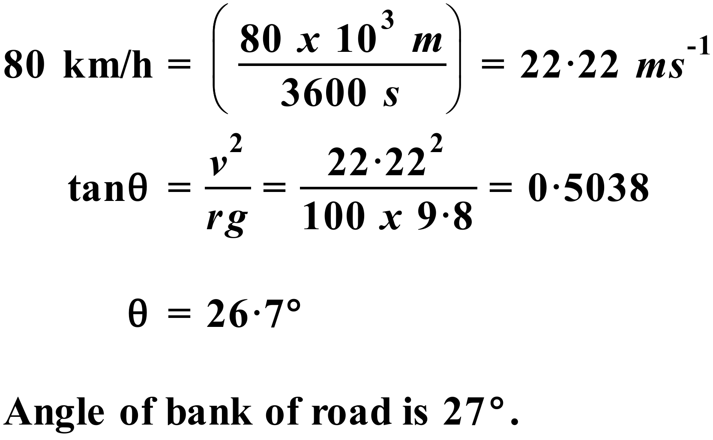
- Extension Problem: Draw a diagram showing the relevant forces. The jet is shown at the bottom of the loop. Two forces act on the pilot at this point.
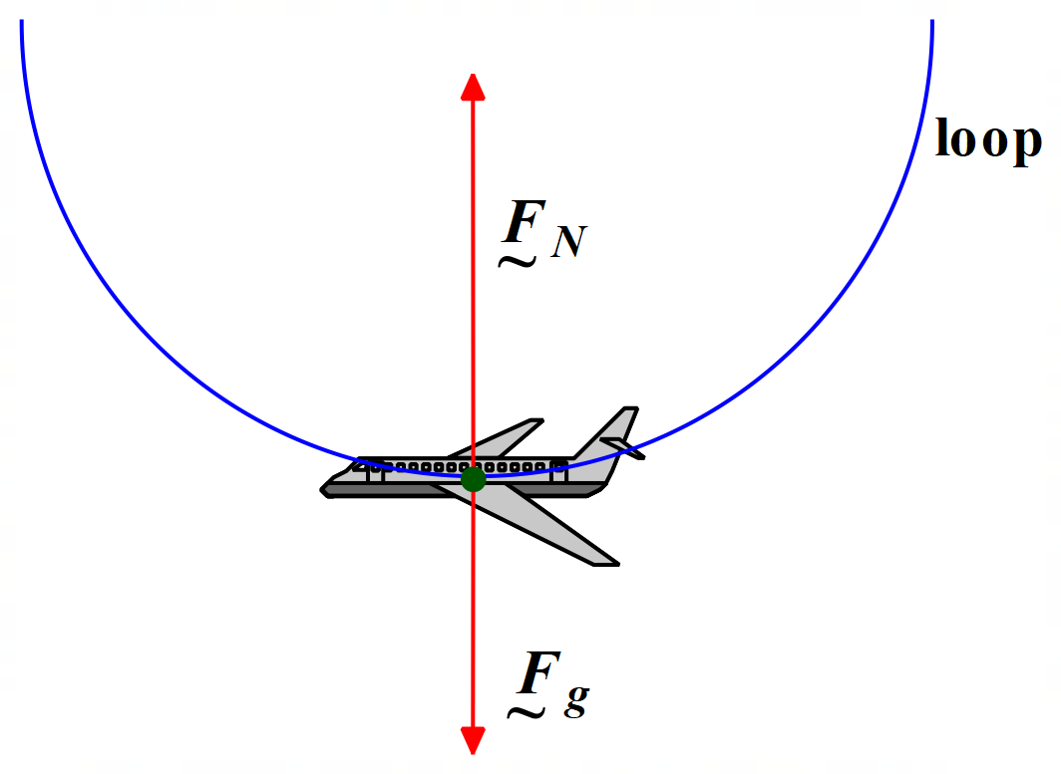
F_{N} is the normal force acting on the pilot due to the seat. F_{g} is the force due to gravity acting on the pilot down toward the centre of the Earth. Clearly, F_{N} > F_{g}, or the pilot would continue to fall from the sky.
The net force, F_{c}, acting on the jet at the bottom of the loop, is the sum of the forces F_{N} & F_{g}. This net force must be centripetal in nature, acting upward toward the centre of the circular loop since a centripetal force is required to keep the pilot (and the jet) traversing the loop. Hence, we can write:
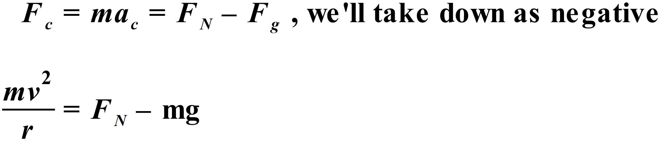
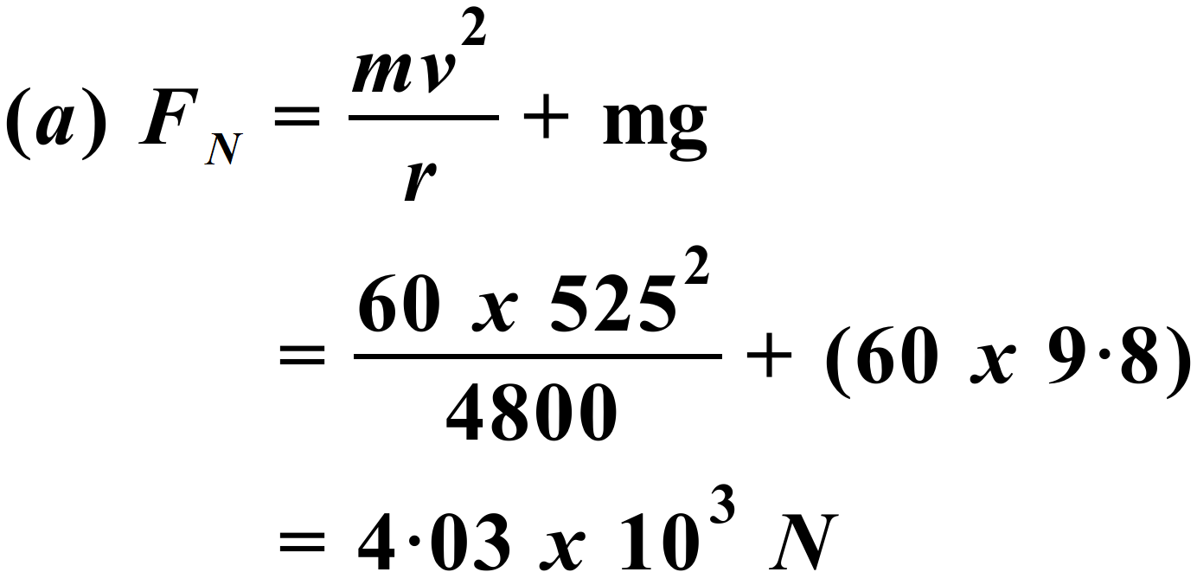
So, the normal force acting on the pilot due to the seat is 4.03 x 10³ N, upwards towards centre of circular loop.
Note that this is higher than the pilot’s true weight, mg. By Newton’s 3rd Law, F_{N} is the magnitude of the force the pilot exerts on the seat – that is, his/her apparent weight. Thus, the apparent weight of the pilot is greater than his/her true weight at the bottom of the loop. He/she feels heavier.
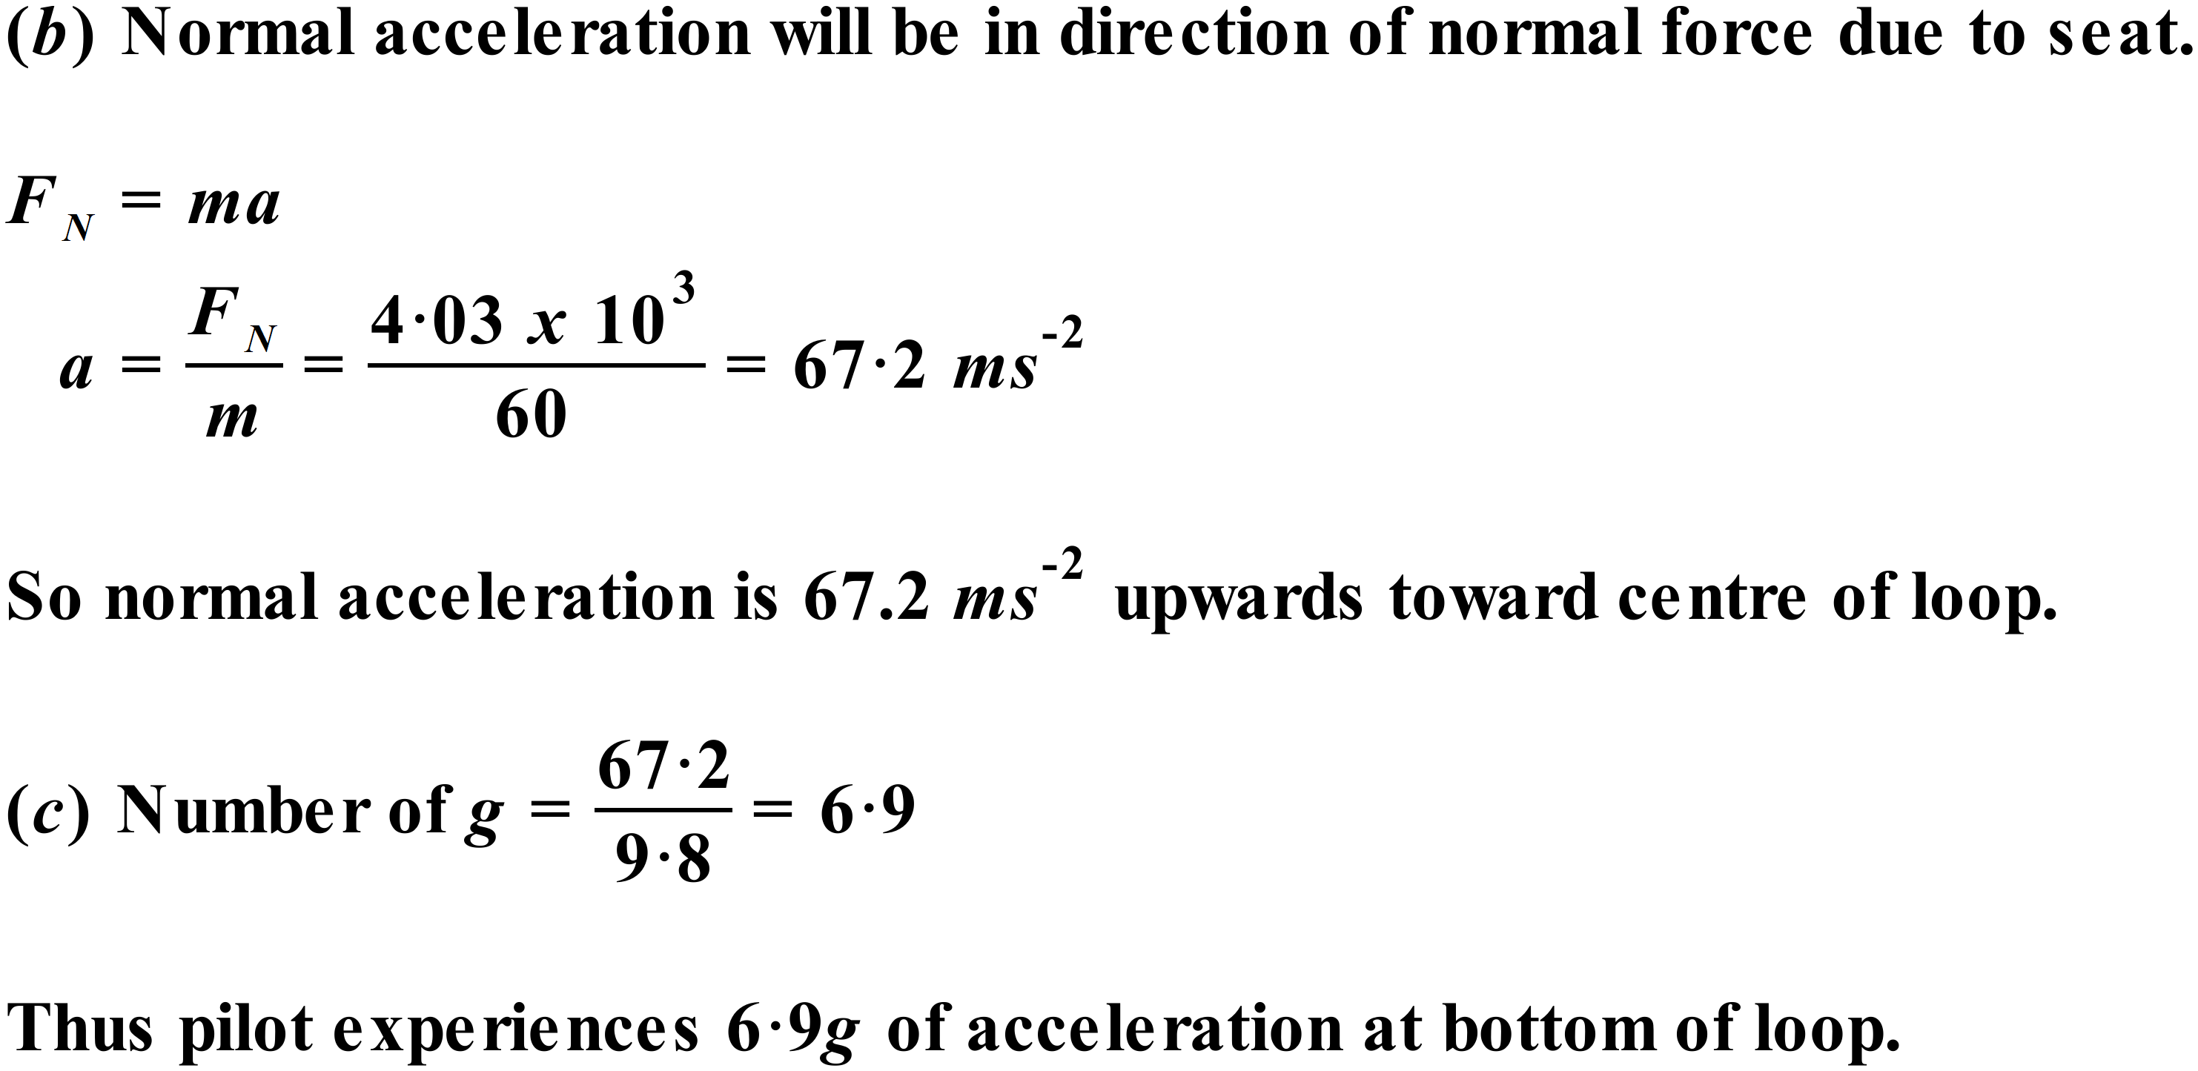
Just by way of further explanation in relation to this (and similar) question(s):

- The normal force on the pilot due to the seat is mainly provided by the wings of the jet. The wings create most of the lift on the jet. So, we could just as easily call the normal force on the pilot due to the seat, the lift force.
- Intuitively, it makes sense that the normal force on the pilot due to the seat is the sum of the centripetal force and the weight force. The seat must supply a force upward equal to the weight force to balance out the force of gravity. The seat must also supply the centripetal force upwards to keep the jet moving in its circular path.

