Calculation of an Orbit
Calculus is needed to derive the laws of orbital motion from Newton’s laws, but once those laws are established, an orbit can usually be calculated from a single position and velocity vector using algebraic formulas alone.
So, imagine an object of mass m is in a stable orbit around the Earth of mass M, where m << M. Earth is the central body. And at a time t, the position and velocity vectors for the object are known.
Assume:
- the orbit is a standard two-body gravitational orbit
- the orbital velocity at the given point is purely tangential
Let’s say at time t, we have the following data:
- $μ=398600{\text{ km}}^{3}{\text{/s}}^{2}$
- $r=7000\text{ km}$ is the magnitude of the position vector
- $v=9.0\text{ km/s}$ is the magnitude of the velocity vector
where:
- $μ=GM$is the gravitational parameter from Newton’s Law of Universal Gravitation
- $G$= gravitational constant
- $r$= distance of object in orbit from Earth’s centre
- $v$= orbital speed of object in orbit
The following are the steps you would use to calculate the total orbit of the object from the known position & velocity vectors, using the standard equations of orbital mechanics derived from Newtonian mechanics.
1. Find the Specific Orbital Energy
The total orbital energy (kinetic + potential) per unit mass is:
$$ε=\frac{v^{2}}{2}-\frac{μ}{r}$$

Definitions:
- $ε$ = specific orbital energy
- $\frac{v^{2}}{2}$ = kinetic energy per unit mass
- $\frac{μ}{r}$ = gravitational potential term
Substitution:
$$ε=\frac{9^{2}}{2}-\frac{398600}{7000} \\ =40.5-56.94 \\ =-16.44{\text{ km}}^{2}/{\text{s}}^{2}$$
The negative sign means the orbit is bound (elliptical).
2. Calculate the Semi-Major Axis
The semi-major axis is:
$$a=-\frac{μ}{2ε}$$
Definitions:
- $a$= semi-major axis
- $ε$= specific orbital energy
Substitution:
$$a=-\frac{398600}{2(-16.44)} \\ =12121\text{ km}$$

3. Determine the Specific Angular Momentum
For tangential motion:
$$h=rv$$
Definitions:
- $h$= specific angular momentum (the angular momentum per unit mass)
- $r$= orbital radius
- $v$= tangential (orbital) speed

Substitution:
$$h=7000×9 \\ h=63000{\text{ km}}^{2}/\text{s}$$
4. Find the Semi-Latus Rectum
The semi-latus rectum is:
$$p=\frac{h^{2}}{μ}$$
Definitions:
- $p$= semi-latus rectum
- $h$= specific angular momentum

Substitution:
$$p=\frac{{63000}^{2}}{398600} \\ p≈9957\text{ km}$$

5. Now you can determine the Eccentricity of the Orbit
The eccentricity is calculated from:
$$e=\sqrt{1-\frac{p}{a}}$$
Definitions:
- $e$= eccentricity
- $p$= semi-latus rectum
- $a$= semi-major axis

Substitution:
$$e=\sqrt{1-\frac{9957}{12121}} \\ e≈0.422$$
Since:
- $e=0$ → circle
- $0<e<1$ → ellipse
- $e=1$ → parabola
- $e>1$ → hyperbola

this orbit is elliptical.

6. Now Calculate the Periapsis and Apoapsis Distances
Closest distance:
$$r_{p}=a(1-e)$$
Furthest distance:
$$r_{a}=a(1+e)$$
Definitions:
- $r_{p}$= periapsis radius
- $r_{a}$= apoapsis radius
Substitution:
$$r_{p}=12121(1-0.422)≈7006\text{ km} \\ r_{a}=12121(1+0.422)≈17236\text{ km}$$

7. Calculation of Orbit
Finally, the orbit itself is plotted using the polar equation of a conic:
$$r=\frac{p}{1+ecos⁡θ}$$
Definitions:
- $r$ = distance from focus
- $p$ = semi-latus rectum
- $e$ = eccentricity
- $θ$ = true anomaly (orbital angle) - As you vary $θ$ between 0 and 2 pi, it outputs the corresponding orbital radius $r$ at that exact angle. At $θ$ = 0 rads object is at periapsis and $r$is minimum. At $θ$ = pi rads object is at apoapsis and $r$ is maximum.
This equation generates the entire ellipse point by point. Write your own program to accomplish this polar plot or use standard software like Efofex, etc. Best to leave it as a polar plot, but if you wish you can change to cartesian coordinates using x = r cos ϑ, y= r sin ϑ and r = √(x² & y²) and generate the standard cartesian equation for this elliptical orbit:
$\frac{{\left(x+c\right)}^{2}}{a^{2}}+\frac{y^{2}}{b^{2}}=1$,
where c = ae, is the linear eccentricity, representing the distance from the centre of the ellipse to the focal point where Earth is located and b = a √(1 - e²) is the semi-minor axis.
NOTE: If you wanted to know the object’s position as a function of time — exactly where it will be after 37 minutes, for example — then solving Kepler’s Equation introduces transcendental equations and numerical methods, where calculus concepts become much more important again. Kepler’s Equation gives the actual position along the ellipse as a function of time. Note also that this is not one of Kepler’s three Laws of motion, it is a separate equation.
I have provided below, a plot of the example case we calculated, on the cartesian plane.

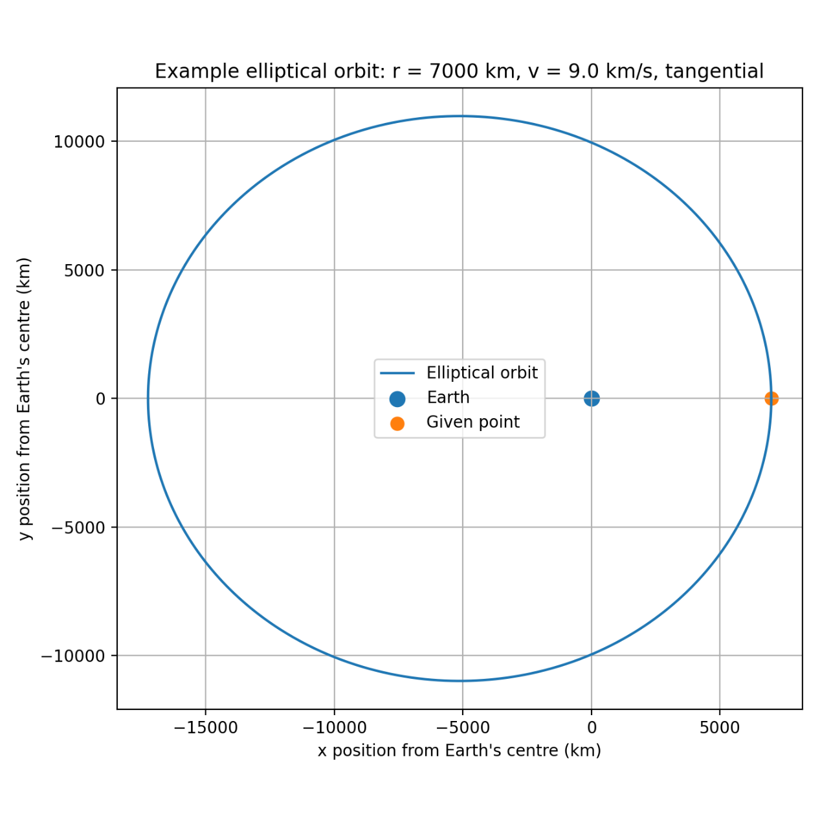
Note on three body problem follows on next page.

Students are often fascinated by the three-body problem. This is great and I encourage you to investigate this extremely interesting problem.
The best mathematical tool for doing this is Hamiltonian Mechanics, which is the most profound and flexible framework for advanced physics. It is one of the formulations of classical mechanics.
High school physics uses Newtonian Mechanics, which focuses on forces and accelerations. If you study physics at Uni, in third year you are introduced to Lagrangian Mechanics, which focuses on energy differences and the principle of least action. Lagrangian Mechanics is more able to deal with complex physical problems than Newtonian Mechanics.
Also in third year, you meet Hamiltonian Mechanics, which focuses on the geometry of motion in phase space. It transforms equations into a geometrical structure that bridges classical, quantum, and statistical mechanics.
Note that all three formulations of Classical Mechanics are equivalent. They are different languages for describing the same physical reality. Both Lagrangian & Hamiltonian Mechanics require advanced mathematics from the start. Newtonian Mechanics also requires advanced mathematics at higher levels than school.

