Kinematics and Dynamics Practicals

These pracs may be of use to teachers in the Kinematics & Dynamics Modules of the Year 11 Course.

Practical No. 1 – Average Velocity (Kinematics Module)

Introduction:
This prac is very simple. The main point of this prac from my view is to introduce you to the linear air track as a piece of physics equipment. We will use the air track again (next time with data loggers) to perform a momentum conservation experiment.

Aim:
To measure the average speed of an object.
Method:
1. Place a small car on the linear air track at the end near the air source (vacuum cleaner).
2. Arrange a metre ruler on the side of the air track.
3. Turn the air supply on by pressing the switch on the side of the vacuum cleaner.
4. Push the metal clip on the car gently against the metal clip at the end of the air track until the black pen mark on the side of the air track is just covered by the car.
5. Release the car and measure the time taken for the car to move 1 metre down the air track.
6. Record this data in the Table below.
7. Repeat the experiment 4 more times. Calculate the average speed of the car for each trial.

Results:

Table: Average Speed of Car over distance of 1 metre
TIME (s) | AVERAGE SPEED OF CAR (m/s)

Discussion & Conclusion
As directed by the teacher

Practical No. 2 – Acceleration Due to Gravity By Ticker-Timer (Kinematics Module)
Introduction:
The Ticker-Timer provides a simple means of collecting distance versus time data in motion experiments. Today it has been superseded by the data logger. It is, however, worthwhile to have a familiarity with data collection using the Ticker-Timer. Teachers should discuss with students the relative merits of the two instruments.

Aim:
To determine the local value of the acceleration due to gravity using the ticker-timer.

Method:
1. Set up the equipment as shown below.
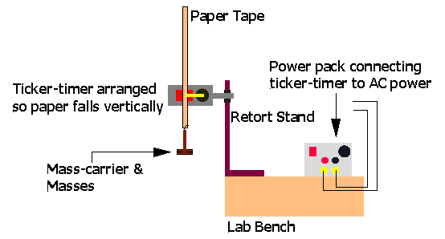
2. Turn power on and drop paper tape, allowing the attached weight to pull it through the ticker-timer.
3. Examine tape to ensure that the dots are spaced so as to indicate uniformly accelerated motion. If not, repeat step 2. Do not waste tape!
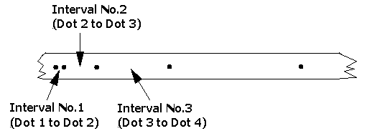
4. Produce a tape that has at least six dots in a row from the start clearly showing uniformly accelerated motion. Analyse this section of the tape to complete the Table below. Take more dots into account if you can. Remember that the time between consecutive dots is 0.02 seconds (1/50 s – the frequency of the mains supply).
5. Draw a graph of average velocity versus time and calculate the slope of this graph. Remember that average velocity over a time interval occurs at the middle of that time interval. The value of the slope is your experimental value of the local acceleration due to gravity.

Results:

Table: Analysis of data from tape
Interval No. | Time for each Interval (s) | Displacement covered in each Interval (cm) | Average Velocity during each Interval (cm/s) | Total time elapsed to middle of Interval (s)
1 | 0.02 |  |  | 0.01
2 | 0.02 |  |  | 0.03
3 | 0.02 |  |  | 0.05
4 | 0.02 |  |  | 0.07
5 | 0.02 |  |  | 0.09

Draw your graph of Average Velocity versus Time.
Slope of your average velocity versus time graph = __________
Comment on any discrepancy between your experimental value of the acceleration due to gravity and the accepted average value of 980 cms⁻².

…………………………………………………………………………………………………..
…………………………………………………………………………………………………..
Practical No. 3 – Balls on Slopes (Kinematics Module)
Introduction:
In a now famous experiment, Galileo demonstrated that the motion of a ball rolling down an inclined plane is uniformly accelerated motion. From this he extrapolated that the motion of any body free falling vertically is also uniformly accelerated motion.
Using the principle of conservation of energy and some basic rotational kinematics, it can be shown that for a solid spherical ball rolling down an inclined plane, the linear speed of the ball at the bottom of the inclined plane is given by:
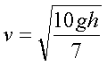
where v = linear speed of ball at bottom of incline, h = height of inclined plane and g = acceleration due to gravity, which can be assumed to be 9.8 ms⁻².

Aim:
To verify that the speed of the ball at the bottom of the inclined plane is proportional to the square root of the height of the incline.

Your Task:
Design a Method for achieving the above Aim. HINTS: Remember your basic definitional equations for average velocity given earlier in this course. Remember the benefit of graphs and straight-line relationships between variables. Use the equipment available to check out the practicality of your ideas.

Draw a diagram of proposed Experimental set-up.
Write out your Method.

Practical No. 4 – Vector Addition & Subtraction (Dynamics Module)
Introduction:
The vertical “Force Board” is a board to which two pulleys have been attached. String can be threaded over the pulleys and various masses can be hung from the ends of the string. A third known or unknown mass can then be added to the string between the two end masses in a position that results in an equilibrium of forces. The acceleration due to gravity acting vertically downwards produces the weight force of each set of masses. A white sheet of paper can be attached to the board behind the masses and the pattern of forces can then be traced onto the paper (or photographed using your mobile phone). The forces can then be analyzed using vector analysis.
Key learning objectives
• To visualize what a vector triangle really means.
• To develop students’ skills in manipulating apparatus.
When students draw vector triangles in their work, they sometimes have difficulty in visualizing what the diagram really means. This experiment will give them a clear example and will help them to visualize the meaning of vector triangles in other contexts. As this experiment is a little fiddly, it is a good chance for students to develop their manual dexterity in manipulating apparatus. Both of the learning objectives above should be stressed to the students before they carry out the experiment. They should also be encouraged to take time in order to get good quality results.
In this experiment, all three masses are known. However, you can adjust the method to calculate the size of an unknown third mass.

Aim:
To demonstrate vector addition & subtraction.

Method:
1. Use the Force Board supplied to arrange an example of equilibrium of forces. That is, arrange the three sets of masses and mass carriers on the board so that there is no movement – one set at each end of the string and one in the middle. Once there is no movement, the three weight force vectors are in equilibrium.
2. Place a blank sheet of paper behind the middle mass carrier and carefully trace the pattern made by the string and mass carrier so that your diagram clearly shows the angles made by the string and the middle mass carrier. These are the same as the angles made between the three force vectors.
3. Determine the magnitude (size) of each force vector in newtons by using F = ma, assuming a = 9.8 ms⁻². Record these in the Table below.
4. Use your traced diagram and a protractor to measure the angles between the force vectors. Record these in the space provided over the page.
5. In the space provided below, use the information you have collected to draw a scaled vector diagram showing the addition of the three force vectors. Since the forces are in equilibrium, your diagram should form a closed vector polygon. In other words, your three vectors should add together to give zero – the size of the net force acting on a system in equilibrium.

Results:

Table: Size of Forces
Force Number* | Total Mass Hanging (kg) | Size of Force (N)
1
2
3
*See diagram below for numbering of forces.

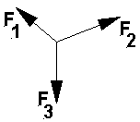

Angle between Force 1 and 2 = ____________

Angle between Force 2 and 3 = ____________

Angle between Force 3 and 1 = ____________

Now draw your Scaled Vector Addition Diagram:
Scale: ___________

* What does it mean if your vector diagram is not a closed triangle? Think about this and discuss with your group and teacher.

Practical No. 5 – Acceleration Versus Mass (Dynamics Module)

Introduction:
This prac uses Experiment M10 Acceleration & Mass from the Sensing Science software from Data Harvest. Data loggers & light gates are required.

Aim:
To investigate the relationship between the mass of a body and the acceleration produced by constant force acting on that body.

Method:
1. Set up the experimental apparatus as shown below.
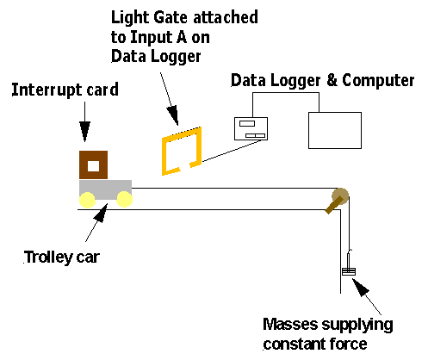
2. Measure the mass of the trolley car with string & interrupt card attached.
3. Launch and set-up the Timing Software.
4. Choose a pulling force by placing four to six 50g masses on the mass carrier provided. This pulling force will remain the same throughout the experiment.
5. Hold the trolley car in the start position. Check that the string moves freely over the pulley with the weight attached and that the trolley car will move in a straight path through the light gate without colliding with anything.
6. Return the trolley car to the start position. Click on the Run icon to start the timing software and release the trolley car. The acceleration of the car will be measured as the interrupt card passes through the light gate and should appear in the Table & graph on the computer screen.
7. Click on the Run icon to turn off the timing and move the car back to the start position.
8. Add a 500g mass to the car.
9. Click on the Run icon to re-start the timing & release the trolley.
10. Repeat steps 7 to 9 until the total mass added to the trolley is 2.0kg.
11. Record the five sets of measurements in the Table below.
12. Use the graph paper provided to plot a graph of acceleration (vertical axis) versus 1 / mass (horizontal axis).
13. Comment in the space provided on what conclusion you can draw from the nature of your graph.

Results:

Table: Acceleration v's Mass Data
Mass (kg) | (1/Mass) (kg⁻¹) | Acceleration (ms⁻²)
1.0 (trolley car by itself) | 1.0
1.5 | 0.67
2.0 | 0.5
2.5 | 0.4
3.0 | 0.33
Now draw your graph of Acceleration v's (1/Mass). Use both graph paper & Excel Spreadsheet and draw the graph twice. This is to gain experience in both methods of graphing.

Conclusion:
What conclusion can you draw from your graphs?
…………………………………………………………………………………………………..
…………………………………………………………………………………………………..

Practical No. 6 – Acceleration Versus Force (Dynamics Module)
Introduction:
This prac uses Experiment M9 Force, Mass & Acceleration from the Sensing Science software from Data Harvest. Data loggers & light gates are required.

Aim:
To investigate the relationship between the acceleration of a system of constant mass and the applied net force acting on that system.

Method:
Use the same basic method as for the Prac No.3 but this time start with five 50g masses on the trolley and a 50g mass carrier hanging over the pulley to act as the initial force on the system. Measure the acceleration produced. Increase the force on the system by transferring one 50g mass from the trolley to the mass carrier and repeat the experiment. Note that the total mass of the system remains constant as you increase the force acting on the system. Continue until all of the 50g masses are on the mass carrier. (Note: By “system” in this prac, we mean the trolley + masses on trolley + interrupt card + masses hanging over pulley + cord. The force due to gravity acting on the masses hanging over pulley is applied to this whole system NOT just to the trolley.)

Results:

Table: Acceleration v's Force Data
Total Mass Hanging from Pulley (kg) | Force on System (N) | Acceleration of System (ms⁻²)
Draw a graph of Acceleration (vertical axis) versus Force (horizontal axis).

Conclusion:
What conclusion can you draw from your graph?
…………………………………………………………………………………………………..
…………………………………………………………………………………………………..
If you wish to take the prac further, you can calculate the mass of the whole system from the slope of the acceleration v's force graph and then compare this mass with the value obtained using electronic scales. Mass of system = 1/slope of your graph.

Practical No. 7 – Conservation of Momentum (Dynamics Module)
Introduction:
If no external net force acts during a collision, the total momentum of the system is not changed by the collision and therefore the total momentum of the system before collision equals the total momentum of the system after collision. The practical that follows is based on Experiment M15 Inelastic Collisions from the Sensing Science software from Data Harvest.
Aim:
To analyse the change in momentum of a system of two linear air track vehicles during collision.

Method:
1. Set up the equipment as shown in the following diagram. The light gates are connected to the input terminals of a data logger as shown. Place blue tack firmly on the ends of vehicles 1 & 2 that are facing each other. Measure and record the masses of vehicles 1 & 2 with blue tack & interrupt cards attached. Note that the diagram below was copied from the notes supplied with Experiment M15 Inelastic Collisions from the Sensing Science software from Data Harvest. Note also that the pin & cork shown on the ends of the vehicles were replaced by blue tack in our version of the practical.
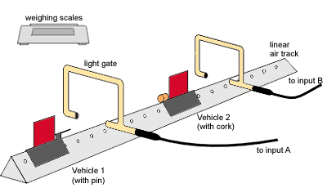
2. Launch and set-up the Timing Software to enable the velocity of vehicle 1 to be measured before the collision and the velocity of vehicle 1 & 2 combined to be measured after collision.
3. Click on the Run icon to start the timing software. The relevant velocities will be measured as the interrupt cards pass through the relevant light gates and should appear in the Table & graph on the computer screen.
4. Turn the air on in the linear air track. Hold vehicle 2 at rest in a designated spot between the light gates until vehicle 1 is in motion.
5. Push the metal clip on vehicle 1 firmly against the metal clip at the end of the air track until the black pen mark on the side of the air track is just covered by vehicle 1. This will allow vehicle 1 to spring forward when released. The clips & pen mark are not shown in the diagram above. There are many ways of applying an initial force to vehicle 1 in a consistent manner.
6. Release vehicle 1 and record the velocities measured by the data logger in the Table below. Record the before and after velocities only for cases where the vehicles collide and coalesce.
7. Repeat the experiment 4 more times.

Results:
Table No.1: System Data Before Collision
Trial No. | Mass of Vehicle 1 (kg) | Velocity of Vehicle 1 (m/s) | Mass of Vehicle 2 (kg) | Velocity of Vehicle 2 (m/s) | Total Momentum of System Before Collision (Ns)
1 |  |  |  | 0
2 |  |  |  | 0
3 |  |  |  | 0
4 |  |  |  | 0
5 |  |  |  | 0

Table No.2: System Data After Collision
Trial No. | Mass of Vehicles 1 & 2 Combined (kg) | Velocity of Combined Vehicles (m/s) | Total Momentum of System After Collision (Ns)
1
2
3
4
5

Table No.3: Change of Momentum of System During Collision
Trial No. | Change of Momentum of System During Collision (Ns)
1
2
3
4
5

Conclusion:
Comment on the extent to which your results support the idea that if no external net force acts during a collision, the total momentum of the system is not changed by the collision.

