Example 1:
A Ford Focus is travelling at a constant velocity of 30 ms⁻¹ east along a straight, flat road. The driver applies the brakes to produce a uniform deceleration of magnitude 10 ms⁻² west to bring the car to rest. Determine the time taken by the car to come to rest.
Solution:
Having read the problem through once, we go back, draw a diagram and write down what we know & what we are looking for. This produces the following.
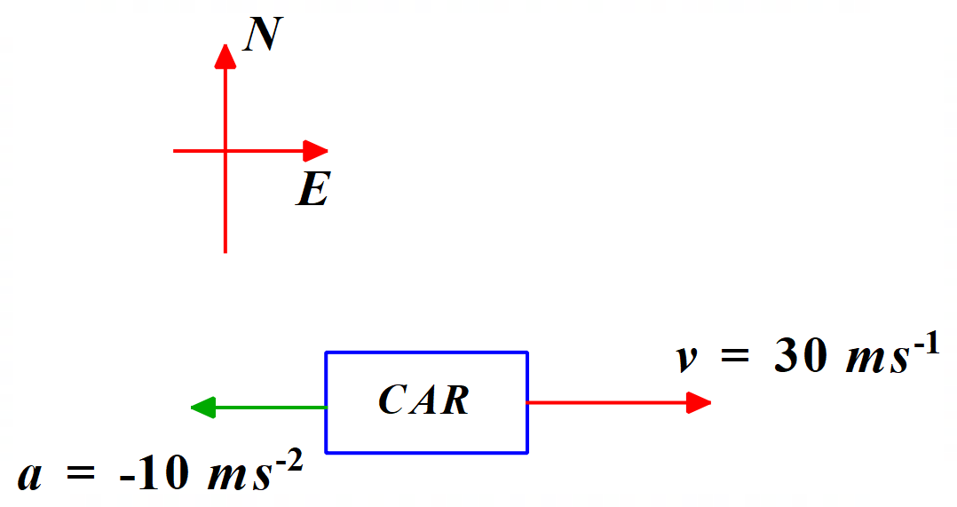

u = 30 ms⁻¹ East = + 30 ms⁻¹ (note that we have decided that East is positive)
a = 10 ms⁻² West = - 10 ms⁻²
v = 0 ms⁻¹
t = ? (we are looking for the time)

The data clearly suggest using the equation v = u + at. So, re-arranging this equation before entering the data, we have:
t = (v – u) / a.

Substituting into this equation, we have:

t = (0 – 30) / (-10) = 3 s.

Clearly, the time taken by the car to come to rest is 3 seconds.

