PHYSICS COURSE – YEAR 11

MODULE 4: ELECTRICITY AND MAGNETISM

Atomic theory and the laws of conservation of energy and electric charge are unifying concepts in understanding the electrical and magnetic properties and behaviour of matter. Interactions resulting from these properties and behaviour can be understood and analysed in terms of electric fields represented by lines. Students use these representations and mathematical models to make predictions about the behaviour of objects and explore the limitations of the models.

Students also examine how the analysis of the behaviour of electrical circuits and the transfer and conversion of energy in electrical circuits has led to a variety of technological applications.

ELECTROSTATICS

Inquiry Question: How do charged objects interact with other charged objects and with neutral objects?

CHARGE

As early as the 7th Century BC, the ancient Greeks were aware that amber (dried resin from certain trees), when rubbed vigorously, could attract dust and cloth from a distance. Today, we say that such objects are “charged”. For example, a plastic ruler when rubbed can pick up tiny pieces of paper.

The word "elektron" in Greek means amber and it is from this word that our word “electric” is derived. Electrostatics is the study of stationary charge.

Experiments by William Gilbert (1544-1603), Benjamin Franklin (1706-1790) and others suggested the following rules regarding charge:

- There are only two kinds of charge – called positive and negative. These were originally called vitreous and resinous respectively, because of the materials that produced each type of charge.
- Like charges repel.
- Unlike charges attract.

Atoms & Charge
We know today that charge results from the fundamental particles of matter. Atoms are believed to consist of three sub-atomic particles – proton (positive), neutron (neutral) & electron (negative). The charge on the proton is the same size as that on the electron, but opposite in sign. The model of the atom you would be familiar with from Years 9 & 10 shows the atom arranged as follows:

In a neutral atom, the number of protons is equal to the number of electrons. In a negatively charged object there is an excess of electrons. In a positively charged object, there is a deficiency of electrons. Experimental evidence indicates that only the electrons are free to move in most materials.

Methods of Charging
Teacher demonstrations with perspex & ebonite rods, pith balls, clock glasses, paper, etc should be done here.

We have all experienced being zapped by electrostatic discharges, getting out of a car on a dry day for instance and touching the metal door or rubbing our feet on carpet on a dry day and then touching a metal doorknob or another person. Objects in our world become charged. Let us examine how this happens. There are three main methods by which objects may be charged – friction, contact and induction.

- Friction: Rubbing two materials together may result in electrons being transferred from one material to the other. For example, perspex rubbed with silk acquires a positive charge; ebonite rubbed with wool acquires a negative charge.
- Contact: If a charged object is touched to an uncharged (neutral) object, charge will flow to the uncharged object. The electrons will move as far away from one another as possible. The charge on both objects after charging is necessarily the same.
Although only negative charges can move, for convenience we often draw positive charges as moving. Two identical objects, one charged and the other uncharged, will share the charge evenly when brought into contact, as shown below.
- Induction: A charged object brought near to but not touching an uncharged object causes a charge separation to occur. If the second object is then earthed very quickly, some charges will flow from earth or to earth. Upon removal of the earth, the second object will have acquired a charge. The charge on both objects after induction is necessarily different.

I imagine, the example above of a charge separation in a neutral object caused by a charged object is an example of what the syllabus is referring to as: “the forces produced by other objects as a result of their interactions with charged objects (ACSPH103)”. It really is very ambiguous. This syllabus statement may also refer to the fact that once a neutral object has been charged by friction, contact or induction, it too can produce forces on other charged objects.
Conservation of Charge
Experiment shows that the net (total) charge of any system is constant. For example, in nuclear physics, a photon of energy called a gamma ray may collide with another gamma ray to produce an electron and a positron (a positive electron – the antimatter equivalent to the electron). The total charge before and after this process is zero. Charge has been conserved.

Methods of Charge Detection
Teacher demonstrations with rods & electroscope should be done here.

- Pith Balls – may be attracted to or repelled from a charged object.
- The Electroscope – This instrument may be used to detect the presence of charge, to identify the type of charge and to compare the relative strengths of different charges. It can also be used to study the intensities of radiations, when these radiations ionize the air around the electroscope, causing the leaves to collapse.
An electroscope consists of a metal charging plate or sphere at one end and two metal leaves at the other, as shown below. When charge is transferred to the top plate, it causes the leaves to deflect. The amount of deflection is a measure of the charge on the electroscope.
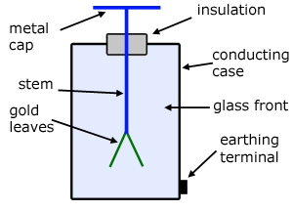
A Gold-Leaf Electroscope – Diagram From Wikimedia Commons
In the diagram on the next page, we see the electroscope being charged firstly by contact and then by induction. The steps for charging by contact are very straight forward and easy to follow. In the charging by induction example, the diagram on the left shows the charge separation. The proximity of the negatively charged rod to the top plate causes a charge separation, electrons in the metal moving away from the negative charges in the rod. This causes the leaves to spread as extra electrons enter the leaves. The earthing of the electroscope is usually done in such a demonstration by very quickly touching the top plate with your finger, while keeping the negatively charged rod near the top plate. This allows the extra electrons in the leaves to escape to ground through your body. The leaves collapse. The electroscope now has an overall shortage of electrons, so, when you take the rod away, the leaves spread again as the electroscope now has a net positive charge.
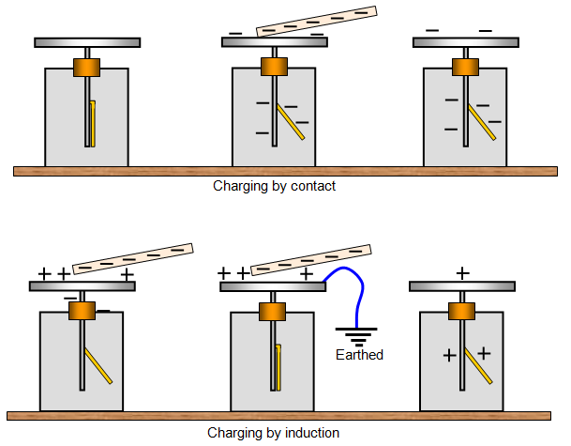
Charging an Electroscope – Diagram from Wikimedia Commons

Coulomb’s Law – The Force Between Charges
Charles Coulomb (1736-1806) discovered the following law governing the behaviour of charges:

For two charges q₁ and q₂, distant r apart, the force between them varies directly as the product of the two charges and inversely as the square of the distance between them.

Mathematically, , where = 9 x 10⁹ SI units and ε₀ is an experimentally determined constant called the permittivity of free space, with a value of 8.85 x 10⁻¹² SI units.

The force acts along the line joining the centres of the two charges. Each charge experiences the same sized force.

The SI unit of charge is the coulomb (C). One coulomb of charge is equal to the charge on 6.25 x 10¹⁸ electrons.

Let us now look at an example of the use of Coulomb’s Law equation.

Example Question: Study the diagram below.

The three charges shown above have magnitudes of q₁ = 1C, q₂ = 1.3C and q₃ = 2C. Determine:

- The force on q₃ due to q₁
- The force on q₃ due to q₂
- The total force on q₃ due to the presence of the other two charges.

Solution

- We use vector addition to determine the total force on q₃.

Total force on q₃ is 3 x 10¹⁰ N at 150°40’ in a clockwise direction from the line joining q₂ to q₃.

THE ELECTRIC FIELD
A “field” in physics is a region of influence of some kind. If a stationary charge experiences a force in a particular region of space, we say that there is an electric field present in that region.
The magnitude of the electric field strength at a particular point in space is defined as the force per unit charge at that point.

where E = electric field strength, q = size of the charge and F = force experienced by q at the point in question. The arrows above E and F indicate that these quantities are vectors and thus, must be specified in terms of size and direction.

The SI units of electric field strength are NC⁻¹.

The direction of the electric field at any point is defined as the direction in which a positive test charge would move if placed in the field at that point.

The relative strengths and directions of different electric fields may be represented diagrammatically by using lines of force. The spacing of the lines of force indicates the strength of the field. The closer the lines are together, the stronger the field. The direction of the field at a given point is indicated by the direction of the tangent to the lines of force at the point in question. Lines of force, also called field lines, are always drawn as emanating from positive charges and as terminating at negative charges.

The following are examples of the electric field around various objects.

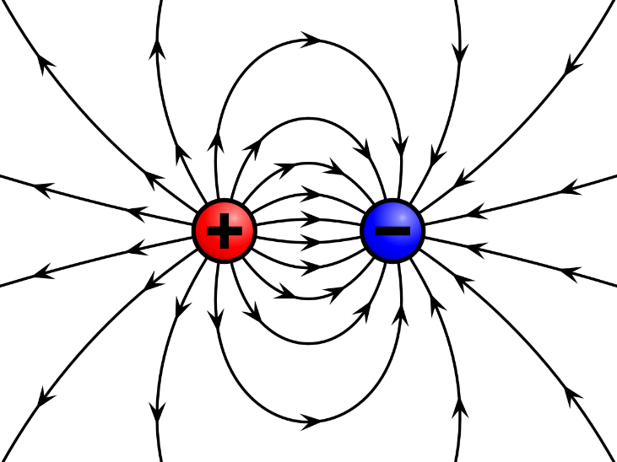

(b) E field around a dipole. A dipole consists of a positive and negative charge separated by a short distance. Diagram From: Wikimedia Commons

Note that in (c) the field is uniform between the plates but non-uniform towards the edges.

As shown in (d) above, the electric field inside a conductor under electrostatic conditions is zero. Also note that charge tends to accumulate at narrow or sharp ends of objects. You may like to think about why this would be expected and any consequences that may follow from such a phenomenon.

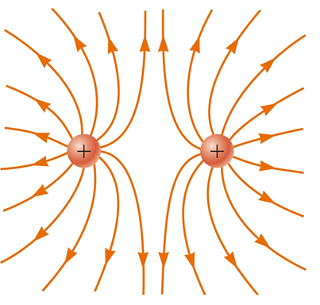

(e) The E Field around two positive charges separated by a short distance. Diagram From: Wikimedia Commons (altered slightly using Paint 3D to remove a letter marking a spot in the field)

Potential Difference
Consider a charge of + q coulombs in a uniform electric field as shown below:

To move charge +q from A to B back against the field direction, we must do work. The amount of work, W, that we must do is found from:

where F = the force applied to move the charge & d = displacement moved by the charge in the direction of the applied force. The SI unit of work is the joule (J).

In the E field, the force, F, on the charge is given by from the definition of electric field strength. Therefore, we have:

as the work done on the charge.

Since we have done work on q to move it from A to B, we can say that we have increased its potential energy (ie its ability to do work for us).

Further, we can say that there is a difference in potential between points A and B, in the E field. In general, we can say that there is a potential difference between any two points in an electric field, whenever we have to do work to move a charge from one point to the other. By definition:

That is, the potential difference between A and B, V_{AB}, equals the work done in moving the charge from A to B, W_{AB}, divided by the size of that charge, q. Since the work done is the change in potential energy of the charge, we can say that the potential difference between two points is the change in potential energy per unit charge moving from one point to the other. So, we can also write:

The SI unit of potential difference is the volt (V). 1V = 1JC⁻¹. Potential difference is often referred to as voltage. The terms are interchangeable.

Consider two oppositely charged, parallel, metallic plates separated by a distance, d. If connected to the terminals of a battery, this arrangement can be used to produce an electric field as shown below.

Note that the strength of the field is uniform between the plates but non-uniform towards the edges.

From previously, the work, W, done in moving a positive charge from one plate to the other, back against the direction of the field is:

And the potential difference, V, between the plates is given by:

So, therefore, the magnitude, E, of the electric field between the plates is given by:

where d is the distance between the plates. This gives alternate SI units for E as Vm⁻¹.

Equipotentials
In the diagram below, no work is required to move a charge from A to B, since the line AB is at right angles to the field (ie there is no component of AB in the direction of the force applied by the field). Thus, A and B are said to be at the same potential.

Lines like AB, which join points of equal potential are called equipotentials. Such lines are always at right angles to the electric field lines of force. For example, the equipotentials around a point charge are circles with centre at the position of the charge.

Equipotential Surfaces
If all the points on a surface are at the same potential, the surface is called an equipotential surface. No work is needed to move a charge around on such a surface, since the potential difference between points is zero. An example is a conductor holding an electrostatic charge – eg a Van de Graaf generator.

Teachers could demonstrate & explain the Van de Graaf generator at this point.

Charge from Van de Graaf generator causing girl’s hair to stand on end. Photograph From: Wikimedia Commons - Biswarup Ganguly, CC BY 3.0 <https://creativecommons.org/licenses/by/3.0>, via Wikimedia Commons

Example Questions
- A charge of -2.1 C is placed in an electric field of 0.2 NC⁻¹ north.
  - What is the force on the charged particle?
  - If the mass of the charged particle is 0.1 kg, what is the acceleration of the particle?
- Points A and B in the diagram below are the ends of the red line segment shown. How much work is done in moving a charge of 2.3 C from A to B, if the distance, d, between A and B is 0.4 m, E is 5 NC⁻¹ and θ is 30º?

Solutions
- (a) F = qE = -2.1 x 0.2 = -0.42 N
Force on charge is 0.42 N south. (Negative charge will move in opposite direction to
the field direction.)
(b) a = F/m = -0.42 / 0.1 = -4.2 ms⁻²
Acceleration of charge is 4.2 ms⁻² south.
- Be careful here. To calculate the work done on the charge, we need the displacement moved by the charge in the direction of the force applied by the electric field. This is the force against which we are doing work to push the charge from A to B. The force is not along the line AB. The force acts in the direction of the E field. We are working against this force.
In other words we need to calculate the component of displacement parallel to the field lines.
Component of d in direction of field = d cos θ.
Then from W = F.s = qEd cos θ = 2.3 x 5 x 0.4cos30° = 4.0 J
Work done on charge is 4.0 J.

ELECTRIC CIRCUITS

Inquiry Question: How do the processes of the transfer and the transformation of energy occur in electric circuits?

ELECTRODYNAMICS

Electrodynamics is the study of moving charges.

Conductors and Insulators
Substances containing large numbers of electrons that can move from one atom to another (free electrons) are called conductors, since they can be used to conduct a stream of electrons from one point to another. At ordinary temperatures, silver is the best conductor but it is too expensive for most uses. Copper is nearly as good a conductor as silver and far less expensive. Gold, aluminium and zinc are the next three best metallic conductors.

Metals are good conductors of electricity and heat because of their atomic structure. Metals, except mercury, are solids at room temperature. The structure of a solid metal consists of closely packed metal atoms. These atoms are arranged in a regular way to form a three-dimensional metallic lattice structure. In this structure, the atoms of the metal have one or more valence electrons which are free to move throughout the solid. The free electrons move randomly through the lattice at average speeds of around 10⁶ m/s, frequently colliding with the atomic nuclei in the lattice. If an electric field is applied in the metal, the electrons experience a force in the opposite direction to the field, causing them to drift in that direction. This motion is called electron drift and constitutes an electric current. The drift velocity of the electron is around 10⁻⁴ m/s.

No material used at ordinary temperatures is a perfect conductor. There is always some opposition to the flow of electrons eg electron collisions with atomic nuclei. This opposition results in the loss of energy from the moving stream of electrons. This lost energy appears in the form of heat, which warms the conductor. If too much energy is lost the rise in temperature may melt or vaporize the conductor.

In many substances, including glass, most plastics, rubber and wood, the outer or valence electrons are linked by chemical bonds to the corresponding electrons of adjacent atoms. In these substances the electrons are not free to move. Since electrons cannot move from atom to atom within these materials, they cannot conduct a flow of electrons. These substances are called non-conductors or insulators.

Electric Current
A current is defined to be a flow of charge. By definition, the direction of a current is taken to be the direction in which the positive charge flows. This is called a conventional current.

This direction was chosen because the early researchers in this field did not know whether the moving charges in a current were positive or negative. Today we know that it is the electrons that actually carry the charge in a current, but for convenience we still use conventional current direction as the direction of flow of a given current.

Mathematically, we define current as the rate at which charge flows (ie the amount of charge flowing per unit time):

The SI unit of current is the ampere (A). 1A = 1Cs⁻¹.

When current flows continually in one direction it is called a direct current (DC). When a current consists of charges that periodically change direction, backward and forward, it is called an alternating current (AC).

How is a current produced? When the ends of a conductor are connected to a battery, the free electrons in the conductor drift towards the positive terminal. The electrons are attracted by the positive terminal and accelerate toward it, but constantly bump into atoms on the way, so on average they just drift along.

A current, a flow of charge, is often compared to a flow of water, as an aid to understanding. A flow of water is a useful model of a flow of charge. Water flows downhill, from a high point to a low point, under a potential gradient caused by gravity. Charges in a conductor move from high potential to low potential following a potential gradient in the wire set up by a battery or other source of potential difference. If a certain volume of water flows into one end of a pipe, the same volume comes out the other end. If a certain quantity of charge enters one section of a conducting wire, the same quantity of charge leaves that section of the wire at the other end. If water lies in a perfectly level (equipotential) channel, it does not flow in any net direction. If a charge is sitting on an equipotential surface, it does not move (flow) in any net direction – it remains stationary.

Resistance of Conductors
The opposition that conductors offer to the movement of electrons across them is called the resistance of the conductor. Resistance is a property of a body due to the arrangements of the atoms of the body. Every material has a certain ability to resist the passage of an electric current through it. Thus, every material has a certain resistance value.

The resistance of a conductor is found experimentally to depend on four physical factors:
- Type of material – different materials can have different atomic arrangements (different geometrical arrangements, different spacing between the atoms, different sized atoms etc). Silver, copper and aluminium are all metallic conductors used to conduct electricity in various applications. If all other factors are equal, the three metals still have different resistance values because of their slightly different structures on an atomic scale.
- Length of conductor – the longer a conductor, the higher the resistance (resistance ∝ length).

- Cross-sectional area of conductor – the larger the cross-sectional area, A, of a conductor, the smaller the resistance (R ∝ 1/A)

- Temperature – Temperature effects on conductors are quite complex. In general, the metals used as conductors suffer an increase in resistance as their temperature increases. A formula exists which allows the resistance values of conductors to be determined for temperatures other than the reference temperature of 20ºC. This formula is beyond the scope of the current syllabus.

Ohm’s Law
Consider a current, I, flowing through a metal conductor, the potential difference across its ends being V.

In 1826 George Ohm found that for a given conductor at constant temperature, the ratio of the potential difference across its ends to the steady current flowing through it was a constant. This constant is called the resistance of the conductor.

This relationship is now called Ohm’s Law.

The SI unit of resistance is the ohm (Ω). A conductor is said to have a resistance of one ohm if, when the potential difference across its ends is one volt, the current flowing through it is one ampere.

It is worth noting that Ohm’s Law does not apply to all conductors. Those conductors obeying Ohm’s Law are called ohmic conductors. In general, metals are ohmic conductors. A conductor may obey Ohm’s Law over a particular temperature range and be non-ohmic outside that range. Some conductors, for example electronic components such as diodes, transistors, thyristors and semiconductors are non-ohmic.

The graph below shows a plot of potential difference versus current for both an ohmic and non-ohmic conductor. The gradient of the straight-line graph for the ohmic conductor is the resistance value for that conductor since V = IR is the equation of that line.

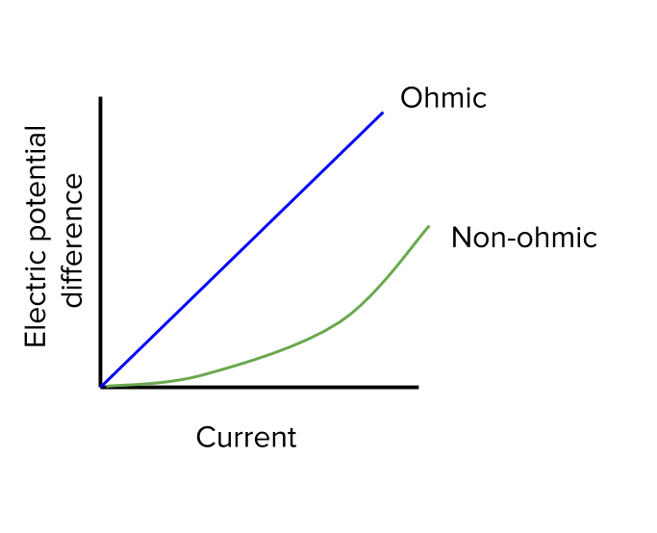
Diagram From: Wikimedia Commons

Non-Ohmic Resistors
So, while V = IR is used for calculating current in or voltage across ohmic resistors, how do we deal with non-ohmic circuit elements? For these, we need a characteristic V v’s I curve for the component we are using. We can then read from the graph the value of V for each value of I. For example, if you know the current flowing into a non-ohmic component, you read the voltage across it from the graph.
Circuit Diagrams
The following symbols are used in circuit diagrams to represent various circuit components shown:

Combinations of Resistors

Resistors in Series
Resistors joined end to end, so that the current only has one path along which it may travel, are said to be connected in series. For the circuit segment shown below the potential difference between points A and B is V.

Clearly, the current through each resistor is the same. Also, the total potential difference across the segment is equal to the sum of the potential differences across each resistor (Kirchhoff’s Voltage Law). Therefore, the total resistance, R, of the segment is found from:

IR = IR₁ + IR₂ + IR₃

IR = I.(R₁ + R₂ + R₃)

R = R₁ + R₂ + R₃

Thus, the effective resistance of a number of resistors in series is equal to the sum of the resistances of the individual resistors.

Resistors in Parallel
Resistors in parallel provide two or more different paths by which the current can travel through the circuit. In the following diagram the total current, I, splits into three components I₁, I₂ and I₃, such that I = I₁ + I₂ + I₃ (Kirchhoff’s Current Law).

The ends of each resistor are connected to the same points, A and B, in the circuit. It follows that the potential difference across each resistor is the same and in each case is equal to V.

Since I = I₁ + I₂ + I₃, we can write (from Ohm’s Law):

Thus, the reciprocal of the effective resistance of a number of resistors in parallel is equal to the sum of the reciprocals of each individual resistance.

Kirchhoff’s Laws of DC Circuit Analysis
Kirchhoff’s Laws are fundamental to DC circuit analysis. They can also be used in AC circuit analysis, which will not be considered in the Stage 6 course.

Kirchhoff’s Current Law – Conservation of Charge
The sum of the currents flowing into a particular point in a circuit equals the sum of the currents flowing out of that point.

See the section of the parallel resistor circuit above where the total current I splits into three components. Kirchhoff’s Current Law says that the sum of those components must equal I.

$$I=\sum_{n}{I_{n}}$$

Obviously, this can also be expressed as:

$$I-\sum_{n}{I_{n}}=0$$

Kirchhoff’s Current Law is really a consequence of the Law of Conservation of Charge, which states that the total net charge of any system is constant.

Kirchhoff’s Voltage Law – Conservation of Energy
In a closed loop, the sum of the voltage sources (the total voltage across the circuit) equals the sum of the voltage drops.

$$V=\sum_{n}{V_{n}}$$

Obviously, this can also be expressed as:

$$V-\sum_{n}{V_{n}}=0$$

For a simple example of this, observe the circuit segment below, repeated from the series resistor section above. This shows three resistors in series, with a total voltage across the segment of V volts.

We can make this segment into a loop by imagining the ends of the segment are attached to the positive & negative terminals of a battery supplying V volts across the loop. A certain amount of energy is needed to force current (moving charges) through each resistor. This energy is supplied by the potential difference (voltage) applied across the loop. A certain amount of this total voltage is used by the moving charges to force their way through each resistor. The amount of voltage used to force current through a resistor is called the voltage drop across the resistor. For instance, V1 above is the voltage drop across resistor R1.

Kirchhoff’s Voltage Law says that if we add up all the voltage drops that occur around the loop, the total will be equal to the total voltage applied across the loop. Nothing is “left over”. All of the available voltage is used up by the time the current has passed right around the loop.

Kirchhoff’s Voltage Law is really a consequence of the Law of Conservation of Energy, which states that energy can neither be created nor destroyed but merely transformed from one form into another.

Measuring Current and Voltage in Circuits
A galvanometer is a very sensitive device that measures very small currents. To enhance the range and type of measurements that a galvanometer can make, we combine the galvanometer with a couple of simple arrangements of resistors. This creates two new devices. One to measure current, the ammeter, and the other voltage, the voltmeter. See the extension topic in Appendix A if you are interested in how this is done.

An ammeter is used to measure the current flowing in an electrical circuit or in part of a circuit. The ammeter is placed in series in a circuit to enable it to sample the current that it is to measure. The ammeter is designed so that it has a very low resistance, so that it does not alter the current flowing in the circuit.

A voltmeter is used to measure the potential difference across an electrical circuit or across elements in a circuit. The voltmeter is placed in parallel with an element to enable it to measure the difference in potential between one end of the element and the other. The voltmeter is designed with a very high resistance to ensure that it does not change the current in the element across which it is connected. If it changed the current in the element, it would have changed the voltage across the element, which is what it was trying to measure.

In the circuit below, an ammeter measures the current flowing in the circuit and a voltmeter measures the potential difference (voltage) across the 8Ω resistor.

Today, digital multimeters are used in most school, TAFE & university laboratories. These can measure voltage drop and resistance as well as current.

Some Important Circuit Terminology
In the following circuit there are two switches, S₁ & S₂.

Load: The circuit element or elements connected to a battery is referred to as the load on the battery. In the circuit above, the load consists of the two series resistors, a total of 13Ω.

Closed Circuit: If we close S₁ and leave S₂ open, we have a closed circuit because conventional current will flow from the positive terminal of the battery through the two series resistors and then onto the negative terminal of the battery. We know in reality that it is the electrons travelling in the opposite direction around the circuit that constitute the current but in circuit analysis we always deal with conventional current direction (the direction in which positive charge would flow).

Open Circuit: If we leave both S₁ and S₂ open or if we close S₂ but leave S₁ open, we have an open circuit because there is no path for current to flow from one side of the battery to the other through the load.

Short Circuit: If we close both S₁ and S₂ we have a short circuit because there is a path of zero resistance (almost) from the positive terminal of the battery through S₂ to the negative terminal. All current will travel via this path. No current will flow through the load.

Example Questions (Have a go at these first before reading the solutions provided.)

- Consider the following circuit.
For this circuit, determine:
  - The total resistance of the two series resistors.
  - The total resistance of the two parallel resistors.
  - The total resistance of the circuit.
  - The current flowing through the circuit.
  - The current flowing through the two series resistors.
  - The current flowing through the 2 Ω resistor.
  - Describe the direction of the current.
- Examine the following circuit diagram. A galvanometer has been placed between points X and Y in the circuit. The galvanometer measures very small currents.
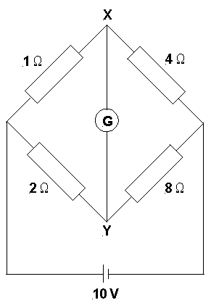
Determine:
  - The total resistance of the circuit.
  - The total current flowing in the circuit.
  - The current flowing through each parallel arm of the circuit.
  - The potential difference across the 1 Ω resistor.
  - The potential difference across the 2 Ω resistor.
  - The potential difference across the 4 Ω & 8 Ω resistors.
  - The current flowing through the galvanometer.

Solutions begin on the following page.
Solutions

- Don’t get confused. If in doubt about which resistors are in series & which in parallel, trace your finger over the circuit from the positive terminal of the battery back to the negative terminal. Parallel arms of the circuit occur where your finger has two (or more) possible directions to take. Clearly, the 1Ω & 4Ω resistors are in series with each other, as are the 2Ω & 8Ω resistors. The top arm of the circuit containing the 1Ω & 4Ω resistors is in parallel with the bottom arm of the circuit containing the 2Ω & 8Ω resistors. The galvanometer connects a point, X, on one parallel arm of the circuit to a point, Y, on the other. Current will only flow through the galvanometer, if there is a potential difference between X and Y.

The Work Done by a Current
In crossing a conductor, work must be done by the electrons to overcome the resistance of the conductor. The electrons collide frequently with the atoms of the conductor, causing them to vibrate more and producing an increase in the temperature of the conductor. The energy expended by the electrons is thus transformed into heat. Thus, a conductor gets hot when current passes through it. Some devices are designed to deliberately take advantage of the heating effect of a current. Examples of such devices include electric radiators, electric kettles, electric irons, toasters, stoves, electric soldering irons and incandescent lamps.

Consider a current of I ampere flowing through a conductor of resistance R ohm, with a potential difference of V volt across its ends. Remember that the work done in taking q coulombs of charge between two points differing in potential by V volts is given by:
W = qV.

So, the energy, W, expended by a charge q passing through a circuit component with a potential difference of V across its end is:

W = qV

= VIt, since I = q/t

= RI²t, since V = IR

= V²t/R, since I = V/R

Clearly, the total amount of energy used by an electrical component or circuit depends on the length of time the current is flowing.

Power in Electrical Circuits
The power of a circuit or circuit component tells us the rate at which energy is transformed from one form into another by the circuit or component. By definition, power is equal to the rate at which energy is expended.

Therefore, in an electric circuit: , since W = VIt.

So clearly, the power dissipated by an electrical component is determined by multiplying the current through the component by the voltage across the component. The SI unit for power is the watt (W).

Or using Ohm’s Law to re-arrange the equation, P = I²R or P = V²/R.

Electromotive Force (emf) of a Battery
The electromotive force (emf), ε, of a battery or any energy source is defined to be the power of the source per unit of current produced.

Now if this battery is connected to a circuit, then P = VI, where V is the potential difference across the circuit. So, we have:

Note that this is only true if the internal resistance of the battery is negligible.

Internal Resistance of a Battery
All real batteries have some internal resistance. The emf of the battery is used in:

- Forcing charge against the resistance of the circuit; and
- Forcing charge against the internal resistance of the battery.

Consider the following circuit showing a battery depicted as its emf, E, and its internal resistance, r. Assume current in circuit is I and potential difference across the variable resistor is V.

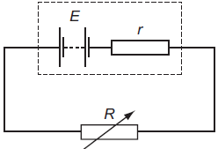

Emf & internal resistance of battery – Diagram From: Wikimedia Commons

The power of the battery is equal to the rate at which work is done against r plus the rate at which work is done against the circuit (load) resistance, R.

Clearly, if the internal resistance of the battery, r, is negligible, then the emf of the battery is the potential difference across the circuit.

You will often read circuit analysis questions that tell you to assume the internal resistance of the battery is negligible. This takes away one level of complication from such questions, which is always good when you are just learning how to do such questions.

Example Questions (Have a go at these first before reading the solutions provided.)

- Consider the following circuit. Assume the battery has negligible internal resistance.
  - When switch S is open, what is the potential difference between points X and A?
  - When switch S is open, what is the potential difference between points Y and A?
The rest of these questions assume that the switch S is closed.
  - What is the equivalent single resistor that could be used to replace the 12Ω and 4Ω parallel resistor combination? Show your working.
  - What is the current in the 2Ω resistor? Show your working.
  - What is the potential difference between points A and B? Show your working.
  - What is the rate at which the 10 V battery supplies energy to the circuit? Show your working.

- In this circuit all the light globes are identical and of equal brightness.
If the ammeter A₁ reads 0.9 A, what does the ammeter A₂ read?
- An ohmic water heating element has a resistance of 16Ω. Its power rating is 3.5 kW. When operational, what current flows through the heating element?

Solutions

  - When S is open, no current flows in the circuit. X is connected to the positive terminal of the battery and A is connected to the negative terminal. Therefore, the potential difference between X and A is 10 V.
  - Again, when S is open, no current flows in the circuit. Y is connected to the negative terminal of the battery, as is A. Therefore, the potential difference between Y and A is 0 V (zero volts).
- Ammeter A₁ reads the total current in circuit = 0.9A. The globes are all identical and are in parallel. The total current will therefore be split into three equal amounts. 0.3 A will flow through each parallel arm. Following the conventional current around the circuit from the positive terminal of the battery, 0.3A will flow into each parallel arm. A₂ must therefore read 0.3A coming from the right-hand globe and 0.3A coming from the middle globe. Therefore, A₂ must read 0.3A + 0.3A = 0.6A.

MAGNETISM

Inquiry Question: How do magnetised and magnetic objects interact?

MAGNETISM
Ancient people learned about magnetism from lodestones. A lodestone is a naturally magnetized piece of the mineral magnetite. They are naturally occurring magnets, which can attract iron. The earliest known surviving descriptions of magnets and their properties are from Greece, India, and China around 2500 years ago.

All magnetism arises from either the orbital motion or the spin motion of electrons in atoms. The orbital motion of electrons around the nucleus gives rise to diamagnetism. The spin motion of the electrons produces paramagnetism. Both diamagnetism and paramagnetism are weak and exist only in the presence of an applied magnetic field. Diamagnetic and paramagnetic materials respond differently to one another to the influence of a magnetic field. The details of this are not needed in the current syllabus.

A subclass of paramagnetism is called ferromagnetism. Ferromagnetic materials retain their magnetic properties even without an applied magnetic field. They are strongly attracted to magnets. Elements such as iron, cobalt and nickel and the many alloys made from them are ferromagnetic.

Both permanent magnets (bar magnets, horseshoe magnets, circular magnets, etc) and temporary magnets (eg electromagnets) exist. If suspended by a thread and allowed to rotate freely, a bar magnet will orient itself along one line – the north-south line of the Earth’s magnetic field. The end of the magnet which points north is called the north pole of the magnet. The other end is the south pole. The point on the Earth’s surface to which the north pole of a magnet points is called the Magnetic North Pole. Compass needles consist of small bar magnets pivoted in the middle so that they can swing about in response to magnetic forces.

MAGNETIC FIELDS
We know that if we bring the north poles of two bar magnets close together, they repel one another. The same thing happens if we bring two south poles close together. If we bring a north pole and a south pole close together, they attract one another. In summary, like poles repel and unlike poles attract.

It is interesting to note then, that if the north pole of a magnet points towards the Earth’s Magnetic North Pole, the Earth’s Magnetic North Pole must be a south pole in nature. Think about it.

Just as we did in the case of electric fields, we can use lines of force to represent a magnetic field. The direction of the field is indicated by arrows on the lines. The strength of the field is indicated by the separation of the lines.

By definition, a magnetic field is said to exist at a point if a compass needle (small bar magnet) placed there experiences a force. The direction of the field is the direction of the force on the north pole of a compass needle placed at the point in question.
The shape of the magnetic field around a bar magnet is as shown below. Note that the field lines emerge from the north pole and re-enter the magnet at the south pole. The magnetic field lines themselves are continuous. We say magnetic field lines are closed. They travel through the magnet. Note also that no example of a single magnetic pole (monopole) existing on its own has ever been found. (Some experimental physicists look for magnetic monopoles – certain theories on the nature of matter in the universe suggest that they could exist.)

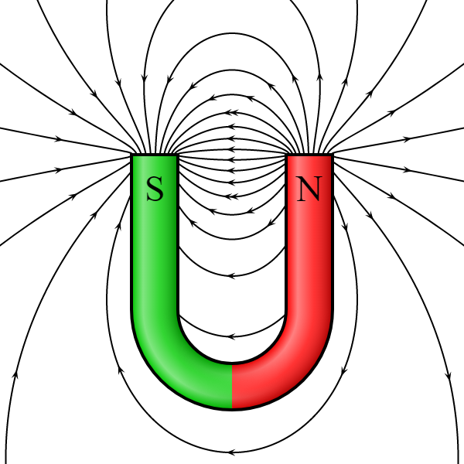

Magnetic field around a horseshoe magnet
Diagram From: Wikimedia Commons
Note that all field lines above are closed. The diagram
is not large enough to show this for every line.

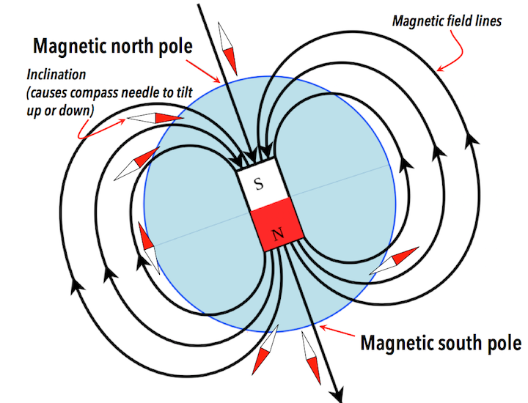

Earth’s Magnetic Poles - Diagram From: Wikimedia Commons

Your teacher should provide time for you to explore magnets & magnetic fields. The following photos show the use of iron filings to highlight the nature of magnetic fields around particular magnets. You should have seen this in junior high school Science lessons.

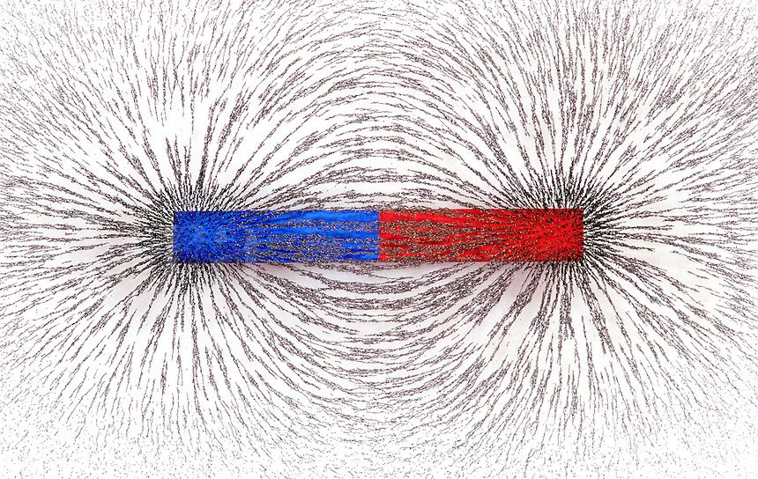
Diagram From: Wikimedia Commons

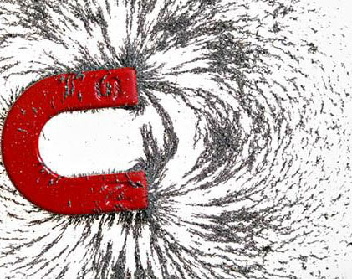

Diagram From: Wikimedia Commons

Generation of Magnetic Fields
As mentioned above, bar magnets and other so-called permanent magnets are made out of a material called ferromagnetic material. Ferromagnetic materials derive their magnetic properties from the spin motion of electrons in atoms. Let us take a closer look at this for ferromagnetic materials.

The spinning of an electron makes it behave like a little current loop, which has a magnetic field like that of a bar magnet, but on a much smaller scale. In most materials, the field from one electron cancels that from another, the net effect being no magnetic field. Ferromagnetic materials, however, consist of small regions (10⁻¹² to 10⁻⁸ m³ volume) called magnetic domains in which the spins of electrons line up with each other to produce distinct north and south poles within the region. In the absence of an external magnetic field, these domains point in random directions. In the presence of a weak magnetic field, the domains line up in a particular direction and produce a net magnetic effect.

If a magnetic field is required to keep the domains aligned, the magnet is called a temporary magnet (eg soft iron). If the domains remain aligned, the magnet is called a permanent magnet (eg hard steel). Note that even in permanent magnets, the domains will eventually relax into a random orientation, once out of the influence of the weak external magnetic field. This relaxation may take many, many years.

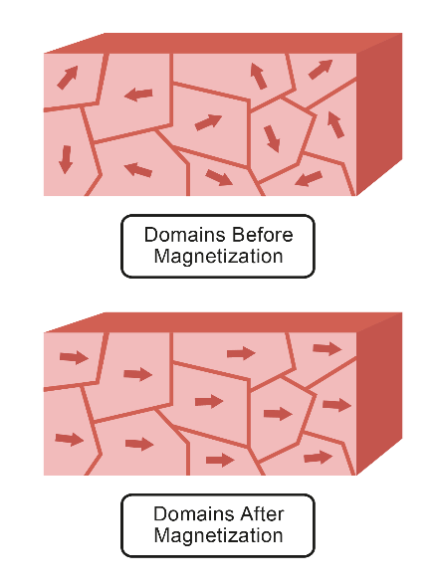
Diagram From: Wikimedia Commons
Magnetic Fields Caused by Currents
Electric currents produce magnetic fields. In fact, any moving charge has a magnetic field associated with it. These magnetic fields are the same as those produced by permanent bar magnets.

In 1820, a Danish scientist, Hans Christian Oersted, became the first person to record this phenomenon. While demonstrating the flow of an electric current in a wire connected to a voltaic pile (the forerunner of the battery), Oersted noticed that the current caused a nearby compass needle to change direction. Oersted’s observation showed that there was a magnetic field surrounding the electric current. Further investigation suggested that all electric currents are surrounded by magnetic fields. Scientists such as Jean Baptiste Biot, Felix Savart, Pierre-Simon Laplace and André-Marie Ampère developed Oersted’s observation into a mathematical model.

Since every moving charge has a magnetic field associated with it, it makes sense that a current must also have a magnetic field associated with it. For a current moving through a straight conductor, the magnetic fields of the component charges add together to produce circular magnetic field lines concentric about the conductor. See below.

The direction of the field is given by the Right-Hand Grip Rule, which states: Hold the thumb of the right hand in the direction of the conventional current flow through the conductor. The direction in which the fingers of the right hand naturally curl around the conductor, is the direction of the magnetic field.

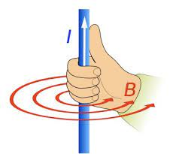

Right-Hand Grip Rule – Diagram From: Wikimedia Commons

In the example below, the X in the middle of the conductor indicates that the current is flowing down into the page, perpendicular to the page. The field is then clockwise, looking from above the page, by the RH Grip Rule.

Solenoids
A solenoid is simply a coil of insulated wire. If we pass a current through a solenoid, we find that the solenoid has a magnetic field similar to that of a bar magnet. This field can be intensified greatly by adding a soft iron core inside the solenoid. Such an arrangement is called an electromagnet.

Another way of representing a solenoid is to draw it in cross section, as shown below.

In the diagram above, the solenoid has been cut through vertically. The current is coming up out of the page through the bottom row of conductors (indicated by the dot in the middle of each conductor) and down into the page through the top row of conductors. Using the RH Grip rule, the magnetic field direction is as shown.

We can understand why a solenoid has such a magnetic field by realizing that the fields due to each turn of wire in the coil, simply add together to produce the typical bar magnet field. Note that at points inside the solenoid and reasonably far from the wires, the magnetic field is fairly uniform and parallel to the solenoid axis. In the limiting case of adjacent, square, tightly packed wires, the solenoid becomes essentially a cylindrical current sheet and the requirements of symmetry then make the previous statement necessarily true.

Magnetic Flux Density Vector
One measure of the strength of a magnetic field is the Magnetic Flux Density Vector, B. This is also called the Magnetic Induction Vector. The higher the value of B, the stronger the magnetic field. The direction of the B vector at a point in space is the direction of the magnetic field at that point. The SI Unit for B is called the tesla (T). Most magnetic fields are much smaller than 1T. For instance, at the Earth's magnetic equator, the magnetic flux density is 0.0000305 tesla, or 3.05 x 10⁻⁵ T.

I will take this opportunity to point out a very common error when dealing with magnetic fields. Many textbooks, teachers and students refer to the vector B as the “magnetic field strength”. This is wrong. The vector B is called either the magnetic flux density or the magnetic induction. While it serves as a useful measure of the strength of a magnetic field, it should never be referred to as the magnetic strength vector. That vector is designated H (magnetic field strength or magnetic intensity). B and H are two different vectors. B is the one we are dealing with here – the magnetic flux density or the magnetic induction vector. You will come across the vector H if you do physics at university. Terminology is important and students should be taught the correct terminology from the very beginning.
Magnetic Field Around an Infinitely Long Straight Conducting Wire
In 1820, following on from Oersted’s observation, Biot and Savart, developed a mathematical expression for the magnetic flux density at a point in space due to a steady current through a small element (section) of a conducting wire. This was an important development because it allowed us to calculate the magnetic field produced by a current-carrying wire of arbitrary shape and size. Knowing the magnetic flux density due to a small (infinitesimal) section of the current-carrying conductor allows us to use integral calculus to add up all of the components of the magnetic field to calculate the size and shape of the whole field around the conductor.

This process is slightly beyond the mathematical requirements of the current syllabus but it is a great example of the power of mathematics to describe our universe. Mathematics is a beautiful thing! Let us examine the simplest of the formulae that the Biot-Savart Law allows us to determine.

Consider the following diagram showing a cross-section of the magnetic field around a straight, infinitely long, conductor carrying current down into the plane of the page. We are interested in the magnitude of B at point P a small perpendicular distance, r, from the conductor.

The magnitude of the magnetic flux density, B, at a point a perpendicular distance, r, from a straight conductor of infinite length carrying a current, I, is given by:

µ₀ is called the permeability of free space and is a measure of the ability of free space to support a magnetic field. Clearly, the constant .

Strictly speaking, the above formula only applies to a wire of infinite length. A finite length wire can be approximated as infinite for close points around the wire. So, we can use this formula to calculate B for a real wire at points close to the wire, to a reasonable degree of accuracy. (If higher accuracy is required, or if the point in question is not close to the wire, we would have to use the more sophisticated formula for the magnetic field due to current in a finite straight wire. This is not required for the Stage 6 Physics Course.)

Magnetic Field Inside a Solenoid Carrying a Current
As we have said, Biot-Savart Law enables us to calculate the magnetic field produced by a current carrying wire of arbitrary shape. So, it can be used to determine the magnetic flux density inside a solenoid.

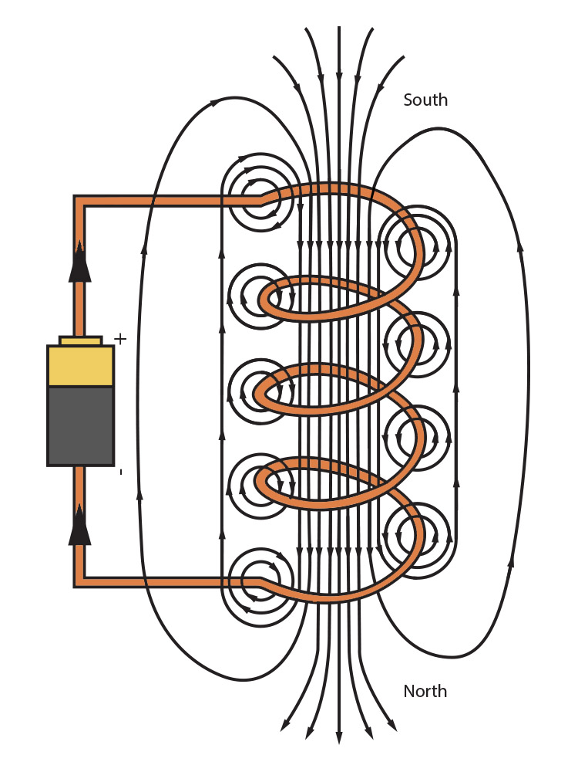
Magnetic Field around a Solenoid
Diagram From: Wikimedia Commons

In the diagram above, note that at points inside the solenoid and reasonably far from the wires, the magnetic field is uniform and parallel to the solenoid axis. The magnetic flux density, B, inside a solenoid of length L and N turns of wire, carrying a current, I, is given by:

Example Questions (Have a go at these first before reading the solutions provided.)

- Consider the diagram below that shows two magnets sitting near each other.
If the magnets above are fixed in position so that they cannot move, draw the magnetic field resulting from these two magnets being placed close to one another. Assume the field of each magnet is sufficiently strong to enable it to interact with the field of the nearby magnet.
- The diagram below shows a compass needle placed on a laboratory bench and pointing north. A magnetic field is then applied so that the compass needle is sitting completely inside the uniform magnetic field. The applied field is much stronger than the field of the compass needle and the compass needle is free to move in any direction. If the direction of the applied field is East, draw a diagram showing the forces acting on the north and south poles of the compass needle when the applied field is switched on. Draw a second diagram showing the position of the compass needle once it has come to equilibrium with the applied field.
- A current of 6A flows through a long thin solenoid of length 0.3 m. If the solenoid consists of 270 turns of wire determine the magnetic flux density at the centre of the air core inside the solenoid.
- Study the diagram below that shows three long parallel current-carrying conductors sitting close to one another at the corners of a square of side length 1.0 cm. All conductors are carrying currents of 2A down into the plane of the page as indicated.
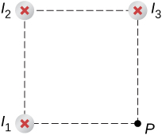
Diagram From: Wikimedia Commons
  - Determine the direction of the magnetic field at P, the other corner of the square, due to each of these currents. Draw B-vectors at P to show these directions.
  - Calculate the magnitude and direction of the resultant magnetic flux density at P due to the three currents.
Solutions

- 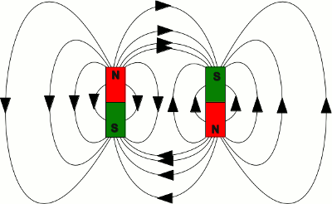
Diagram From: Wikimedia Commons
Note that the field line density in the space between the magnets is low, while that near the poles is high. There is an attractive force acting on both magnets. If the magnets could move, as they approached each other, the field strength at the top and bottom of the arrangement near the poles would be intensified, while elsewhere it would be weakened.

  - 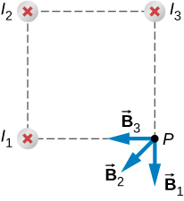
Diagram From: Wikimedia Commons
Applying the RH Grip rule to each of the currents leads to the diagram above of the B-field directions. For example, when applying the RH Grip rule to I₁, with the thumb of the right hand pointing down into the page at I₁, the fingers naturally curl clockwise and as they pass through point P, they are pointing down the page.
Alternatively, we could draw a circle (field line) centred at the location of each wire and out toward the point P. The field around each wire is clockwise by the RH Grip rule. The direction of the magnetic field contribution from each wire is tangential to the circle at P, considering the clockwise direction of the field around each wire.
  - Since the distance from I₁ to P is the same as that from I₃ to P, wires 1 and 3 produce equal magnitude magnetic flux density values at P. So,
So, the angle between B₁ & B₂ and B₂ & B₃ is 45º.
Now we can add the three vectors together to get the resultant.
Therefore, the resultant magnetic flux density at P due to the three currents is 8 x 10⁻⁵ T.
Clearly, the direction of the resultant magnetic flux density is given by
So, the resultant magnetic flux density at P has a direction along the same line as B₂.

Comment on Module 4
Module 4 leads very nicely into Module 6 Electromagnetism. We have now completed all Syllabus points for Module 4. Your teacher should provide you with appropriate practical demonstrations and time for your own practical work.

Your teacher may also decide to teach some aspects of Module 6 during Module 4. Possible topics could include Force on Moving Charges in Magnetic Fields and Force on Current-Carrying Conductors in a Magnetic Field. It could be argued that these topics fit in with the syllabus for Module 4, even though they are not mentioned in this part of the syllabus. They are certainly mentioned specifically in the syllabus for Module 6.

If you need notes on the above topics, please see the Electromagnetism page of my website.

BIBLIOGRAPHY

- Halliday, D. & Resnick, R. (1966). Physics Parts I & II Combined Edition, New York, Wiley
- Giancoli, D.C., (2008). Physics for Scientists & Engineers – Volume II, USA, Pearson Education Inc.
- Christian, D. & Crossley, W. (1982). Essential Physics Book One, Strathfield, Australia, Sapphire Books Pty Ltd
- Houston, J.G., Reid, D. & Wilson, J.M. (1971). Multiple Choice Questions for Assessment in Physics, London, Heinemann Educational Books
- Øgrim, O. & Vaughan, A. E. (1977). SI Quantities and Units in Science, Marrickville, NSW, Australia, Science Press
- Schaum, D. (1977). Schaum’s Outline Series – Theory and Problems of College Physics 6th Edition SI (metric) edition, Edited by Van Der Merwe, C. W., New York, McGraw-Hill Book Company
- Churchman, L. W. (1976). Introduction to Circuits, New York, Holt, Rinehart and Winston
- Warren, N.G. (1982). Physics Outlines Core & Electives For Higher School Certificate Students, Rushcutters Bay, NSW, Australia, Pergamon Press
- Gardiner, E.D. (1975). Problems In Physics SI Edition, Sydney, McGraw-Hill Book Company

APPENDIX A - Extension Section
The Design of Ammeters and Voltmeters (Not required by the syllabus)
Analogue ammeters and voltmeters are based on galvanometers, very sensitive current measuring devices.

Ammeters
Ammeters are placed in series with the current they are measuring and must have a very small resistance so as not to alter that current. They are designed by placing a shunt resistor of small value in parallel with the galvanometer, as shown below. In the diagram, R_{g} is the resistance of the galvanometer, R_{s} is the shunt resistor, i is the very small current, usually 1 mA, flowing through the galvanometer and I is the total current flowing in the section of circuit being measured by the ammeter.

Voltmeters
Voltmeters are placed in parallel with the voltage they are measuring and must have a very large resistance so as not to alter that voltage. They are designed by placing a resistor of large value in series with the galvanometer, as shown below. In the diagram, R_{g} is the resistance of the galvanometer, R_{ser} is the series resistor, i is the very small current, usually 1 mA, flowing through the galvanometer, I is the total current flowing in the section of circuit being measured by the voltmeter and V is the voltage being measured across the circuit component of interest, in this case, the resistor R.

Example Questions

- A galvanometer has a resistance of 100Ω and gives a deflection of its pointer right across the scale (full-scale deflection, fsd) for 1 mA of current. What shunt resistor is needed for this meter to be capable of reading 5 A?
- A galvanometer has a resistance of 100Ω and gives a full-scale deflection for 1 mA of current. Calculate the size of the resistor we need to place in series with the galvanometer to enable the meter to read 10 V full-scale?

Solutions

- Using the circuit diagram above showing the design of an ammeter, we have that:
Therefore, the size of the shunt resistor required is 0.02 Ω.
- Using the circuit diagram above showing the design of a voltmeter, we have that:
Therefore, the size of the series resistor required is 9900 Ω.

Clearly, designing ammeters and voltmeters is a very straight forward procedure.

APPENDIX B
Statement of Syllabus Content Covered in these Notes

The following indicates the specific content from the Stage 6 Physics Syllabus that has been covered in the notes, worksheets & practicals provided on the Electricity and Magnetism Module web page.

The resources on this website are meant to supplement the work you do in class NOT replace it. The notes will always provide you with a comprehensive and accurate set of notes on the Module under study. The worksheets will provide some introduction & practice to appropriate problem-solving skills for the topic. You will need to do much more problem-solving practice than just what is provided on this website. The practicals section will provide some experiments relevant to the topic but again you will need to do more than just what is suggested here. Your teacher should provide you with much more problem-solving & practical experience than you will find on this website.

The content statements that are ticked have been covered. Those left without a tick have either not been covered at all or have been only partially covered. These are mainly content statements requiring practical work of some kind.

Content

Electrostatics
Inquiry question: How do charged objects interact with other charged objects and with neutral objects?

Students:
- conduct investigations to describe and analyse qualitatively and quantitatively:
  - processes by which objects become electrically charged (ACSPH002)
  - the forces produced by other objects as a result of their interactions with charged objects (ACSPH103)
  - variables that affect electrostatic forces between those objects (ACSPH103)
- using the electric field lines representation, model qualitatively the direction and strength of electric fields produced by:
  - simple point charges
  - pairs of charges
  - dipoles
  - parallel charged plates
- apply the electric field model to account for and quantitatively analyse interactions between charged objects using:
  - $\vec{F}=q\vec{E}$ (ACSPH103, ACSPH104)
  - $E=\frac{V}{d}$
  - $F=\frac{1}{4πε_{0}}\frac{q_{1}q_{2}}{r^{2}}$ (ACSPH102)
- analyse the effects of a moving charge in an electric field, in order to relate potential energy, work and equipotential lines, by applying: (ACSPH105)
  - $V=\frac{∆U}{q}$, where $U$ is potential energy and $q$ is the charge

Electric Circuits
Inquiry question: How do the processes of the transfer and the transformation of energy occur in electric circuits?

Students:
- investigate the flow of electric current in metals and apply models to represent current, including:
  - $I=\frac{q}{t}$(ACSPH038)
- investigate quantitatively the current–voltage relationships in ohmic and non-ohmic resistors to explore the usefulness and limitations of Ohm’s Law using:
  - $W=qV$
  - $V=IR$ (ACSPH003, ACSPH041, ACSPH043)
- investigate quantitatively and analyse the rate of conversion of electrical energy in components of electric circuits, including the production of heat and light, by applying $P=VI$ and $E=Pt$ and variations that involve Ohm’s Law (ACSPH042)
- investigate qualitatively and quantitatively series and parallel circuits to relate the flow of current through the individual components, the potential differences across those components and the rate of energy conversion by the components to the laws of conservation of charge and energy, by deriving the following relationships: (ACSPH038, ACSPH039, ACSPH044)
  - $ΣI=0$(Kirchhoff’s current law – conservation of charge)
  - $ΣV=0$(Kirchhoff’s voltage law – conservation of energy)
  - $R_{Series}=R_{1}+R_{2}+...{+ R}_{n}$
  - $\frac{1}{R_{Parallel}}=\frac{1}{R_{1}}+\frac{1}{R_{2}}+...+ \frac{1}{ R_{n}}$
- investigate quantitatively the application of the law of conservation of energy to the heating effects of electric currents, including the application of $P=VI$ and variations of this involving Ohm’s Law (ACSPH043)

Magnetism
Inquiry question: How do magnetised and magnetic objects interact?

Students:
- investigate and describe qualitatively the force produced between magnetised and magnetic materials in the context of ferromagnetic materials (ACSPH079)
- use magnetic field lines to model qualitatively the direction and strength of magnetic fields produced by magnets, current-carrying wires and solenoids and relate these fields to their effect on magnetic materials that are placed within them (ACSPH083)
- conduct investigations into and describe quantitatively the magnetic fields produced by wires and solenoids, including: (ACSPH106, ACSPH107)
  - $B=\frac{μ_{0}I}{2πr}$ V
  - $B=\frac{μ_{0}NI}{L}$ V
- investigate and explain the process by which ferromagnetic materials become magnetised (ACSPH083)
- apply models to represent qualitatively and describe quantitatively the features of magnetic fields
Appendix C & D appear on the following pages.

APPENDIX C
The following notes are not required for the Module 4 syllabus and are supplied here for interest.

CHOICE OF UNITS FOR MEASURING HOUSEHOLD ELECTRICAL ENERGY CONSUMPTION – The kilowatt-hour (kWh)

If you look at your parents’ electric power bill you will notice that the amount of electrical energy consumed by your household is quoted in units of kWh – kilowatt-hours. This seems strange considering that the correct SI unit for energy is the joule (J). Let us see why the kWh is used in place of the joule in this instance.

Consider an electric radiator. The amount of electrical energy used by a radiator can be calculated as follows: Say the radiator has a power rating of 2000 watts. Using the definition of power, that means the radiator will use 2000 joules of energy every second. Thus, the total energy used in a time of t seconds will be 2000 t joules, since W = P t.

Let’s assume we use the radiator for 90 days at an average of 4 hours use per day. The amount of energy used will be:

Energy = 2000 x 4 x 60 x 60 x 90 = 2 592 000 000 joules.

Rather large, isn’t it? And remember this is just the energy used by one radiator for a few hours each day for a quarter of the year. Imagine how large the total energy usage for a whole household would be! Here we have the main reason as to why the kilowatt-hour is used to measure electricity consumption rather than the joule. The joule is a very small unit of energy, while the kilowatt-hour is a much larger unit. Electrical energy authorities in Australia use the kWh as the unit for energy simply because it produces more friendly, easily understood energy consumption figures.

The kilowatt-hour is defined as the amount of energy used in one hour by an appliance rated at 1 kW (1000 W). The equivalent energy in joules is:

1 kWh = (1 x 10³ watts x 60 x 60 seconds) = 3.6 x 10⁶ J

Clearly, the kilowatt-hour is a much larger unit than the joule.
So, for our example of the radiator, the amount of energy used in kWh is:
Energy = 2 kilowatts x 360 hours = 720 kWh
I think most people would agree that this is a much more manageable figure than the roughly 2.6 billion joules calculated above.

APPENDIX D
The following notes are not required for the Module 4 syllabus and are supplied here for interest.

ELECTRICAL SAFETY

As mentioned above, fuses and circuit breakers are common devices found in household electrical circuits. Both devices are designed to protect the house wiring from overload and thereby prevent fires. For each separate household circuit, a fuse or circuit breaker is placed in the meter box, in series between the external power supply and the internal house wiring. In the case of a fuse, if too much current is drawn for too long a time, the fuse simply melts, thus breaking the circuit and protecting the wiring. In the case of a circuit breaker, if too much current is drawn for too long, the circuit breaker opens, breaking the circuit and protecting the wiring. Fuses can be quicker for interrupting the flow of power but when they melt, they must be replaced; circuit breakers on the other hand just need to be reset. Thus, circuit breakers are rapidly becoming more common than fuses.

Neither fuses nor circuit breakers act fast enough to protect people from electrocution.
Since 1991, Residual Current Devices (RCDs), also known as safety switches, have been installed in all new homes built in NSW. RCDs detect very small earth currents, as small as 0.03 amps and immediately trip the circuit (in less than 20 milliseconds), vastly reducing the risk of injury by electrocution. RCDs are also installed if a house is substantially rewired or has a Smart Meter installed. All new electricity meters installed after 2017 in NSW must be smart meters.

All household electrical appliances are either earthed or double insulated (explained below). Many appliances are earthed by connecting a conducting wire from the metal body of the appliance to the earth wire of the household. As mentioned previously, this earth wire is connected to the ground. If a fault within the appliance results in current from the active wire leaking to the metal body of the appliance, two things will happen almost simultaneously. Firstly, the current will flow safely to the ground via the earth wire. Secondly, due to the large increase in current flowing in this household circuit via the short-circuit to ground, the fuse in this household circuit will blow or the circuit breaker in this household circuit will open, as the case maybe.

Insulators play an important part in making household electrical appliances safe to use. Individual electrical conducting wires are covered with insulating material such as PVC (polyvinyl chloride) to prevent leakage of current. Power cables that enclose sets of insulated wires connected to appliances are also made from PVC or similar material. Light switches and power point plates are made from hard plastics. Fuse wires are held in place in household circuits using porcelain plugs. The internal insulation of electrical equipment may be made of mica or glass fibres with a plastic binder.

Many small electrical appliances are double insulated which means that not only are the wires inside insulated but also the body itself, being made of plastic, is an insulator. Desk lamps, battery rechargers, electric drills, hair driers, electric mixers and electric razors are just a few examples. Such appliances have only two wires connected to them and a plug with two pins, one for the active and one for the neutral. Any metal screws or pins used to hold parts together are totally enclosed in plastic tubes. There are no electrically conductive parts that give a path for a current to the outside, even if a fault inside puts the body in direct contact with the active wire.

Having mentioned some of the safety features present in household electrical circuits and appliances, it is appropriate to consider the dangers of electricity. Electricity can kill a person in two ways:

- It can cause the muscles of the heart and lungs (or other vital organs) to malfunction; or
- It can cause fatal burns.

Even a small electric current can seriously disrupt body cell functions. When the electric current is 1mA (1 milliampere) or higher, a person can feel the sensation of shock. At currents ten times larger, 10mA, a person is unable to release the electric wire held in his/her hand because the current causes his/her muscles to contract violently. Currents larger than 20mA paralyze the respiratory muscles and stop breathing. Unless Expired Air Resuscitation is started immediately the victim will suffocate. A current of 100mA passing through the region of the heart, will shock the heart muscles into rapid, erratic contractions (ventricular fibrillation) so the heart can no longer function. Death would usually follow in a matter of a few minutes. Currents of 1A (1000mA) and higher through body tissue cause serious burns.

Typically, the 240V AC mains supply causes a 25mA current in the body, which can easily cause death. This is the reason why some countries use 110V AC as their mains supply voltage – it is safer in the event of an electric shock. With AC, the frequency of the supply also affects the damage that the current causes. Since heart muscle is most sensitive to electricity of frequency 30-100Hz, the Australian mains frequency of 50Hz is ideal for inducing fibrillation. Higher frequencies, DC electrical current, and AC which does not pass through the heart do not cause fibrillation but rather heat up and burn the muscle they flow through.

Overall, the most important quantity to control in preventing injury is the electric current. Voltage is important only in that it can cause current to flow. For example, even though your body can be charged to a potential thousands of volts higher than the metal frame of your car, simply by sliding across the car seat, you feel only a harmless shock as you touch the door handle. Your body cannot hold much charge on itself, and so the current flowing through your hand to the door handle is short-lived and the effect on your body cells is negligible.

