Block on Inclined Plane Problem

Consider a block of mass 100 kg placed on a plane inclined at an angle of 30° to the horizontal as shown below. A friction force of 170 N acts on this block up the plane and parallel to the plane.

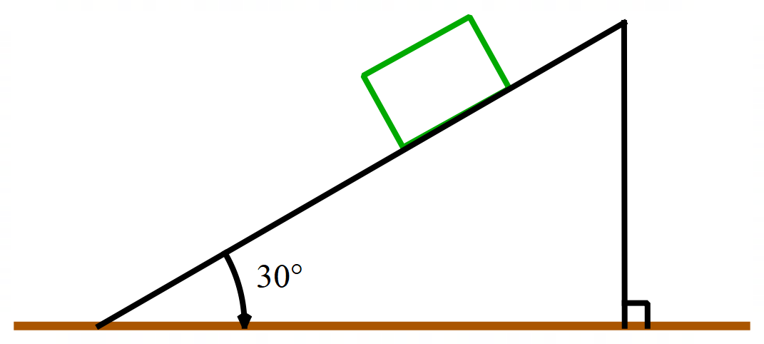

- Re-draw this diagram showing the vectors representing the force due to gravity and the friction force acting on the block. Resolve the force due to gravity into rectangular components parallel and perpendicular to the plane.
- Calculate the magnitudes of the two rectangular components in (a). Use the acceleration due to gravity as 9.8 ms⁻².
- Determine the net force (total force) acting on the block parallel to the plane.
- Find the acceleration of the block.
- If it takes 3.0 seconds for the block to move from rest to the end of the plane, how far does the block move down the plane.

Solutions over page.

Solutions

- 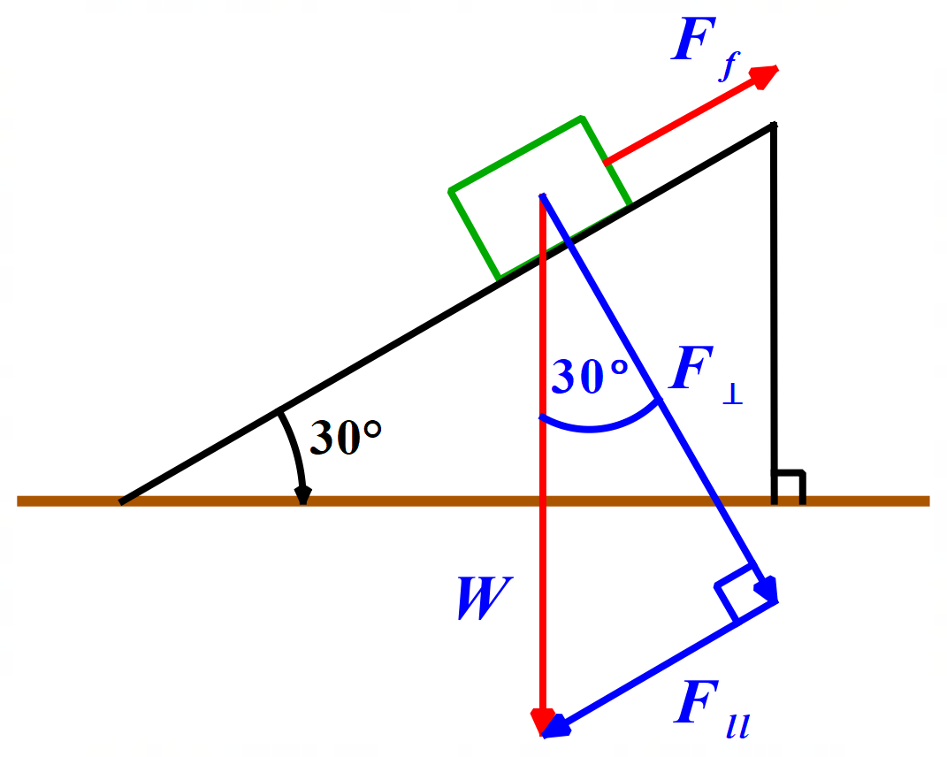
- 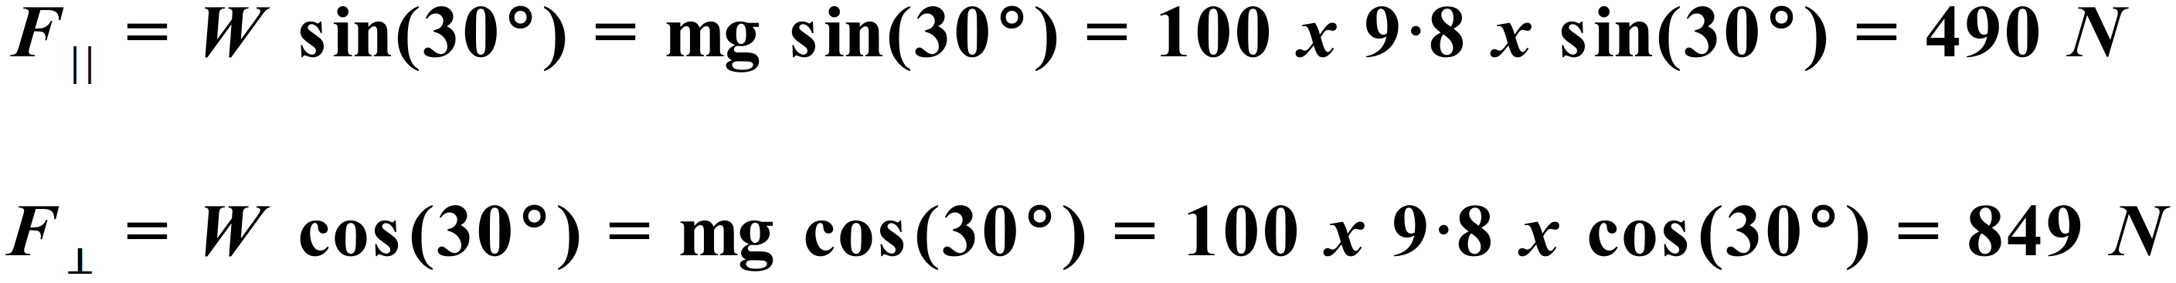
- Net force on block parallel to plane:
Note that 170 N of the 490 N component is used to overcome friction to allow the block to move.
- Acceleration of block:
- Distance moved down plane:
