ENERGY IN UCM & TORQUE WORKSHEET
- A mechanical arm is used to swing a spherical brass mass of 0.5 kg in horizontal uniform circular motion of radius 1.0 m. The linear velocity of the mass is 12 ms⁻¹. Determine:
  - The angular velocity of the mass. (12 rads⁻¹)
  - The kinetic energy of the mass. (36 J)
  - The work done on the mass by the centripetal force. (0 J)
- Consider the Earth-Moon system. The Moon revolves around the Earth in a nearly circular orbit, with approximately constant linear velocity, kept there by the gravitational force exerted by the Earth. Does the Earth do work on the Moon? Explain your answer. (Answer on page 3)
- 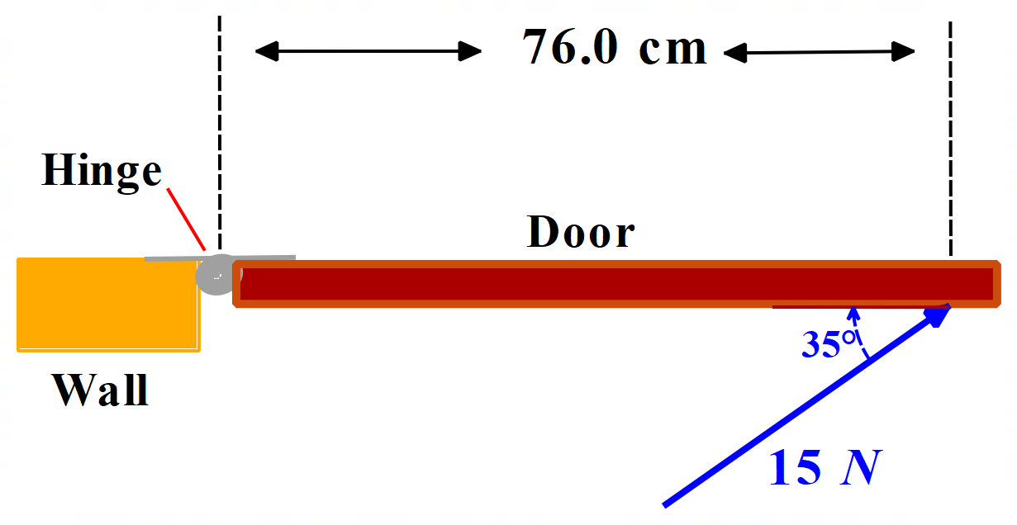The diagram below shows a door being pushed open by a force of 15 N applied at an angle of 35° to the surface of the door. The axis of rotation of the door is located at the hinge.
Calculate the torque applied to the door. (6.5 Nm)
- Study the diagram below of a spanner loosening a nut.
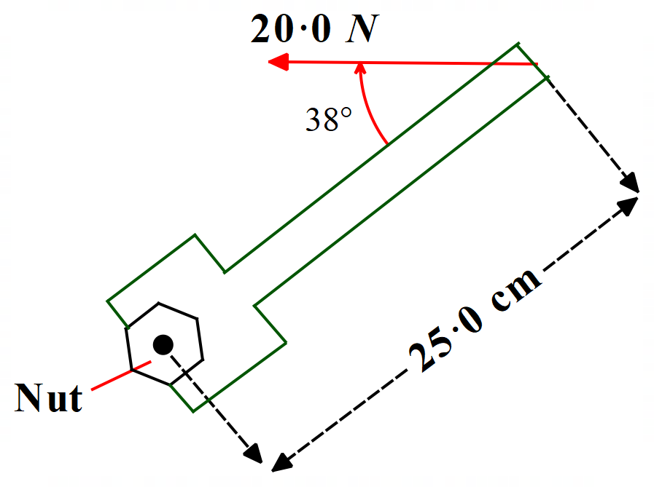
A mechanic uses the spanner above to loosen a nut. He applies a 20.0 N force at the end of the handle, at 38° with the handle as shown. The force acts through a distance of 25.0 cm to the axis of rotation (the centre of the nut).
  - Find the torque that the mechanic exerts about the centre of the nut? (3.1 Nm)
  - Calculate the maximum torque he could exert with this force? (5.0 Nm)
Solutions appear on the next page.

Solutions

- 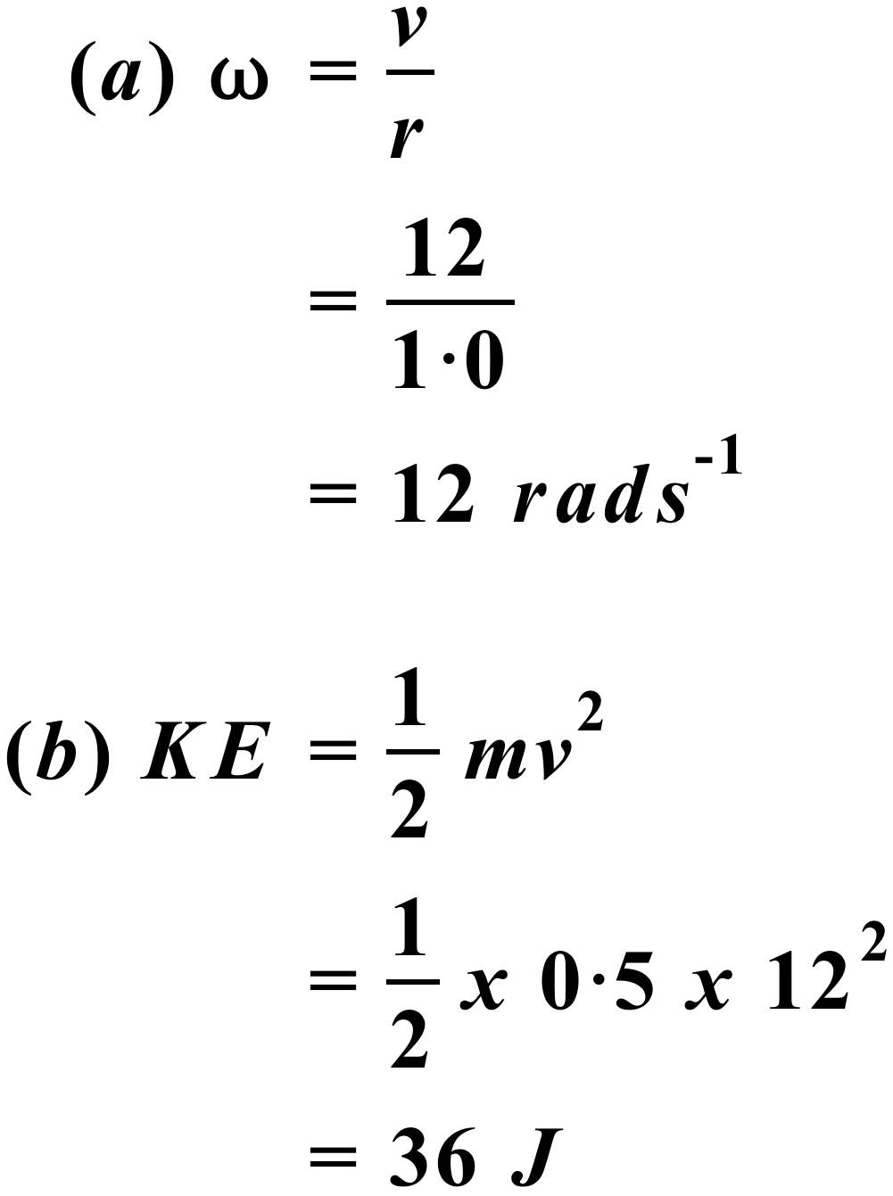
(c) In UCM, the linear velocity of the mass remains constant in magnitude. Thus,
the KE of the mass remains constant. There is no change in KE and therefore
no work done on the mass, in accordance with the Work-Energy Theorem.
- The gravitational force of the Earth on the Moon acts toward the Earth and provides the centripetal force inward along the radius of the Moon’s orbit. The centripetal force always acts toward the centre of the orbit (centre of Earth), but at each instant the linear velocity and therefore the displacement of the Moon is at right angles to the centripetal force. The angle between the applied force and the displacement is 90°. As W = Fscosθ, and cos 90° = 0, the work done by Earth’s gravity on the Moon is zero. (This is why the Moon, as well as artificial satellites, can stay in orbit without expenditure of fuel. No work needs to be done against the force of gravity.)
- 
 