**DYNAMICS WORKSHEET 3 – FORCES**

Solutions to these problems are available on the Dynamics page of the website.

1. 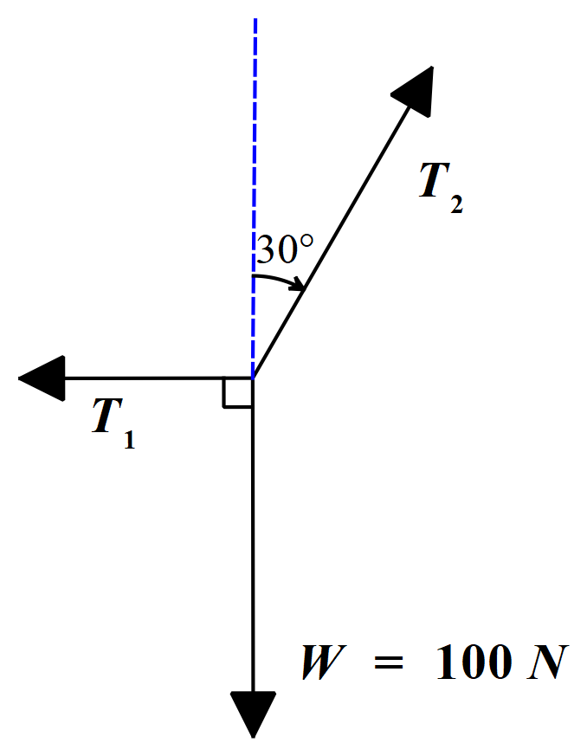A weight of 100 N is supported in equilibrium by two ropes, as shown in the free body diagram below.  
     
     
     
     
     
     
     
     
     
     
     
     
     
     
     
     
     
     
     
     
   One of the ropes pulls in a horizontal direction and the other in a direction of 30° with the vertical. Calculate the tension in each rope. (T1 = 57.7 N, T2 = 115 N)
2. 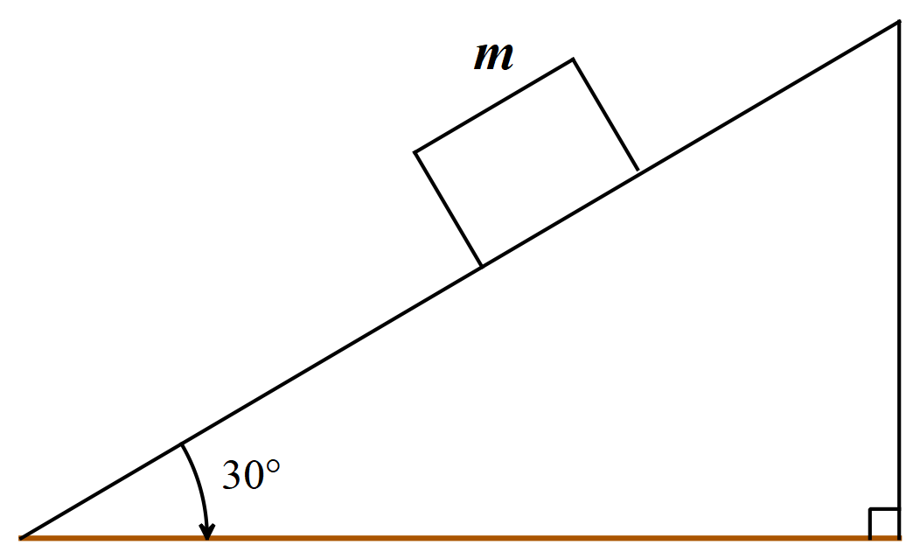In the diagram below a block of mass m is sliding down a 30° incline. The coefficient of sliding friction is 0.20. Take g = 9.8 ms-2. Find the acceleration of the block down the incline. (3.2 ms-2)
3. Assuming the acceleration due to gravity is 9.8 ms-2, determine the force that a 90 kg woman exerts on the floor of an elevator when it:
   1. Is at rest
   2. Rises with constant velocity 1.5 m/s
   3. Descends with constant velocity 1.5 m/s
   4. Rises with constant acceleration 1.5 ms-2
   5. 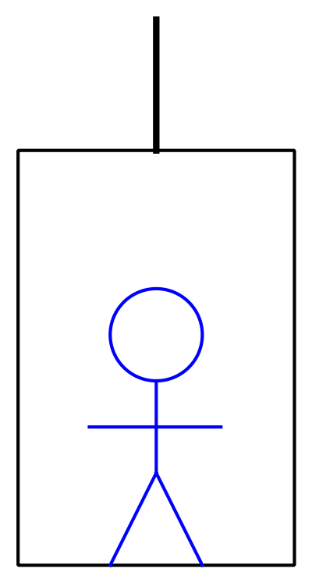Descends with constant acceleration 1.5 ms-2  
        
        
        
        
        
        
        
        
        
        
        
        
        
        
        
      Answers: (a), (b) & (c) are all 882 N; (d) 1017 N; (e) 747 N
4. 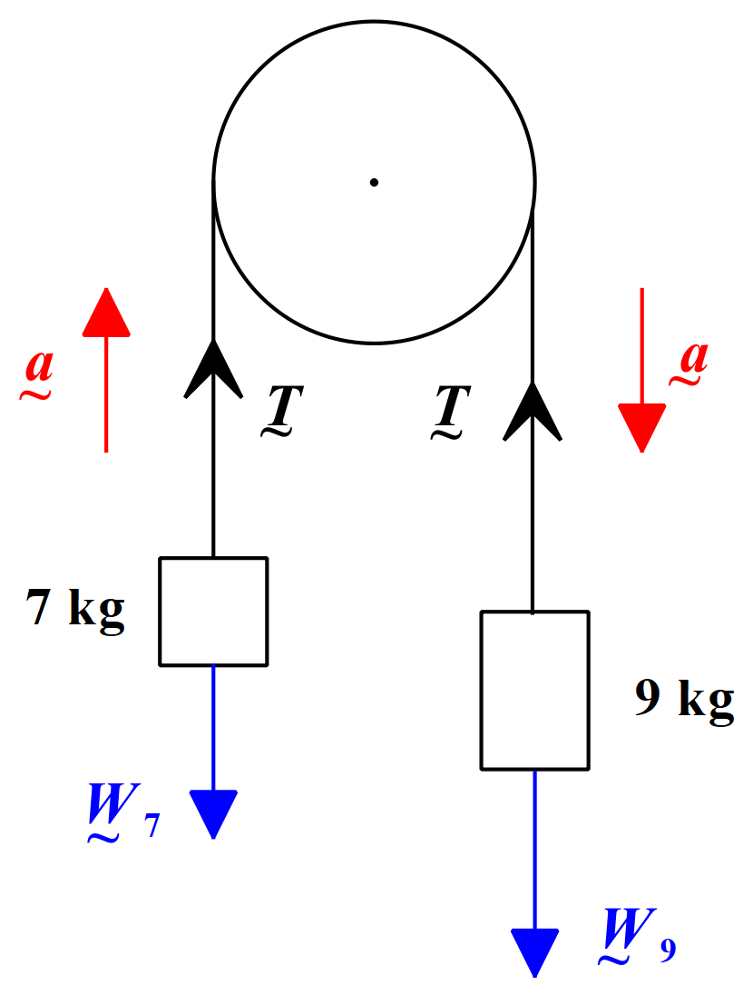A cord passing over a pulley has a 7 kg mass tied to one end and a 9 kg mass on the other. Determine the acceleration of the masses and the tension in the cord. Neglect friction and the mass of the cord. Take g = 9.8 ms-2. (a = 1.23 ms-2, T = 77.2 N)
5. 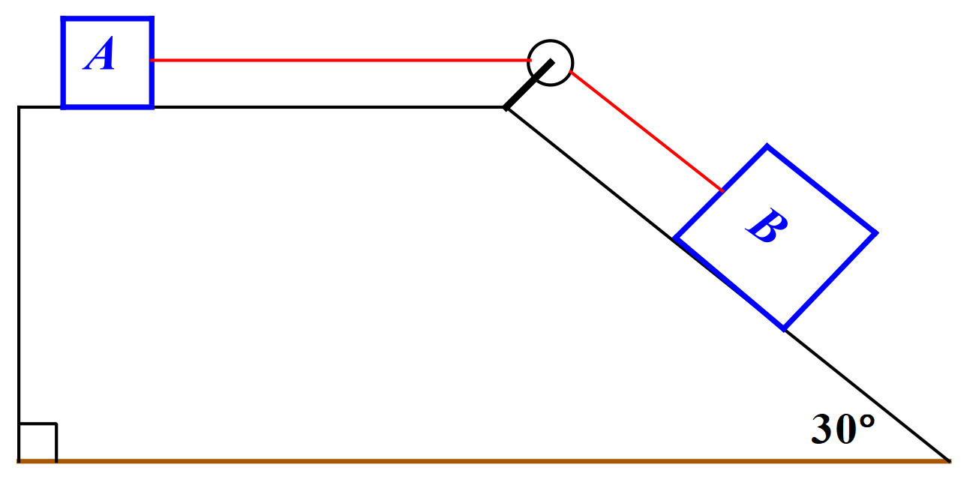  
     
     
     
     
     
     
     
     
     
     
     
     
     
     
   In the diagram above, block A has a mass of 20 kg and block B has a mass of 30 kg. The two blocks are joined by a thin, inextensible, cord. The cord passes through a pulley as shown. When released, the system of masses accelerates. The coefficient of friction for the surface is 0.2. Assume that the acceleration due to gravity is 9.8 ms-2 and that the mass of the cord is negligible. Find the acceleration of the system and the tension in the cord.  
   (1.14 ms-2, 62 N)

If you have difficulty with questions 3, 4 or 5, it may help to read the “Tensions in Strings” extension topic notes available on the Dynamics page of the website.