Extension Problem – Kirchhoff’s Laws

The power of Kirchhoff’s Laws is not really evident in the simple circuit analysis done in the Stage 6 syllabus. Have a look at the problem that follows. I emphasize that this is not necessary for the HSC but if you are interested and a keen mathematician, have a go. I will do an example and then set you another question to have a go at yourself. These are questions at first year Uni standard.

Examine the following circuit.

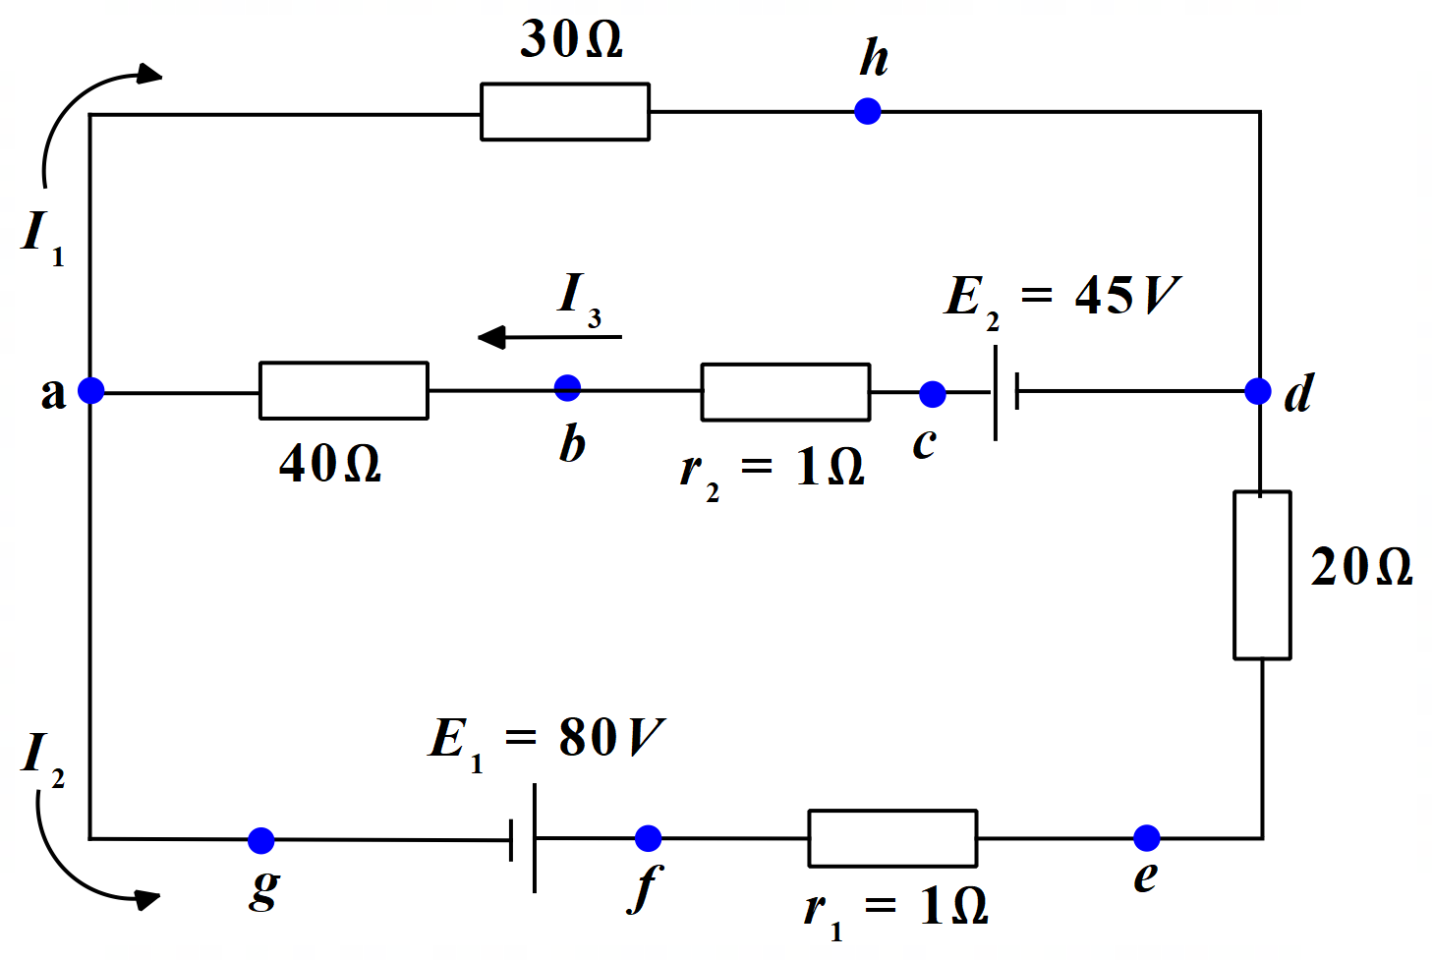

There are two sources of emf in this circuit, E₁ & E₂. Their internal resistances are shown as r₁ & r₂ respectively. Find the values of the currents I₁, I₂ & I₃ in the three branches of the circuit.

To solve this problem we follow the standard rules for using Kirchhoff’s Laws as follows.

- Label the currents in each separate branch. In this question, this has already been done for us. Note that the direction of the currents can be chosen arbitrarily. So, if you don’t know which way the current will be going, just pick a direction. If the current is really in the opposite direction, it will come out with a minus sign in the solution.
- Identify the unknowns – what is it you have to find? You need as many independent equations as you have unknowns to find. So, we need three independent equations, to enable us to find the three currents.
- Apply Kirchhoff’s Current Law (also called the junction law) at one or more junctions. This gives you one or more equations.
- Apply Kirchhoff’s Voltage Law (also called the mesh or loop law) to one or more loops of the circuit; follow each loop in one direction only. Pay careful attention to subscripts and to signs:
  - For a resistor apply Ohm’s Law. The potential difference is negative (a decrease) if your chosen loop direction is the same as the chosen current direction through that resistor. The potential difference is positive (an increase) if your chosen loop direction is opposite to the chosen current direction. (Think this through – it makes sense. Voltage drops as it forces current through a resistor in a particular direction. Going back the other way, is going in the direction of increasing voltage.)
  - For a battery, the potential difference is positive if your chosen loop direction is from the negative terminal toward the positive terminal. The potential difference is negative if the chosen loop direction is from the positive terminal toward the negative terminal. (Again this makes sense. For a circuit containing just one source of emf, voltage decreases around the circuit as you move from the positive to the negative terminal. Going the other way, is moving in the direction of increasing voltage.)
- Solve the equations. Take care with signs. When you have your solutions, check them by inserting them into the original equations.

Solution:

Let’s run through the rules.

If we had to choose the current directions, we would have chosen the directions shown for I₂ & I₃, since these are the directions you would expect conventional current to flow in these branches. However, the direction of I₁ is hard to tell. So, we would assign it an arbitrary direction. We’ll go with the one indicated for us.

We know we have to find I₁, I₂ & I₃.

We apply Kirchhoff’s Current Law at the junction labelled a. So, we have:

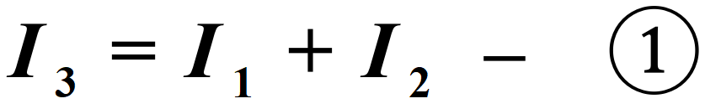

We apply Kirchhoff’s Voltage Law, firstly around the loop ahdcba. From a to h we have a potential decrease V_{ha} = - 30I₁. From h to d there is no change but from d to c the potential increases by 45V, that is V_{cd} = +45V. From c to a, the potential decreases through the two resistances by an amount V_{ac} = -41I₃. Thus, we have V_{ha} + V_{cd} + V_{ac} = 0 or:

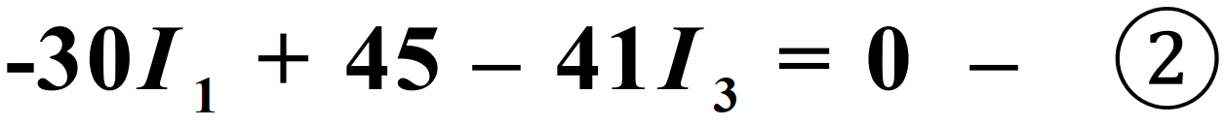

OK. We need one more independent equation. We could now apply Kirchhoff’s Voltage Law to either loop ahdefga or loop abcdefga to obtain that equation. Let’s use the former.

As before, V_{ha} = - 30I₁ and V_{dh} = 0. From d to e, we are moving in the opposite direction to the assumed current direction of I₂, so we are increasing the potential. So we have, V_{ed} = +20I₂. Likewise, V_{fe} = 1 x I2. From f to g there is a decrease in potential of 80V, since we are moving from the positive terminal of the battery to the negative terminal. So, V_{gf} =
-80V. From g to a, there is no change. So our equation is:

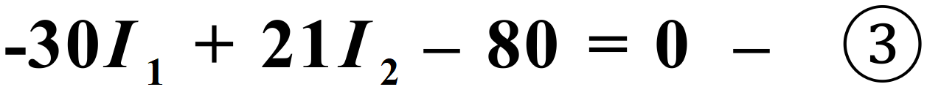

Now, we solve these three equations.

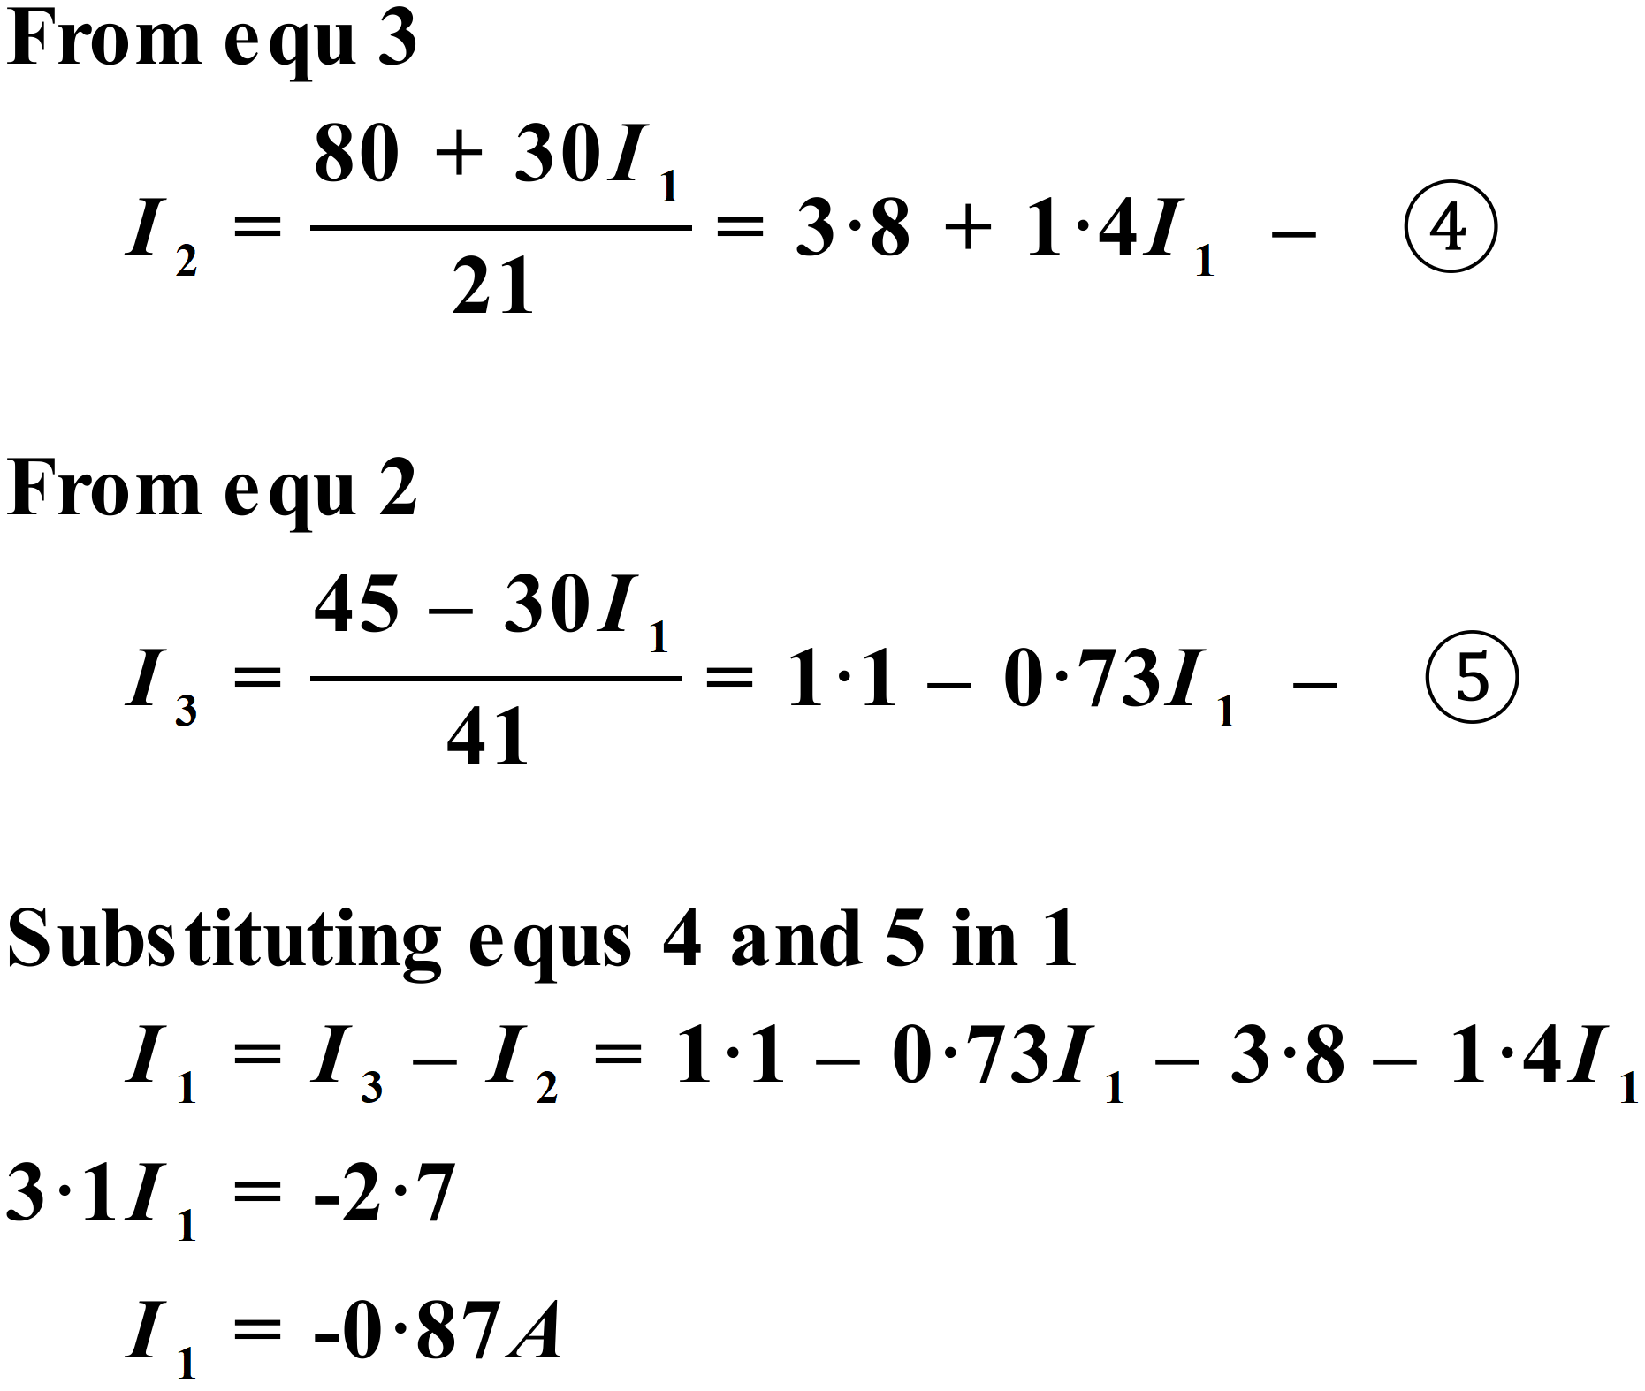

Note that the negative sign indicates that our assumed direction for I₁ was in fact incorrect. The real direction of I₁ is in the opposite direction to that shown in the circuit diagram. Using equations 4 & 5, we obtain:

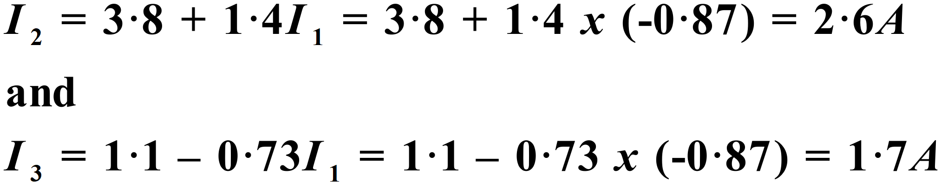

We have determined the three required currents.

Question for you to try
In the circuit below, two sources of emf are present. Assume their internal resistances are negligible. Calculate the magnitude and direction of the currents in each branch of the circuit.

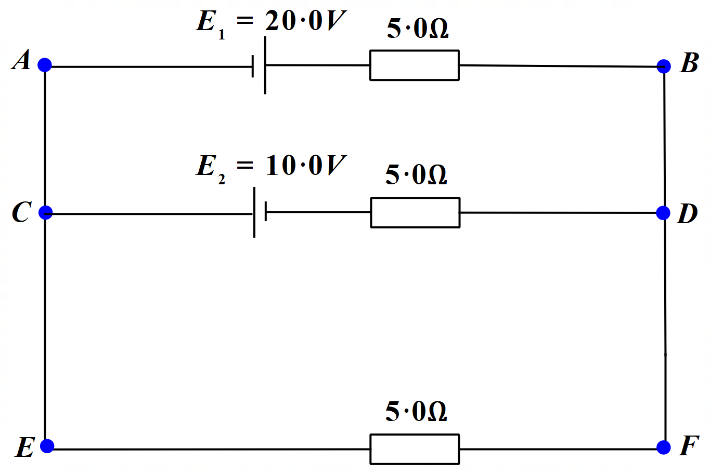
Answers:

Current in AB = 3.3A from A to B

Current in CD = 2.7A from D to C

Current in EF = 0.67A from F to E

And remember, when you check your answers by inserting them back into the equations, use the full answer not the answers corrected to two significant figures. So, use 3.333333 for the current in the top arm etc.

A solution to this question is provided on the Module 4 webpage, if you need it.

