Worksheet 3 – Module 7 – The Nature of Light

Electromagnetic Spectrum
- Describe Maxwell’s contribution to the classical theory of electromagnetism and explain the significance of his work.
- Study the diagram below.
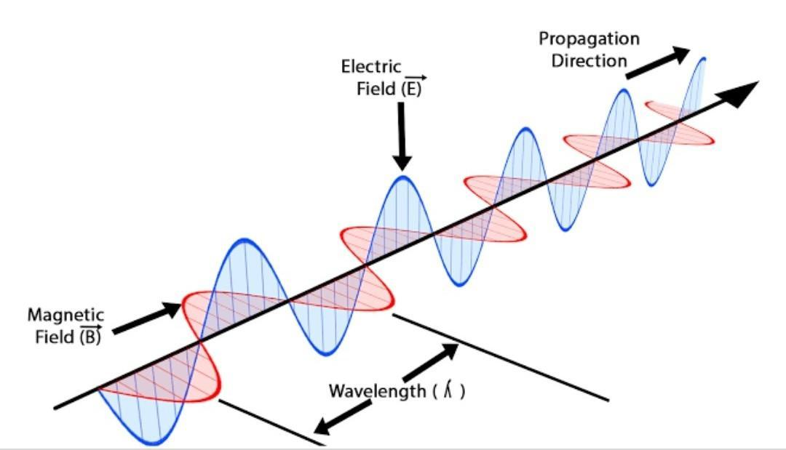
Depiction of an EM Wave – diagram taken without alteration from
https://commons.wikimedia.org/wiki/File:Electromagnetic_waves.png
Describe the production and propagation of electromagnetic waves and relate these processes qualitatively to the predictions made by Maxwell’s electromagnetic theory.
- Compare an historical and a contemporary experimental method used to determine the speed of light.
- Explain how the speed of light is used in the modern-day measurement of distance.
- Compare the spectra produced by incandescent filaments, discharge tubes and reflected sunlight.
- Explain how spectroscopy can be used to provide information about the identification of elements.

- The following table shows five physical characteristics of stars and the spectral features used to gather information about these characteristics for stars. Match the correct spectral feature with each stellar characteristic.
Stellar Characteristic | Spectral Features
Surface temperature | line strengths of each spectral line
Rotational velocity | unique patterns of spectral lines
Translational velocity | intensity versus wavelength plot for star
Number densities of the atoms | Doppler shifts of the star’s spectral lines
Chemical composition | the shapes of individual spectral lines

Answers & Solutions
- In 1864, Maxwell published his most famous paper, “A Dynamical Theory of the Electromagnetic Field”. This summed up everything that it is possible to say about classical electricity and magnetism, in a set of four equations that have become known simply as Maxwell’s equations. Every problem involving electricity and magnetism can be solved using these equations, except for certain quantum phenomena.
Two of Maxwell’s equations (Faraday’s Law & Ampère’s Law equations) explain how self-sustaining EM waves can travel through free space. Maxwell’s equations contain a constant c, which represents the speed at which the EM waves propagate. When Maxwell calculated the value of this constant, it was so close to the then known value of the speed of light that Maxwell concluded that light itself (including radiant heat and other radiations, if any) is an electromagnetic disturbance in the form of waves propagated through the electromagnetic field according to electromagnetic laws.
The significance of Maxwell’s work is that Maxwell’s equations and theory unified the two concepts of electricity and magnetism into one concept of the electromagnetic field, predicted EM waves and the velocity of these waves. His work allowed advances in this and many other areas of Physics to proceed and facilitated technological advancements, too many to count, that had many benefits to society eg electricity generation and distribution, radio, telecommunications, MRI scanners, magnetic tape, computers and many others.
- Two of Maxwell’s equations (Faraday’s Law & Ampère’s Law equations) explain how self-sustaining EM waves can travel through free space. Faraday’s law indicates that a changing magnetic field will generate an electric field and Ampère’s law with Maxwell’s addition indicates that a changing electric field or a current in a wire will generate a magnetic field.
So, if we produce an AC current in a long wire or an antenna system, it will generate a changing magnetic field around the wire or antenna. At any point in and around the wire or antenna, this changing magnetic field must by its very nature induce a changing electric field at right angles to the magnetic field. This changing electric field must generate another changing magnetic field at right angles to the electric field and so on. In this way a series of electric and magnetic oscillations at right angles to each other is set up and propagates as an EM wave in a direction at right angles to both the electric and magnetic field directions. The speed of propagation is 3 x 10⁸ m/s (approx).
The following diagram shows how a series of changing electric and magnetic fields propagate through space as an EM wave. (Diagram taken without change from Openstax – Maxwell’s Equations and Electromagnetic Waves page)
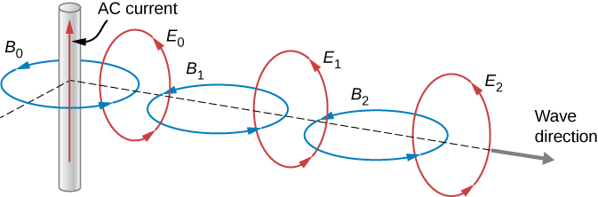
- Galileo made one of the first serious attempts at measuring the speed of light in 1638. Galileo and an assistant each climbed to the tops of hills separated by about a kilometre. Each carried a lantern covered by a cloth. Galileo had a time piece with him. Galileo uncovered his lantern and when his assistant saw the light from Galileo’s lantern, he uncovered his own lantern. Galileo attempted to time the round trip of the light. All he managed to do was to determine that the speed of light was extremely high, much faster than the speed of sound.
Albert Michelson used significantly more precise and accurate methods over many years to measure the speed of light. His first experiments were performed in 1878; by 1926, he had refined the technique so well that he found c to be (2.99796 ± 0.00004) × 10⁸ m/s. He used a rotating mirror technique that works as described below.

The image of the source can be seen by the observer through a telescope. When the mirror starts rotating the image disappears. The speed of rotation is gradually increased until the image of the source reappears at a particular angular speed, ω. At this speed the rotating mirror is moving through exactly the right angular distance, θ, so that the next face of the rotating mirror takes the place of the previous face exactly, in the time it takes light to make the round-trip distance 2L, where L is the distance between the rotating and concave mirrors. So, we have:
For an octagonal mirror, θ = π/4 radians, so we have
Clearly, Michelson’s method was much more technologically advanced and much more precise and accurate than that of Galileo. Michelson is still held in awe by scientists for his great skill and meticulous planning in obtaining extremely precise and accurate values for c. One of those measurements (1923-24) for instance involved a distance between the rotating and concave mirrors of 35 km measured to an accuracy of less than 2.5 cm.
- The SI unit of distance is the metre. The metre is defined as the length of the path travelled by light in a vacuum during a specific time interval, a very small fraction of a second. (Quote ¹⁄₂₉₉₇₉₂₄₅₈ of a second if you wish to.) This fixes the value of the speed of light at 2.99792458 x 10⁸ m/s by definition. Fixing the definition of the metre in terms of a constant like the speed of light ensures that the fundamental unit for length is derivable from an unchanging universal natural phenomenon. It remains the same over time, it is always accessible and it is easily reproducible – three essential features for any standard of measurement.
- Incandescence is the effect of dense objects emitting electromagnetic radiation due to their temperature. A hot, glowing solid or liquid, or a hot, glowing, dense gas produces a spectrum consisting of a continuous series of coloured bands ranging from violet on one end to red on the other. This is the spectrum produced by the tungsten filament in an incandescent light globe, for instance. Examples of other objects that produce continuous spectra include the inner layers of stars and galaxies.
A gas discharge tube produces an emission spectrum which is a series of bright, coloured lines on a black background, produced by a hot, glowing, diffuse gas. Only colours corresponding to particular wavelengths of light are produced. In the hydrogen emission spectrum, for example, the overall colour of the gas discharge as seen by our eyes is blue violet. However, when the discharge is examined with a spectrometer, the emission spectrum is seen to consist of 4 visible lines each of a different colour. Each element has its own specific emission spectrum.
Reflected sunlight produces an absorption spectrum, which is a series of dark spectral lines among the colours of the continuous spectrum. Absorption spectra are produced when light from a hot source of continuous spectrum passes through a cooler, non-luminous, diffuse gas. The cooler gas absorbs certain wavelengths, leaving dark spaces in their place in the spectrum. We see planets and moons in our solar system because of the sunlight reflected from them. When sunlight hits the planet or moon, some light is absorbed by the atmosphere and/or surface and the rest is reflected. Examination of the reflected sunlight provides information on the composition of the planet’s or moon’s atmosphere or surface.
- Each element has its own unique emission spectrum. This is because each element has a unique atomic structure and when excited to produce its emission spectrum, the energy transitions inside the atom produce a unique pattern of spectral lines, as electrons drop from higher (excited) energy states to their original states and emit the excess energy as EM radiation of specific frequencies (and wavelengths). Since an absorption spectrum for an element consists of dark spectral lines at exactly the same wavelengths the element would have emitted in its emission spectrum, an element’s absorption spectrum is also unique. Thus, both emission and absorption spectra, when examined using a spectrometer or similar device, provide unique patterns of spectral lines that can be used to identify the elements that have given rise to them. In this way, spectroscopy, the systematic study of spectra and spectral lines, can be used to identify elements.
- The matching pairs of stellar characteristics and spectral features are as follows:
Surface Temperature & intensity versus wavelength plot for star
Rotational velocity & the shapes of individual spectral lines
Translational velocity & Doppler shifts of the star’s spectral lines
Number densities of atoms & line strengths of each spectral line
Chemical composition & unique patterns of spectral lines

