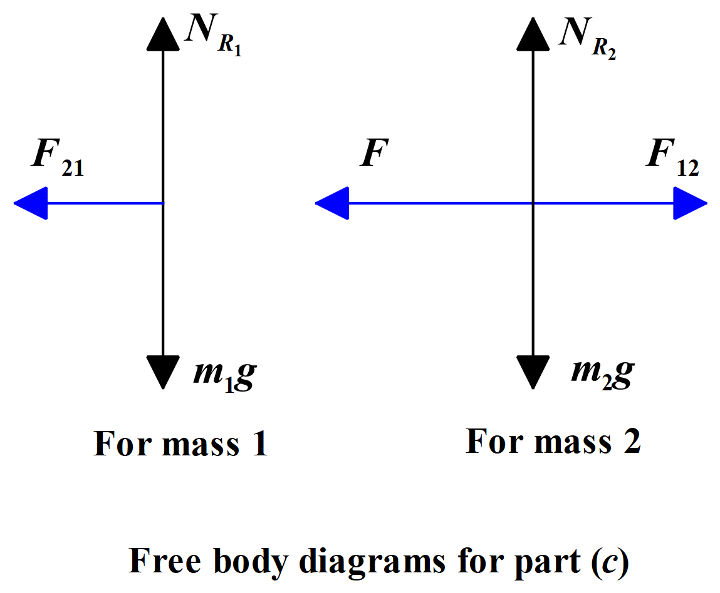BLOCK QUESTION PART (C)

Note: Since F₁₂ = F₂₁ in magnitude, we have set both equal to f
