PHYSICS COURSE – YEAR 12

MODULE 8: FROM THE UNIVERSE TO THE ATOM

Humans have always been fascinated with the finite or infinite state of the Universe and whether there ever was a beginning to time. Where does all the matter that makes up the Universe come from? Ideas and theories about the beginnings of the Universe, based on sound scientific evidence, have come and gone. Current theories such as the Big Bang theory and claims of an expanding Universe are based on scientific evidence available today through investigations that use modern technologies. Evidence gathered on the nucleosynthesis reactions in stars allows scientists to understand how elements are made in the nuclear furnace of stars. On scales as large as the Universe to those as small as an atom, humans look to the sky for answers through astronomical observations of stars and galaxies.

Beginning in the late 19th and early 20th centuries, experimental discoveries revolutionised the accepted understanding of the nature of matter on an atomic scale. Observations of the properties of matter and light inspired the development of better models of matter, which in turn have been modified or abandoned in the light of further experimental investigations.

By studying the development of the atomic models through the work of Thomson and Rutherford, who established the nuclear model of the atom – a positive nucleus surrounded by electrons – students further their understanding of the limitations of theories and models. The work of Bohr, de Broglie and, later, Schrödinger demonstrated that the quantum mechanical nature of matter was a better way to understand the structure of the atom. Experimental investigations of the nucleus have led to an understanding of radioactive decay, the ability to extract energy from nuclear fission and fusion, and a deeper understanding of the atomic model.

Particle accelerators have revealed that protons themselves are not fundamental and have continued to provide evidence in support of the Standard Model of matter. In studying this module, students can appreciate that the fundamental particle model is forever being updated and that our understanding of the nature of matter remains incomplete.

NOTE ON ORDER OF PRESENTATION OF THIS MODULE

The order in which this module is best taught, in my opinion, is to start with Structure of the Atom, then do Quantum Mechanical Nature of the Atom, then Deep Inside the Atom and finally Origins of the Elements. The reason for this is that some of the material to be studied in the Origins of the Elements section relies on the knowledge and understanding of concepts taught in the other three sections. So, although the module is called From the Universe to the Atom, it is more logical to teach it in the other way around.

STRUCTURE OF THE ATOM

Inquiry Question: How is it known that atoms are made up of protons, neutrons and electrons?

EXPERIMENTAL EVIDENCE SUPPORTING THE EXISTENCE & PROPERTIES OF THE ELECTRON

THE INVESTIGATION OF CATHODE RAYS

In 1855 the German inventor and glassblower Heinrich Geissler, invented a vacuum pump that could remove enough gas from a glass tube to reduce the pressure to 0.01% of normal air pressure at sea level. (normal air pressure at sea level = 1 atmosphere = 760 mm of Hg = 101 325 N/m²)

This provided his friend, Julius Plucker, with the apparatus to experiment with electrical current through gases at low pressure. Plucker sealed electrodes into a glass tube and then evacuated the tube to very low pressure. When Plucker applied very high voltage to the electrodes, current flowed through the tube and he noticed that the glass tube itself glowed with a pale green glow, mainly in the vicinity of the anode (positive terminal). He concluded that rays of some form were emanating from the cathode (negative electrode) and that these rays caused the glass to glow. These rays were eventually named cathode rays, as they appeared to come from the cathode (negative electrode) of the tube. Plucker also showed that the rays were deflected by an external magnetic field.

When we repeat Plucker’s investigations in the laboratory, we find that if the air pressure in the tube is reduced to a few centimetres of mercury, then electrical discharge occurs. Flickering red streamers are observed. If the pressure is further reduced the discharge beams become steady and a pink glow fills the tube. On further reducing the pressure, the anode glows, Faraday’s dark spaces are observed and the glow becomes striated.

The following diagram shows a cathode ray tube with the various glows and dark spaces labeled. The voltage applied between the cathode and anode is a high voltage and is usually supplied by an induction coil. The diagram is not to scale.

By 1875, William Crookes had designed new tubes for studying the glow produced when an electric current passes through an evacuated tube. When he used a bent tube, the most intense green glow appeared on the part of the tube opposite the cathode. This suggested that the green glow was caused by something that came out of the cathode and then travelled down the tube until it hit the glass. Eugen Goldstein suggested the name cathode rays.

Crookes also did other ingenious experiments with gas tubes. He placed a metallic Maltese cross in the path of the rays from the cathode. This produced a sharp shadow of the cross on the glass at the end of the tube. Crookes concluded that cathode rays travelled in straight lines and could not penetrate metal. See diagram below.

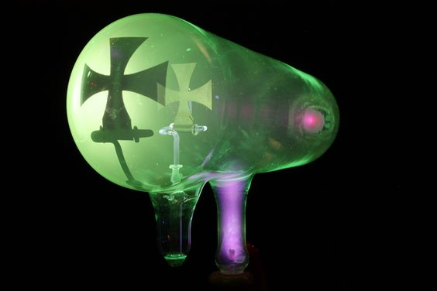
Diagram from isites.harvard.edu

Crookes also used a magnet near the tube to produce a horizontal magnetic field for the rays to pass through – see below. The path of the rays was made visible by placing a fluorescent screen lengthways down the tube and arranging a small aperture near the cathode to collimate the rays into a thin beam. He observed that the rays were deflected by the magnetic field as if they were negatively charged particles.

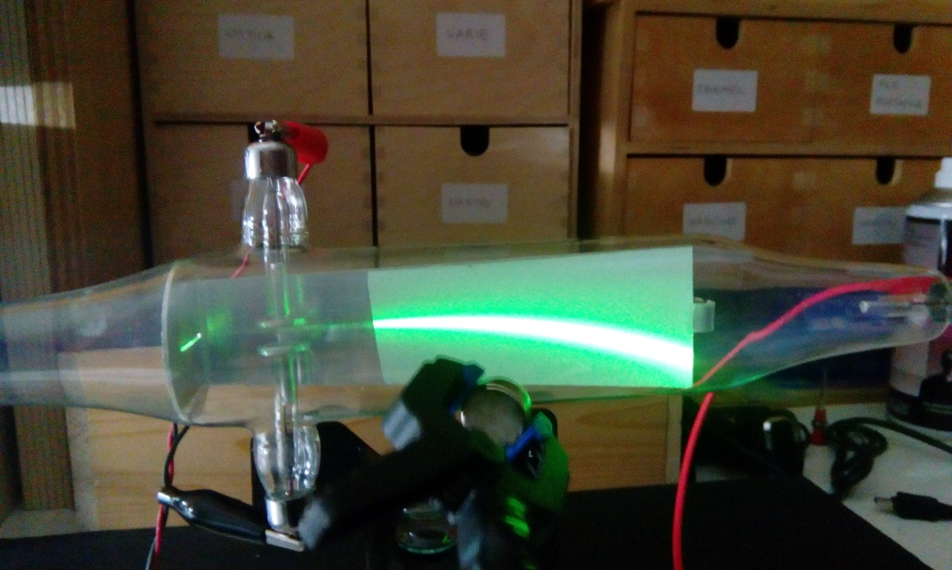

Photo is from PhysicsOpenLab - https://physicsopenlab.org/2017/04/18/cathode-ray-tube-experiments/

Using a tube containing a paddle wheel supported by glass rails, Crookes showed that the cathode rays possessed energy and momentum. The rays striking the paddle wheel moved it along the rails. See below.

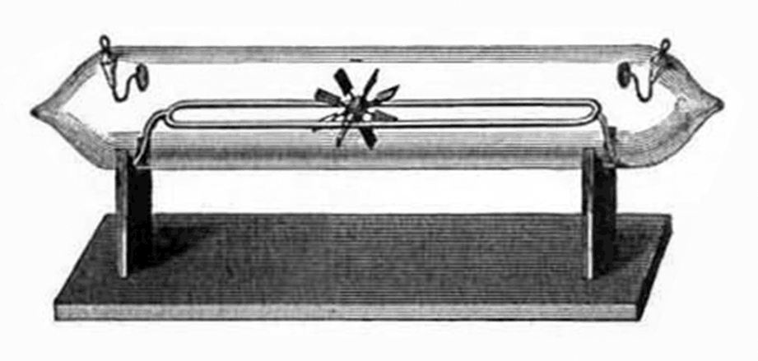
Diagram is from: https://commons.wikimedia.org/wiki/File:Crookes_paddlewheel_tube.png

These and many other experiments led Crookes to conclude that cathode rays:

- were always the same regardless of which metal was used as the cathode;
- always travelled in straight lines perpendicular to the surface emitting them;
- are deflected by a magnetic field as if they were negatively charged particles.
- cause glass to fluoresce;
- carry energy and momentum; and
- produce some chemical reactions similar to the reactions produced by light – some silver salts change colour when struck by cathode rays.

Note that Crookes also believed that cathode rays could be deflected by an electric field but never succeeded in demonstrating this experimentally.

Some of the properties above suggested to Physicists that cathode rays were a wave similar to light. For instance, they produced fluorescence, they travelled in straight lines, they produced similar chemical reactions to those produced by light and they were not deflected by electric fields. Yet cathode rays were deflected by a magnetic field as if they were negatively charged particles. This apparently inconsistent behaviour of cathode rays led to much controversy over whether the rays were a stream of negatively charged particles or a form of EM wave like light.

By the end of the 19th Century, the argument in favour of cathode rays being charged particles had become much stronger. By then, it had been shown by Eugen Goldstein that the rays could be deflected by electric fields and by Jean Perrin that the charge on the rays was negative. The final piece of evidence was provided by Joseph John Thomson in a brilliant experiment conducted in 1897.

THOMSON’S MEASUREMENT OF CHARGE TO MASS RATIO OF CATHODE RAYS

J.J Thomson subjected beams of cathode rays to deflection by known electric and magnetic fields set at right angles to each other (crossed fields) in order to measure the charge to mass ratio of the cathode rays. The experimental set up was as shown below:

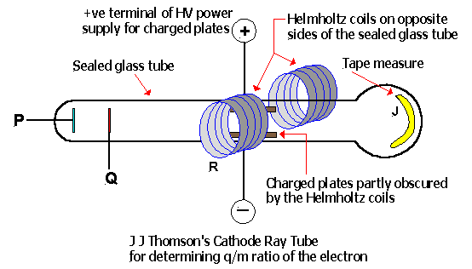

The tube above contained a cold cathode, P, that produced cathode rays by using a strong electric field in the vicinity of the cathode to cause gas discharge. The cathode rays so formed were accelerated towards the anode, Q, by the potential difference between the anode and cathode. At the anode, some of the cathode rays were collimated into a thin beam by passing through a slit and then travelled with constant velocity to produce a bright spot on the phosphorescent screen at the far end of the tube. An electric field could be applied between the metallic plates and a magnetic field at right angles to the electric field was produced by two Helmholtz induction coils sitting on either side of the tube.

The experimental procedure was to set E and B to zero and note the position on the screen where the undeflected beam of cathode rays struck. Then a known magnetic field was applied and the position of the deflected beam noted. Finally, an electric field E (=V/d) was applied and its value adjusted until the deflection of the beam returned to zero.

Mathematically,

for the particles curving in the B field: mv²/R = qvB

which can be re-arranged to give: q/m = v/BR (equation 1).

Note that q/m, the charge to mass ratio of the cathode rays, is the value we are after.
The value of B was known from the arrangement of the Helmholtz coils. R, the radius of curvature of the particles in the magnetic field, was found geometrically from the displacement of the beam spot on the screen. To determine v, the velocity of the particles, Thomson applied the E and B fields simultaneously and adjusted the E field value until the deflection of the beam returned to zero. This meant that the magnetic force (qvB) on the particles was exactly balanced by the electric force (qE) on the particles:

qE = qvB

So we have that: v = E/B (equation 2)

The value of E was known from the arrangements of the charged plates (E = V/d, where V = voltage between plates & d = distance between plates).

So combining equations 1 & 2 we have:

and all of the quantities on the RHS are known. Thomson determined q/m for cathode rays as 1.76 x 10¹¹ C/kg regardless of the material used for the cathode. This determination effectively confirmed the particulate nature of cathode rays.

In other experiments, Thomson showed that the charge on the cathode ray particles was the same size as the charge on the hydrogen ion. This combined with the fact that the q/m ratio for cathode rays was 1800 times larger than that for the hydrogen ion (determined in electrolysis experiments) meant that the mass of the cathode ray particles had to be 1800 times smaller than that of the hydrogen ion. On the basis of all these results, Thomson suggested that the cathode ray particle was a fundamental constituent of the atom. Although he originally referred to the particles as “corpuscles”, the name “electron” slowly became accepted as the official name.

(As an aside, it is an interesting historical point that Sir Joseph John Thomson was awarded the 1906 Nobel Prize in Physics for proving that the electron is a particle and his son, Sir George Paget Thomson was awarded the 1937 Nobel Prize for Physics for showing that the electron is a wave.)

MILLIKAN’S OIL DROP EXPERIMENT

J J Thomson had successfully measured the charge to mass ratio of the electron. The next important thing to investigate was the magnitude of the negative charge, e, on the electron. Robert A Millikan, an American physicist, performed a series of brilliant experiments in 1909 that successfully achieved this goal.

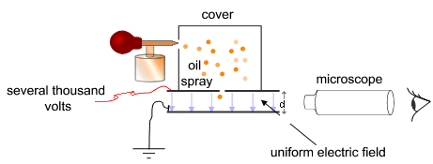

Simplified diagram of Millikan’s experimental apparatus – from Wikimedia Commons

Millikan sprayed a fine mist of oil droplets into a chamber above a set of charged parallel plates. Some drops passed through an aperture into the area between the charged plates. These oil drops were exposed briefly to X-rays and became negatively charged. The charged drops fell under gravity.

The terminal velocity of the oil drops due to gravity alone was measured. This enabled Millikan to determine the radius of the drops using the equation of motion of the drops from Fluid Mechanics. By using an oil with a known density, he was able to determine the mass of the oil drops using the equation for density (D = M/V).

The electric field, E, between the plates was then turned on and the size of E was adjusted until the drops, viewed through a microscope, were suspended in mid-air. At this point, the force of gravity downward on the oil drop is equal to the electrostatic force upward on the drop. (It’s an interesting experiment to perform for yourself. The microscope inverts the image, so you are observing the drop appear to fall upwards due to gravity.)

So, if the oil drop acquires a charge q, then we have:

Thus, Millikan was able to determine the charge on an oil drop. By repeating the experiment many, many times, Millikan found that the charge on each droplet was a small whole number multiple of 1.60 x 10⁻¹⁹ C. No charge less than 1.60 x 10⁻¹⁹ C was ever observed. Millikan interpreted these results to mean that the smallest charge that could be found in nature was 1.60 x 10⁻¹⁹ C and this was described to be the charge on the electron.

Now that the charge on an electron was known, the mass of the electron could be determined from the value of the charge to mass ratio. This was found to be 9.11 x 10⁻³¹ kg.

The Plum Pudding Model of the Atom

From these discoveries, J J Thomson proposed a model of the atom that became known as the Plum Pudding Model. Thomson suggested that the atom consisted of a sphere of positive fluid with negative electrons symmetrically embedded in the fluid, like plums in a pudding.

EXPERIMENTAL EVIDENCE SUPPORTING THE NUCLEAR MODEL OF THE ATOM

THE GEIGER-MARSDEN EXPERIMENT

In 1910 the New Zealand born physicist Ernest Rutherford, working in England, instructed two of his students, Hans Geiger and Ernest Marsden, to investigate alpha particle scattering from thin metal foils. What they discovered greatly enhanced our understanding of the atom.

We know today that alpha particles are doubly charged helium nuclei and have a mass about 7500 times that of the electron and a velocity in this scattering experiment of about 1.6 x 10⁷ m/s. The existing model of the atom at that time (Thomson’s “Plum Pudding Model”) predicted that almost all of the alpha particles fired at a metal target would simply pass straight through the metal undeflected. To their great surprise, Geiger & Marsden found that a significant number of alpha particles were deflected by angles greater than 90º. That is, the alpha particles were being reflected by the metal foil. Some even came back almost retracing their original path. See the diagram of the Geiger-Marsden experimental setup below.

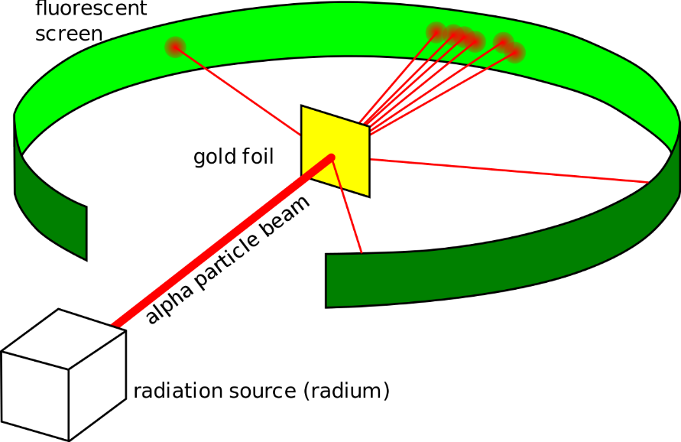

Diagram from: Kurzon - Own work, CC BY-SA 3.0,
https://commons.wikimedia.org/w/index.php?curid=32190781

RUTHERFORD’S ATOMIC MODEL

In 1911, Rutherford proposed his model of the atom, based on the results of many scattering experiments similar to the Geiger-Marsden experiment. Rutherford proposed that the atom consisted mainly of empty space with a tiny, positively charged nucleus, containing most of the mass of the atom, surrounded by negative electrons in orbit around the nucleus like planets orbiting the sun. The electrons could not be stationary because if this were the case they would be attracted towards the positive nucleus and be neutralized. The Coulomb force of attraction between the positive nucleus and the negative electrons provided the necessary centripetal force to keep the electrons in orbit. The Rutherford model was a great step forward in our understanding of atomic structure.

MAJOR COMPONENTS OF THE NUCLEUS

The quest to discover the nature of the nucleus has occupied generations of physicists since Rutherford discovered its existence in 1911. Rutherford determined from his scattering experiments that the nucleus was of the order of 10⁻¹⁴ m in diameter. This turned out to be about 1/10 000 of the diameter of the atom, determined by Max von Laue in 1912 using X-ray diffraction to be 10⁻¹⁰ m. Rutherford showed that the nucleus contained all of the positive charge of the atom and most of the atom’s mass. Henry Moseley, a graduate student working with Rutherford, found a direct correlation between an element’s position in the Periodic Table and its nuclear charge and also discovered that the total charge on a nucleus was equal to the total charge of the orbiting electrons in a neutral atom. By 1914 scientists accepted that a hydrogen ion (a hydrogen atom which has lost its electron) consisted of a singly charged particle. Rutherford named this the proton.

THE PROTON-ELECTRON MODEL OF THE NUCLEUS

A possible structure for the nucleus was then suggested by Rutherford. It was known in 1914 that an atom such as fluorine (atomic number 9) for example, had a mass equivalent to 19 protons but a charge of only 9 protons. So Rutherford suggested that the nucleus contained protons and electrons to balance the charge discrepancy. A fluorine nucleus would therefore contain 19 protons and 10 electrons – a total charge of 9 protons and total mass of 19 protons (electron mass being negligible compared to the proton mass).

This model was called the Proton-Electron Model. In general, a nucleus contained A protons and (A – Z) electrons, where A is called the mass number and Z the atomic number of the nucleus. This model could explain how α particles & β particles (electrons) could be emitted from some radioactive nuclei but problems arose:

- Energies of emitted β-particles could not be accurately predicted.
- Quantum number anomalies arose with the spin of electrons and protons within the nucleus.
- Heisenberg’s Uncertainty Principle suggested that electrons could not be confined within the nucleus.

Hence, the model was abandoned.

CHADWICK’S DISCOVERY OF THE NEUTRON

In a lecture in 1920, Rutherford suggested that a proton and an electron within the nucleus might combine together to produce a neutral particle. He named this particle the neutron. Experimental difficulties associated with the detection of a neutral particle greatly hindered the research. In 12 years of searching, no such particle was found.

In 1930, two German physicists, Bothe & Becker, bombarded the elements boron (B) and beryllium (Be) with α−particles. These elements, especially the Be, emitted a very penetrating form of radiation that was much more energetic than gamma rays (very high energy EM radiation).

Frederic & Irene Joliot (Irene was the daughter of Marie Curie) found in 1932 that although this radiation could pass through thick sheets of lead, it was stopped by water or paraffin wax. They found that large numbers of very energetic (5 MeV) protons were emitted from the paraffin when it absorbed the radiation. The Joliots assumed that the radiation must be an extremely energetic form of gamma radiation. In the same year, however, the English physicist, James Chadwick showed theoretically that gamma rays produced by α−bombardment of Be would not have sufficient energy to knock protons out of paraffin, and that momentum could not be conserved in such a collision between a gamma ray and a proton. So, it was unlikely that the unknown radiation was gamma rays.

Chadwick repeated the Joliot’s experiments many times. He measured the energy of the radiation emitted by the Be and the energies (and therefore the velocities) of the protons coming from the paraffin. On the basis of its great penetrating power, Chadwick proposed that the radiation emitted from the Be was a new type of neutral particle – the neutron, as originally proposed by Rutherford. He then applied the conservation of energy and momentum laws to his experimental results and showed that the particles emitted from the Be had to be neutral particles with about the same mass as the proton. Chadwick had indeed discovered the neutron.

Chadwick explained the process occurring in the experiment as:

Chadwick explained that when the neutrons emitted from the Be collided with the light hydrogen nuclei in the paraffin, the neutron came to a sudden stop and the hydrogen nucleus (proton) moved off with the same momentum as the neutron had before the collision.

THE PROTON-NEUTRON MODEL OF THE NUCLEUS

Following Chadwick’s discovery of the neutron, a new model of the nucleus was proposed. This model suggests that the nucleus consists of protons and neutrons. Together these particles are called the nucleons – particles that make up the nucleus. Protons and neutrons have approximately the same mass, which is about 1800 times that of the electron. Protons are positively charged and neutrons are neutral.

The number of protons in the nucleus is called the atomic number of the nucleus and corresponds to the position of the nucleus in the Periodic Table of Elements. The total number of protons and neutrons in the nucleus is called the mass number of the nucleus. Each nucleus can be represented by using nuclide notation. A nuclide is a nucleus written in the form:

where X = element symbol (eg Na, Co, U), Z = atomic number and A = mass number. Clearly, A = N + Z, where N = number of neutrons in nucleus. An alternate notation is to write the nucleus with its mass number after it – eg U-235 for uranium with a mass number of 235.

Isotopes of an element are atoms of that element varying in the number of neutrons present in their nuclei. Clearly, isotopes of the same element have the same atomic number but different mass numbers (and therefore slightly different masses). So, U-234, U-235 and U-238 are all isotopes of uranium – they all have 92 protons but differ in mass number.

The proton-neutron model of the nucleus is still the basic model used today. Many more nuclear particles have been found, however, and we will examine some of these a little later. For now, we turn our attention to the quantum mechanical nature of the atom.

QUANTUM MECHANICAL NATURE OF THE ATOM

Inquiry Question: How is it known that classical physics cannot explain the properties of the atom?

LIMITATIONS OF THE RUTHERFORD ATOMIC MODEL

The Rutherford model was a great step forward in our understanding of atomic structure but it still had its limitations. Since the electrons were in circular motion, they would be experiencing centripetal acceleration and according to Maxwell’s Theory of Electromagnetism should be emitting electromagnetic radiation. This loss of energy would cause the electrons to gradually spiral closer and closer to the nucleus and to eventually crash into the nucleus. Thus, matter would be very unstable. This was clearly not the case. Also, Rutherford’s model could not explain the observed line spectra of elements. As electrons spiraled towards the nucleus with increasing speed, they should emit all frequencies of radiation not just one. Thus, the observed spectrum of the element should be a continuous spectrum not a line spectrum.

THE BOHR MODEL OF THE ATOM

Niels Bohr went to work with Rutherford in 1912. During the next two years he studied the Rutherford model of the atom. Bohr was inspired by the work of Max Planck on quantized energy and attempted to incorporate this idea into the atomic model to explain the discrepancies between the observed spectra of the elements and the spectra predicted on the basis of Rutherford’s atomic model.

As we saw in “The Nature of Light” topic, in 1900 Max Planck investigated the relationship between the intensity and frequency of the radiation emitted by very hot objects. Planck showed that the radiation from a hot body was emitted only in discrete quantities or “packets” called quanta. The energy, E, of each quantum was shown to be proportional to the frequency, f, of the radiation emitted.

E = h f

where h = Planck’s constant = 6.63 x 10⁻³⁴ Js. This idea led directly to the belief that atoms could only absorb or emit energy in discrete quanta. Albert Einstein’s use of Planck’s quantization idea to successfully explain the photoelectric effect added great support to this belief. So, Bohr was convinced that a successful atomic model had to incorporate this energy quantization phenomenon.

Bohr’s thinking on a new atomic model was also guided by the work that had been done on the spectrum of hydrogen. Let us briefly review what is meant by the term spectrum and secondly the understanding of elemental spectra that existed at the time of Bohr’s work on the atom.

SPECTRA

When an element such as hydrogen is heated to incandescence, or when it is ionized in a gas discharge tube, it emits visible light and other radiation that can be broken into its component parts using a spectroscope and a glass prism or a diffraction grating. The particular radiation emitted is known as the emission spectrum of that element and is unique to that element. When the emission spectrum of hydrogen is examined using a spectroscope, it is found to consist of four lines of visible light – a red line, a green line, a blue line and a violet line on a dark background. It can be shown that all elements produce emission line spectra rather than the continuous spectra predicted by the Rutherford model of the atom.

Another type of elemental spectrum is produced by passing white light through the cool gas of an element. The cool gas will absorb the same frequencies that it would otherwise emit if heated to incandescence. This spectrum is called the absorption spectrum of an element and consists of a continuous band of colours (different frequencies) with black lines present where particular frequencies have been absorbed by the cool gas. This spectrum is also unique to each element and is used to provide information on the elemental composition of stars.

The study of emission and absorption spectra of different elements provided much information towards the understanding of atomic structure. From 1884 to 1886 Johann Balmer, a Swiss schoolteacher, suggested a mathematical formula to fit the known wavelengths of the hydrogen emission spectrum:

where m is an integer with a different value for each line (m = 3, 4, 5, 6) & b is a constant with a value of 364.56 nm. This formula produces wavelength values for the hydrogen emission spectral lines in excellent agreement with measured values. This series of lines has become known as the Balmer series. Balmer predicted that there should be other series of hydrogen spectral lines and that their wavelengths could be found by substituting values higher than the 2 shown on the right-hand side of the denominator in his formula.

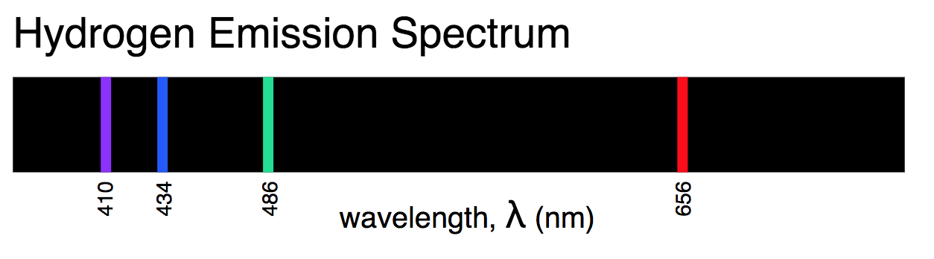
Spectrogram of visible lines in the Balmer series of hydrogen as obtained with a constant-deviation spectrograph – Diagram from Wikimedia Commons

In 1890, Johannes Rydberg produced a generalized form of Balmer’s formula for all wavelengths emitted from excited hydrogen gas:

where R = Rydberg’s constant = 1.097 x 10⁷ m⁻¹, n_{f} = an integer specific to a spectral series (eg for the Balmer series n_{f} = 2) and n_{i} = 2, 3, 4, ……

Gradually, other series of hydrogen emission lines besides the Balmer were found. The following table gives the details.

Name of Series | Date of Discovery | Region of EM Spectrum | Value of n_{f} | Value of n_{i}
Lyman | 1906-1914 | UV | 1 | 2, 3, 4, …..
Balmer | 1885 | UV/Visible | 2 | 3, 4, 5, …..
Paschen | 1908 | IR | 3 | 4, 5, 6, …..
Brackett | 1922 | IR | 4 | 5, 6, 7, …..
Pfund | 1924 | IR | 5 | 6, 7, 8, …..

Although Rydberg’s equation was very accurate in its predictions of the wavelengths of hydrogen emission lines, for a long time no-one could explain why it worked – that is, the physical significance behind the equation. Bohr was the first to do so.

In 1913, Niels Bohr proposed his model of the atom. He postulated that:

- An electron executes circular motion around the nucleus under the influence of the Coulomb attraction between the electron and nucleus and in accordance with the laws of classical physics.
- The electron can occupy only certain allowed orbits or stationary states for which the orbital angular momentum, L, of the electron is an integral multiple of Planck’s constant divided by 2π. Mathematically, that is: L = n h / 2π where n = the Principal Quantum Number, the number of the Bohr orbit (stationary state).
(So, the Bohr orbit closest to the nucleus is n = 1, the next is n = 2 and so on; n = ∞ represents a free electron outside the atom. The n = 1 orbit is usually called the ground state of the atom, as it is the state of lowest energy. The n = 1 orbit is also known by the name “the Bohr radius”.)
- An electron in a stationary state does not radiate electromagnetic energy.
- Energy is emitted or absorbed by an atom when an electron moves from one stationary state to another. The difference in energy between the initial and final states is equal to the energy of the emitted or absorbed photon, as a consequence of the law of conservation of energy and is quantised according to the Planck relationship as shown below:
ΔE = E_{f} – E_{i} = hf and ΔE = hc/λ (since c = f λ)

The first postulate retains the basic structure that successfully explains the results of the Rutherford alpha particle scattering experiments.

The second postulate was necessary to explain the observed atomic emission spectra of hydrogen. Only the separation of allowed orbits according to the second postulate gave the experimentally observed spectra. Clearly, Bohr’s study of the hydrogen spectrum was instrumental in the development of his model of the atom.

Clearly, the third postulate accounts for the observed stability of atoms. Bohr did not know why the stationary states existed; he simply assumed that they must because of the observed stability of matter.

The fourth postulate explains how atoms emit and absorb specific frequencies of electromagnetic radiation. An electron in its lowest energy state (called the ground state) can only jump to a higher energy state within the atom when it is given exactly the right amount of energy to do so by absorbing that energy from a photon of EM radiation of the right energy. Once the electron has jumped to the higher level, it will remain there only briefly. As it returns to its original lower energy level, it emits the energy that it originally absorbed in the form of a photon of EM radiation. This is a consequence of the law of conservation of energy. The frequency of the energy emitted will have a particular value and will therefore be measured as a single emission line of particular frequency and therefore of particular colour if in the visible region of the EM spectrum.

Starting with these four postulates and using a mixture of classical and quantum physics, Bohr derived equations for: (i) the velocity of an electron in a particular stationary state; (ii) the energy of an electron in a particular stationary state; (iii) the energy difference between any two stationary states; (iv) the ionisation energy of hydrogen; (v) the radii of the various stationary states; (vi) the Rydberg constant; and (vii) the Rydberg equation for the wavelengths of hydrogen emission spectral lines.

In successfully deriving the Rydberg equation from his basic postulates, Bohr had developed a mathematical model of the atom that successfully explained the observed emission spectrum of hydrogen and provided a physical basis for the accuracy of the Rydberg equation. The physical meaning of the Rydberg equation was at last revealed. The n_{f} and n_{i} in the equation represented the final and initial stationary states respectively of the electron within the atom. The hydrogen emission spectrum consists only of particular wavelengths of radiation because the stationary states or energy levels within every hydrogen atom are separated by particular set distances, as described by the second postulate. The value of the Rydberg constant calculated by Bohr was in excellent agreement with the experimentally measured value.

Bohr’s atomic model led to some useful ways of representing the quantum jumps of electrons involved in each of the different series of the hydrogen emission spectrum.

One type of diagram represents the stationary states as circular orbits around the nucleus and depicts transitions of electrons from an initial to a final state. The example given below produces the first line in the Balmer Series, H_{α}, n_{i} = 3 to n_{f} = 2.

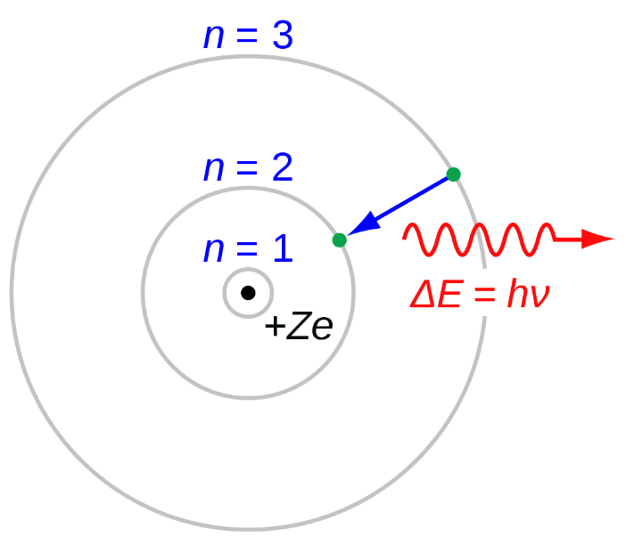

Diagram From: JabberWok, CC BY-SA 3.0,
https://commons.wikimedia.org/w/index.php?curid=2639910

Another example depicts the transitions involved in each of the different hydrogen emission series.

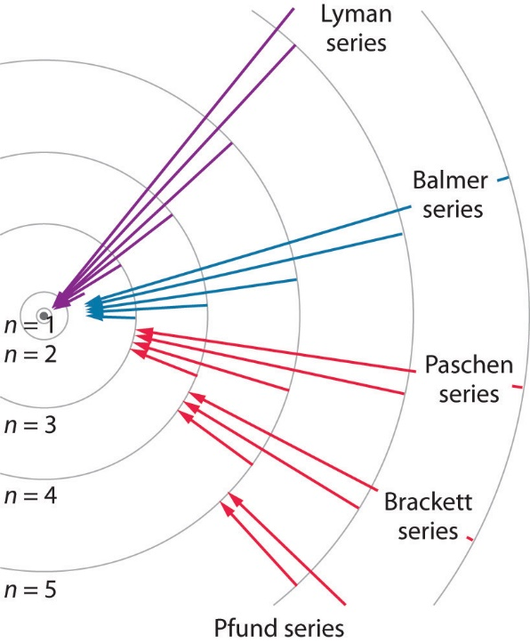

Diagram From: Wikimedia Commons

Another type of diagram, called an Energy Level Diagram, shows the energy associated with each stationary state and depicts transitions of electrons from an initial energy level to a final energy level. The example given shows the transitions involved in the Lyman, Balmer & Paschen series of the hydrogen emission spectrum.

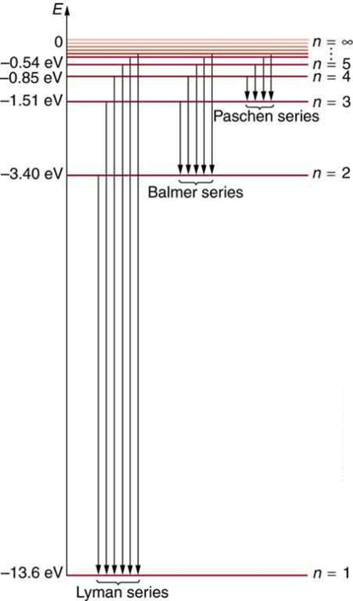

Diagram From: Wikimedia Commons

LIMITATIONS OF THE BOHR MODEL OF THE ATOM

In reality Bohr’s model was a huge breakthrough in our understanding of the atom. For his great contribution to atomic theory Bohr was awarded the 1922 Nobel Prize in Physics. As with any scientific model, however, there were limitations. The problems with the Bohr model can be summarised as follows:

- Bohr used a mixture of classical and quantum physics, mainly the former. He assumed that some laws of classical physics worked while others did not.
- The model could not explain the relative intensities of spectral lines. Some lines were more intense than others.
- It could not explain the hyperfine structure of spectral lines. Some spectral lines actually consist of a series of very fine, closely spaced lines.
- It could not satisfactorily be extended to atoms with more than one electron in their valence shell.
- It could not explain the “Zeeman splitting” of spectral lines under the influence of a magnetic field.

THE DE BROGLIE MODEL OF THE ATOM – MATTER WAVES

In 1924, Louis de Broglie, a French physicist, suggested that the wave-particle dualism that applies to EM radiation also applies to particles of matter. He proposed that every kind of particle has both wave and particle properties. Hence, electrons can be thought of as either particles or waves.

De Broglie reasoned that just as photons of EM energy have a momentum associated with their wavelength (p = h / λ), particles of matter should have a wavelength associated with their momentum:

where p = momentum of particle, m = mass of particle, v = velocity of particle and h = Planck’s constant.

The impact of de Broglie’s proposal was far reaching. Its immediate impact was to provide a physical interpretation of the Bohr quantisation of stationary states within an atom. Its ongoing impact was to provide a new way of describing the nature of matter, which assisted greatly in the development of quantum mechanics. Erwin Schrodinger in 1926 used de Broglie’s ideas on matter waves as the basis of his wave mechanics, one of several equivalent formulations of quantum mechanics.

Let us examine how de Broglie’s matter wave proposal explains the Bohr quantisation of stationary states. Bohr’s second postulate states that:

An electron can occupy only certain allowed orbits or stationary states for which the orbital angular momentum, L, of the electron is an integral multiple of Planck’s constant divided by 2π. Mathematically, this can be written as:

L = n h / 2π

De Broglie proposed that Bohr’s allowed orbits corresponded to radii where electrons formed standing waves around the nucleus. The condition for a standing wave to form would be that a whole number, n, of de Broglie wavelengths must fit around the circumference of an orbit of radius r.

n λ = 2 π r

Substituting for λ from the de Broglie relationship above, we have:

n (h / mv) = 2 π r

m v r = n h / 2π

Since (mvr) is the correct expression for the orbital angular momentum, L, of the electron in orbit around the nucleus, de Broglie had succeeded in showing that Bohr’s allowed orbits (or stationary states) are those for which the circumference of the orbit can contain exactly an integral number of de Broglie wavelengths. Thus, as shown in the figure below, the first stationary energy state (n = 1) corresponds to an allowed orbit containing one complete electron wavelength; the second stationary state corresponds to an allowed orbit containing two complete electron wavelengths; and so on.

De Broglie was then able to explain the stability of electron orbits in the Bohr atom. When an electron is in one of the allowed orbits or stationary states, it behaves as if it is a standing wave, not a particle experiencing centripetal acceleration. Thus, the electron does not emit EM radiation when it is in a stationary state within the atom.

Experimental confirmation of de Broglie’s proposal on matter waves was achieved in 1927 by Clinton Davisson and Lester Germer in the USA and by George Thomson in Scotland. Davisson and Germer conducted an experiment in which electrons in an electron beam produced the same diffraction pattern as X-rays when they were scattered by a small crystal of nickel.

As you will recall, diffraction is the name given to the phenomenon in which a wave spreads out as it passes through a small aperture or around an obstacle. Diffraction patterns are formed when the diffracted waves interfere with one another to produce light and dark bands on a screen or piece of film. Diffraction patterns are most intense when the size of the aperture or obstacle is comparable to the size of the wavelength of the wave. The electrons in the Davisson & Germer experiment were scattered in specific directions, which could only be explained by treating the electrons as waves with a wavelength related to their momentum by the de Broglie relation. Particles would have bounced off the nickel in all directions randomly.

The following is a diagram of the apparatus used by Davisson & Germer. Electrons from filament F are accelerated by a variable potential difference V. After scattering from the nickel crystal, they are collected by the detector D. D can be moved to measure the scatter yield at any angle.

CONTRIBUTION OF SCHRODINGER TO THE ATOMIC MODEL

In 1926 Erwin Schrödinger, an Austrian physicist, took the Bohr model one step further. Adopting the proposal made by Louis de Broglie in 1924 that particles of matter have a dual nature and, in some situations, act like waves, Schrödinger introduced a theory describing the behaviour of electrons by a wave equation that is now known as the Schrödinger equation. The Schrödinger equation describes the probability of finding an electron in a certain position at a certain time.

This was a completely quantum mechanical description of the atom. Unlike the Bohr model, the quantum mechanical model does not define the exact path of an electron, but rather, predicts the odds of the location of the electron. This model can be portrayed as a nucleus surrounded by an electron cloud. Where the cloud is most dense, the probability of finding the electron is greatest, and conversely, the electron is less likely to be in a less dense area of the cloud. Thus, this model introduced the concept of sub-energy levels.

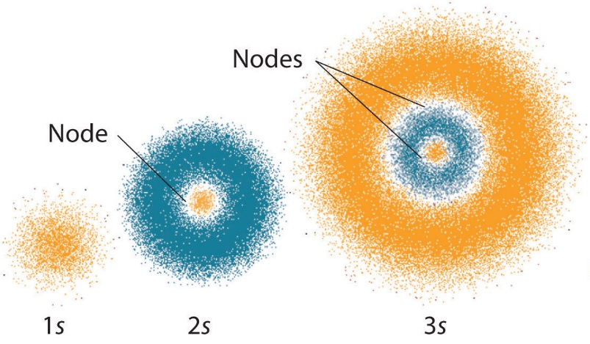

Probability distributions for 1s, 2s, and 3s orbitals. Greater color intensity indicates regions where electrons are more likely to exist. Nodes indicate regions where an electron has zero probability of being found. Image credit: UCDavis Chemwiki, CC BY-NC-SA 3.0 US

When Schrödinger applied his equation to the hydrogen atom, he was able to reproduce Bohr’s expression for the energy and, thus, the Rydberg formula governing hydrogen spectra. Schrödinger described electrons as three-dimensional stationary waves, or wavefunctions, represented by the Greek letter psi, ψ.

Schrödinger liked to think of the wavefunction as a real wave. A fellow physicist, Max Born, proposed an interpretation of the wavefunction ψ that is still accepted today: Electrons are still particles, and so the waves represented by ψ are not physical waves but, instead, are complex probability amplitudes. The square of the magnitude of a wavefunction ∣ψ∣² describes the probability of the quantum particle being present near a certain location in space. This means that wavefunctions can be used to determine the distribution of the electron’s density with respect to the nucleus in an atom.

The quantum mechanical model describes an atomic orbital as a three-dimensional space around the nucleus within an atom, where the probability of finding an electron is the highest. The model requires 3 quantum numbers (not 1 as for Bohr’s model) to describe the size, shape, and orientation in space of the orbitals in an atom. A fourth quantum number (spin) is added to completely describe the quantum state of an electron. The term orbital is used in the modern model as distinct from the term orbit used by Bohr.

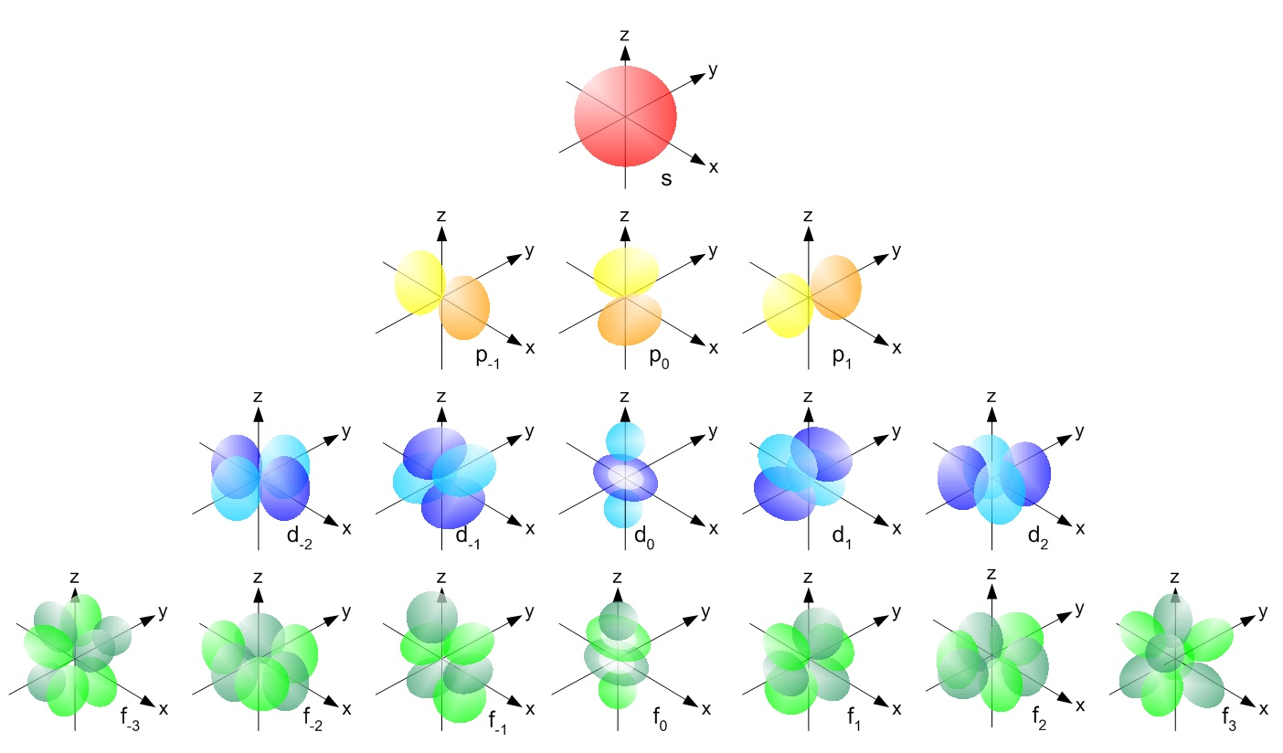

Shape & orientation of s, p, d & f orbitals for a single electron atom such as hydrogen - Diagram From: Wikimedia Commons – You do not have to memorize these diagrams.

Schrödinger was deeply involved in the debate that took place in the early years of quantum theory around the correct interpretation of the theory. What did the theory really mean? Between the years 1925 to 1927, Niels Bohr & Werner Heisenberg put forward what became known as the Copenhagen Interpretation of quantum mechanics. The Copenhagen interpretation suggested a way to think about how the mathematics of quantum theory relates to physical reality. There are several aspects to the interpretation but the one that Schrödinger clearly objected to, was the idea that a quantum particle does not exist in one state or another, but in all its possible states at once. It is only when we observe its state that a quantum particle is essentially forced to choose one probability, and that is the state that we observe.

Schrödinger thought this was nonsense. He proposed the now famous experiment with a cat to demonstrate how such an interpretation leads to ridiculous consequences. In essence, Schrödinger’s Cat Experiment, is a thought experiment in which a cat is placed in a sealed box with a mechanism that may or may not kill the cat within the hour during which the experiment is run. Schrödinger points out that according to the Copenhagen interpretation, the wavefunction of the entire system would describe the cat as being in a superposition of all possible states simultaneously, that is both dead and alive, until we open the box. The act of opening the box and observing the cat collapses the wavefunction into one of the two possible states – dead or alive. Schrödinger’s argument was that this way of thinking about quantum mechanics is not helpful.

Diagram From: Sloyment - de.wikipedia.org: 09:18, 25. Feb 2005 . . Sloyment ({{Bild-PD}}), CC0, https://commons.wikimedia.org/w/index.php?curid=453851

Schrödinger’s objection did not prevail in the end. The Copenhagen Interpretation is still regarded by most physicists as a reasonable one. There are others in circulation today.

Schrödinger’s contribution to our current understanding of the atom is huge. Quantum Mechanics is arguably the most successful theory ever developed. It is used today in a huge variety of scientific and engineering fields. Schrödinger’s work in formulating his wave mechanical theory of the atom and his subsequent involvement in its development place him as one of the greatest physicists of all time.

Quantum mechanics has effectively explained all of the limitations of the Bohr model of the atom. It helps us explain and utilize the properties of metals, insulators, semiconductors and superconductors. The inventors of the transistor acknowledge the part quantum theory played in their discovery. That discovery led to the development of ever more powerful computers and microcomputers that have led to a revolution in communications and information. Lasers and masers are quantum devices. Quantum mechanics explains the structure of the atom and nucleus as well as mechanical and thermal properties of solids.

Quantum mechanics gave chemistry a firm base and explained chemical bonding. The new areas of molecular biology and genetic engineering have arisen from quantum chemistry. In astrophysics, the processes that occur in stars can be explained by quantum mechanics and even our understanding of such exotic objects as black holes are assisted by quantum mechanics. There has even been the suggestion that our universe began as a quantum fluctuation. Quantum computing will become a reality in the not-too-distant future. Professor Michelle Simmons, 2018 Australian of the Year, leads a team at Uni of NSW, Sydney, who are leading the world in quantum computing research and engineering.

For further information on the quantum mechanical model of the atom, please see the Khan Academy – excellent resource – more detail than you need for Year 12.

PROPERTIES OF THE NUCLEUS

Inquiry Question: How can the energy of the atomic nucleus be harnessed?

NATURAL RADIOACTIVITY AND TRANSMUTATION

Experimental work around the turn of the 20th Century by Henri Becquerel (1896), Ernest Rutherford, Marie & Pierre Curie, Paul Villard and many other physicists led to the discovery of the three kinds of natural radiations – alpha particles, beta particles and gamma rays. These radiations were emitted naturally from certain elements (uranium, polonium, radium, actinium). Further, it was found that the emission of natural radiations by one element usually led to the production of a different element. For instance, radium was produced as a result of the radioactive decay of uranium.

Henri Becquerel discovered radioactivity in 1896 when he was studying the radiation emitted from phosphorescent substances that had previously been exposed to sunlight. Becquerel found by accident that a salt of uranium, potassium–uranyl sulfate, continuously emitted radiation regardless of whether or not it had been exposed to sunlight. This radiation penetrated matter, passing through black paper (opaque to light) and causing a photographic plate to become darkened. It seemed to be similar in nature to X-rays, which had been
recently discovered in 1895 by Wilhelm Roentgen.

In 1898, Rutherford showed that there were two components (alpha and beta rays) of the radiation discovered by Becquerel, and in 1900 Paul Villard discovered the third component
(gamma rays).

The properties of alpha, beta and gamma radiation can be summarised as follows.

Table 1: Properties of three main radioactive emissions (“Nuclear Physics” by J Joyce & R Vogt, Brooks Waterloo, 1990, page 9)

Radiation | Speed | Penetration Ability | Ionising Ability | Charge | Nature | Symbol
α-particle | 2x10⁷ m/s  (approx.) | Low – few cm of air; thin paper | Very High | Positive | Helium nucleus
β-particle | 2x10⁸ m/s  (approx.) | Higher than α − 10 cm of air | Less than α | Negative  (can be positive) | Electron  (positron)
γ-ray | 3x10⁸ m/s | Very High – several cm of lead | Less than β | Neutral | EM radiation

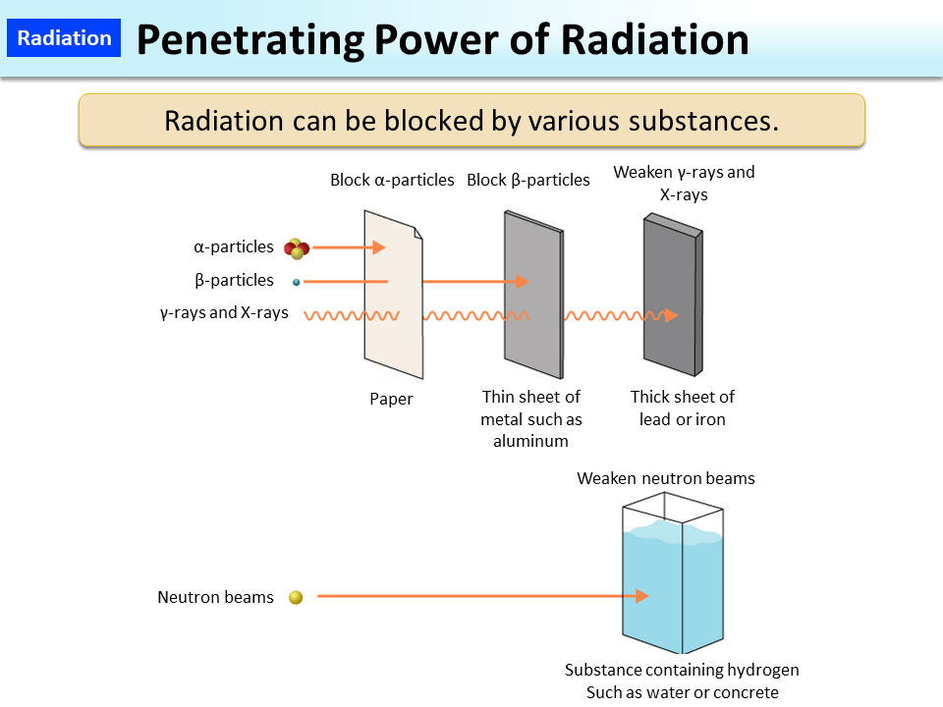
Diagram From: Wikimedia Commons

TRANSMUTATION

The change of a parent nucleus into a different daughter nucleus is called nuclear transmutation. One element effectively changes into another element.

When transmutation occurs, the sum of the atomic numbers on the left-hand side of the nuclear equation equals the sum of the atomic numbers on the right-hand side. Likewise, the sum of the mass numbers on the left-hand side of the nuclear equation equals the sum of the mass numbers on the right-hand side.

ALPHA DECAY

A nucleus of an element X changes into a nucleus of an element Y according to:

where the helium-4 nucleus is the emitted alpha particle. Alpha decay occurs primarily among nuclei with atomic numbers greater than 83.

BETA DECAY (THE WEAK INTERACTION)

Early attempts to explain beta decay assumed that an electron in the nucleus (Proton-Electron Model) was emitted in a process like that by which an alpha particle was emitted from a nucleus. One problem with this explanation, however, was that although all alpha particles emitted from a given species of nucleus had the same energy, beta particles emitted from a given species of nucleus seemed to have a continuous spectrum of energies.

James Chadwick, in some experiments conducted prior to World War I, used a Geiger Counter to study beta particles emitted from a source and then deflected by a uniform magnetic field. He found that the beta particles had a wide range of radii of curvature in the field, indicating that the beta particles had different velocities and therefore different energies. Similar experiments by many Physicists during the 1920’s and early 1930’s clearly indicated that during the beta decay of a particular nuclear species (eg Bi-210) electrons were emitted with a distribution of energies rather than with a distinct single value of energy.

The following graph shows the energy spectrum for electrons emitted during the decay of Bi-210. The intensity (vertical axis) shows the number of electrons emitted with each particular kinetic energy (horizontal axis).

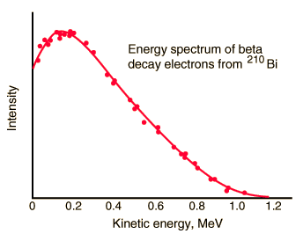

This graph above was taken from the web link:

http://hyperphysics.phy-astr.gsu.edu/hbase/nuclear/beta2.html#c1

Graphs such as this could not be explained. Why did the beta decay of a particular nuclear species produce many different beta particle emission energies? How was this possible when the decay process produced exactly the same daughter nucleus in each case?

Other experiments also suggested that the Law of Conservation of Energy was being violated. The total energy lost by the nucleus during β−decay was not equal to the total energy of the emitted β−particle.

The need to account for the energy distribution of electrons emitted in beta decay and to satisfy the Law of Conservation of Energy prompted Austrian physicist Wolfgang Pauli in 1930 to suggest that a neutral particle was emitted along with the β−particle. This particle would have no charge and no rest mass but would possess spin, energy and momentum.

Pauli believed that the emission of such a particle would successfully explain the spectrum of energies for emitted beta particles. For each beta emission, the total energy carried away from the decaying nucleus would be shared between the beta particle and the neutral particle emitted with it. So, when studying the beta decay of a sample, it would be expected that the beta particles emitted would have a range of energies depending on the energies of the neutral particles emitted with them. Clearly, Pauli’s idea also allows for the energy of reaction to be conserved, with both the beta particle and the neutral particle sharing the energy carried away from the decaying nucleus.

In 1934, Italian physicist Enrico Fermi named Pauli’s particle the neutrino (ν), meaning “little neutral one” in Italian, and formulated a theory of β−decay using this particle. Fermi’s theory successfully explained all experimental observations. For instance, the shape of the energy curve shown above for Bi-210 can be predicted from the Fermi Theory of beta decay. Despite several ingenious attempts, the neutrino was not experimentally observed until 1956. In that year, two American Physicists, Cowan and Reines successfully identified the neutrino by detecting the products of a reaction that could only have been initiated by the neutrino. Basic details of this experiment are provided in “Nuclear Physics” by J Joyce & R Vogt (Brooks Waterloo, 1990) or online.

β−decay is often referred to as the weak interaction because it is 10¹² times weaker than the strong nuclear force that holds the nucleus together.

There are two types of β−decay:

β⁻ decay (Beta Minus Decay) in which a neutron decays to produce a proton, an electron and an anti-neutrino . The electron and the anti-neutrino are emitted but the proton stays behind, thus increasing the atomic number by one.

In general,

The following equation for example, describes the spontaneous decay of C-14 in the upper atmosphere, as it is produced by bombardment of nitrogen by neutrons in cosmic rays:

β⁺ decay (Beta Plus Decay) in which a positron (positive electron – antimatter particle) is emitted after a proton decays to produce a neutron, a positron and a neutrino.

In general,

The following equation for example, describes the β−decay of the artificially produced N-13 nucleus:

(As an aside, it is worth noting that the distinguishing feature between the neutrino & anti-neutrino is their helicity. The anti-neutrino has its spin angular momentum parallel to its linear momentum – it has a right-hand screw helicity. The neutrino has its spin angular momentum anti-parallel to its linear momentum – it has a left-hand screw helicity.)

GAMMA EMISSION

This usually accompanies α or β decay. A nucleus de-excites by emitting a high-energy gamma ray photon. This is not a transmutation.

where the * represents an excited nucleus. Gamma rays are a form of very high energy electromagnetic radiation.

Artificial Transmutation

Transmutation can be achieved artificially. This was first achieved by Rutherford in 1919. Nitrogen gas was bombarded with high energy α-particles, producing a number of high energy protons. The α-particles had knocked the protons out of the nitrogen nuclei and an isotope of oxygen had been produced.

HALF-LIFE & MATHEMATICS OF RADIOACTIVE DECAY

The rate at which a nucleus decays is a characteristic of that nucleus and is independent of external conditions. This rate is measured by the half-life, which is defined to be the time for half the given mass of an element to decay into a new element. This can range from microseconds to thousands of years.

The graph below is a radioactive decay curve. It shows the time in half lives for a sample of an element to decay. After 1 half-life, 50% (1/2) of the sample has decayed. After 2 half-lives, a further 50% of the remaining sample has decayed, meaning that only 25% (1/4) of the original sample remains. After three half-lives, a further 50% of the remaining sample has decayed, meaning that only 12.5% (or 1/8) of the original sample is left. And so on.

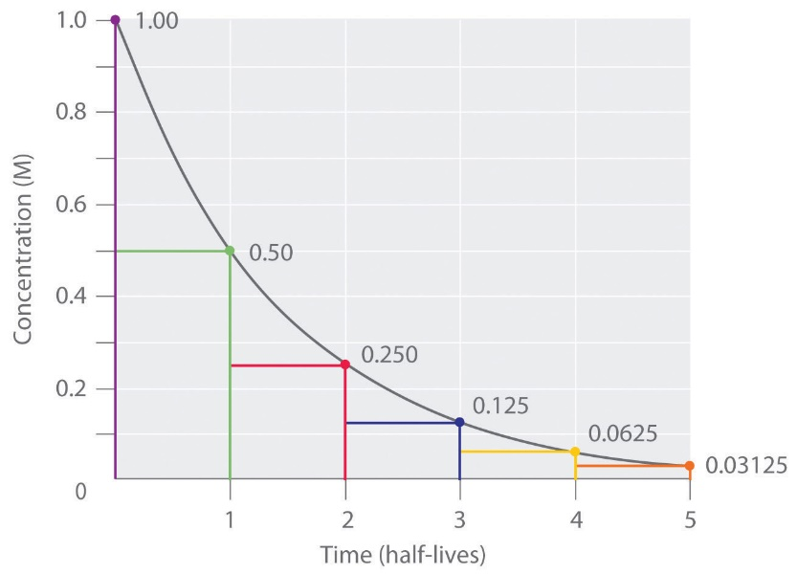

Diagram From: Wikimedia Commons

The rate of decay depends upon the number of radioactive nuclei, N, present in the sample at a particular time. Using the mathematics of exponential decay, we can derive some useful equations that enable us to make quantitative predictions.

Suppose N is the size of a population of radioactive atoms at a given time t, and dN is the amount by which the population decreases in time dt; then the rate of change is given by the equation dN/dt = −λN, where λ is the decay constant (or rate constant).

The following derivation is not required for the Year 12 course but is instructive of the power of mathematics to reveal physical relationships which assist in our understanding of our universe.

See next page.

Thus, if originally there are N₀ radioactive nuclei, then the number of nuclei remaining after a time, t, is given by:

Where λ = the decay constant for the given material. The decay constant, λ, is the probability that a nucleus will decay per second, so its SI unit is s⁻¹.

To derive a formula for half-life, we substitute into the above equation,

t = T_{1/2} (or T_{0.5}) and N = N₀ /2

Thus, our half-life equation is:

As examples: the half-life of U-238 is 4.5 x 10⁹ years; that of Pu-239 is 2.5 x 10⁴ years; and that of Po-212 is 3.0 x 10⁻⁷ seconds.

Clearly, if we wish to calculate the decay constant, λ, we rearrange this equation.

The activity, A, of a radioactive element is the number of nuclei that disintegrate per second. In other words, it is the rate of change of the number of nuclei left per second, which we have already seen above is given by:

The minus sign from the original equation for dN/dt is removed since A must be positive. The SI unit of radioactive activity is the becquerel (Bq).

As an aside, remembering that the decay constant, λ, is the probability that a nucleus will decay per second, we could also derive the activity formula by realizing that the activity must be λ times the number of nuclei remaining, N.

Example Problems

- The half-life of Th-234 is 24 days.
  - What fraction of the element remains after 72 days?
  - How long does it take for 10% of a sample Th-234 to decay?
- One sixteenth of the original sample of a radioactive element remains after 12 minutes. What is the half-life of this element?
- If we start with 1.00 g of strontium-90, 0.952 g will remain after 2.0 years.
  - Calculate the half-life of strontium-90.
  - How much strontium-90 would remain after 5.0 years?
Have a go at these questions & then examine the solutions below.

Solutions

Question 1

- T_{1/2} = 24 days, clearly 72 days is 3 half-lives and thus (1/2)³ = 1/8 of the sample remains after 72 days.
- When 10% of sample has decayed, percentage remaining is 90%. So, we have:

So, it takes 3.6 days for 10% of the sample to decay.
Question 2

One-half of the sample decays each half-life. So, we need to solve:

We could also use the formulae we have derived but in this case that would take longer.

Question 3

- Half-life of strontium-90 is 28.2 years.
- Mass left after 5 years is 0.9 g

THE STRONG NUCLEAR FORCE

It is known that there is an electrostatic Coulomb repulsion force between any two like charges. So, in the case of protons in the nucleus, there must be some sort of force that holds the protons together. At first, we might be tempted to suggest that the gravitational attraction that exists between all bodies possessing mass is responsible for holding the protons together. However, if we evaluate the relative contributions of the electrostatic and gravitational forces between protons, we find that the gravitational force is millions of times smaller than the electrostatic force. Thus, there must be another force at work.

The force responsible for holding all nucleons together is the strong nuclear force. The graph below shows the strong nuclear force between nucleons as a function of the separation of the nucleons.

The main properties of the strong nuclear force are:

- At typical nucleon separation (1.3 x 10⁻¹⁵m) it is a very strong attractive force (10⁴ N).
- At much smaller separations between nucleons the force is very powerfully repulsive.
- Beyond about 1.3 x 10⁻¹⁵m separation, the force quickly dies off to zero.
- Thus, the strong nuclear force is a very short-range force.
- The much smaller Coulomb force between protons has a much larger range and becomes the only significant force between protons when their separation exceeds about 2.5 x 10⁻¹⁵m.
- The strong nuclear force is not connected with charge. Proton-proton, proton-neutron and neutron-neutron forces are the same. (The force between protons, however, must always be modified by the Coulomb repulsion between them.)
NUCLEAR STABILITY

Consider the following graph showing the number of protons in the nucleus versus the number of neutrons in the nucleus. This is very useful for considering what makes a nucleus stable.

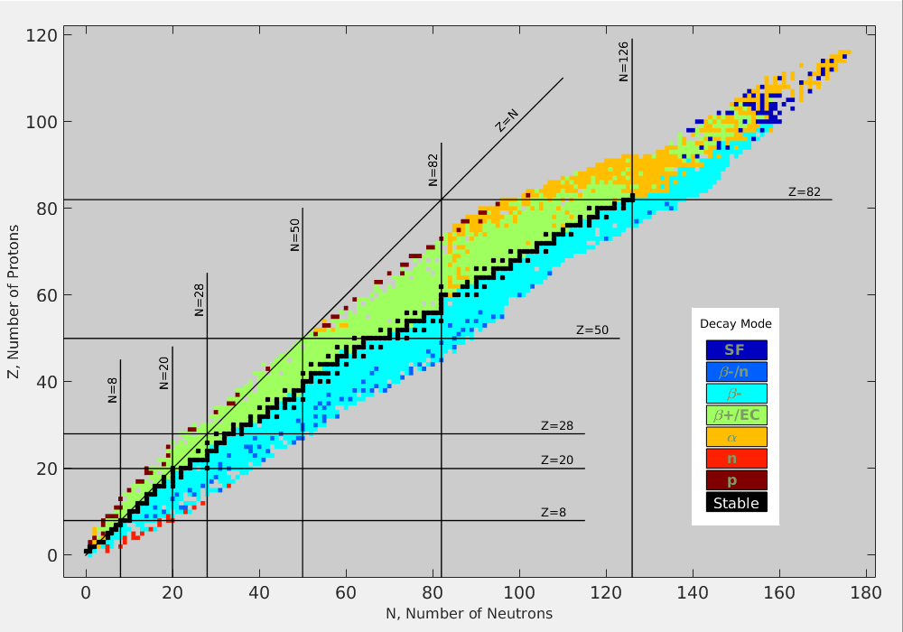

This graph is a chart of nuclides by type of decay. Black squares are stable nuclides. Nuclides with excessive neutrons or protons are unstable to β⁻ (light blue) or β⁺ (green) decay, respectively. At high atomic number, alpha emission (orange) or spontaneous fission (dark blue) become common decay modes. Diagram From: Wikimedia Commons

The points to note from this graph are the following:

- For low atomic number nuclei, the proton-neutron ratio is 1:1 approximately.
- For every value of atomic number, a stable nucleus requires a certain number of neutrons. If this number is exceeded or not reached, the nucleus is unstable. Such nuclei can become stable by either β⁻ or β⁺ emission, since these two decay modes result in a neutron changing into a proton or vice versa.
- If it were not for the Coulomb repulsion of protons in the nucleus, the proton to neutron ratio would follow the straight-line Z = N. However, because the mutual repulsion of protons in the nucleus becomes greater as the number of protons increases, the line or belt of stability tends toward an excess of neutrons. The addition of a neutron to the nucleus increases the strong nuclear force without increasing the Coulomb electrostatic force of repulsion. It becomes energetically more favourable to add a neutron rather than a proton.
- There are no stable nuclei with atomic numbers greater than 83. (As an aside, beyond an atomic number of 100, there are no long-lived nuclei. Not seen from this graph.)
- Thus, when a heavy nucleus decays, the daughter species is often unstable itself. This usually leads to one of three possible natural radioactive decay series: the thorium series, the uranium series and the actinium series. In all cases the end product is a stable isotope of lead. See an example of the U-238 series below.

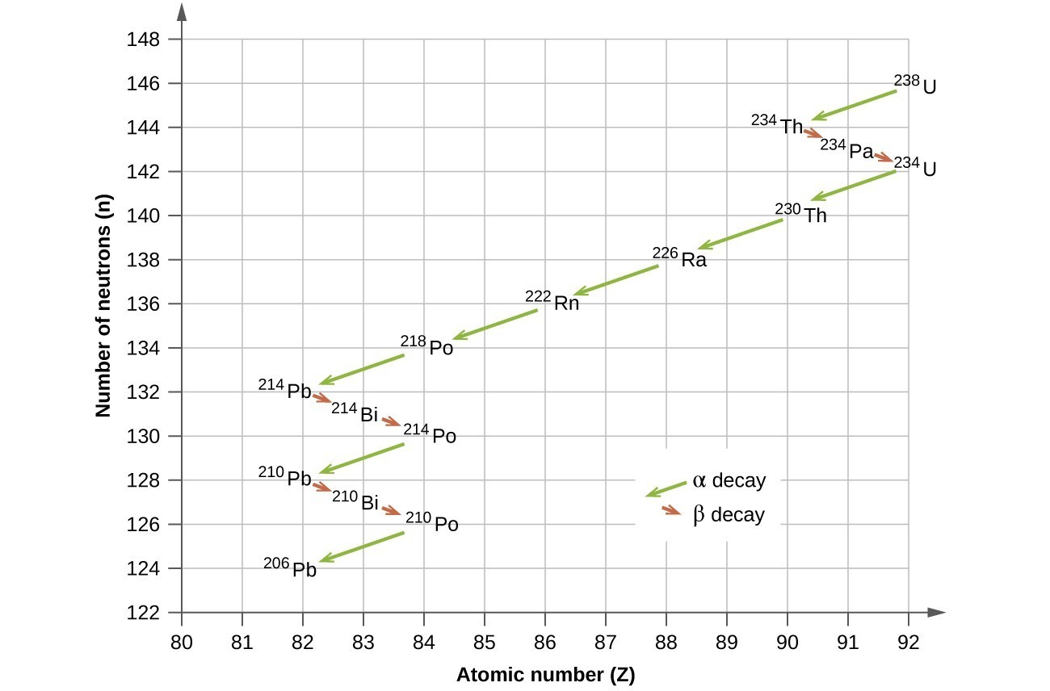

Uranium-238 undergoes a radioactive decay series consisting of 14 separate steps before producing stable lead-206. This series consists of eight α decays and six β decays. Diagram From: Wikimedia Commons

COMMON UNITS USED IN NUCLEAR PHYSICS
For convenience, nuclear physicists usually use the atomic mass unit (u) as the unit of mass and the electron volt (eV) or Mega electron volt (MeV) as the unit of energy. These are defined as follows.

ATOMIC MASS & ATOMIC MASS UNIT

The present standard atom is the atom of the commonest isotope of carbon, C-12. By definition, this isotope of carbon has a mass of 12.0000 atomic mass units (u) exactly. Thus, since the mass of one C-12 atom is 1.9924 x 10⁻²⁶ kg (by mass spectrograph measurements), we have:

1.0000 u = 1.9924 x 10⁻²⁶/12.0000

= 1.6603 x 10⁻²⁷ kg

THE ELECTRON VOLT

The electron volt is the amount of energy gained by an electron as it is accelerated through a potential difference of one volt.

1 eV = 1.602 x 10⁻¹⁹ J (from W = qV)

1 MeV = 1.602 x 10⁻¹³ J

Clearly, using Einstein’s equation E = mc² for the equivalence of mass and energy we have:

1 u = 931.5 MeV

MASS DEFECT AND BINDING ENERGY

The experimentally measured mass of any nucleus is less than the sum of the masses of its constituent protons and neutrons.

The mass of a proton is 1.00728 u.
The mass of a neutron is 1.00867 u.
The mass of an electron is 0.00055 u.

For example, let us consider an atom of the commonest isotope of chlorine, Cl-35.

The actual mass of this atom, determined by experiment, is 34.980175 u.

The combined mass of the constituent particles may be determined as follows:

Mass of 17 protons = 17 x 1.00728 = 17.12376 u
Mass of 18 neutrons = 18 x 1.00867 = 18.15606 u
Mass of 17 electrons = 17 x 0.00055 = 0.00935 u
Combined Mass = 35.28917 u

The difference in mass is called the mass defect of the atom (or nucleus, if we are dealing with the nucleus only). In this case, the mass defect is about 0.309 u or 5.13 x 10⁻²⁸ kg.

This small mass has been converted into the binding energy of the nucleus (the energy holding the nucleus together). The mass defect of a nucleus can therefore be defined as the mass equivalent of the binding energy of the nucleus. The amount of binding energy involved in this example is:

E = mc² or E = 931.5 x 0.309
E = 5.13 x 10⁻²⁸ x (3 x 10⁸)² = 287.8 MeV
= 4.617 x 10⁻¹¹ J
= 288.2 MeV

By definition, the binding energy of the nucleus is the energy needed to separate the nucleus into its constituent parts. When the nucleons come together to form the nucleus, they release this binding energy to stabilize the nucleus.

If we take the total binding energy of a nucleus and divide it by the total number of nucleons in the nucleus, we get a very good measure of how tightly each individual nucleon is held in the nucleus. This binding energy per nucleon figure is a very good measure of the stability of the nucleus. The higher the binding energy per nucleon, the more stable the nucleus. The diagram below shows the basic shape of the binding energy per nucleon versus mass number graph. This will be a useful tool for explaining nuclear fission and fusion a little later. (The vertical axis has been drawn on the right for clarity.)

Note that the binding energy per nucleon is low for low mass number nuclei. This is because in such nuclei each nucleon is not uniformly surrounded and thus does not experience the full effects of the strong nuclear force. Most nuclei have binding energy per nucleon values between 7 and 9 MeV, with the highest value being that for Fe-56. For very high mass number nuclei the electrostatic repulsive forces between the protons result in a gradual decrease in binding energy per nucleon values.

NUCLEAR FISSION

Nuclear fission is the name given to the process in which a heavy nucleus splits to form two lighter nuclei, each of which is more stable than the original nucleus. The first artificially induced nuclear fission reaction was achieved by Enrico Fermi in 1934, although at the time he did not realise that fission had occurred. Fermi bombarded uranium with neutrons and produced radioactive products that emitted β-particles. Fermi assumed that he had produced a new isotope of uranium, U-239, and that this had undergone beta decay to form an isotope of the first transuranic element, atomic number 93, known today as neptunium-239. Further transuranic elements could then be formed by further beta decays.

Two German chemists, Otto Hahn and Fritz Strassman, repeated Fermi’s experiments in 1938 and used careful isotopic half-life analysis to identify the products of the reaction. To their surprise they found that not only was U-239 produced but also various lighter elements, such as Ba-141, Kr-92, Ba-144, Kr-89, La-148, Br-85, Xe-143 & Sr-90. Hahn and Strassman suspected that these lighter elements were the products of the splitting of the uranium nucleus. This suspicion was confirmed in 1939 by two Austrian physicists, Lise Meitner and Otto Frisch, who showed that when a U-235 nucleus absorbs a neutron, the nucleus splits into two smaller nuclei and emits one, two or three neutrons in the process. Meitner & Frisch called the process nuclear fission.

In 1940, when the Manhattan Project (to build an atomic bomb) was initiated in the USA, Fermi was placed in charge of the development of the first ever nuclear reactor (or pile). Fermi determined theoretically that a fission chain reaction, that is a reaction where one reaction would lead to another and so on, could be achieved using naturally occurring uranium. Fermi designed his reactor so that the uranium fuel was spread evenly throughout a pile of very high purity carbon blocks. The carbon blocks were designed to slow (or moderate) the speed of neutrons ejected from uranium nuclei, so that they could then produce another fission reaction. Cadmium rods were also inserted throughout the pile to capture neutrons and thereby control the reaction. (Cadmium is a good neutron absorber.)

Fermi’s reactor was built on the squash courts under the football stadium at the University of Chicago. On December 2nd 1942, the cadmium control rods were slowly, partially withdrawn from the pile. The amount of radiation produced and the rate and magnitude of temperature increase were in agreement with Fermi’s predictions. The reactor ran at a steady rate, indicating that the control rods were absorbing sufficient neutrons to maintain a chain reaction. Fermi had demonstrated the first artificially created, controlled, nuclear fission chain reaction.

ENERGY FROM FISSION
The binding energy curve shows that a heavy nucleus has a binding energy of about 7 MeV per nucleon, whereas nuclei of elements with roughly half the mass number have average binding energies of about 8 MeV per nucleon. Thus, when the heavy nucleus splits to form two lighter nuclei, there is a release of about 1 MeV of energy per nucleon. So, for a heavy nucleus of 200 nucleons, there would be a release of about 200 MeV of energy from each fission. Clearly, tremendous amounts of energy can be produced from sustained fission reactions. For example, the fission of 1 kg of uranium releases about 9 x 10¹⁰ kJ of energy. Taking a typical energy value for coal of about 30 kJ/g means that the fission of 1 kg of uranium produces as much energy as the burning of about 3 million kg of coal.

An example of a typical fission reaction is:

We can calculate the energy released in this reaction in a couple of different ways. We can either determine the difference between the binding energies of the products and reactants or we can find the difference between the masses of the products and reactants and then convert this mass difference into its energy equivalent using Einstein’s E = mc² equation.

Note that as a general rule, energy is released from a nuclear reaction when the binding energy of the products is greater than that of the reactants. Energy is released because some mass is converted to energy. Cleary then, we can also say that energy is released from a nuclear reaction when the mass of the products is less than that of the reactants.

CHAIN REACTIONS & CRITICALITY

On average, 2.4 neutrons are produced by every fission of U-235. A fission chain reaction is one where the neutrons produced in one fission go on to produce another fission and so on. In order for a fission chain reaction to occur, the sample of fissionable material must have a certain minimum size referred to as its critical mass. Otherwise, neutrons escape from the sample before they have an opportunity to strike a nucleus and cause fission. The chain stops if enough neutrons are lost. The reaction is then said to be subcritical. As an example, critical mass for weapons grade plutonium-239 is about 4 to 6 kg depending on shape. For weapons grade (highly enriched) U-235 it is even less.

If the mass is large enough to maintain the chain reaction with a constant rate of fission, the reaction is said to be critical. This situation results if only one neutron from each fission is subsequently successful in producing another fission. Such a reaction is controllable. See diagram below.

If the mass is larger still, few of the neutrons produced are able to escape. If one fission produces two neutrons, these two neutrons can cause two fissions. The four neutrons thereby released produce four fissions and so on. The number of fissions and their associated energies quickly increase and if unchecked the result is a violent explosion. Such branching chain reactions are said to be supercritical and the reaction is uncontrollable. See diagram below.

An excellent example of a controlled nuclear fission reaction occurs in a fission reactor. See Appendix B for details. Fission reactors are not required for the current syllabus.

An excellent example of an uncontrolled nuclear fission reaction occurs in an atomic bomb. See Appendix C for details. The atomic bomb is not required for the current syllabus.

NUCLEAR FUSION

This is the joining together or fusing of two light nuclei to form a heavier nucleus. It is clear from the binding energy per nucleon curve that fusion can result in much greater releases of energy per unit mass than can fission. For example, if two deuterium nuclei, H-2, of binding energy 1 MeV per nucleon combine to form helium of binding energy 7 MeV per nucleon, the release of energy would be of the order of 6 MeV per nucleon. See binding energy curve. Compare this with the average energy release for fission of 1 MeV per nucleon.
For nuclei to collide with sufficient energy to overcome the Coulomb repulsion force, they must have extremely high temperatures. As we know, temperature is a measure of the average kinetic energy per molecule. Temperatures of the order of 100 million degrees Celsius are required. For this reason, nuclear fusion is called a thermonuclear reaction. Fusion is the process by which all stars produce their energy.

At such high temperatures all matter exists in a fourth state called plasma. This means that all atoms have been completely stripped of their electrons. So, a plasma can be thought of as consisting of two separate gases – bare nuclei and electrons.

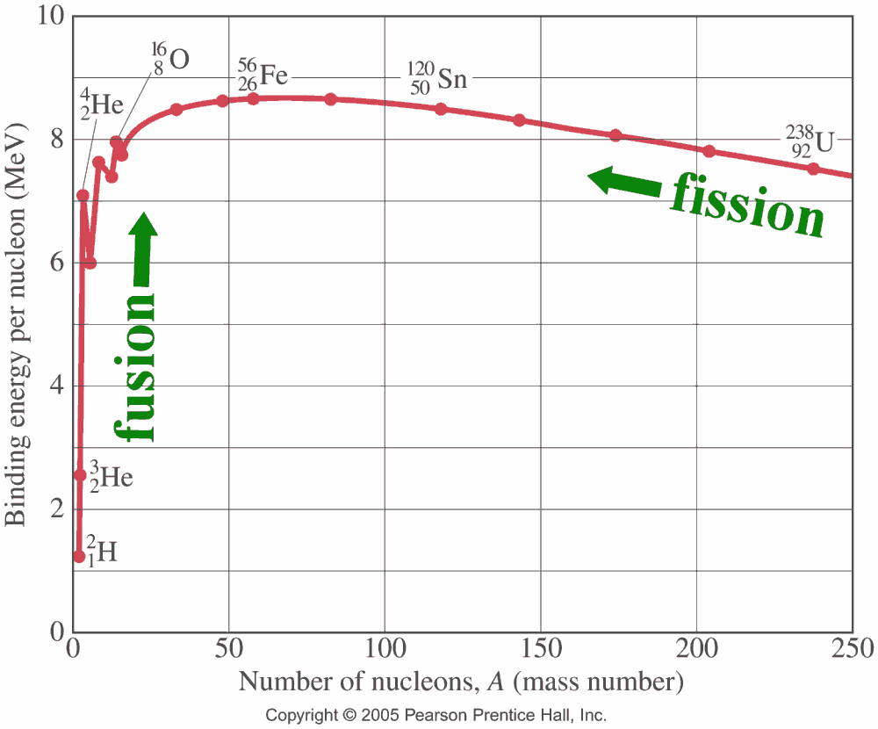

Diagram showing fission releases energy by splitting large nuclei into smaller ones and fusion releases energy by joining small nuclei together to make larger ones. In both cases, the product nuclei are further toward the peak of the binding energy per nucleon curve than the reactant nucleus or nuclei. Diagram From: Wikimedia Commons

In 1934 Ernest Rutherford performed an experiment which showed the fusion of deuterium into helium and observed that "an enormous effect was produced" during the process. His assistant, Australian-born Mark Oliphant, played a key role in these early fusion experiments, discovering tritium (H-3), the second heavy isotope of hydrogen, and helium-3, the rare helium isotope.
From the 1950’s onward plans were developed for the construction of fusion reactors to supply energy for the world. Fusion reactors are almost pollution free. Fusion reactors produce only short-lived radioactive waste products compared to the extremely long-lived radioactive waste that comes from fission reactors. Fusing atoms together in a controlled way releases nearly four million times more energy than a chemical reaction such as the burning of fossil fuels and on average four times as much as nuclear fission reactions per unit mass.
It may sound unfeasible to achieve the huge temperatures required for fusion. It may sound impossible to contain and control such high energy plasma once created. However, fusion research has come a very long way since the 1950’s. Many countries are developing fusion reactors and it is highly likely that by 2050 we will have fully operational fusion power reactors supplying all our power needs.

FUELS FOR FUSION PROCESSES
The two most common fusion fuels are deuterium (H-2) and tritium (H-3). Deuterium is abundant in nature, there being 1 deuterium atom for every 7000 hydrogen atoms. It can easily be extracted from water. Tritium is not naturally occurring but can be produced from lithium as shown below.
Note that these are not fusion reactions. They are neutron bombardment reactions.

COMMON FUSION REACTIONS
When deuterium (D or H-2) is used as the fuel in a controlled thermonuclear reaction, the primary reactions which occur (with equal probability) are:

H-3 in the first equation is tritium.
In addition to the above, the following secondary reactions occur:
The final equation above is the easiest of the 4 to do in the laboratory.

FURTHER EXAMPLE ENERGY CALCULATIONS
- Determine the mass defect, the binding energy and the binding energy per nucleon of an alpha particle. Experimental mass of He-4 atom = 4.002604 u.
Data: mass of a proton, m_{p} = 1.00728 u, mass of a neutron, m_{n} = 1.00867 u & mass of electron, m_{e} = 0.00055 u; 1 u = 931.5 MeV; 1.0000 u = 1.6603 x 10⁻²⁷ kg.
- Determine the energy released when U-238 decays into Th-234 via alpha decay. Experimental mass of U-238 = 238.05079 u & of Th-234 = 234.04363 u.
- Use the law of conservation of energy to explain why a nucleus will emit an α-particle rather than four separate nucleons. Your calculations in answer to question 2 above may assist you to do this. We are asking here, why we never see the reaction:
Data: mass of a proton, m_{p} = 1.007 276 u & mass of a neutron, m_{n} = 1.008 665 u.
Solutions
- For the mass defect calculation, we need to calculate the theoretical mass of the He-4 atom and determine the difference between this and the experimentally determined mass.
Just a few comments on this solution: we include electrons in the binding energy calculation because we use atomic masses of the atoms involved and these include electrons. Note the two possible methods for calculating the binding energy. The discrepancy between the two values calculated for binding energy is due to the number of significant figures used in the mass values of the protons, neutrons & electrons and the various conversion factors.
- To determine the energy released, we must calculate the mass lost between reactants and products. This mass has been converted into energy and carried away by the ejected alpha particle.
Mass of reactants (LHS):
Mass of U-238 = 238.05079 u
Mass of Products (RHS):
Mass of Th-234 = 234.04363 u
Mass of He-4 = 4.00260 u
Total Mass RHS = 238.04623 u
Mass Defect = 238.05079 - 238.04623 = 0.00456 u
Therefore, energy released = (0.00456 u) x (931.5 MeV/u) = 4.25 MeV
- Let us consider the mass of reactants and products for the reaction proposed above.
Mass of reactants (LHS):
Mass of U-238 = 238.05079 u
Mass of Products (RHS):
Mass of Th-234 = 234.04363 u
Mass of 2 Neutrons = 2 x 1.008665 = 2.01733 u
Mass of 2 Protons = 2 x 1.007276 = 2.014552 u
Total Mass of products = 238.07551 u
Mass Defect = 238.05079 - 238.07551 = - 0.02472 u
The negative mass defect indicates that this equation violates the law of conservation of energy and is therefore not possible. The calculations in answer to question 2 above show that the emission of an alpha particle (2 protons & 2 neutrons tightly bound together) is energetically favourable, releasing 4.25 MeV of energy. (It is almost always true that the emission of a single nucleon is energetically not possible in natural processes.)

Note that any question you are asked to solve involving calculation of energy released by a nuclear reaction, can be solved by application of the law of conservation of mass-energy. The total mass-energy of the system must be conserved. So, if mass is lost when the reactants become the products that mass must have been converted into energy and carried away by one or more of the emitted particles or by a gamma ray. This applies to any nuclear reaction where energy is released: radioactive decays, transmutations (natural or artificial), nuclear fission and nuclear fusion. I will provide some practice questions on this type of calculation on the From the Universe to the Atom topic web page.

DEEP INSIDE THE ATOM

Inquiry Question: How is it known that human understanding of matter is still incomplete?

NATURE OF FUNDAMENATL PARTICLES

By the mid-1930’s, it was recognized that all atoms were composed of protons, neutrons and electrons. Besides these elementary or fundamental particles, several others were also known: the positron (positive electron), the neutrino and the gamma ray (photon). That made a total of six fundamental particles.
Elementary particle physics might be said to have begun in 1935. In that year, the Japanese physicist, Hideki Yukawa, postulated that the force between nucleons could be explained by assuming that between each pair of nucleons, there is a continual exchange of certain particles. This is similar to the way we explain the forces that electrostatic charges exert on one another – they exchange virtual photons with each other. Yukawa predicted the properties of these particles, their mass being about 250 times that of the electron. Yukawa called this particle a meson (meaning medium mass).
In 1947, the particle predicted by Yukawa was discovered in cosmic rays by C. F. Powell & G. Occhialini and is called the π-meson or simply the pion. The Yukawa model of pion exchange as a carrier of the strong force was accepted until it was superseded by quantum chromodynamics (QCD).
Research on cosmic rays uncovered several new particles beside the pion. In 1933, Carl D. Anderson was investigating the charged particles in cosmic ray showers and observed
a particle that had the same mass as the electron, but with a positive charge. He had discovered a new particle, the positron. In 1936, Anderson & Seth Neddermeyer, found a particle of about the mass of the particle predicted by Yukawa but without a strong interaction with atomic nuclei. They called this the u-meson or muon.

By the 1950’s & 1960’s many new types of particles similar to the neutron and proton had been discovered, as well as mesons whose masses were mostly less than nucleon masses but more than the electron mass. Physicists believed that all of these particles could not possibly be fundamental and must therefore be composed of even smaller constituents. In 1964, Murray Gell-Mann and, independently, George Zweig, proposed the existence of quarks, particles of which protons and neutrons were composed.
The existence of the quark was confirmed by deep inelastic scattering experiments at SLAC in 1968. Today, when high-energy electron beams are used to probe the proton or neutron, three distinct scattering centres are found inside each particle, suggesting the presence of three quarks in each particle.
Today quarks and leptons are considered the fundamental particles in nature rather than protons and neutrons. Let us now learn about their natures.

THE STANDARD MODEL OF MATTER

For more than two thousand years philosophers have asked the question: “What are things made of?” As we have seen in this topic much progress has been made, especially in the 20th Century, towards answering this question. Up until the 1960’s it was thought that the constituents of the nucleus were fundamental (indivisible) particles but experiments in which protons were collided with other protons or electrons at high speeds indicated that they were composed of smaller particles. These particles were named quarks by the Caltech physicist Murray Gell-Mann, who won the 1969 Nobel Prize for his work on them.

The currently accepted model of the structure of matter that has emerged over the last fifty years is called the Standard Model of Matter. The standard model attempts to describe all interactions of subatomic particles, excluding those due to gravity. The standard model uses a small number of fundamental particles and interactions to explain the existence of hundreds of particles and interactions. The predictions of the standard model agree very closely with experimental evidence.

The standard model asserts that matter can be grouped into three families: bosons, quarks and leptons.

Bosons: These are force-carrying particles. Each of the fundamental forces in nature is carried between particles by a gauge boson, as described below. Recall that there are believed to be four fundamental forces in nature:

- The gravitational force – a long-range force acting on all masses in the universe. It is the weakest of all the forces. It is believed to be carried by the graviton, which has not yet been observed experimentally.
- The electromagnetic force – a long-range force that acts on all charges in the universe. It holds atoms and molecules together. It is carried by the photon.
- The strong nuclear force – holds protons and neutrons together in the nucleus. It is a short-range force operating at nuclear distances (10⁻¹⁵ m). In the standard model, it also binds quarks together and is carried by the gluon.
- The weak nuclear force – interacts with particles such as electrons to change them into other forms of particle. It is short-ranged (10⁻¹⁷ m). In the standard model it also transforms one quark type into another and is carried by the W and Z bosons.

Quarks: These are matter particles with charges that are sub-multiples of the electronic charge. They are considered fundamental particles, since they have no known components. The following table shows the flavours (types), symbols and charges associated with the quarks.

QUARK FLAVOUR | SYMBOL | CHARGE
Up | u | (+2/3) e
Down | d | (-1/3) e
Strange | s | (-1/3) e
Charm | c | (+2/3) e
Bottom | b | (-1/3) e
Top | t | (+2/3) e

For every quark, there is a corresponding anti-quark, represented in the usual way with a bar above the symbol. Antimatter is like regular matter in every way except with the opposite electrical charge. Quarks are never found in isolation, because the strong force that binds them together is such that it increases in strength with increasing distance. So, quarks act as the constituents of other particles.

A particle composed of quarks is called a hadron. Hadrons can be divided into two groups:

- Baryons – 3 quark combinations. The most well-known, lightest and most stable baryons are the proton and neutron. The proton is composed of two up quarks and one down quark (uud) and has a net charge of +1 e. The neutron is composed of one up quark and two down quarks (udd) and is therefore neutral. Many other baryons exist (lambda, sigma, xi, omega). All baryons interact through the strong force.
- Mesons – 2 quark combinations. Mesons consist of a quark and an anti-quark. They are unstable and decay in millionths of a second to produce other particles such as photons, electrons and neutrinos. Examples of mesons are pions, kaons and eta-mesons. For example a π⁺ meson is composed of an up quark and a down anti-quark , giving a total charge of +1e. All mesons interact through the strong force.

The existence of quarks has been well established by experimentation. As mentioned earlier, when high-energy electron beams are used to probe the proton or neutron for instance, three distinct scattering centres are found inside each particle.

Leptons: These are matter particles with little or no mass. They do not experience the strong force and interact through the weak force (and the electromagnetic force if they are charged). Leptons are considered fundamental particles, since they have no known components. The flavours (types), symbols and charges of the leptons are shown in the following table.

LEPTON FLAVOUR | SYMBOL | CHARGE
Electron | e⁻ | -1 e
Electron-neutrino | ν_{e} | 0
Muon | μ⁻ | -1 e
Muon-neutrino | ν_{μ} | 0
Tau | τ⁻ | -1 e
Tau-neutrino | ν_{τ} | 0

As is the case with quarks, for every lepton there is a corresponding anti-lepton. However, unlike quarks, individual leptons can be found in isolation.

Success of the Standard Model:

It is a testament to the power of the Standard Model that all of the hundreds of subatomic particles so far discovered can be explained as combinations of these twelve fundamental particles (6 quarks & 6 leptons) and their anti-particles. Everyday matter is composed of up and down quarks, the electron and the electron neutrino. For this reason, these particles are called first generation particles.

Second generation particles consist of charm and strange quarks, the muon and the muon-neutrino. Third generation particles consist of top and bottom quarks, the tau meson and the tau-neutrino. Second and third generation particles are unstable and decay into first generation particles.

The standard model asserts that the forces governing the interaction of quarks and leptons can be understood by using the quantum mechanics of fields. Quantum field theory suggests that forces are carried between particles by special force-carrying particles. These are the gauge (or field) bosons mentioned earlier. Two successful quantum field theories exist. The first is called Electroweak Theory. This successfully explains the source and operation of the Electromagnetic and Weak forces in terms of the photon and the W and Z bosons and shows that at high energies these two forces combine into a single electroweak force mediated by the W and Z bosons.

The second theory is called Quantum Chromodynamics (QCD) and successfully explains the source and operation of the strong force in terms of gluons. QCD theory suggests that quarks do not only carry electrical charge but also possess another form of charge called colour. This is the source of the powerful forces that bind quarks together and build up the baryons and mesons. Whereas electrical charges are either positive or negative, there are three varieties of colour: positive or negative of either red, green or blue colour. These have nothing to do with real colour, of course; colour is just a name used to distinguish them. It is the quantum interactions between the various possible colours that determine which particles are formed. It is the gluons that carry the colour force between quarks, just as it is the photon that carries the electromagnetic force between electrostatic charges.

Even though the Standard Model is currently the best description there is of the subatomic world, it does not explain the complete picture. The theory incorporates only three out of the four fundamental forces. The most familiar force in our everyday lives, gravity, is not part of the Standard Model. Fitting gravity comfortably into this framework has proved to be a difficult challenge. The quantum theory used to describe the micro world, and the general theory of relativity used to describe the macro world, are difficult to fit into a single framework. No one has managed to make the two mathematically compatible in the context of the Standard Model. The work on this continues along several fascinating lines of research.

There are also important questions that the Standard Model does not answer, such as “What is dark matter?”, or “What happened to the antimatter after the big bang?”, “Why are there three generations of quarks and leptons with such a different mass scale?” and more. Last but not least, is the “Higgs boson an essential component of the Standard Model?”

PARTICLE ACCELERATORS

Particle accelerators are used to accelerate sub-atomic particles to very high energies. The two main uses of particle accelerators are: (a) to produce radioisotopes by bombarding elements with various sub-atomic particles; and (b) to produce beams of very high-energy particles that can be used to probe the structure of matter. It is this second use that we will now study.

Beams of very high-energy particles are useful matter probes for two main reasons. Firstly, the higher the energy (and therefore velocity) of a particle, the smaller the de Broglie wavelength. The smaller the de Broglie wavelength, the smaller the detail the particle can “see” – ie the better the resolving power of a beam of such particles. Secondly, the higher the energy of a probe particle colliding with a target particle, the more massive are the possible product particles, since in every reaction, some of the energy of the probe particle is converted into mass according to E = mc². This means effectively that physicists can re-create and study in the laboratory, conditions that may have existed in the early stages of the creation of the universe. This enables physicists to test and validate aspects of theories, such as theories of the early history of the universe and especially aspects of the Standard Model of matter itself.

Detectors

In order for the high energy collisions between particles to provide useful scientific information, appropriate detectors must be placed at various locations in and around accelerators. Detectors record such information as the trajectory, speed, mass, charge, energy and momentum of the particles involved in the collision and the collision products. This enables physicists to identify the particles created in the collision.

So, for example at the Large Hadron Collider (LHC) at CERN ("Conseil Européen pour la Recherche Nucléaire", or European Council for Nuclear Research) in Switzerland, scientists and engineers use detectors that consist of layers of sub-detectors, each designed to look for particular properties, or specific types of particle. Tracking devices reveal the path of a particle; calorimeters stop, absorb and measure a particle’s energy; and particle-identification detectors use a range of techniques to pin down a particle's identity.

Once a particle has passed through the tracking devices and the calorimeters, physicists have two further methods of narrowing down its identity. Both methods work by detecting radiation emitted by charged particles.

When a charged particle travels faster than light does through a given medium (not a vacuum), it emits Cherenkov radiation at an angle that depends on its velocity. The particle's velocity can be calculated from this angle. Velocity can then be combined with a measure of the particle's momentum to determine its mass, and therefore its identity.

When a fast charged particle crosses the boundary between two electrical insulators with different resistances to electric currents, it emits transition radiation. The phenomenon is related to the energy of the particle and so can distinguish different particle types.

Collating all these clues from different parts of the detector, physicists build up a snapshot of what was in the detector at the moment of a collision. The next step is to scour the collisions for unusual particles, or for results that do not fit current theories.

Examples of Accelerators

There are many different types of particle accelerator: the Van de Graaff Accelerator used to accelerate protons, deuterons & α−particles; the Cyclotron, Synchro-Cyclotron, Synchrotron and Linear Accelerator used to accelerate a variety of charged particles; and the Betatron used to accelerate electrons. Two examples will be described here.

The Synchrotron
Synchrotrons are the main type of accelerator in use today. A synchrotron consists of a single, circular, evacuated tube. High-energy particles from another accelerator are injected into the synchrotron and are controlled by a large magnetic field as they move around the circular path. The particles are accelerated by a high frequency electric field applied across gaps in metallic cavities inside the synchrotron tube. The frequency is synchronised with the constant angular frequency of the particles in the accelerator. The particles are accelerated while in the cavities. As the particles gain velocity, the strength of the magnetic field is increased to counteract the relativistic increase in mass of the particles. Both protons and electrons are commonly accelerated using the synchrotron.

The largest synchrotron-type accelerator, also the largest particle accelerator in the world, is the 27-kilometre-circumference, Large Hadron Collider (LHC) at CERN, near Geneva, Switzerland. Built between 1998 and 2008, in collaboration with over 10,000 scientists and hundreds of universities and laboratories, as well as more than 100 countries, it went online in 2010. The first collisions were achieved at an energy of 3.5 teraelectronvolts (TeV) per beam, about four times the previous world record. After upgrades it reached 6.5 TeV per beam (13 TeV total collision energy, the present world record). At the end of 2018, it entered a two-year shutdown period for further upgrades.

The LHC is due to recommence operation in May 2021. The next upgrade, the High-Luminosity LHC is scheduled to come into operation at the end of 2027. This will generate many more collisions than the LHC, accumulating ten times more data than its predecessor throughout its operation. Something to look forward to indeed.

The LHC has had many successes but probably the most famous one is the discovery in 2012 of the Higgs particle, related to the Higgs mechanism responsible for elementary particle masses. The Higgs particle is highly unstable. It lives for only 10⁻²² second. Thus, in order to discern evidence for its existence, physicists had to examine the interactions of its decay products.

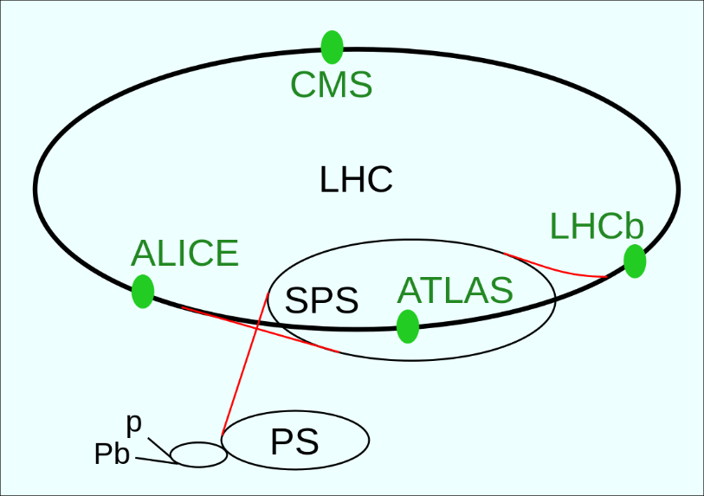

Diagram of arrangement of LHC experiments & pre-accelerators. The path of the protons (and ions) begins at linear accelerators (marked p and Pb, respectively). They continue their way in the booster (the small unmarked circle), in the Proton Synchrotron (PS), in the Super Proton Synchrotron (SPS) and finally they get into the 27-km-long LHC tunnel. In the LHC there are 4 large experiments marked with green dots and text. Taken From: Wikimedia Commons - Drawn by Arpad Horvath with Inkscape; adapted by User Jaybear with notepad;, CC BY-SA 3.0 <https://creativecommons.org/licenses/by-sa/3.0>, via Wikimedia Commons.

The Linear Accelerator (Linac)
This is a particle accelerator in which electrons or protons are accelerated along a straight evacuated chamber by an electric field of constant radio frequency. In older machines cylindrical electrodes called drift tubes are aligned coaxially with the chamber. Keeping in phase with the radio frequency supply, the charged particles are accelerated in the gaps between the electrodes. In other words, initially, the tube in front of the particles has an opposite charge to that of the particles, and hence attracts the particles. Once in the tube, the polarity of the tube changes. The particles are repelled from the tube and attracted to the next tube, and so on. Since the frequency of the electric field is constant and the particles increase in speed, the tubes get progressively longer to ensure that the particles spend the same amount of time in each tube and therefore keep in phase with the electric field.

Modern high-energy linacs are usually travelling wave accelerators in which particles are accelerated by the electric component of a travelling wave set up in a waveguide. No drift tubes are used, the radio frequency being boosted at regular intervals along the chamber by means of klystrons (microwave generators used for the amplification or generation of high frequency waves). Only a small magnetic field, supplied by magnetic lenses between the radio frequency cavities is required to focus the particles and keep them in a straight line. Typical rates of energy gain in a linac are 7 MeV per metre for electrons and 1.5 MeV per metre for protons.

CERN is famous for its circular accelerators, in particular the LHC, but the protons that circulate in these bigger machines first undergo acceleration in a humble and relatively small linear accelerator. In 2018, Linac 2, which had fed protons to CERN’s accelerator complex since 1978, was finally retired, with the 86-meter-long, Linac 4 ready to take its place. Linac 4 will achieve a beam energy of 160 MeV and accelerate negative hydrogen ions to around 1.75 x 10⁸ m/s before sending them onto the Proton Synchrotron Booster, which further accelerates the protons before injecting them into the Proton Synchrotron. The LHC accelerates protons to an extremely high fraction of the speed of light (99.9999991%).

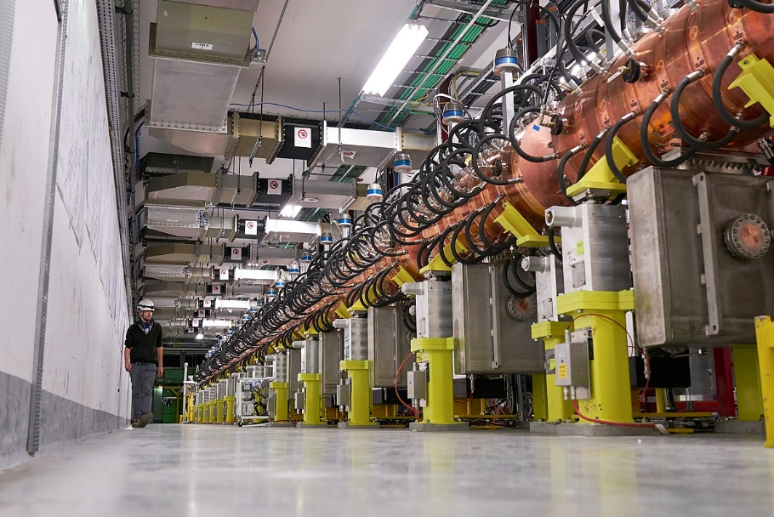

LINAC 4 - Photo From: Wikimedia Commons

ORIGINS OF THE ELEMENTS

Inquiry Question: What evidence is there for the origins of the elements?

EVIDENCE FOR HUBBLE’S LAW
Up until the 1920’s, it was commonly believed that the universe was in a steady state of balance. What you saw when you looked up at night was believed to be our galaxy, the Milky Way. The heavenly bodies were believed to be stationary relative to one another. This view was one that dates back to Isaac Newton.

In 1912, Henrietta Leavitt was studying Cepheid variable stars. These stars brighten and dim in a predictable pattern, and Leavitt discovered that their distance from us can be worked out by measuring how bright they appear to us. Leavitt's discovery provided astronomers with the first "standard candle" with which to measure the distance to faraway bodies.

Recall from “The Nature of Light” topic that the Doppler Effect of light can be used to tell if a source of light is moving away from or toward an observer. If light emitted by the source is red shifted, the source is moving away. In 1914, Vesto Slipher, an American astronomer, announced results of his studies into the Doppler shifts of the most prominent spiral nebulae (the objects that would eventually be called galaxies). Out of 15 nebulae studied, 11 were red shifted and therefore moving away from us and 4 were blue-shifted and therefore moving toward us. Slipher performed further measurements and in 1917 reported that out of 25 nebulae studied, 21 had red shifts.

By 1919, another American astronomer, Harlow Shapley, had built on Leavitt’s findings and shocked the world with his conclusions about the size of the Milky Way. Using Cepheid variables, Shapley judged that the Milky Way was 300,000 light years across, about 10 times bigger than previously thought. In his work he also noticed that globular clusters were not confined to the plane of the Milky Way, as the stars were, but rather were clustered around its centre in a sphere.

In 1924, Edwin Hubble used Leavitt’s discovery to show that the spiral nebula Andromeda was approximately 860,000 light years away. That is more than eight times the distance to the farthest stars in the Milky Way. This conclusively proved that the nebulae are separate star systems and that our galaxy is not the whole universe. Andromeda is actually a galaxy and the Milky Way is just one of many galaxies in the universe.

During the 1920’s, following on from the work of Slipher, Edwin Hubble and Milton Humason, photographed the spectra of many galaxies with the 2.5 m telescope on Mount Wilson in California. They found that most galaxies show a red shift in their spectrum. From the redshifts, Hubble used the Doppler formula to calculate the speed of recession of each galaxy.

Next, by using Leavitt’s method, observing the apparent brightnesses and pulsation periods of Cepheid variables in these galaxies, Hubble & Humason were able to determine the distance to each galaxy. When they plotted speed versus distance for the galaxies under study, Hubble & Humason found a direct correlation between the distance to a galaxy and its red shift: The more distant the galaxy, the greater its red shift and therefore the more rapidly it is receding from us.

This universal recessional movement is referred to as the Hubble flow. The velocities of recession, v, of remote galaxies are related to their distances from earth, r, via Hubble’s Law:

where H₀ is Hubble’s constant, the slope of a plot of recessional velocity v’s distance to galaxy. The actual value of this constant is one of the most controversial issues in modern astronomy because of its extreme importance – it tells us the rate at which the universe is expanding.

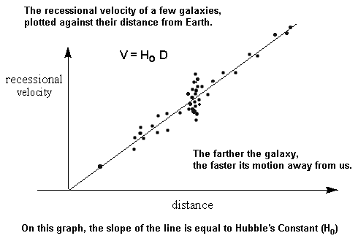
Diagram From: Wikimedia Commons

The current best direct measurement of the Hubble constant is 73.8 km/s/Mpc (give or take 2.4 km/s/Mpc including, both random and systematic errors), corresponding to a 3% uncertainty. Using only WMAP data, the Hubble constant is estimated to be 70.0 km/s/Mpc (give or take 2.2 km/sec/Mpc), also a 3% measurement. (NOTE: 1 Mpc = 1 megaparsec, a unit of distance = 3.09 x 10¹⁹ km.)

Hubble’s Law (also called the Hubble- Lemaître Law) suggests that the universe is expanding uniformly. It is important to realise that each galaxy, or cluster of galaxies, does not expand as it is held together by its own gravitational forces. It is the intergalactic space between widely separated galaxies, or clusters of galaxies, which expands with time.

Nearby galaxies have their own intrinsic velocity relative to one another due to their mutual gravitational attraction. For nearby galaxies, the speed of the Hubble flow is small compared to these intrinsic velocities. Any Doppler shifts observed are due to the intrinsic motion of the galaxies. These can be red or blue shifts. Andromeda, for instance, our closest neighbour galaxy, is moving toward us and will one day collide with the Milky Way.

For distant galaxies, the Hubble speed is much greater than any intrinsic motion the galaxies may have. The observed red shift of such galaxies is called the cosmological red shift, to highlight the fact that the observed stretching of the wavelength of the light from the galaxy is due to the expansion of space not the intrinsic velocity of the galaxy (Doppler shift).

THE BIG BANG
If we mentally reverse the expansion process, then at some time in the dim, distant past, all the matter, energy, space in the universe must have been located in a very small volume – a singularity (point) of infinite density in fact. It is generally believed that our universe resulted from the expansion of this singularity – the so-called Big Bang.

How long ago??? Hubble’s Law provides a good estimate of the answer. Let T₀ be the time it has taken the most distant galaxies (at R from us) to move away from us. Then T₀ = R/v = R/ H₀R = 1/ H₀. So, the reciprocal of the Hubble constant gives us an estimate of the age of the universe. It works out to be roughly 14 billion years. The current best estimate is 13.8 billion years (made in 2019).

The birth of the universe was not an explosion, because an explosion blows piece out into the surrounding space. Instead, the Big Bang was the start of an expansion (stretching) of space itself from a very hot and compressed beginning. A Belgian priest named Georges Lemaître first suggested the concept of the big bang theory in the 1920s and his suggestion gained support from the work of Hubble.

When hearing of the Big Bang for the first time some students wonder where it happened. Can we just trace the expanding universe backwards and find the place? The answer is no because there is no need! The reason for this can be explained in many ways but ultimately the simplest explanation is just this: the Big Bang happened where you are right now and everywhere else; in the beginning, all locations we now see as separate were the same location.

EVIDENCE FOR THE BIG BANG
The early universe was extremely hot. The hot universe contained many short wavelength photons which formed a radiation field. As the universe expanded the short wavelength photons had their wavelengths stretched to become low energy, long wavelength photons.

By the present day, the temperature of this cosmic radiation field should be quite low, just above absolute zero. This cooled down cosmic radiation field was discovered in 1965. It is called the cosmic microwave background and has a temperature of about 2.7 K. This microwave background is almost perfectly isotropic, which confirms Einstein’s assumption that the universe is isotropic. The cosmic microwave background (CMB) is a major piece of evidence for the Big Bang. (Isotropic means that the universe looks the same in all directions.)

The Big Bang Theory also predicts the correct proportion of hydrogen to helium within the universe. Using the Hubble Law, we also obtain an estimate of the age of the universe that is in good agreement with other age predictions.

PROCESSES THAT TRANSFORMED RADIATION INTO MATTER FOLLOWING THE BIG BANG
Consider the diagram below, showing the history of the development of the universe.
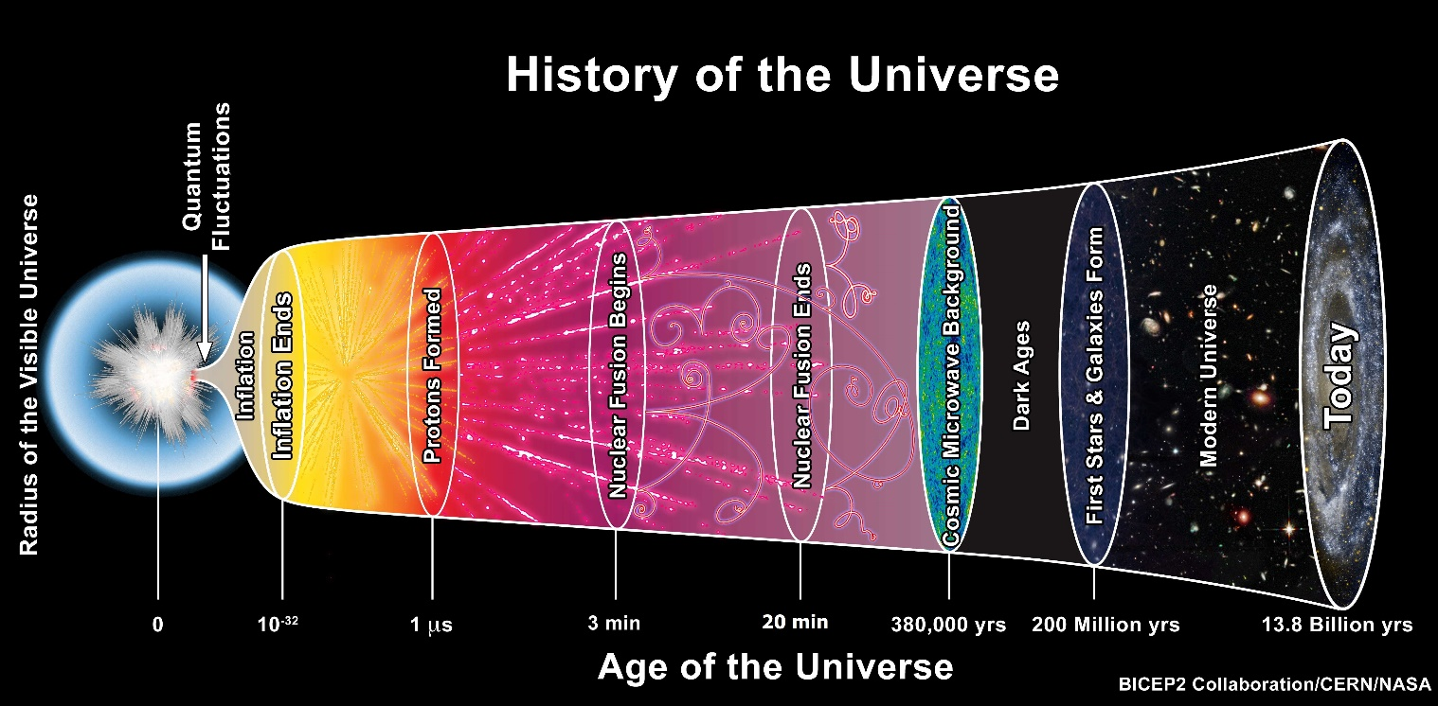

Diagram From: Wikimedia Commons - TheAstronomyBum, CC0, via Wikimedia Commons

Everything in the universe today falls into one of two categories – matter or energy. The matter in the universe is contained in such luminous objects as stars, planets and galaxies, as well as in non-luminous dark matter. Today, when we describe the constituents of matter, we do so in terms of atoms. The atom consists of a nucleus containing protons (positive charges) and neutrons (neutral) surrounded by electrons (negative charges) in orbit around the nucleus. The nucleus is of the order of 10⁻¹⁴ m in diameter and the whole atom is about 10⁻¹⁰ m in diameter.

The energy of the universe consists of radiation, that is, photons. Most photons in the universe belong to the cosmic microwave background. Physicists have determined that in the very early universe, radiation dominated over matter, that is, the mass density of radiation was greater than the average density of matter. Let us investigate the processes that led to the transformation of radiation into matter after the Big Bang.

Time in our universe began with the Big Bang. There is a point in time known as the Planck time (within 10⁻⁴³ second of the Big Bang) when gravity is comparable in strength to the other forces of nature and due to this the laws of physics as we know them do not apply. To deal with the first 10⁻⁴³ second of our universe’s existence, we need a quantum theory of gravity. The universe began with an unimaginably enormous density and temperature. It is believed that in the first 10⁻⁴³ second, the four fundamental forces of nature existed as a single, unified force and that the temperature would have been greater than 10³² K.

Expansion and Cooling
A major process that caused radiation to transform into matter was the cooling of the universe as it expanded.

The Standard Model of matter suggests that at t = 10⁻⁴³ second, the temperature of the universe was around 10³² K and that at that temperature, in a kind of phase transition, the gravitational force condensed out as a separate force. We say the symmetry of the four forces was broken. In other words, the effect of gravity became distinct from the effect of the other three forces (the strong, weak & electromagnetic forces), all of which remained unified. From t = 10⁻⁴³ second after the Big Bang to t = 10⁻³⁶ s is called the grand unified era of the universe, because during this time those three fundamental forces were unified.

The universe continued to expand and cool. At t = 10⁻³⁶ s, particle energy was 10¹⁴ GeV, the temperature was 10²⁷ K and a second spontaneous symmetry breaking occurred with the strong nuclear force being “frozen out”. It is possible that some part of this condensation process caused a small excess of matter over antimatter, resulting in the prevalence of matter today.

A period of extremely rapid expansion, called the cosmic inflation, is then believed to have occurred (see later section), during which the universe increased in size by a factor of about 10²⁶. At the end of the inflationary period, the Higgs boson responsible for elementary particle masses formed.

At t = 10⁻¹² s, the particle energy was around 10² GeV, the temperature about 10¹⁵ K, and the electromagnetic force separated from the weak nuclear force in a third symmetry breaking event. Particles began to appear in large numbers, including quarks, electrons and neutrinos. Most particles still formed in pairs with an antiparticle, but a slight bias towards particles resulted in matter that was not annihilated through contact with antimatter.

At t = 10⁻⁶ s, the particle energy was about 1 GeV and the temperature about 10¹³ K, low enough to allow quarks to remain confined to individual protons and neutrons. This period is called the period of confinement.

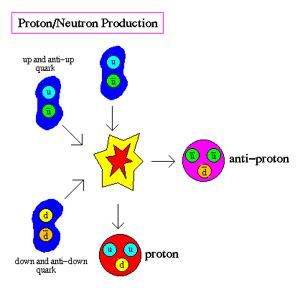
Diagram From: Wikimedia Commons
From around t = 3 min, fusion began. Deuterium, a nucleus consisting of one proton and one neutron, began to form via this process. The background radiation had cooled sufficiently (10⁹ K) to enable the deuterium nuclei to exist freely, and their average energies (100 KeV) allowed them to fuse with remaining free protons and neutrons to form helium nuclei. The process of forming nuclei such as deuterium and helium from protons and neutrons is called nucleosynthesis.

The universe was now cooling too quickly to enable fusion to continue. By t = 20 min, fusion ceased but during these few minutes most of the nuclei in the universe formed. Fusion did not occur again for millions of years (in stars). After around t = 20 min, matter consisted mainly of bare hydrogen nuclei (about 75%), helium (about 25%) and electrons. Radiation (photons) still dominated the universe.

This ratio of hydrogen to helium was due to the ratio of protons to neutrons available for fusion. The ratio of total neutrons to protons was about 1/7. Almost all neutrons that fused instead of decaying ended up combined into helium-4 because helium-4 has the highest binding energy per nucleon among light elements. So, on average, out of every 16 particles, 2 will be neutrons, 14 protons. To make He-4 we require 2 neutrons & 2 protons, leaving 12 protons remaining out of our 16 particles. Thus, for every He-4 nucleus formed, there will be 12 hydrogen nuclei, or a mass fraction of helium-4 of about 25%, and hydrogen 75%, which is in line with observations.

Around 380 000 years after the Big Bang a fundamental change occurred in the nature of the universe. At this time, the temperature was around 3000 K and the energy of photons, electrons and nuclei was less than 1 eV. Since the ionization energies of atoms is of the order of eV, once the temperature dropped below this point, protons and electrons could combine to form hydrogen atoms. This is a major step in the evolution of the universe, since today hydrogen is the most abundant element in the universe. The epoch when atoms first formed is called the era of recombination (a bit of a misnomer really, considering electrons had never before been combined with nuclei to form atoms).

As the universe expanded, the wavelength of photons increased, and their energy decreased. Models suggest that somewhere between 56 000 and 70 000 years after the Big Bang, the total energy contained in radiation became less than the total energy contained in matter. The universe was now matter-dominated. As the universe continued to expand, the EM radiation cooled further, to 2.7 K today, forming the cosmic microwave background radiation we detect everywhere in the universe.

The diagram on page 66 titled “The Early History of our Universe” is an excellent visual summary of the above details.

Let us highlight some specific processes mentioned above that assisted in the transformation of radiation into matter, as the universe expanded and cooled.

Cosmic Inflation
At t = 10⁻³⁶ s an extremely brief period of exponential expansion, called cosmic inflation, occurred. From t = 10⁻³⁶ s to somewhere between 10⁻³³ and 10⁻³² of a second after the Big Bang, the linear size of the universe increased by a factor of about 10²⁶. Physicists still do not understand what caused this inflation.

During inflation, the energy density of the universe was dominated by a type of vacuum energy that later decayed to produce the matter and radiation that fill the universe today. At the end of inflation, the universe slowed down its breakneck expansion to a more moderate rate. The energy inherent in that inflation was dumped into the universe – as matter and radiation.

Prior to inflation, the portion of the universe we can observe today was microscopic, and quantum fluctuation in the density of matter on these microscopic scales expanded to astronomical scales during inflation. Over the next several hundred million years, the higher density regions condensed into stars, galaxies, and clusters of galaxies.

Photon Collisions Resulting in Particle Pair Production
A major process by which radiation was transformed into matter after the Big Bang, was by photon collisions resulting in particle pair production. Two photons colliding with the right amount of energy can produce a particle-antiparticle pair of particles. Einstein’s E = mc² equation can be used to calculate the energy required. The total photon energy must be at least equivalent to the total rest mass of the particles to be produced.

During the grand unified era for instance, photons had sufficient energies to form the first matter particles – quarks and leptons. The matter particles produced quickly collided with their antimatter equivalents resulting in annihilation and the transformation of the matter back into energy in the form of photons.

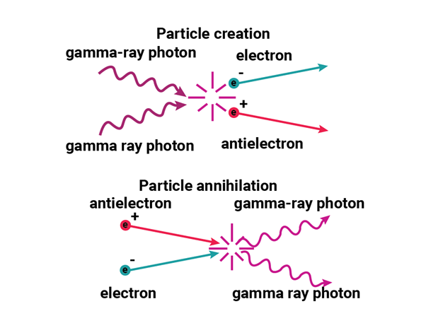
Diagram From: Wikimedia Commons

Symmetry Breaking
During its early evolution, as the temperature decreased, certain critical temperatures were reached where phase transitions occurred. At some of these phase transitions, symmetry breaking occurred and resulted in the condensation, one after the other, of the four fundamental forces from the single unified force which existed in the Planck era. See diagram below. Note the discrepancy with the timing of the condensation of the strong nuclear force. Some models say this occurred at 10⁻³⁵ s and others at 10⁻³⁶ s.

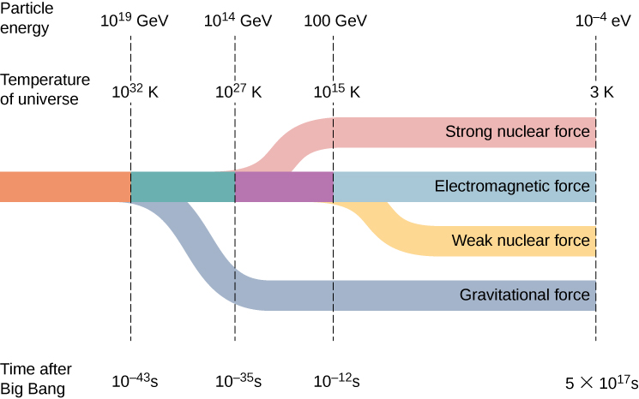

Diagram From: Wikimedia Commons

The term symmetry breaking simply means that as each force condensed from the single unified force, it acquired the specific characteristics that it displays today. So, for instance, as the strong nuclear force condensed, it became able to combine nucleons and quarks together strongly enough to eventually produce the nuclei and atoms we see today. Without the strong nuclear force being exactly as it is today, matter as we know it may never have formed from the radiation in the early universe. Without gravity, stars and galaxies would never have formed and life as we know it would not exist. Each of the symmetry breaking events helped in some way to transform radiation into matter.

Nucleosynthesis
Nucleosynthesis is the process of creating elements by nuclear reactions. The Big Bang nucleosynthesis is the process of forming nuclei such as deuterium, helium and small amounts of lithium from protons and neutrons. This too is an important process which helped transform radiation into matter in the early universe and formed the first atomic nuclei. Common reactions are as shown below. d represents deuterium.

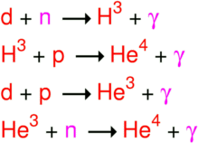

Diagram From: Wikimedia Commons

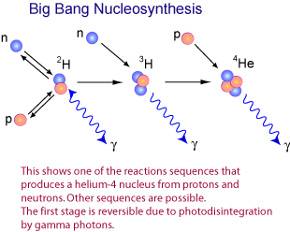

Diagram From: Wikimedia Commons

Comment: Dark Matter & Dark Energy (not required for the Stage 6 Syllabus)
WMAP and other experiments have convinced scientists that the visible universe is only a tiny amount (about 5%) of what the universe is made of. A very large fraction of the universe, about 27%, is made of an unknown type of matter called dark matter. Unlike stars and galaxies, dark matter does not emit any light or electromagnetic radiation of any kind, so that we can detect it only through its gravitational effects.

An even more mysterious form of energy called dark energy accounts for about 68% of the mass-energy content of the universe. Even less is known about it than dark matter. This idea stems from the observation that all distant galaxies appear to be receding from each other at an accelerating pace, implying that some invisible extra energy is at work.
Diagram: The Early History of our Universe (see next page)
The timeline of the Big Bang on the next page shows a sequence of events as currently theorized by physicists (up to date as at 2021), that takes us from the Big Bang through to the stage of a matter dominated universe.
The vertical scale is a logarithmic scale that shows 10.log₁₀ second instead of second. For example, one microsecond is 10.log₁₀ (0.000001) second = 10 x (-6) = -60. To convert −430 read on the scale, to seconds, calculate 10^{-430/10} = 10⁻⁴³ second. On a logarithmic time scale a step lasts ten times longer than the previous step.

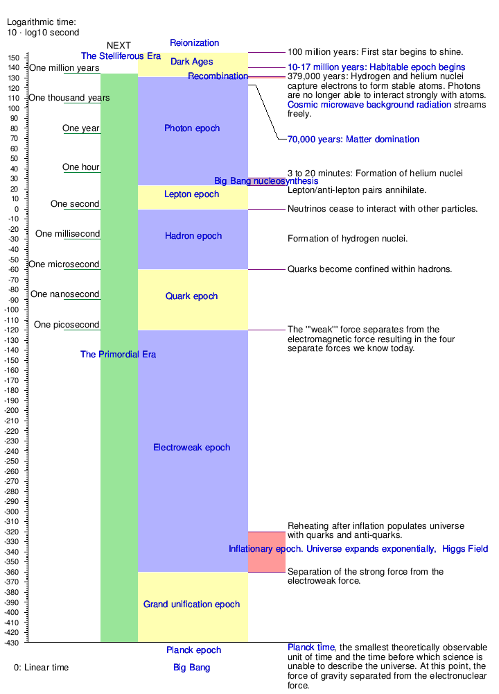

The Early History of our Universe – Diagram From: Wikimedia Commons

NUCLEAR REACTIONS THAT OCCUR IN STARS

The Equivalence of Mass and Energy
As we have seen previously, mass is a form of energy. It turns out that mass = energy/c² or in a more recognizable form:

E = mc²

This is Einstein’s most famous equation.

This equation states the equivalence of mass and energy. It establishes that energy can be converted into mass and vice versa. For example, when a particle and its antiparticle collide, all the mass is converted into energy. When two photons collide with sufficient energy, a particle-antiparticle pair is created. Mass is converted into energy in nuclear fission and fusion. When a body gives off energy E in the form of radiation, its mass decreases by an amount equal to E/c². This has been experimentally verified to a very high degree of precision. Note that the E = mc² equation shows that a very large amount of energy is released by the conversion of a very small amount of mass.

The equation E = mc² gives the rest energy, usually called the internal energy, of an object. It is the energy possessed by an object by virtue of its mass. If an object is in motion, the total relativistic energy E_{T}, is given by the equation:

The derivation of this equation is beyond the scope of this course. The equation is not one mentioned in the Syllabus. I include it here for completeness.

In Special Relativity, the Law of Conservation of Energy and the Law of Conservation of Mass have been replaced by the Law of Conservation of Mass-Energy.

In 1920, Arthur Eddington (1882-1944) suggested hydrogen-helium fusion could be the primary source of stellar energy. He used Einstein’s mass-energy equivalence equation as the basis for his suggestion. He stated that even if only 5% of the sun’s mass was hydrogen, its gradual transformation into helium by fusion would account for the sun’s energy production. In 1925, Cecilia Payne (1900–1979), used spectroscopy to demonstrate that the Sun was mostly made of hydrogen, giving great credibility to Eddington’s suggestion. In 1938-39, Hans Bethe (1906-2005), finally determined the theory of the main cycle of nuclear fusion in stars.
So, in stars, nuclear fusion reactions are responsible for producing energy. Some of the mass of the star is converted into energy via a series of fusion reactions. We described the process of nuclear fusion earlier in this module. We have already seen that Einstein’s E = mc² can be used to determine the amount of energy released in fusion reactions.
For example, consider one of the simplest fusion reactions which involves the production of deuterium (H-2), from a neutron and a proton. Einstein’s equation can be used to calculate the amount of energy released in this reaction. The energy released equals the difference in mass (times c²) between initial and final masses. You have the necessary data from previous examples, except for mass of deuterium atom, H-2 = 2.014082 u.
Solution
The 2.24 MeV is carried off by the H-2 nucleus and the γ-ray.

SPECTRA

As we saw in The Nature of Light module, when a beam of sunlight is shone through a triangular glass prism, the white light is dispersed, producing a rainbow of colours, which can be displayed on a screen. The rainbow of colours is called a spectrum. In 1814 the German optician Joseph von Fraunhofer used a spectroscope to study the spectrum of sunlight in detail and discovered that it contains hundreds of fine dark lines, now called spectral lines. Fifty years later, chemists found that they could produce spectral lines in the laboratory and use these lines to analyze the kinds of atoms of which substances were made.

There are three basic types of spectrum: a continuous spectrum, an emission spectrum and an absorption spectrum. Let us now examine each in turn.

Continuous Spectrum
A hot, glowing solid or liquid or a hot, glowing, dense gas produces a spectrum consisting of a continuous series of coloured bands ranging from violet on one end to red on the other. In fact, this is just the visible section of the continuous spectrum of blackbody radiation, which we have previously studied. Examples of objects that produce continuous spectra include: an incandescent light globe, the inner layers of a star and galaxies.

Recall that a blackbody is a hypothetical body that is a perfect absorber and emitter of electromagnetic radiation. At any temperature above absolute zero a blackbody emits as much energy as it absorbs. The emitted radiation has a continuous distribution of wavelengths and the intensity of the spectrum at any given wavelength depends only on the temperature of the surface of the body. A perfect blackbody does not reflect any light at all. This is the reason why any radiation that it emits is entirely due to its temperature.

The theoretical intensity (energy density) versus wavelength curves for blackbody radiation are as shown below. There is a very close correlation between the theoretical blackbody curves and the observed intensity curves for most stars. Since the physics of blackbody radiation is well understood, this correlation allows a great deal of information about stars to be determined by studying their intensity versus wavelength curves. More on this soon.

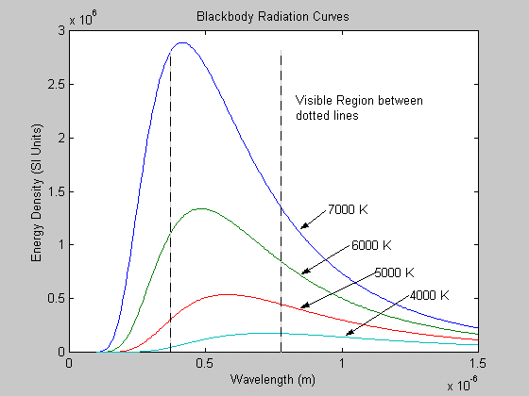

Emission Spectrum
This is a series of bright, coloured lines on a black background, produced by a hot, glowing, diffuse gas. For example, the spectrum of hydrogen when heated to incandescence by passing an electric discharge through the gas is a series of four spectral lines (violet, blue, green & red) seen on a black background. See diagram below. Other examples of objects producing emission spectra include emission nebulae such as planetary nebulae; quasars; and Wolf-Rayet stars.

Spectrogram of visible lines in the Balmer series of hydrogen as obtained with a
constant-deviation spectrograph – Diagram from Wikimedia Commons

Note that the emission lines in the above diagram are not representative of the exact colour or line thickness of the real hydrogen emission lines. The line thickness varies, with red normally being the broadest line and violet the thinnest.

To account for the production of emission spectra we need to consider what is happening on an atomic level. When a gas is heated, the electrons increase their energies to higher energy levels. These higher energy levels are temporary and energy is released when an electron drops back down to one of the lower energy levels in the atom. This energy is emitted as EM radiation of very specific frequencies, some of which are visible light.

Absorption Spectra
This is a series of dark spectral lines among the colours of the continuous spectrum. These dark spectral lines represent wavelengths that are missing from an otherwise continuous spectrum. Absorption spectra are produced when light from a hot source of continuous spectrum passes through a cooler, non-luminous, diffuse gas. The spectra of normal cool stars such as the Sun fall into this category. Note that the dark lines in the absorption spectrum of a particular gas occur at the same wavelengths as the bright lines in the emission spectrum of the same gas. See some example absorption spectra below.

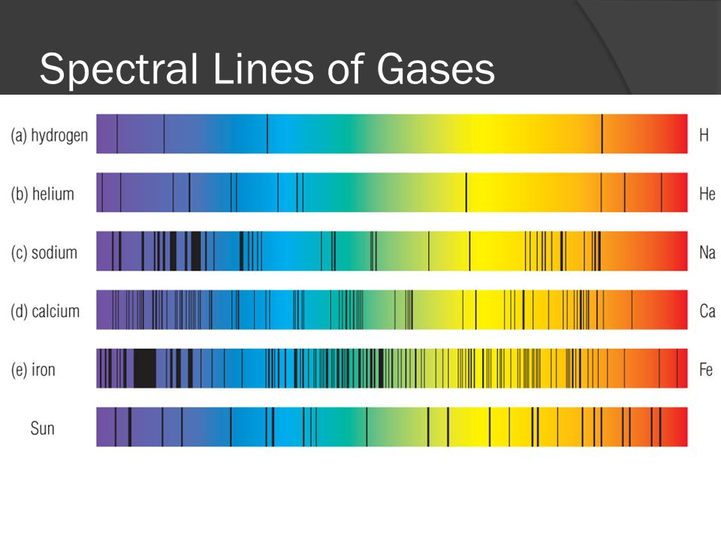
Diagram From: Wikimedia Commons

To account for the production of absorption spectra it is again convenient to think on an atomic level. Consider the core of a star like our sun. The hot, dense plasma in the core produces light with a continuous spectrum, behaving like an ideal black body radiator. Photons from this source of continuous spectrum pass through the cool diffuse gas (eg hydrogen) lying in the star’s outer atmosphere. The atoms of the gas will absorb those photons whose energies match allowed energy transitions within the atom. The absorbed photons raise electrons within the atom from lower to higher orbits. When these electrons drop back to their original orbits, they emit the energy they originally absorbed but in all directions not just in the original direction of motion of the photons. Therefore, these energies, with their corresponding frequencies are removed from the continuous spectrum observed on Earth and a series of black lines is seen in their place.

Comparison of Emission & Absorption Spectra with a Continuous Blackbody Spectrum
An emission spectrum is clearly very different to a blackbody spectrum. An emission spectrum is a line spectrum with each coloured line corresponding to a particular wavelength (or frequency) of emission. Between the lines there is darkness. The blackbody spectrum is a continuous spectrum of colours from red to violet in the visible range.

An absorption spectrum is much closer in appearance to a blackbody spectrum than is an emission spectrum. An absorption spectrum consists of an almost continuous background of colours from red to violet, with the continuity broken by black absorption lines representing wavelengths of radiation that have been absorbed somewhere between the source of radiation and the observer.

As mentioned earlier, a great deal of information about stars and other celestial objects can be obtained by comparing their spectra to blackbody spectra. For example, by comparing the intensity versus wavelength curves for real stars with those of a blackbody we can determine the surface temperature of stars. By comparing a star’s absorption spectrum with a blackbody spectrum and noting the differences we can determine the chemical composition of the star.

Stellar Spectra and the Classification of Stars
As astronomers made more and more observations of the absorption spectra of stars during the nineteenth century, they discovered a bewildering variety of different spectra. Thanks to Cecilia Payne’s work in the 1920’s, we know today that this is because a star’s spectrum is profoundly affected by its surface temperature. Every element has a characteristic temperature range over which it produces prominent absorption lines in the observable part of the spectrum. For example, for the Balmer hydrogen lines to be prominent in a star’s spectrum, the star must be hot enough to excite the electrons out of the ground state but not so hot that all the hydrogen atoms become ionized. A stellar surface temperature of around 9000 K produces the strongest hydrogen lines. Different temperatures produce different degrees of excitation or ionization of the various atoms and molecules present in a star. This in turn produces different strength absorption lines.

To bring order to the huge variety of different spectra they had found, astronomers grouped stars into several spectral classes that summarize features such as colour, surface temperature and chemical composition. The order of these classes from highest to lowest temperature can be remembered using the mnemonic “Oh, Be A Fine Girl (or Guy), Kiss Me Lots Today”. See the Table below which has been taken from Universe (Ninth Edition) by Kaufmann & Freedman p.449.

Spectral  Class | Colour | Temperature  (K) | Spectral Line Features | Examples
O | Blue-violet | 30000-50000 | Ionized atoms especially helium | Mintaka  (δ Orionis)
B | Blue-white | 11000-30000 | Neutral helium, some hydrogen | Rigel  (β Orionis)
A | White | 7500-11000 | Strong hydrogen, some ionized metals | Sirius  (α Canis Majoris)
F | Yellow-white | 5900-7500 | Hydrogen, ionized metals (Ca, Fe) | Canopus  (α Carinae)
G | Yellow | 5200-5900 | Both neutral & ionized metals, especially ionized Ca | Sun
K | Orange | 3900-5200 | Neutral metals | Aldebaran  (α Tauri)
M | Red-orange | 2500-3900 | Strong titanium oxide & some neutral Ca | Antares  (α Scorpii)
L | Red | 1300-2500 | Neutral potassium, rubidium & cesium & metal hydrides | Brown Dwarf Teide 1
T | Red | Below 1300 | Strong neutral potassium & some water | Brown Dwarf Gliese 229B, HD 3651B

Note that astronomers use the term “metals” to refer to any element above helium in the Periodic Table. Clearly, this is different to the term’s meaning in chemistry.

Each spectral class is further sub-divided into finer steps called spectral types. These are indicated by adding a number from 0 to 9 after the appropriate letter for the spectral class. The “0” is the hottest spectral type and the “9” is the coldest. So we have for example, the spectral class F, which includes spectral types F0, F1, F2, ….. F9.

The modern stellar classification system also includes a luminosity class, which indicates for example, whether a star is a supergiant, giant or dwarf. This is useful since luminosity can vary widely within a spectral type, as can be seen easily from the diagram below. This is a type of Hertzsprung-Russell (H-R) diagram. We study H-R Diagrams next.

Luminosity classes Ia and Ib are composed of Bright Super Giant stars and Super Giant stars respectively. Luminosity class V includes all main sequence stars. The classes in between provide a useful means of distinguishing giant stars of various luminosities – Class II Bright Giant stars, Class III Giant stars and Class IV Subgiant stars. Class VI consists of Subdwarf stars. There is no luminosity class assigned to white dwarfs, since they represent a final stage in stellar evolution in which no thermonuclear reactions are taking place. Consequently, white dwarfs are referred to only by the letter D (for dwarf).

On an H-R diagram astronomers describe stars by giving both a spectral class and a luminosity class. The spectral class indicates the star’s surface temperature and the luminosity class its luminosity. For instance, Aldebaran is a K5 III star, which means that it is a red giant with a luminosity around 500 times that of the sun and a surface temperature of about 4000 K. The sun is a G2 V star, which means that it is a main sequence star of luminosity equal to the sun (obviously) and surface temperature of about 5800 K.

This two-dimensional classification scheme enables astronomers to locate a star’s position on the H-R diagram based entirely on the appearance of its spectrum. This is very useful, since once the star’s absolute magnitude has been read from the vertical axis of the H-R diagram, the distance to the star can be calculated using a method called spectroscopic parallax.

THE HERTZSPRUNG-RUSSELL (H-R) DIAGRAM

Even though in photographs of stars, bright stars appear larger than dim ones, it would be very wrong to assume that this is actually the case. In fact, to determine the size of a star, an astronomer must combine information about the star’s luminosity (determined from its distance & apparent brightness) and its surface temperature (determined from its spectral type). Luminosity is the total amount of electromagnetic energy emitted per unit of time by a star, galaxy, or other astronomical object. Its SI unit is therefore the watt (W).

Using the Stefan-Boltzmann law, we can deduce the relationship between a star’s luminosity, radius and surface temperature:

where L = star’s luminosity (watts), R = radius of star (m), σ = Stefan-Boltzmann constant and T = star’s surface temperature (kelvin). Clearly then, even a very cool star (low T) can have a very high luminosity, if its radius is sufficiently large.

This relationship between luminosity and surface temperature led the Danish astronomer, Ejnar Hertzsprung, in 1911 to discover that a regular pattern is revealed when absolute magnitudes of stars (a measure of their luminosities) are plotted against their colours (a measure of their surface temperatures). In 1913 the American astronomer, Henry Norris Russell, independently found a similar pattern in a plot of absolute magnitudes versus spectral types (another measure of surface temperature).

Today, the Hertzsprung-Russell (H-R) Diagram is one of the most important in all astronomy because of its ability to summarize so many trends so succinctly and because of its usefulness in helping us to understand the evolution of stars. Let us now examine the H-R Diagram in detail.

The Hertzsprung-Russell Diagram is a graph of the luminosities of stars against their colour or surface temperature. On such a graph each data point represents a star whose spectral type and luminosity have been determined. The most luminous stars are near the top of the graph, the least luminous stars are near the bottom. Hot stars (O & B stars) are towards the left side of the graph while cool stars (M stars) are toward the right. The graph below shows only a few stars and is designed to show the general patterns which emerge on an H-R plot.

Note the different possibilities for axes. H-R diagrams can be plotted as:

- Luminosity v’s surface temperature (or spectral class or colour index)
- Absolute magnitude v’s surface temperature (or spectral class or colour index)
- Log₁₀ of the luminosity relative to the sun v’s surface temperature etc

The first important lesson to come from the H-R diagram is the existence of fundamentally different types of stars. The plot clearly shows that stars are found in four main groups: Main Sequence, Red Giants, Super Giants and White Dwarfs.

The main sequence stars are represented by a band that runs from bright, hot, blue giant, O class stars in the top left corner down to dim, cool, red dwarf, M class stars in the lower right corner. Between 80% and 90% of all stars are main sequence stars. They are in their hydrogen burning phase and remain on the main sequence until the hydrogen in their cores is exhausted. Note that here the word “burning” is used to mean “nuclear fusion” – a common piece of jargon used by astronomers. Stars on the main sequence are very stable. The sun is a main sequence star of intermediate luminosity, surface temperature (and radius) and has sufficient hydrogen to keep it on the main sequence for at least another five billion years.

The masses of main sequence stars are directly related to their absolute magnitudes. The brighter the star, the greater the mass of the star; the dimmer the star, the lower the mass.

Red Giant stars are found in the upper right section of the H-R plot. They are 10 to 100 times more massive than the sun and are also about 100 times more luminous than the sun. Since these stars clearly have low surface temperature, their high luminosity can only come from a very large radius. These stars are cool, reddish in colour and gigantic in size. They fuse helium to carbon in their cores and have hydrogen fusion continuing in the shell around the core. Aldebaran in the constellation of Taurus and Arcturus in the constellation of Bootes are examples of Red Giant stars.

A few rare stars are considerably bigger and brighter than typical red giants, with radii up to 1000 times that of the sun. These stars are referred to as Super Giants. They have multiple fusion reactions occurring in the shells surrounding the core and can form elements up to iron in their cores. Betelgeuse in Orion and Antares in Scorpius are two examples of Super Giant stars.

White dwarfs form the fourth main group of stars on the H-R plot and are located in the bottom left section. These stars are about the same size as the earth and can only be seen with the aid of a telescope. They have temperatures of about 10 000 K on average, are very dim and typically whitish in colour. Note however, that surface temperatures for white dwarfs do range from 5000 K to 80 000 K and that therefore they can have colours other than white. White dwarfs are the remains of giant stars at the end of their life. They have no thermonuclear reactions occurring in their interiors.

Evolutionary Stage
Stars are not static objects. As a star consumes fuel in fusion, its structure and composition changes, affecting its colour and luminosity. Thus, the H-R diagram not only allows us to determine the type, colour, temperature and luminosity of stars, it shows these stars at different stages of their evolution.
See the H-R diagram below showing the evolutionary track for a 1 solar mass star (eg our Sun), taken from the Sloan Digital Sky Survey website at:

http://cas.sdss.org/dr4/en/astro/stars/stars.asp

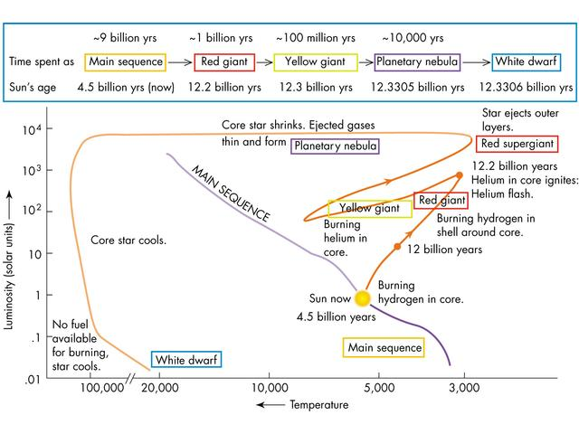
The time spent on the main sequence depends on a star’s mass. The more massive the star, the faster it burns fuel and the less time it spends on the main sequence. Over time, a star on the main sequence, becomes a red giant and moves to the red giant area in the upper right of the H-R diagram. Massive O-stars become red giants in only 10 million years. Less massive stars, like our Sun, take 10 billion years to become red giants. This actually provides a way of determining the age of a group of stars. Scientists plot H-R diagrams for the stars in the group and note which classes of stars have evolved off the main sequence.
Once all the helium in a red giant core has been consumed, what happens next depends on the mass of the star. For stars of 8 solar masses or less, the star sheds its outer layers to form a planetary nebula, leaving the core as a white dwarf. For stars of mass greater than 8 solar masses, carbon fusion commences. Once the carbon is consumed, these stars explode as supernovae, leaving behind neutron stars or black holes, depending on the mass of the stellar core.

NUCLEOSYNTHESIS IN MAIN SEQUENCE AND POST-MAIN SEQUENCE STARS – Where did the elements come from?

By definition, a main sequence star is one that produces energy by the fusion of hydrogen nuclei (protons) to helium nuclei in its core. This fusion reaction produces energy by the conversion of some of the hydrogen nuclei mass into energy according to Einstein’s equation, E = mc². Note that astronomers are notorious for referring to fusion reactions as “burning”. So, they speak of “hydrogen burning” instead of hydrogen fusion and “helium burning” instead of helium fusion, and so on.

Two different fusion mechanisms are responsible for the helium production and consequent release of energy in main sequence stars. Both mechanisms can occur simultaneously in a main sequence star. However, for stars whose core temperatures are below 16 million K the proton-proton chain reaction is the main mechanism, while for stars whose core temperatures are above this, the carbon-nitrogen-oxygen (or CNO) cycle predominates. Let us now investigate these two mechanisms.

The Proton-Proton Chain Reaction
This reaction predominates in stars like our Sun. Originally proposed by the American physicist Charles Critchfield, this reaction has three branches. Since the primary branch PP I, produces 85% of the Sun’s energy, we will consider only this branch of the reaction in detail. PP I consists of three steps:

In step 1, two protons combine to form a deuterium nucleus, a positron, a neutrino and 0.44 MeV of energy. In step 2, another proton combines with the deuterium nucleus to form a nucleus of light helium, a gamma ray photon and 5.48 MeV of energy. In step 3, two light helium nuclei combine to produce a nucleus of ordinary helium, two protons and 12.86 MeV of energy.

Thus, the overall reaction is to convert four protons into a nucleus of helium with the release of some energy. Note that it takes two of each of the first two reactions to produce the two He-3 for the third reaction.

In the PP II and PP III branches of the reaction the light helium produced in step 2 above suffers different fates.

In terms of the total energy released by PP I, we have:

E = (2 x 0.44) + (2 x 5.48) + (12.86) = 24.7 MeV

And each of the two positrons annihilates with an electron to produce an extra 1.02 MeV from each annihilation.

Thus, the total energy released in one complete PP I cycle = 24.7 + (2 x 1.02) = 26.7 MeV

The Carbon-Nitrogen-Oxygen (CNO) Cycle
This reaction mechanism predominates in stars whose core temperatures are above 16 million K. Hans Bethe and Carl von Weizsacker discovered it independently. In the CNO cycle the carbon-12 nucleus acts as a catalyst and the following six-step reaction takes place.

Overall, in this reaction four protons are converted into a helium nucleus, two positrons, two neutrinos and high-energy gamma ray photons.

For the CNO cycle to proceed, there must be carbon-12 nuclei present. Obviously, as the carbon-12 is returned at the end of the cycle, it is not actually used up by the reaction.

The fact that fusion is the energy producing process in the sun has been verified in neutrino detection experiments.

The Red Giant Stage in the Life of a Star (Post-Main Sequence)
When the hydrogen has been exhausted in the core of a main sequence star, hydrogen fusion ceases. This leaves a core consisting almost entirely of helium, surrounded by a shell through which hydrogen fusion works its way outward in the star.

When the hydrogen burning stops in the core, the temperature there decreases causing a corresponding decrease in pressure. The core contracts under the weight of the outer layers of the star. As the core contracts it becomes hotter, and the heat flows outwards warming the gases around the core and increasing the rate of shell hydrogen burning. Helium produced by these reactions falls back into the core, which continues to contract and heat up as it gains mass. Over the course of hundreds of millions of years, the core of a one solar mass star compresses to about one-third of its original radius, while the core temperature increases from about 15 million K to about 100 million K.

While the core contracts, the hydrogen fusion continues to move outwards causing an increase in the star’s luminosity and an increase in the star’s internal pressure. This increase in pressure makes the entire star expand to many times its original radius. This massive expansion of the star’s outer layers causes the star’s surface temperature to decrease. Once the surface temperature has reached about 3500 K, the gases glow with a reddish hue, in accordance with Wien’s Law. The star is then called a Red Giant star. Red Giant stars are stars that have finished their time on the main sequence and have evolved into a new stage of post-main sequence existence.

In a moderately low-mass red giant, which the Sun will be in another 5 billion years or so, the dense helium core is about twice the size of the Earth and the star’s bloated surface has a diameter of about 1AU (the distance from the Sun to the Earth).

When a star first becomes a red giant, the temperature of the contracted helium core is still too low for helium fusion to commence. In time, as the hydrogen burning shell continues to add mass to the helium core, the core contracts even more, further increasing the core temperature. When the core temperature reaches about 100 million K, the fusion of helium begins there. This process, also called the triple alpha process, converts helium to carbon and oxygen. In a high-mass red giant (mass > 2 to 3 solar masses), with a hotter core, helium burning begins gradually whereas in a low-mass red giant (mass < 2 to 3 solar masses), it begins very suddenly, in a process called the helium flash.

Note that for red giants with masses less than about 0.5 solar masses, the core will never reach the temperature required for helium fusion and the core and shell both contract and become hotter until the star has become a white dwarf.

The reactions involved in the triple alpha process are as follows:

Clearly, in step 1, two helium nuclei combine to form a very unstable isotope of beryllium. In step 2, a third helium nucleus collides with the beryllium nucleus to form a stable isotope of carbon. A gamma ray photon is emitted in this process. Note that the name “triple alpha process” arises from the common name for the helium nucleus – the “alpha particle”.

Some of the carbon produced in the triple alpha process can fuse with another helium nucleus to produce a stable isotope of oxygen, as shown below:

The triple alpha process produces only 10% of the energy per kilogram of fuel compared with hydrogen fusion. A mature red giant fuses helium in its core for about 20% as long as the time spent on the main sequence. So, for example, in the distant future our Sun will burn helium for about 2 billion years.

The changes that occur in red giants after the onset of helium burning cause some red giants to become unstable. For instance, the hydrogen burning shell may become sufficiently unstable to cause the star to pulsate as a periodic variable, driven by the changed radiation pressure within.
Further Nucleosynthesis Reactions in Post-Main Sequence Stars
Helium fusion eventually ceases in the core of red giant stars. Stars of less than 4 solar masses then undergo further helium fusion in the helium shell surrounding the core. They enter a second red giant phase and over a period of time ultimately give rise to planetary nebulae and white dwarf stars, as mentioned previously.

For a star of 4 solar masses or more after core helium burning ceases, the core is sufficiently massive to continue contracting, increasing the core temperature. When the core temperature reaches 600 million K, carbon fusion commences. This fusion process produces oxygen, neon, sodium and magnesium.

For stars of 8 solar masses or greater, the cessation of carbon fusion results in further contraction and heating of the core. At a core temperature of around 1 billion K, neon fusion begins, which uses up the neon accumulated from the carbon fusion and increases the amounts of oxygen and magnesium in the star’s core.

Once the neon fusion has finished, the core will contract again and oxygen fusion will commence at around 1.5 billion K. This reaction produces sulfur.

When oxygen fusion is complete, the core will contract again and silicon fusion commences at around 2.7 billion K. Silicon fusion produces several nuclei from sulfur to iron.

Each new stage of core fusion generates a new shell of material around the core. After several such stages, the internal structure of a very massive star (eg a 25 solar mass star) resembles that of an onion as shown in the diagram below. Note that iron is the final element that is produced by the fusion reactions occurring inside the core of a massive star. The fusion of iron or any element heavier than iron consumes energy rather than releasing it.

The diagram above shows a high-mass star that has become a supergiant. Its diameter is almost as large as the orbit of Jupiter around the Sun. The star’s energy comes from six concentric burning shells, all contained within a volume roughly the size of Earth. No thermonuclear reactions occur in the iron core, since fusion reactions that involve iron absorb energy rather than releasing it.

Between each new stage of core fusion comes a period of shell fusion and a new red giant phase for the star. This means that the evolutionary tracks of high mass stars go through a series of back-and-forth gyrations on the H-R diagram. See the diagram on the next page showing the evolutionary track for a star of about 10 solar masses.

The energy released by the processes described above causes the star’s outer layers to expand greatly. The result is a Supergiant star. The largest supergiants are a thousand times larger than our present-day Sun, with diameters as large as the orbit of Jupiter around the Sun.

Betelgeuse and Rigel in the constellation of Orion and Antares in the constellation of Scorpius are easily observable examples of supergiant stars. Spring/summer is best for observing Orion in Australia and autumn/winter for Scorpius.

For completeness, we will mention the two main processes that are believed to be responsible for the production of the elements heavier than iron. The first of these is the slow neutron capture reaction. The s-process, as the reaction is called, involves the capture of neutrons by existing nuclei (eg Fe-56) to form heavier ones. Unstable nuclei formed in this way then undergo the beta-decay process to produce new elements. This process can form elements up to and including lead.

The second process is the rapid neutron capture reaction, also called the r-process. This occurs during type II supernova events and builds on iron to produce all of the heavier elements found in the periodic table.

See diagram summarizing life cycle of a star on the next page.

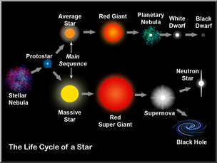

Diagram From: Wikimedia Commons

BIBLIOGRAPHY

- Giancoli, D.C., (2008). Physics for Scientists & Engineers – Volume III, USA, Pearson Education Inc.
- Hollow, R. & Morgan, A., (1990). History of Ideas in Physics – Gravitation and Atomic Structure, Australia, Brooks Waterloo
- Joyce, J. & Vogt, R., (1990). Nuclear Physics, Australia, Brooks Waterloo
- Eisberg, R. & Resnick, R. (1974). Quantum Physics of Atoms, Molecules, Solids, Nuclei and Particles, Canada, Wiley
- Kaufmann, W.J. III, & Freedman, R.A. (2011). Universe, (9th Edition), New York, W.H. Freeman & Company

APPENDIX A

Statement of Syllabus Content Covered in these Notes

The following indicates the specific content from the Stage 6 Physics Syllabus that has been covered in the notes, worksheets & practicals provided on From the Universe to the Atom Module web page.

The resources on this website are meant to supplement the work you do in class NOT replace it. The notes will always provide you with a comprehensive and accurate set of notes on the Module under study. The worksheets will provide some introduction & practice to appropriate problem-solving skills for the topic. You will need to do much more problem-solving practice than just what is provided on this website. The practicals section will provide some experiments relevant to the topic but again you will need to do more than just what is suggested here. Your teacher should provide you with much more problem-solving & practical experience than you will find on this website.

The content statements that are ticked have been covered. Those left without a tick have either not been covered at all or have been only partially covered. These are mainly content statements requiring practical work of some kind.

Content

Origins of the Elements
Inquiry question: What evidence is there for the origins of the elements?

Students:
- investigate the processes that led to the transformation of radiation into matter that followed the ‘Big Bang’
- investigate the evidence that led to the discovery of the expansion of the Universe by Hubble (ACSPH138)
- analyse and apply Einstein’s description of the equivalence of energy and mass and relate this to the nuclear reactions that occur in stars (ACSPH031)
- account for the production of emission and absorption spectra and compare these with a continuous black body spectrum (ACSPH137)
- investigate the key features of stellar spectra and describe how these are used to classify stars
- investigate the Hertzsprung-Russell diagram and how it can be used to determine the following about a star:
  - characteristics and evolutionary stage
  - surface temperature
  - colour
  - luminosity
- investigate the types of nucleosynthesis reactions involved in Main Sequence and Post-Main Sequence stars, including but not limited to:
  - proton–proton chain
  - CNO (carbon-nitrogen-oxygen) cycle

Structure of the Atom
Inquiry question: How is it known that atoms are made up of protons, neutrons and electrons?

Students:
- investigate, assess and model the experimental evidence supporting the existence and properties of the electron, including:
  - early experiments examining the nature of cathode rays
  - Thomson’s charge-to-mass experiment
  - Millikan's oil drop experiment (ACSPH026)
- investigate, assess and model the experimental evidence supporting the nuclear model of the atom, including:
  - the Geiger-Marsden experiment
  - Rutherford’s atomic model
  - Chadwick’s discovery of the neutron (ACSPH026)

Quantum Mechanical Nature of the Atom
Inquiry question: How is it known that classical physics cannot explain the properties of the atom?

Students:
- assess the limitations of the Rutherford and Bohr atomic models
- investigate the line emission spectra to examine the Balmer series in hydrogen (ACSPH138)
- relate qualitatively and quantitatively the quantised energy levels of the hydrogen atom and the law of conservation of energy to the line emission spectrum of hydrogen using:
  - $E=hf$
  - $E=\frac{hc}{λ}$
  - $\frac{1}{λ}=R\left[\frac{1}{n_{f}^{2}}-\frac{1}{n_{i}^{2}}\right]$ (ACSPH136)
- investigate de Broglie’s matter waves, and the experimental evidence that developed the following formula:
  - $λ=\frac{h}{mv}$(ACSPH140)
- analyse the contribution of Schrödinger to the current model of the atom
Properties of the Nucleus
Inquiry question: How can the energy of the atomic nucleus be harnessed?

Students:
- analyse the spontaneous decay of unstable nuclei, and the properties of the alpha, beta and gamma radiation emitted (ACSPH028, ACSPH030)
- examine the model of half-life in radioactive decay and make quantitative predictions about the activity or amount of a radioactive sample using the following relationships:
  - $N_{t}=N_{o}e^{-λt}$
  - $λ=\frac{ln2}{t_{1/2}}$
where $N_{t}=$ number of particles at time $t$, $N_{0}=$ number of particles present at $t=0,$ $λ=$ decay constant, $t_{1/2}=$ time for half the radioactive amount to decay (ACSPH029)
- model and explain the process of nuclear fission, including the concepts of controlled and uncontrolled chain reactions, and account for the release of energy in the process (ACSPH033, ACSPH034)
- analyse relationships that represent conservation of mass-energy in spontaneous and artificial nuclear transmutations, including alpha decay, beta decay, nuclear fission and nuclear fusion (ACSPH032)
- account for the release of energy in the process of nuclear fusion (ACSPH035, ACSPH036)
- predict quantitatively the energy released in nuclear decays or transmutations, including nuclear fission and nuclear fusion, by applying: (ACSPH031, ACSPH035, ACSPH036)
  - the law of conservation of energy
  - mass defect
  - binding energy
  - Einstein’s mass–energy equivalence relationship $E=mc^{2}$

Deep inside the Atom
Inquiry question: How is it known that human understanding of matter is still incomplete?

Students:
- analyse the evidence that suggests:
  - that protons and neutrons are not fundamental particles
  - the existence of subatomic particles other than protons, neutrons and electrons
- investigate the Standard Model of matter, including:
  - quarks, and the quark composition hadrons
  - leptons
  - fundamental forces (ACSPH141, ACSPH142)
- investigate the operation and role of particle accelerators in obtaining evidence that tests and/or validates aspects of theories, including the Standard Model of matter (ACSPH120, ACSPH121, ACSPH122, ACSPH146)
APPENDIX B: THE FISSION REACTOR

Not required for the current syllabus.

The purpose of a nuclear fission reactor is to release nuclear energy at a controlled rate. Fission reactors can be classified as either Thermal Reactors where the neutrons producing the fission have energies comparable to gas molecules at room temperatures (thermal neutrons) or Fast Reactors where the neutrons producing the fission have high energies (fast neutrons). Most commercial reactors are Thermal Reactors.

In a Thermal Reactor, fuel (fissionable material) is bombarded by neutrons, which have been slowed down to thermal velocities by moderator material, and undergoes fission, which releases heat energy. Control rods containing neutron-absorbing material are used to control the rate of reaction. The heat produced is absorbed by a coolant material and can be transferred via a series of heat exchangers to boil water, to produce steam to drive turbines and produce electricity. Let us now have a closer look at the basic components of a thermal fission reactor.

FUEL: Thermal reactors are fuelled with natural uranium or more commonly with enriched fuel. Enriched fuel is natural uranium, which has been processed by gaseous diffusion or centrifuge techniques to raise the percentage of fissile U-235 in it to between 3 and 7 percent, instead of the 0.7% in nature. U-235 is fissionable with thermal neutrons, whereas U-238 and U-234, the other isotopic components of natural uranium, are not. Pure U-235 is never used in a reactor.

The fuel is converted to UO₂ pellets and packed into zirconium or stainless steel tubes called fuel rods.

MODERATORS: The reactor core is not just a mass of fuel. The fuel rods are spaced out and surrounded by another material called the moderator. Its purpose is to slow down the neutrons released by fission from high speeds to thermal speeds. This is done for two reasons: (a) thermal neutrons are more efficient at fissioning U-235; and (b) fast neutrons are more likely to be captured by U-238 than to fission U-235.

The moderator must contain light atoms so that when the fast neutrons collide with the moderator atoms, they move them and thus give away some of their kinetic energy. If they collided with heavy atoms such as lead, they would simply bounce off with their original energies. Commonly used moderator materials include ordinary water (in reactors using enriched fuel), heavy water (deuterium oxide D₂O), and graphite. Beyond carbon, the atoms are too heavy to do the job efficiently.

CONTROL RODS: These are used to ensure the chain reaction does not accelerate into an uncontrollable state. They are made of neutron absorbing material such as boron or cadmium encased in steel. As soon as the temperature within the core rises above the acceptable value, the control rods are lowered into the spaces between the fuel rods. There they absorb neutrons and slow down the chain reaction.

COOLANT: Most of the energy released in a fission reaction is carried away as the kinetic energy of the fission products. These products collide with other atoms in the vicinity and produce heat. The heat from the reactor core is collected by the coolant. The coolant may be ordinary water, heavy water, liquid sodium, gas (eg CO₂ or air) or certain liquid organic compounds. The coolant is in a closed system to lessen the risk of radiation leaks.

RADIATION SHIELDS: There are usually two shields: (a) A shield to protect the walls of the reactor from radiation damage and at the same time reflect neutrons back into the core; and (b) A Biological Shield used to protect people and the environment. It consists of many centimetres of very high density concrete.

The following diagram shows the basic structure of a thermal reactor.

APPENDIX C: THE FISSION BOMB (ATOMIC BOMB)

Not required for the current syllabus.

In the U-235 atomic bomb, two subcritical masses of U-235 are held well apart at opposite ends of a tube (referred to as the gun barrel). On detonation these two masses are imploded together by a conventional explosive charge (TNT), so that criticality is attained suddenly. In this way the chain reaction spreads throughout the combined mass before it breaks up into subcritical fragments. The result is an uncontrollable fission reaction.

As shown in the diagram below, the two subcritical masses of U-235 each have a hollow cut into their centres. The hollows are lined with beryllium, a good source of neutrons. When the two hemispheres come together, the hollows close around a ball of polonium, a good source of α−particles. The α−particles hit the Be and produce a huge flux of neutrons, which then cause the supercritical fission reaction that leads to the explosion of the device.

The first such atomic bomb consisted of only a few kilograms of U-235, but had an explosive force of 20 000 tons of TNT. U-235 was used in the bomb dropped on Hiroshima (August 6 1945). Pu-239 was used in that dropped on Nagasaki. Together, these relatively small devices killed well in excess of 100 000 people and caused massive devastation to both cities.

Today’s thermonuclear bombs (fusion bombs) use an atomic bomb trigger to generate the heat necessary to initiate the uncontrolled fusion reaction that provides the incredible explosive power of the bomb. Let us hope that these are never used.

