**QUESTIONS & PROBLEMS FOR MODULE 8**

**FROM THE UNIVERSE TO THE ATOM**

**Worksheet on de Broglie and Schrödinger**

1. Determine the de Broglie wavelength of the matter wave associated with a cricket ball of mass 0.175 kg and velocity 23.6 m/s. Use the answer to this question to explain why we do not observe the matter waves associated with macroscopic objects.
2. Calculate the de Broglie wavelength of an electron travelling at 106 m/s. (Mass of electron is 9.11 x 10-31 kg.) Use the answer to this question to explain why we would expect to observe the effects of the matter waves associated with electrons. Give one example of these effects.
3. A proton is travelling at a speed of 1.5 x 107 m/s. Determine the de Broglie wavelength of the proton, given its mass is 1.67 x 10-27 kg.
4. Calculate the momentum of a neutron if it has a de Broglie wavelength of 1.59 x 10-13 m.
5. Determine the speed of the neutron in Q.4, given that the mass of a neutron is 1.67 x 10-27 kg and that the speed is non-relativistic.
6. An electron volt (eV) is an energy unit equivalent to the work done when an electron is moved through a potential difference of 1 volt. If an electron has a kinetic energy of 100 eV, what is its associated de Broglie wavelength? (Charge on an electron is 1.6 x 10-19 C)
7. Describe the experiment that first confirmed de Broglie’s proposal that matter particles should have a wavelength, l, associated with their momentum, p, described by:  
    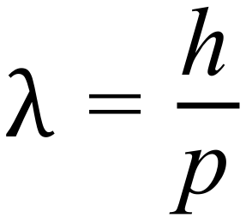 , where h is Planck’s constant.
8. Analyse the contribution of Erwin Schrödinger to the current model of the atom.

**ANSWERS AND SOLUTIONS**

1. 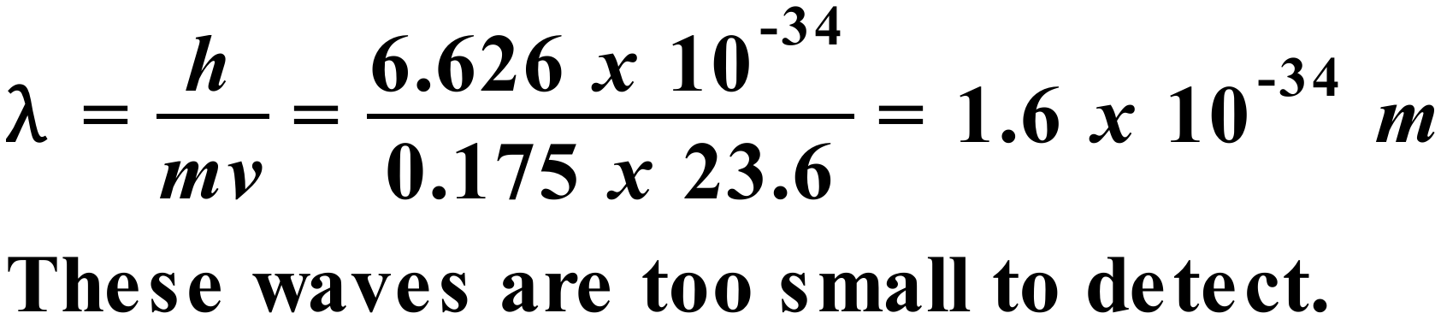
2. 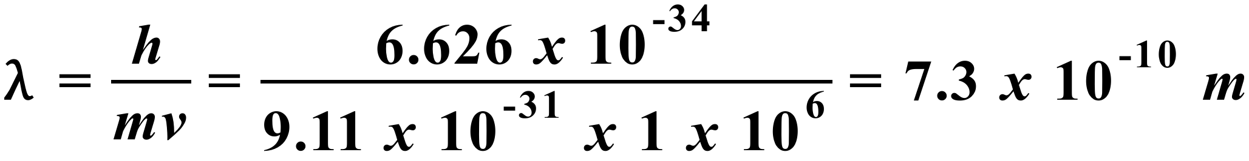  
     
   This l is about the size of the atom. We would therefore expect to observe the effect of such waves, for instance as they pass between layers of atoms in a metal sample producing diffraction and interference. This is the basis of electron diffraction techniques for probing the structure of matter.
3. 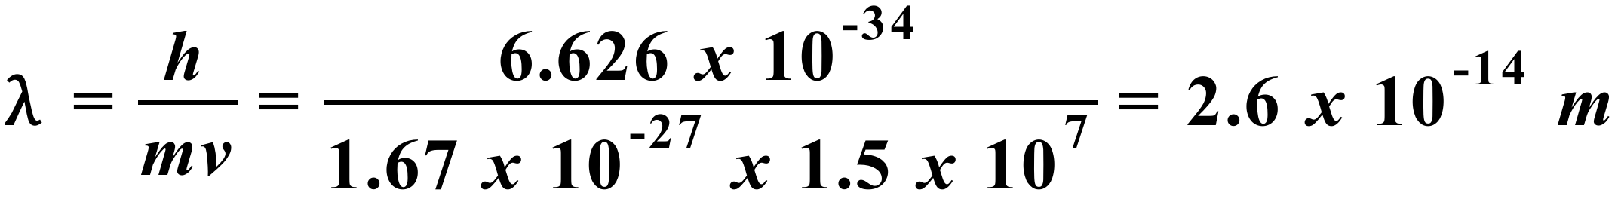
4. 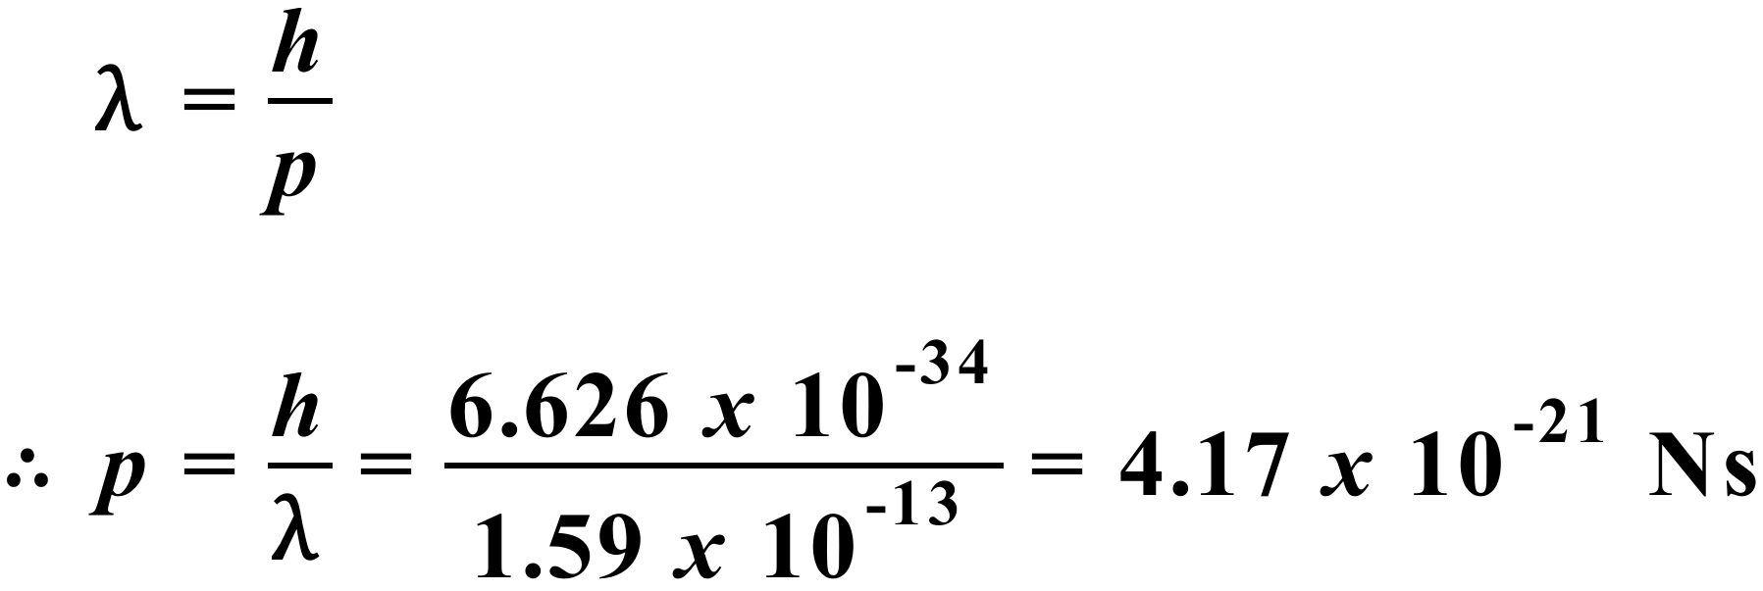
5. 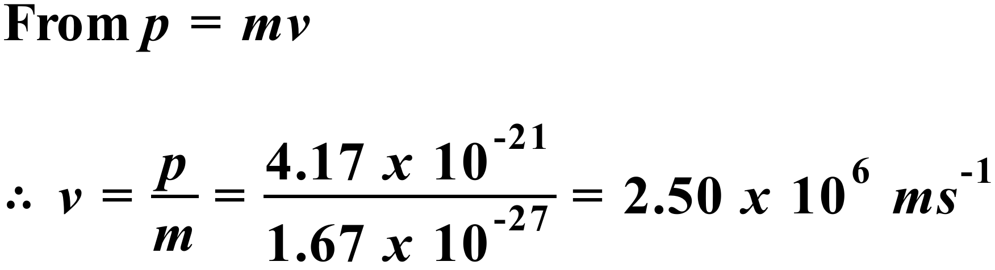
6. 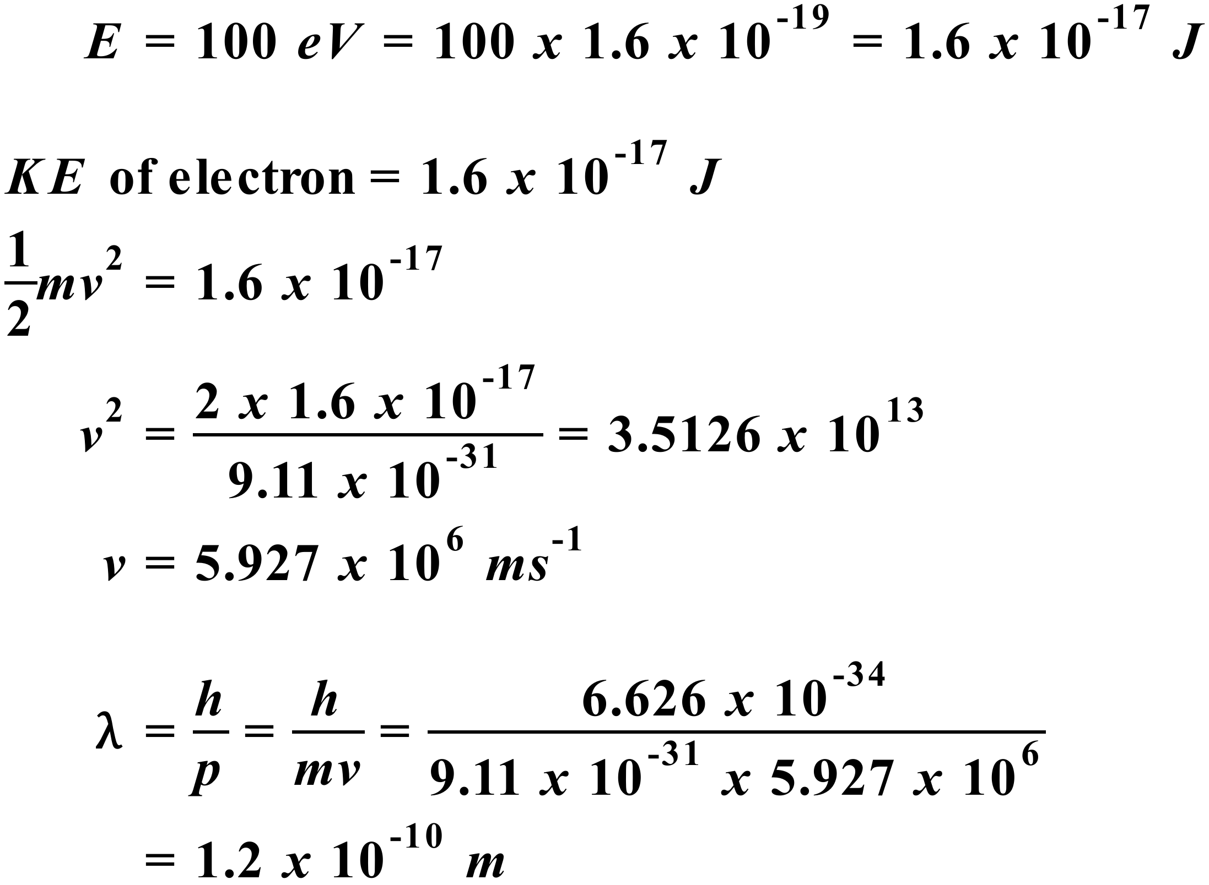
7. Experimental confirmation of de Broglie’s proposal on matter waves was achieved in 1927 by Davisson and Germer in the USA and by George Thomson in Scotland. Davisson and Germer conducted an experiment in which electrons in an electron beam produced the same diffraction pattern as X-rays when they were scattered by a small crystal of nickel. The electrons in the Davisson & Germer experiment were scattered in specific directions, which could only be explained by treating the electrons as waves with a wavelength related to their momentum by the de Broglie relation. Particles would have bounced off the nickel in all directions randomly. The following is a diagram of the apparatus used by Davisson & Germer. Electrons from filament F are accelerated by a variable potential difference V. After scattering from the nickel crystal, they are collected by the detector D. D can be moved to measure the scatter yield at any angle.  
     
    
8. In 1926, Schrödinger proposed a theory describing the behaviour of electrons by a wave equation that is now known as the Schrödinger equation. The Schrödinger equation describes the probability of finding an electron in a certain position at a certain time. It was a completely quantum mechanical description of the atom. Solutions of Schrödinger's equation correctly predict the energy states of hydrogen-like atoms and explain the observed quantization of atomic spectra. The theory also led eventually to a better understanding of chemical bonding and the structure of the periodic table.

Schrödinger was deeply involved in the debate that took place in the early years of quantum theory around the correct interpretation of the theory. He proposed his now famous experiment with a cat to demonstrate how the Copenhagen interpretation proposed by Bohr & Heisenberg leads to ridiculous consequences. Schrödinger’s objection did not prevail in the end. The Copenhagen Interpretation is still regarded by most physicists as a reasonable one.  
  
Schrödinger’s contribution to our current understanding of the atom cannot be underestimated. It is huge. Schrödinger’s work laid the foundations of quantum wave mechanics and guided its early development. Quantum Mechanics is arguably the most successful theory ever developed. It is used today in a huge variety of scientific and engineering fields. Schrödinger’s work in formulating his wave mechanical theory of the atom and his subsequent involvement in its development place him as one of the greatest physicists of all time.