QUESTIONS & PROBLEMS FOR MODULE 8
FROM THE UNIVERSE TO THE ATOM

Worksheet on Bohr’s Model
- State the four postulates used by Bohr to explain the nature of the atom.
- Draw a sketch of the Bohr model of the atom, clearly labelling the electronic transitions responsible for the four visible lines in the hydrogen emission spectrum (H_{α}, H_{β}, H_{γ}, & H_{δ} ).
- The red line within the Balmer series has a wavelength of 6560Å. 1 Å = 1 x 10⁻¹⁰ m. Identify the initial and final stationary states corresponding to this transition within the hydrogen atom?
- Calculate the wavelengths of each of the visible lines in the Balmer series for hydrogen.
- Determine the frequency of the radiation emitted when an electron in a hydrogen atom undergoes a transition from the n_{i} = 2 energy level to the n_{f} = 1 level. Calculate the energy emitted by the electron in making this transition.
- An electron in a hydrogen atom drops from stationary state n = 2 of binding energy 5.43 x 10⁻¹⁹J to stationary state n = 1 of binding energy 21.56 x 10⁻¹⁹J. Determine the energy emitted by the electron in making this transition.
- Extension Question: Starting with the Rydberg equation, derive equations for the frequency and energy of the radiation emitted when an electron in a hydrogen atom undergoes a transition from stationary state n_{i} to stationary state n_{f}. Hence write an equation for the energy of an electron in the n-th stationary state of the hydrogen atom.
ANSWERS & SOLUTIONS
- See your Module 8 notes page 15.

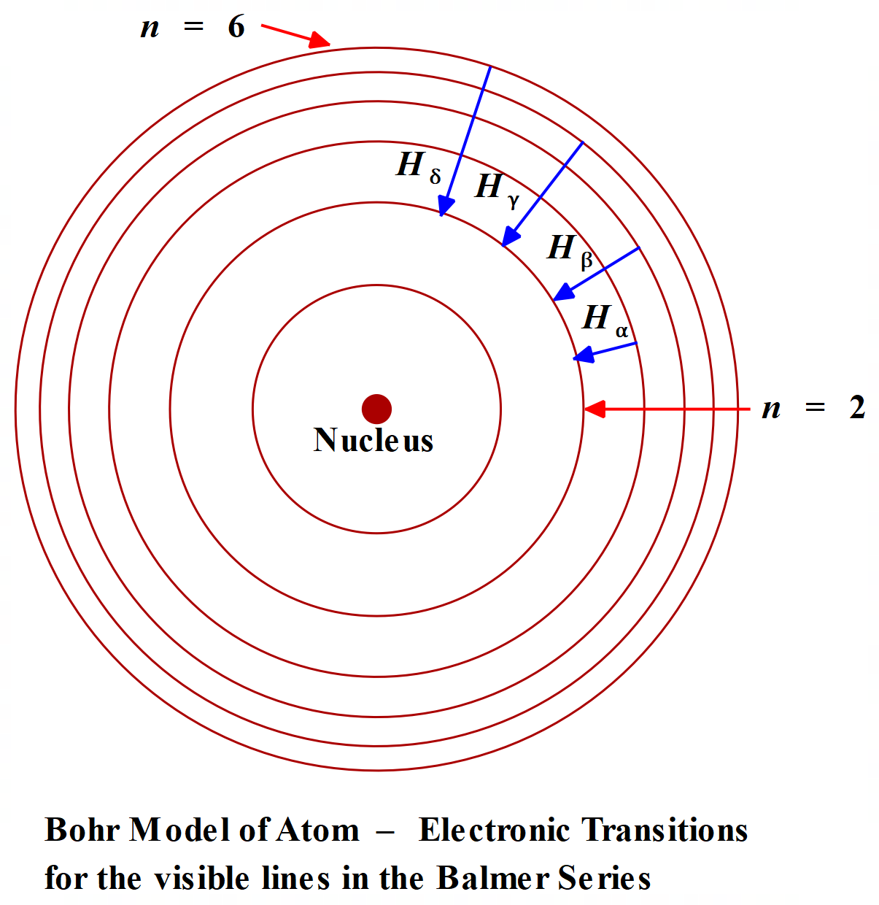
- Red line, H_{α},is produced by the transition n_{i} = 3 to n_{f} = 2.
- 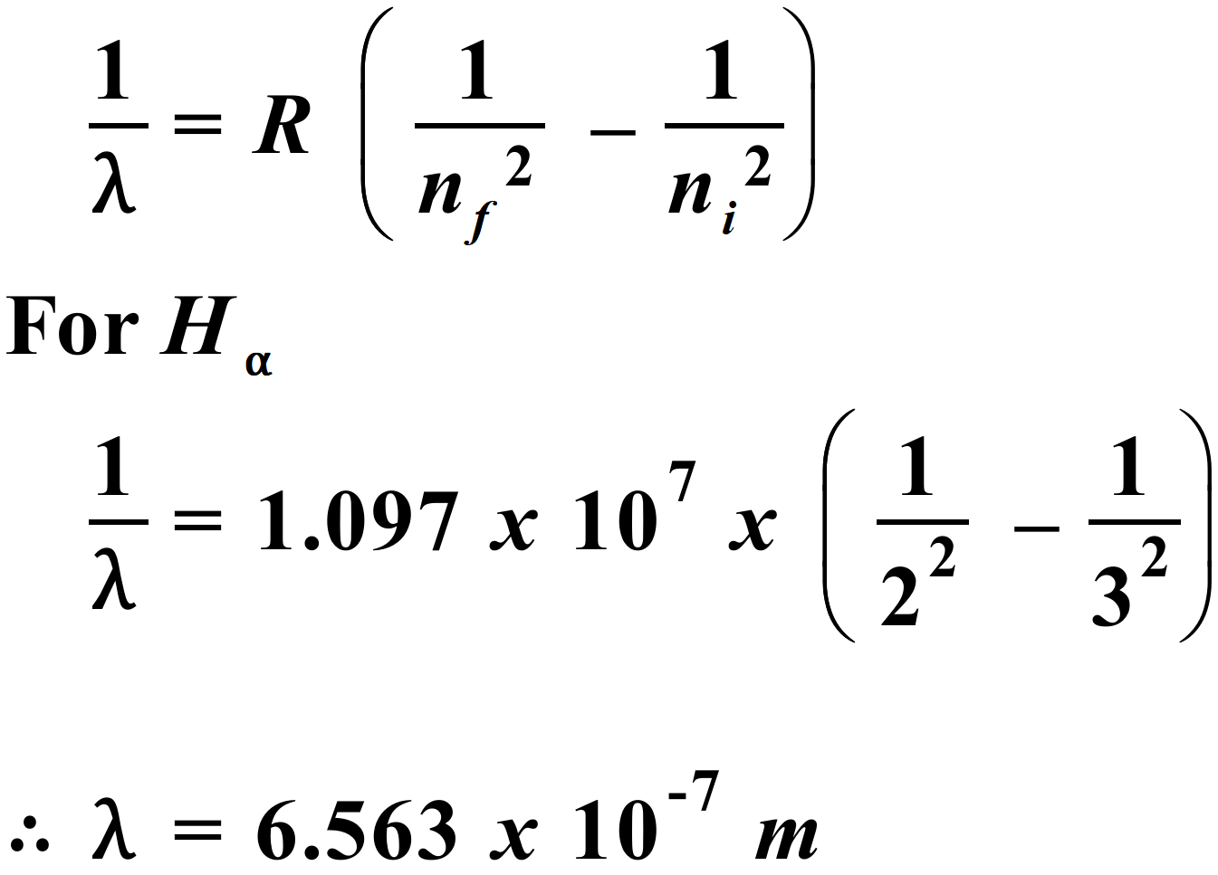
Using same method and n_{f} = 2 each time, with progressively n_{i} = 4, 5 and 6, we obtain the following values for the other three visible lines in the Balmer series:
H_{β}: λ = 4.862 x 10⁻⁷ m; H_{γ}: λ = 4.341 x 10⁻⁷ m; H_{δ}: λ = 4.102 x 10⁻⁷ m.
- 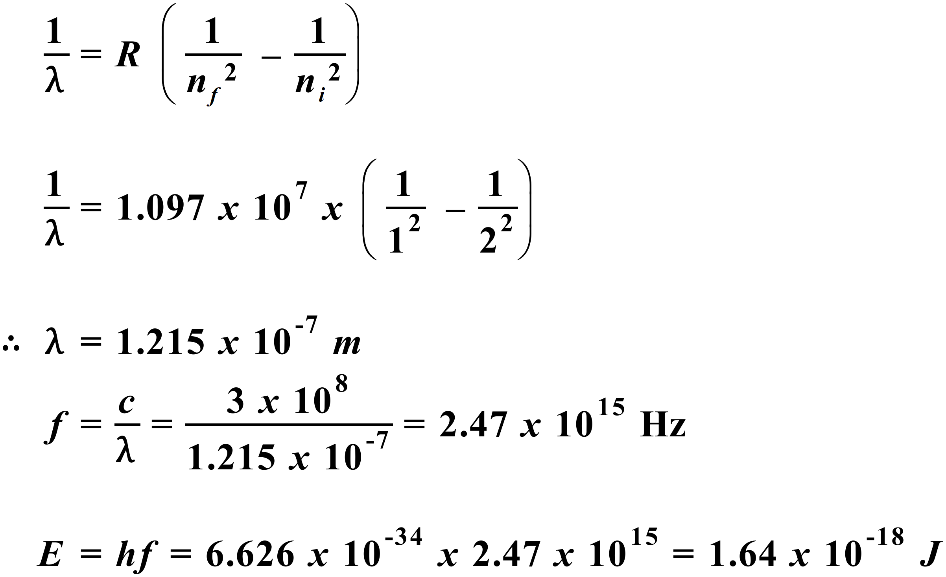
- 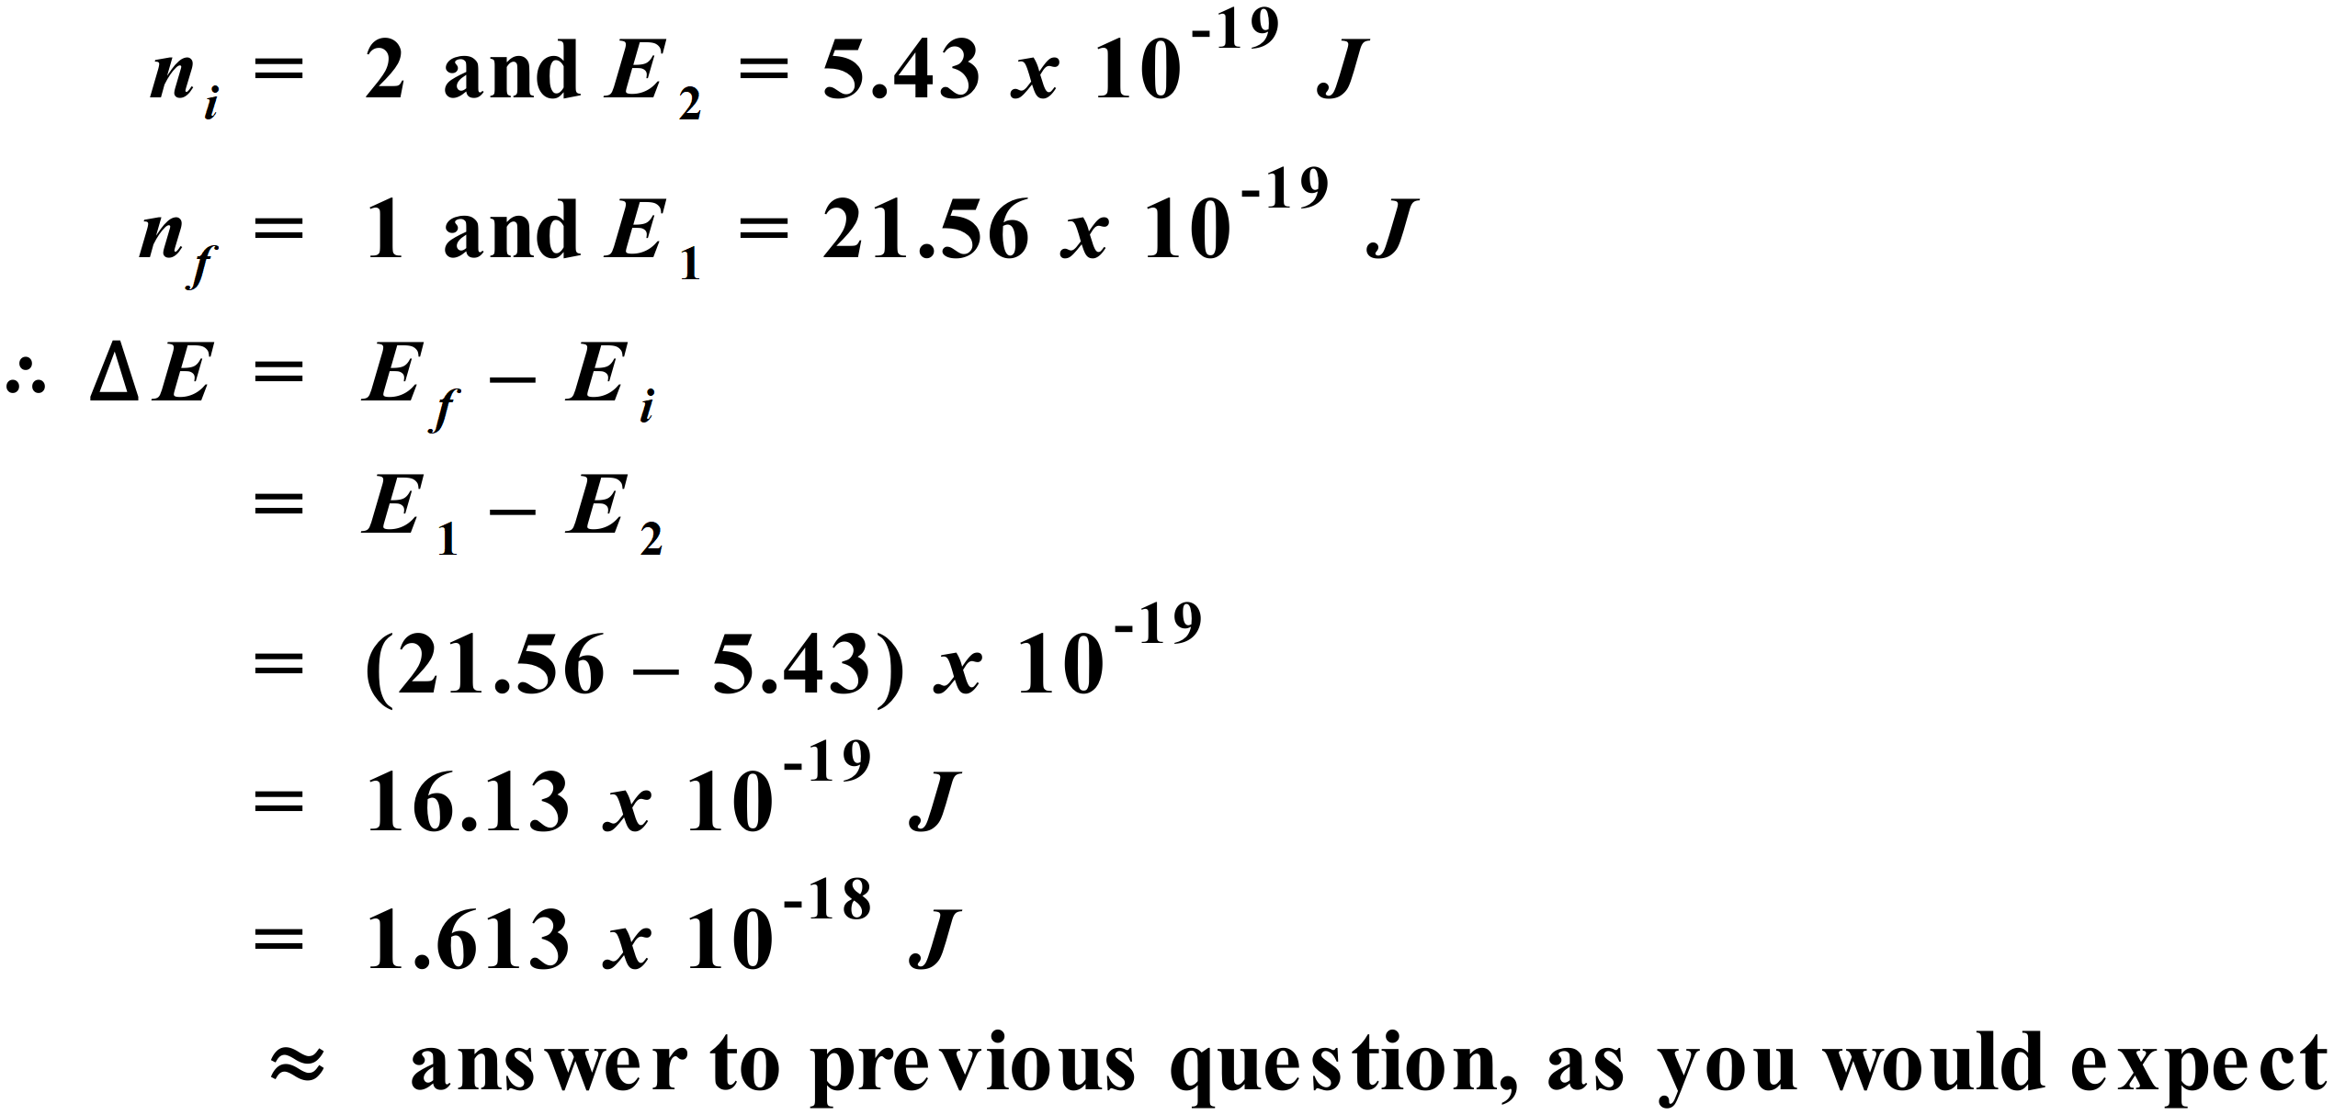
Answer to Q7 on next page.
- 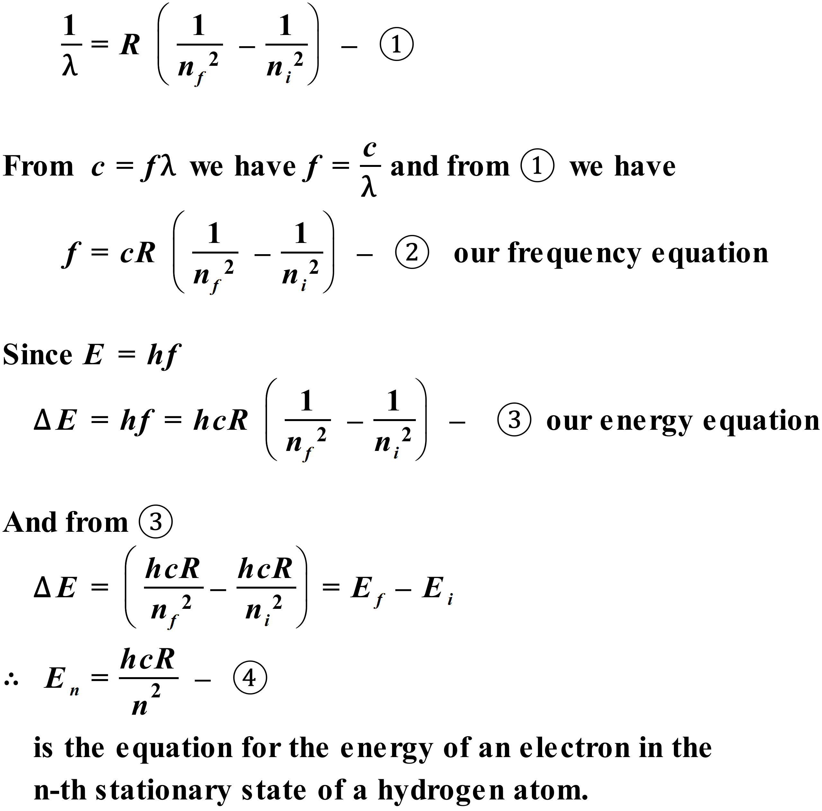
Note: Strictly speaking, 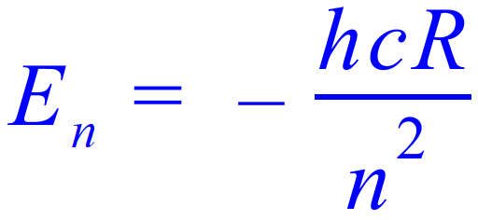 is the ionization energy for the hydrogen atom and 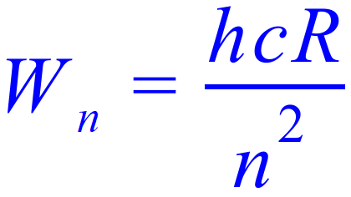 is the binding energy for hydrogen.

