WAVES WORKSHEET No.1

1. **A wave travelling on a string has a wavelength of 0.10 m and a frequency of 7 Hz. Calculate the speed of the wave.**
2. **A sound wave travelling in water at 1440 ms-1 has a wavelength of 0.5 m. Determine the frequency of the wave.**
3. **An electromagnetic wave moving through free space at 3 x 108 m/s has a frequency of 4.62 x 1014 Hz. Find the wavelength of this wave and express it in nanometres.**
4. **A water wave is moving across the surface of a lake in an easterly direction. The wave has a wavelength of 2 m and a frequency of 2.5 cycles/s. Draw a diagram of this situation, looking down from above the lake, showing 5 wavefronts. Label the wavelength and show the direction of propagation by using a ray. Label the ray with the wave velocity.**
5. **A sound wave has a wavelength of 0.65 m and a frequency of 512 Hz. Determine the period of the wave.**
6. **The following two graphs represent data from the same wave travelling due west through a particular medium. From the graphs determine: (a) the wavelength; (b) the amplitude; (c) the period; (d) the frequency and (e) the velocity of the wave.**   
   
7. **Give one example of each of the following: (a) a one-dimensional transverse wave; (b) a two-dimensional transverse wave and (c) a three-dimensional longitudinal wave.**

**Answers on next page.**

**Answers**

1. **0.7 m/s**
2. **2880 Hz**
3. **649 nm**
4. 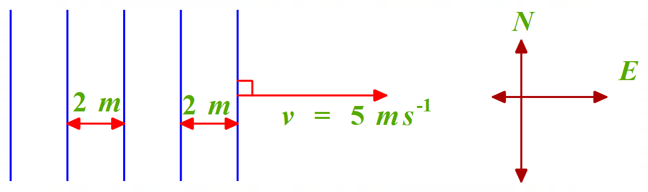
5. **1.95 x 10-3 s**
6. **(a) 2 m; (b) 5 m; (c) 0.2 s; (d) 5 Hz; (e) 10 m/s**
7. **(a) Transverse wave on a rope. (b) Circular ripples on surface of pond. (c) Sound wave from a police car siren.**