**Worksheet on the Atom and the Nucleus**

**Solutions are supplied after the questions section.**

**Structure of the Atom**

1. Assess the experimental evidence provided by J J Thomson’s charge-to-mass experiment for the existence of the electron.

**Quantum Mechanical Nature of the Atom**

1. That matter was composed of extremely small, indivisible particles had been proposed by Anaxagoras (500-428 BC) and Democritus (460-370 BC). John Dalton (1766-1844) first saw a significant connection between the known laws of chemical combination and a particle theory of matter. However, he postulated no internal structure for the atom.  
     
   Describe three pieces of experimental evidence which Ernest Rutherford (1871-1937) used to develop his model of the nuclear atom.
2. The emission spectra produced by heated gases were well known when in 1885, Johann Balmer developed an equation showing the relationship between the four lines in the visible light region of the hydrogen spectrum. Using the modified form of this equation shown below, calculate the longest wavelength of this spectral series.  
     
      
     
   The value of the Rydberg constant, R = 1.097 x 107 SI units.

**Properties of the Nucleus**

1. Nuclear fission produces thermal energy. What is the source of this energy?
2. Describe one piece of experimental evidence that led to the identification of a nucleon and an understanding of its nature.
3. Carbon-14 decays by beta emission. Write a complete equation for this radioactive decay, including mass and atomic numbers and identification of the decay product.
4. When boron-10 is hit by an a-particle, a neutron is ejected. Write an equation for this reaction. What element is produced as a product?
5. Study the following reaction:  
     
    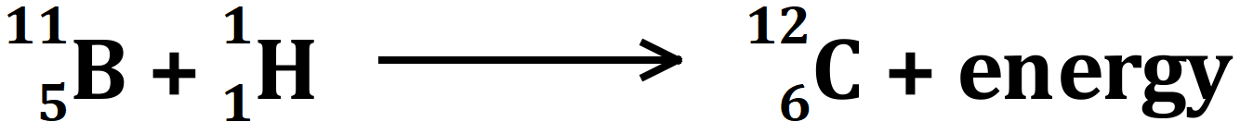   
     
   Given the following data, calculate the amount of energy produced by this reaction.  
     
   Mass of boron = 11.00932 u  
   Mass of proton = 1.00783 u  
   Mass of carbon = 12.0000 u  
     
   1 u = 931.5 MeV
6. In the thorium series, a number of unstable nuclei decay through a series of alpha and beta decays. Complete the reactions for the first four decay events in the series.
   1. Th-232 decays through a-decay
   2. Ra-228 decays through b--decay
   3. Ac-228 decays through b--decay
   4. Th-228 decays through a-decay
7. Igneous rocks can be dated by measuring the amount of a radioactive element and its daughter element. For example, U-238 decays to Pb-207 with a half-life of 7.1 x 108 years. If no other isotope of lead is present, it can be assumed that all the lead was caused by radioactive decay since the rock formed. If a rock sample has a ratio of U-238 to Pb-207 of 1:3, how old is the rock?
8. A certain radioactive substance emits radiation at the rate of 2.4 x 1011 Bq (becquerel) and one day later is emitting radiation at 1.5 x 1010 Bq. Calculate the half-life of the substance.  
     
   Note: The **becquerel (Bq)** is the SI unit of radioactive activity.

**Solutions commence on the next page.**

**Solutions**

**Structure of the Atom**

1. J.J Thomson’s charge-to-mass experiment was critical in establishing the particulate nature of cathode rays and the existence of the electron. Thomson believed that cathode rays were composed of charged particles and that determining a charge to mass ratio would be very strong evidence for this. In successfully determining the charge to mass ratio of cathode ray particles, Thomson established the existence of electrons beyond doubt.  
     
   Thomson subjected beams of cathode rays to deflection by known electric and magnetic fields set at right angles to each other (crossed fields) in order to measure the charge to mass ratio of the cathode rays. He showed that cathode rays could be deflected by electric and magnetic fields. By writing equations describing the curvature of the paths of the particles in the magnetic field (**mv2/R = qvB**) and the balance of electric and magnetic forces on the particles in the crossed fields (**qE = qvB**) Thomson derived a formula for the charge to mass ratio of the particles (**q/m = E/B2R**).   
     
   Thomson determined **q/m** for cathode rays to be a constant value regardless of the material used for the cathode. This determination effectively confirmed the particulate nature of cathode rays. Further experiments in which Thomson showed that the charge on the cathode ray particles was the same size as the charge on the hydrogen ion and that the mass of the cathode ray particles had to be 1800 times smaller than that of the hydrogen ion, led Thomson to suggest that the cathode ray particle was a fundamental constituent of the atom. Originally called “corpuscles”, the name “electron” slowly became accepted as the official name for these particles.  
     
   You would adjust the answer above depending on how many marks this question was allocated. The answer above is a band 6 answer to a question worth at least 5 marks.

**Quantum Mechanical Nature of the Atom**

1. (i) Thomson’s **q/m** ratio experiment showed that cathode rays in a discharge tube could be deflected by electric and/or magnetic fields. (ii) Geiger & Marsden’s a-particle scattering experiment showed that when a-particles were fired at a thin gold foil most past straight through the foil undeflected. (iii) In the same a-particle scattering experiment, it was also observed that very few of the a-particles were deflected at large angles (> 90º).
2. The longest wavelength will be the smallest frequency (lowest energy) spectral line. This is the hydrogen alpha (red line), produced when an electron drops from initial state **ni = 3** to final state **nf = 2**. So, we have:  
     
      
     
     
    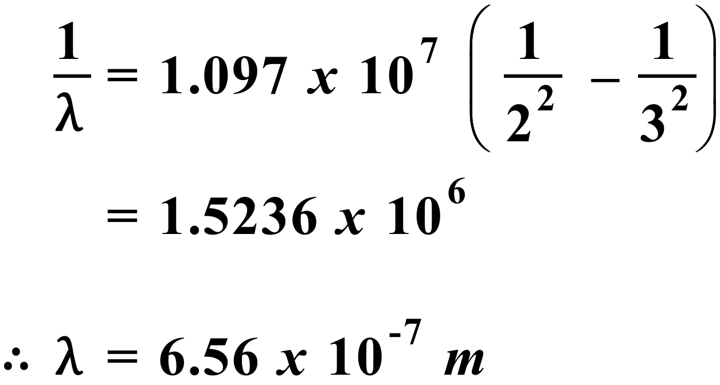

**Properties of the Nucleus**

1. In the nuclear fission process, the total mass of the products is less than the total mass of the reactants. This mass loss is converted into energy.
2.   
     
   Bothe & Becker found an uncharged radiation was emitted from beryllium when struck by a-particles. Frederic & Irene Joliot found that this natural radiation knocked protons from paraffin wax. These protons being positively charged were easily detected. Later analysis of these experiments by James Chadwick identified the neutron to be a neutral particle with a mass about that of a proton.
3. 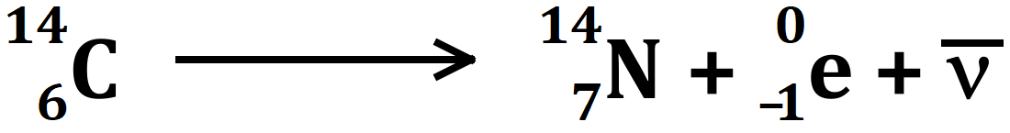   
     
   Decay products are nitrogen-14, a beta-minus particle (electron) and an antineutrino.
4. 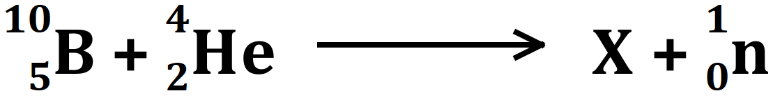   
     
   As atomic numbers and mass numbers must balance on both sides of the equation, X must have an atomic number of 5 + 2 – 0 = 7 and a mass number of 10 + 4 – 1 = 13. So, X must be nitrogen-13 and the full equation is:  
    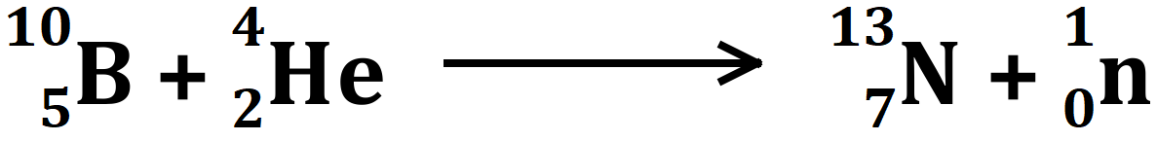
5. Mass of reactants = mass of boron + mass of proton = 12.01715 u  
     
   Mass of products = mass of carbon = 12.0000 u  
     
   Difference in mass between products & reactants = 0.01715 u  
     
   This is transformed into energy. Amount of energy = 0.01715 x 931.5 = **15.98 MeV**.
6. Use the same method as in question 4 above. The atomic number on LHS = atomic number on RHS and the mass number on LHS = mass number on RHS.  
   1. 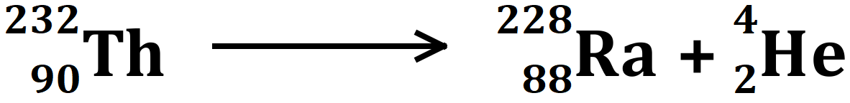   
        
      For conservation of charge the product nucleus must have an atomic number of 88 (88 + 2 = 90) and for conservation of nucleons, the atomic mass number must be 228 (228 + 4 = 232). Thus, the product element is radium.
   2. 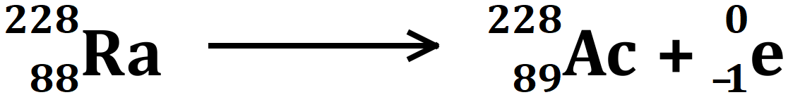
   3. 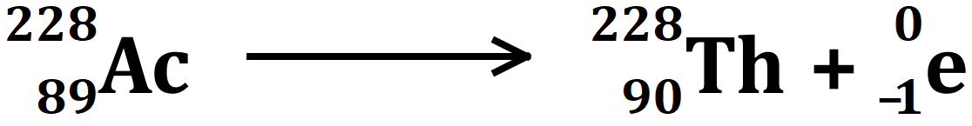
   4. 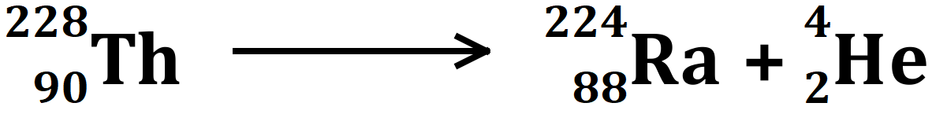
7. Ratio of U-238 to Pb-207 = 1:3  
     
   Therefore, ¼ of the original mass of U-238 is left. ¾ of the original mass of U-238 has decayed into Pb-207.  
     
   Let the number of half-lives that have passed = x  
     
    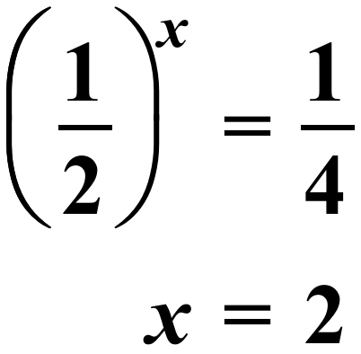   
     
   So, the rock is 2 half-lives old = 1.42 x 109 years old (or 1.42 billion years old)
8. The **activity**, **A**, of a radioactive element is the number of nuclei that disintegrate per second. Activity is given by:  
     
     
    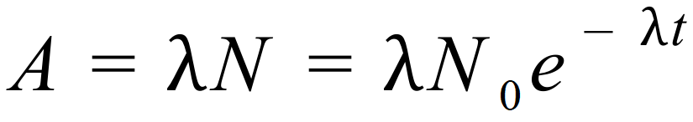   
     
   At time t = 0, A = 2.4 x 1011 Bq = lN0 – equation (1)  
     
   and at time, t = 1 day = 86,400 s, A = 1.5 x 1010 Bq = lN0 e-lt – equation (2)  
     
   So, substituting for lN0 from equ (1) in equ (2), we have:  
     
    